JOB DESCRIPTION

1. JOB DETAILS

Job Title: Assistant Project Accountant

Band: 5

Responsible to: Senior Project Accountant

Accountable to: Senior Project Accountant and Contracts Manager

Department / Directorate: Finance

2. JOB PURPOSE

- To support the Senior Project Accountant and the Contracts Manager in the implementation of a wide range of Finance projects, developing financial and IT skills and expertise, in order to take responsibility for specific aspects of the work.
- To assist in the process of transferring project outcomes to operational staff, through the creation of procedure documentation and supporting training workshops.
- To assist in the monthly income processing, ensuring all income is invoiced, reconciled and reported correctly within the ledgers.

3. KEY WORKING RELATIONSHIPS

- Income and Contracting Team
- Costing and SLR Team
- Business Intelligence Team
- Clinical Applications Team
- Willow Team
- Management Accounting and other Finance staff
- Divisional Business and Cluster Managers/Budget holders
- Divisional Managers

4. ORGANISATIONAL CHART:
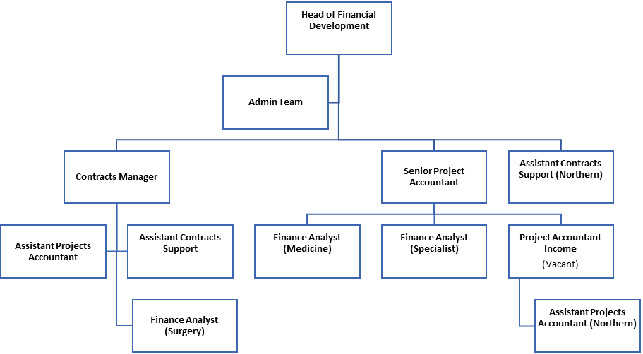

5. KEY RESULT AREAS/PRINCIPAL DUTIES AND RESPONSIBILITIES:

- To provide a support role to the Senior Project Accountant and the Contracting Manager by supporting the implementation of a wide range of Finance projects.

- To support the Senior Project Accountant and Contracts Manager in the delivery of Contracting, by providing day to day assistance to income processing on complex issues including reconciliation issues and detailed patient level income investigations.

- Opportunities will be given to develop knowledge of other sections and gain experience of other roles within Finance with Business Intelligence.
- As part of the Project agenda, the post holder will:
- Investigate and analyse complex accounting problems, seeking explanations for the problem and suggesting appropriate solutions where possible.
- Develop skills in interpreting management information in order to promote improvements, enhance quality, or provide recommendations as required.
- Participate fully in project work, in order to ensure the successful completion of the objectives set for the team as a whole.
- Design and format spread sheets and databases for specific purposes, and be responsible for introducing, adapting and improving financial system for use by others.
- Develop skills and knowledge in a range of finance systems and procedures in order to contribute fully to the sections objectives.
- Assist in transferring completed project work, where appropriate, to operational staff, ensuring that procedures are in place and that training requirements are supported as necessary.
- Undertake project work with other Senior Managers, as required, to support the objectives of the Finance Department or Directorate, and assess the implications and risks of such projects.
- Assist in the completion of other monitoring returns, both internal and external, including Annual Accounts, Financial Returns, Drugs and Devices reports, HCTED and Demand Plan, as directed by the Senior Project Accountant or the Contracts Manager.
- Assist in the delivery of monthly income reports, analysing trends, investigating variances, devising and implementing solutions to enable accurate allocation actual patient income to Divisions.
- Ensure all invoices are raised in a timely manner for any patient income due.
- Complete monthly control account reconciliations according the Trust timetable.
- Develop skills to understand Trust services and the collection of income, in order to support the contracts colleagues in the interpretation of variation orders and patient income received.
- Prioritise and identify own work schedule, while meeting agreed objectives, and use the freedom to do this, within Trust policies and procedures. Be aware of and meet agreed deadlines.
- Participate fully in the creation of own Personal Development Plan through the Trust’s Review process.
- Perform other such duties as may be directed from time to time by Senior Finance Managers.

Other Responsibilities

- To take part in regular performance appraisal
- To undertake any training required in order to maintain competency including mandatory training i.e. Fire, Manual Handling.
- To contribute to and work within a safe working environment
- The post holder is expected to comply with Trust Infection Control Policies and conduct him/herself at all times in such a manner as to minimise the risk of healthcare associated infection.

THE TRUST - PURPOSE AND VALUES

We are committed to serving our community by being a high quality specialist Hospital with consultant-led services. We aim to co-ordinate our services with primary and community care, and to develop a limited number as Sub-Regional Referral Centres with appropriate levels of research, development and educational involvement. Where appropriate, and consistent with our services, we may provide services aimed at preventing disease and debilitation.

We aim to make all our services exemplary in both clinical and operational aspects. We will show leadership in identifying healthcare needs to which we can respond and in determining the most cost-effective way of doing so. We will share our knowledge with neighbouring healthcare agencies and professionals.

We recruit competent staff that we support in maintaining and extending their skills in accordance with the needs of the people we serve. We will pay staff fairly and recognise the whole staff’s commitment to meeting the needs of our patients.

We are committed to equal opportunity for all and encourage flexible working arrangements including job sharing.

The Trust is committed to recruiting and supporting a diverse workforce and so we welcome applications from all sections of the community, regardless of age, disability, gender, race, religion, sexual orientation, maternity/pregnancy, marriage/civil partnership or transgender status. The Trust expects all staff to behave in a way which recognises and respects this diversity, in line with the appropriate standards.

GENERAL

This is a description of the job as it is now. We periodically examine employees' job descriptions and update them to ensure that they reflect the job as it is then being performed, or to incorporate any changes being proposed. This procedure is conducted by the Manager in consultation with the jobholder. You will, therefore, be expected to participate fully in such discussions. We aim to reach agreement on reasonable changes, but if agreement is not possible, the Trust reserves the right to insist on changes to your job description after consultation with you.

The RD&E is a totally smoke-free Trust. Smoking is not permitted anywhere on Trust property, including all buildings, grounds and car parks. For help to quit call: 01392 207462.

As an employee of the Trust, it is a contractual duty that you abide by any relevant code of professional conduct and/or practice applicable to you. A breach of this requirement may result in action being taken against you (in accordance with the Trust’s disciplinary policy) up to and including dismissal.

The post holder is expected to comply with Trust Infection Control Policies and conduct him/her at all times in such a manner as to minimise the risk of healthcare associated infection.

This post has been identified as involving access to vulnerable adults and/or children and in line with Trust policy successful applicants will be required to undertake a Disclosure & Barring Service Disclosure Check.

PERSON SPECIFICATION
POST: Assistant Project Accountant
BAND: 5
REQUIREMENTS | At  Recruitment
QUALIFICATIONS / TRAINING  AAT or equivalent experience within the Contracting department and experience of income processing for a large Acute Trust  Professional Accountancy Qualification (CCAB recognised – Certificate level or equivalent)  Degree (or Equivalent)  Evidence of exam success towards full CCAB qualification | E  D  D  D
KNOWLEDGE/SKILLS:  A good knowledge and experience of computer based management accounting systems and Microsoft Office applications  Strong numerical skills, ability to understand financial information  Strong analytical skills, ability to perform complex investigations  Excellent organisational and time management skills  Knowledge of a range of finance systems, including Payroll, Payments and Invoicing  Knowledge of Finance computer systems  Good Excel/spread sheet skills  Experience using database | E  E  E  E  E  D  E  E  D
EXPERIENCE:  Management Accounting experience  Ability to Prioritise work and meet deadlines  Experience within the Finance function of the NHS | E  E  D
PERSONAL ATTRIBUTES  Good communicator  Confident  Self-motivated  Team worker  Ability to adapt to changing priorities | E  E  E  E
* Essential/Desirable

HAZARDS (tick as appropriate)
Laboratory Specimens  Proteinacious Dusts |  | Clinical contact with Patients |  | Performing exposure prone invasive procedures
Blood / Body Fluids |  | Dusty Environment |  | VDU Use | X
Radiation / Lasers |  | Challenging Behaviour | X | Manual Handling
Solvents |  | Driving |  | Noise / Vibration
Respiratory Sensitisers |  | Food Handling |  | Working in isolation
Cytotoxic Drugs |  | Electrical work |  | Night Working

