

JOB DESCRIPTION
JOB DETAILS
Job Title | Research Nurse
Reports to | Team Lead/Research Nurse Specialist
Band | 5
Department/Directorate | Research & Development

JOB PURPOSE
You will support the safe conduct of research in accordance with the Research Governance Framework and Good Clinical Practice guidelines, and provide assurance that the rights, safety and well-being of trial participants are protected.
The post-holder will work with the research team to plan, implement, organise and manage concurrent research projects. You will develop networks with Multidisciplinary Teams across the Trust and other appropriate local and national agencies. You will coordinate and manage the relevant study portfolio and deliver recruitment accrual in line with performance and monitoring objectives.
The post-holder will be responsible for the implementation and monitoring of the clinical requirements associated with research to ensure optimum delivery of clinical trials. You will ensure that all research procedures are conducted according to study protocols, and will be accountable for the recruitment, data collection and care of research participants with a focus on providing a quality experience.
KEY RESULT AREAS/PRINCIPAL DUTIES AND RESPONSIBILITIES
• | Be responsible for the care of research participants within the relevant sphere of practice and use opportunities to provide health promotion and patient education.
• | Undertake all mandatory training and take part in personal development reviews.
• | Training and support for informed consent will be given. Be responsible for the safe and accurate collection of research data through clinical procedures such as venepuncture, history taking, standard observations (height, weight, BP, RR, HR, SpO2 and temperature) and other assessments such as ECG, physical examinations, disease specific outcome measures, questionnaires, rated scales and qualitative interviewing as required by the protocol.
• | Centrifuge, process, track and ship samples in line with protocol requirements.
• | Refer to other specialists as required in order to provide optimal care of the participant.
• | Contribute to the monitoring of clinical standards within the research team.
• | Treat all persons encountered during the course of duties with respect and courtesy and maintain a standard of conduct which best represents the clinical trials team and the Trust.
• | Work within the relevant professional code of conduct (if applicable) demonstrating accountability for own actions and awareness of own limitations.
• | Provide cover for other research nurses/practitioners as required.
• | Be responsible for promoting the appropriate referral & recruitment of patients to clinical research studies. Work with the clinical trials team and investigators to develop strategies to overcome barriers to recruitment and solve other problems relating to specific studies.
• | Work with other departments within the Trust to ensure that trial-specific investigations and procedures are undertaken as required by the trial protocol, in order to establish eligibility and safety of patients within clinical trials.
• | Escalate on-going study performance issues to the Senior Research Nurse or Team Lead.
• | Co-operate with external and internal audit, data monitoring and quality assurance by working with R&D, sponsors, study monitors and external bodies.
• | Assist in study close-down and the preparation of results of research for presentations as posters, abstracts, papers or scientific presentations.
• | Post-holder will need to have relevant clinical knowledge and the ability to critically evaluate participants’ progression through research pathways in order to respond and refer appropriately.

KEY WORKING RELATIONSHIPS
The post-holder is required to deal effectively with staff of all levels throughout the Trust as and when they encounter them on a day-to-day basis.
In addition, the post-holder will deal with the wider healthcare community, external organisations and the public. This will include verbal, written and electronic media.
Of particular importance are working relationships with:
 | Internal to the Trust | External to the Trust
 | • Lead Research Nurses | • Study participants and their families
 | • Research Team Leads | • Study Sponsors & Clinical Research Associates
 | - Pharmacy Trials Team  - Diagnostic Services  - Finance Team  - Research & Development Dept  - Principal Investigators | • South West Peninsula Clinical Research Network

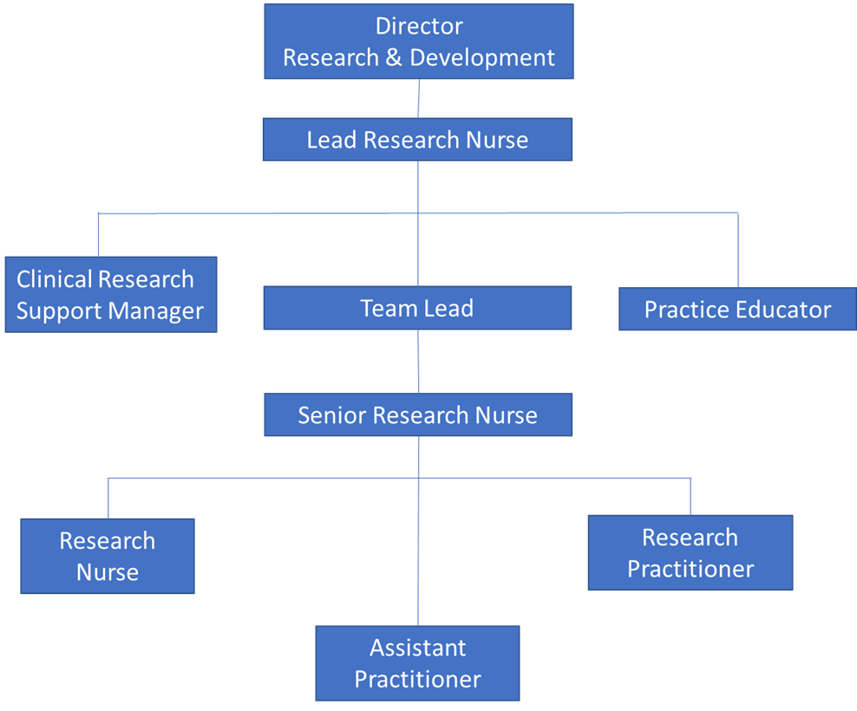
ORGANISATIONAL CHART
FREEDOM TO ACT
- The post-holder will be able to work autonomously whilst ensuring that all research procedures are conducted according to study protocols and Standard Operating Procedures (SOPs), both Trust and study-specific.
- The post-holder will work autonomously within general policies and procedures guided by national policy and regulations and the Trust’s own policies.
- Promote a blame-free culture in reporting incidents, and where appropriate, support local investigation of incidents.

COMMUNICATION/RELATIONSHIP SKILLS

- Facilitate and maintain effective communication within the research team and between the multidisciplinary clinical team. Recognise the different ways of obtaining consent depending on the environment, establishing whether the patient can consent for themselves or if an advocate is more appropriate and acceptable. This conversation may be sensitive so will require a degree of tact and empathy.
- Proactively seek feedback from participants and their families during their research involvement.
- Take responsibility for own health, safety and security, and promote the health, safety and security of the wider team.
ANALYTICAL/JUDGEMENTAL SKILLS
- Use relevant clinical knowledge to screen and identify patients suitable for clinical research using inclusion and exclusion criteria and utilising NHS records, screening clinics, visiting wards and outpatients and using Trust IT systems and databases.
- Act as a resource and role model for all aspects of Research Clinical Practice in order to optimise patient care and clinical practice. This may include carrying out physical assessments, conducting sample retrieval and processing, and providing or coordinating interventions, treatments and clinical monitoring.
- Engage in early evaluation of Expressions of Interest (EOI) received with Principal Investigator and Team Lead to ensure feasibility of study at site is properly assessed.
- Work with the lead clinician and Senior Research Nurse/Team Lead to review complex clinical trial protocols and to develop a balanced portfolio of studies for each speciality that the post-holder works across.
- Clinical knowledge within a relevant sphere of practice is required to enable screening against specified inclusion/exclusion criteria for recruitment.
- Critical research evaluation and the ability to conduct feasibility will be key requirements when working on research protocols.
- Assess and evaluate the progress of ongoing clinical trials for which the post-holder has responsibility, maintaining accurate records of the status of studies and providing regular updates to the department on the status of the studies. This will involve ensuring that EDGE (Local Patient Management System) is updated with key trial data and validated efficiently.
PLANNING/ORGANISATIONAL SKILLS
- Be responsible for managing and organising own day-to-day activities and workload, liaising with the Senior Research Nurse and working within the team to ensure the portfolio remains covered at times of leave.
- To deputise for Senior Research Nurse on an ad-hoc basis.
- Support the planning of both short-term and long-term research projects.
- Works with the Team Lead to understand and plan the portfolio of studies that may be open, in follow-up or in set-up at any one time.
- Respond to data queries generated by the study coordinating team within a timely manner.
- Coordinate and run study visits, including off-site visits, whilst adhering to the lone-worker policy.
- Manage research performance and study timelines of relevant studies.
- Ensure the recording & reporting of Adverse and Serious Adverse Events that occur whilst the participant is in the clinical trial to the trial co-coordinator/Principal Investigator (PI) and R&D office in line with the study protocol, local policies and regulatory requirements.

PATIENT/CLIENT CARE
- Ensure the environment is suitable for patient care and research processes, recognising the importance of privacy, dignity and diversity.
- Demonstrate professional development and an in-depth knowledge of current clinical and research practice.
- Provide ongoing specialist advice and information to patients and their carers/families with regard to their participation in clinical research in order to facilitate effective informed consent.
- Where appropriate receive and document written informed consent from research subjects.
- Ensure the safe administration of any treatments and drugs given within the context of a clinical trial.
- Monitor treatment toxicity/side effects and initiate changes to treatment as required by the protocol. Escalate any concerns to the Principal Investigator or relevant physician.
- Ensure accurate patient trial documentation, including the use of electronic data capture systems, and ensure relevant information is recorded in patients’ medical notes and case report form in a timely manner.
- The post-holder will contribute to ensuring the patient experience is excellent, ensuring patients are at the heart of service design and delivery.

POLICY/SERVICE DEVELOPMENT
- Promote a culture of continuous improvement and transformation, enabling all change management activity, and providing expertise, advice and guidance to staff and working with staff groups and change champions as required.
- Contribute to the development and implementation of clinical and research policies, procedures and SOPs.
- Ensure Trust policies are applied in the Clinical Team, support reporting of complaints and concerns by research participants that may be related to their participation in research, and to ensure these complaints are appropriately managed and acted upon in accordance with requirements of the UK Policy Framework for Health and Social Care Research.
FINANCIAL/PHYSICAL RESOURCES
- Assist in accurate costings for clinical research activity during study set-up. Utilise planning tools such as the intensity toolkit.
- Assist in identifying resource implications for individual studies.
- Ensure research equipment is maintained in an effective working and good clinical order, including ensuring blood kits and IMP are in-date and stored securely and appropriately.
- Contribute to the accurate costing for clinical trials and appropriate negotiation of required financial support to deliver clinical trials.
- Ensure that participants have all information, etc, to claim appropriate travel and other expenses, and complete invoices in a timely and accurate manner.
- Have an awareness of the income stream relevant to Clinical Trials and work within local and Trust-wide financial and budgetary guidelines.

HUMAN RESOURCES
- Supervise Assistant Research Practitioners and a range of junior staff.
- Support senior staff in recruitment and interviewing processes in line with Trust practices and procedures.
- Take an active role in the mentoring and supervision of student nurses and junior staff.
- Provide teaching in practice to other staff and students through clinical supervision and facilitation.
- Assist in the delivery of education and training regarding research for the wider multidisciplinary team and act as an ambassador for research.
- Supervise the work of junior members of staff and delegate work where appropriate.
- Provide relevant mentorship to members of staff and students.
- Participate in Good Clinical Practice (GCP) training.

INFORMATION RESOURCES

- Ensure clear, accurate and concise records are kept for research projects in accordance with all regulatory requirements including the Data Protection Act.
- Respond to data queries generated by the study coordinating team within a timely manner.
- Demonstrate awareness of the Ethics Committee Procedures through prompt reporting of Serious Adverse Events, submission of Trust application, protocols, advertisements and amendments.
- Ensure that data is entered and transcribed accurately where required and assist with the maintenance of the Trial Master File.
- The post-holder will be required to use their excellent IT skills, including MS Office, Google docs, Internet and databases, etc, in order to monitor activity, systems and processes, and to produce reports including in time-bound circumstances.
RESEARCH AND DEVELOPMENT
- Demonstrate awareness of R&D/CRF facilities within the Trust and their working relationships.
- Demonstrate awareness of the Ethics Committee Procedures through prompt reporting of Serious Adverse Events, submission of Trust application, protocols, advertisements and amendments.
- Be responsible for the delivery of the clinical trial portfolio.
- Ensure that the delivery of studies meets requirements with regards to the Department of Health’s Research Governance Framework for Health & Social Care and the EU Clinical Trials Directive by implementing quality systems.
- Contribute to the Expression of Interest/Study Selection process for the relevant specialty.
- Contribute to study set-up, recruitment planning and study delivery.
- Collaborate with other Trusts and organisations within the region to improve research delivery.
- Keep up to date with research management issues through liaison with other Research Specialists/Team Leaders and links with national networks.
PHYSICAL SKILLS
- Standard keyboard skills are required for the inputting and manipulating of data and/or information on computer databases. This is a strong element of the position.
- The post-holder will be expected to be competent in dealing with venepuncture procedures and patient samples on a regular basis.

PHYSICAL EFFORT
- The role requires flexibility as the research offices are not necessarily based where the patients are recruited or seen for their clinical research appointments. Research offices are not based where patients are seen or recruited and the research team members are required to work across multiple sites at the RDE Wonford, and where necessary, Heavitree.
- Attending Investigator Meetings can mean traveling around the country, or even abroad. Travel arrangements are made and costs covered by the sponsors and commercial companies but flexibility is required in order to accommodate attending these meetings.
- Covering a multi-Trust-site portfolio, or performing home visits, will mean the post-holder is required to ensure they can commit to this requirement.
MENTAL EFFORT
- Data accuracy and IT skills are essential to this role and combining clinical skills with these demands can be mentally difficult. Undertaking data entry is a requirement for this role and can often require long periods of concentration in a busy environment with interruptions.
- There can be occasional requirements for focused concentration when performing IT training for a new study requiring mastering a series of IT programmes. This is to ensure accurate data entry and results which will impact the trial integrity if not completed correctly.
EMOTIONAL EFFORT
- Occasional indirect exposure to distressing/emotional circumstances.
- On occasion the post-holder may be required to undertake discussions about research with participants and their families during times of emotional distress.

WORKING CONDITIONS
- If working alone the post-holder will adhere to the Trust’s Lone Worker SOP and the speciality’s Working Instructions.
- The post-holder may be required to respond to an incidence-driven recruitment strategy, and this may be achieved through use of a bleep, group WhatsApp, text, and phone call.

OTHER RESPONSIBILITIES
- Take part in regular performance appraisal.
- Undertake any training required in order to maintain competency including mandatory training, e.g. Manual Handling.
- Contribute to, and work within, a safe working environment.
- You are expected to comply with Trust Infection Control Policies and conduct him/herself at all times in such a manner as to minimise the risk of healthcare-associated infection.
- As an employee of the Trust, it is a contractual duty that you abide by any relevant code of professional conduct and/or practice applicable to you. A breach of this requirement may result in action being taken against you (in accordance with the Trust’s disciplinary policy), up to and including dismissal.

You must also take responsibility for your workplace health and wellbeing:
- When required, gain support from Occupational Health, Human Resources or other sources.
- Familiarise yourself with the health and wellbeing support available from policies and/or Occupational Health.
- Follow the Trust’s health and wellbeing vision of healthy body, healthy mind, healthy you.
- Undertake a Display Screen Equipment assessment (DES), if appropriate to role.

DISCLOSURE AND BARRING SERVICE CHECKS
This post has been identified as involving access to vulnerable adults and/or children, and in line with Trust policy, successful applicants will be required to undertake a Disclosure & Barring Service Disclosure Check.
GENERAL
This is a description of the job as it is now. We periodically examine employees' job descriptions and update them to ensure that they reflect the job as it is then being performed, or to incorporate any changes being proposed. This procedure is conducted by the manager in consultation with the job-holder. You will, therefore, be expected to participate fully in such discussions. We aim to reach agreement on reasonable changes, but if agreement is not possible, we reserve the right to insist on changes to your job description after consultation with you.
Everyone within the Trust has a responsibility for, and is committed to, safeguarding and promoting the welfare of vulnerable adults, children and young people, and for ensuring that they are protected from harm, ensuring that the Trust’s Child Protection and Safeguarding Adult policies and procedures are promoted and adhered to by all members of staff.

PERSON SPECIFICATION

Job Title | Research Nurse

Requirements | Essential | Desirable
QUALIFICATION/ SPECIAL TRAINING  Registered Nurse - Degree Level or equivalent experience  Research Training (e.g. GCP, degree module, informed consent)  Up-to-date professional portfolio | E  E | D
KNOWLEDGE/SKILLS  Good understanding of nursing care methods and models  Understanding of data collection and data entry for clinical trials and pertinent clinical skills  IV Drug Administration  Computer literacy including ability to work with databases  Ability to organise and prioritise own workload, and work to tight deadlines  Ability to make independent decisions  Understand the significance of research and use of validated results to improve practice  Skilled at clinical observations and venepuncture  Knowledge of Research Governance Framework and Good Clinical Practice Guidelines  Knowledge of clinical trials and research methodologies | E  E  E  E  E | D  D  D  D  D
EXPERIENCE  Experience with dealing with confidential patient information  Ability to communicate complex information to patients/carers/members of MDT  Broad and recent clinical experience relevant to the post  Proven record of meeting targets  Experience of clinical research within the NHS setting | E  E  E | D  D
PERSONAL ATTRIBUTES  Ability to work autonomously  Ability to work cohesively as a member of a multidisciplinary team  High level of interpersonal and communication skills  Flexible and adaptable  Willingness to learn, instigate and develop efficient working systems  Willingness to undertake any necessary training and development to enhance work performance  Commitment to openness, honesty and integrity in undertaking the role | E  E  E  E  E  E  E
OTHER REQUIREMENTS  Willingness and ability to work across sites including community | E

FREQUENCY

(Rare/Occasional/
Moderate/Frequent)
WORKING CONDITIONS/HAZARDS |  | R | O | M | F
Hazards/ Risks requiring Immunisation Screening
Laboratory specimens | Y |  |  |  | X
Contact with patients | Y |  |  |  | X
Exposure Prone Procedures | Y |  |  |  | X
Blood/body fluids | Y |  |  |  | X
Laboratory specimens | Y |  |  |  | X
Hazard/Risks requiring Respiratory Health Surveillance
Solvents (e.g. toluene, xylene, white spirit, acetone, formaldehyde and ethyl acetate) | N
Respiratory sensitisers (e.g isocyanates) | N
Chlorine based cleaning solutions (e.g. Chlorclean, Actichlor, Tristel) | N
Animals | N
Cytotoxic drugs | N
Risks requiring Other Health Surveillance
Radiation (>6mSv) | N
Laser (Class 3R, 3B, 4) | N
Dusty environment (>4mg/m3) | N
Noise (over 80dBA) | N
Hand held vibration tools (=>2.5 m/s2) | N
Other General Hazards/ Risks
VDU use ( > 1 hour daily) | Y |  |  |  | X
Heavy manual handling (>10kg) | N
Driving | Y |  | X
Food handling | N
Night working | N
Electrical work | N
Physical effort | Y |  | X
Mental effort | Y |  |  |  | X
Emotional effort | Y |  | X
Working in isolation | N
Challenging behaviour | N

