
JOB DESCRIPTION

1. JOB DETAILS

Job Title: Administrative Line Manager

Band: 5

Responsible To: Administrative Services Manager / Clinical Service Manager

Accountable To: Clinical Service Manager

Department/Division: Central Outpatient Booking Team

2. JOB PURPOSE
The Administrative Line Manager is responsible for the line management of administrative and clerical staff and the day to day running of administrative functions. Specifically, the post holder will:
- Ensure that all staff are managed appropriately and within the parameters set by the Clinical Service Manager and Admin Services Manager
- Ensure that the administrative service is appropriately resourced and the work is closely aligned to the needs of the Trust’s strategic agenda and direction
- Ensure that administrative services function effectively on a day to day basis, supporting the needs of Service Lines and their patients
- Support and motivate the administrative workforce to focus on the needs and experience of patients
- Promote a culture of continuous improvement and share this knowledge across the trust to improve efficiencies, increase patient care and drive down costs
- Ensure implementation and continual compliance with relevant Standard Operating Procedures (SOPs)
- Ensure all information is secure and confidentiality of information is maintained at all times
- Provide excellent customer care which may include communication with distressed and anxious patients and relatives, treating them with tact and empathy
- Ensure the professional image of the Trust is maintained at all times

3. KEY WORKING RELATIONS (Examples below are not exhaustive)

- Administrative Services Manager/Administrative Line Manager
- Consultants and other members of the medical team
- Patients and their relatives
- GPs
- Divisional Management team
- Senior Nursing staff and other ward staff
- Other members of the multi-professional clinical team
- Health Records & IM&T Departments
- Administration and secretarial teams across the Trust
- Central Support Team
- Management accountants

4. DIMENSIONS
Specific area of work and parameters of the post may be added here.

- The post holder will be part of a Trust Administration team. This post may involve some evening/weekend working as required.

5. ORGANISATIONAL CHART
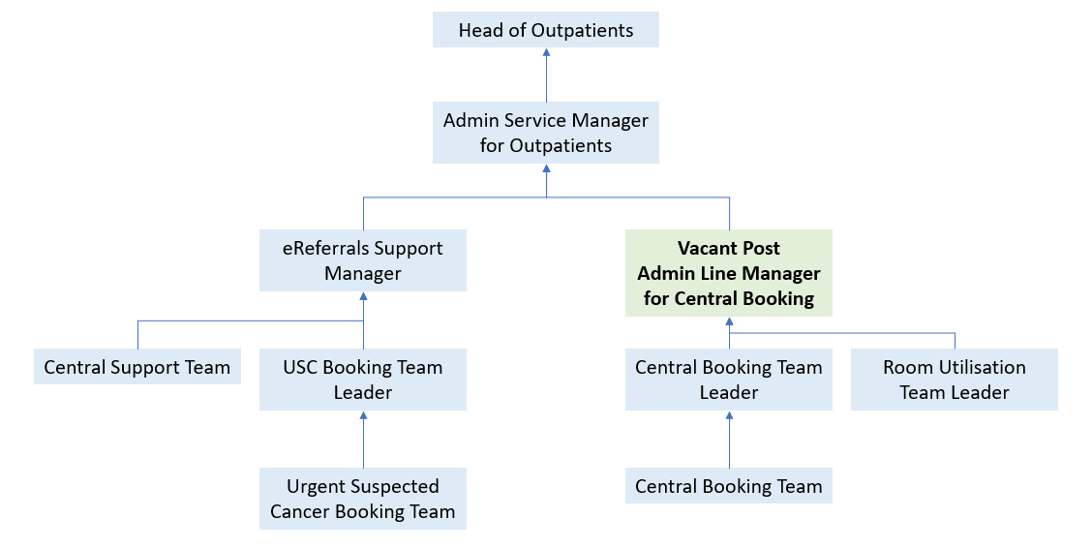
6. KEY RESULT AREAS/PRINCIPAL DUTIES AND RESPONSIBILITIES:

This post is responsible for the day-to-day operational performance of the Central Booking Team, ensuring that a high-quality service is provided to the 14 specialties we book outpatient appointments for, and to every patient who we have contact with. This includes ensuring that the team are well trained to manage high volumes of calls and bookings, are responsive and keep up to date with communications with clinical services, and book to the highest standards of accuracy and in line with Trust best practice.

The post holder will respond and offer solutions to issues arising with clinics and appointments, and be able to confidently provide leadership to a large administrative team. The post holder will be responsible for generating reports and presenting these to clinical services on a regular basis to support operational service delivery and improvement, to accurately detail waiting list position, and to highlight any issues for escalation..

Supervisory and Human Resources

- Responsibility for the line management of a discreet group of administrative staff
- Leadership of administrative staff to foster a positive, supportive culture conducive to the effective delivery of administrative services
- Day to day scheduling of staff and workload to meet the needs of their Service Lines
- Day to day management of annual leave and sickness absence
- Formal performance management of staff such as objective setting, monitoring KPIs and documenting the relevant discussions
- Ensure all mandatory (essential) training, PDRs (appraisals) and sickness absence is correctly recorded on Trust database (ESR) in a timely manner
- Formal performance management of staff up to, but not including, final disciplinary/capability hearings
- Robust and effective recruitment of administrative staff to meet service needs
- Provide an effective link between administrative staff and senior Trust management, cascading information as appropriate and briefing the Administrative Services Manager and senior management on relevant issues
- Effective liaison and co-operation with all administrative Line Managers to share learning and ensure consistency of practice
- Ensuring that administrative staff work within the boundaries of all relevant Trust policies including HR, health and safety and relevant employment legislation
- To remain up to date and compliant with all HR policies and employment legislation
- Support the Division to meet all relevant performance indicators

Administrative functions
- Use multiple computer systems as required within the department such as PAS, NHS E-referrals, ESR
- Ensure accurate and up-to-date patient details are maintained on patient information systems such as PAS in line with Trust Information Governance policy
- Maintain health records and patient files in line with Trust Health Records Policy
- Support the ASM/CSM in ensuring that complaints are dealt with promptly and effectively and where appropriate, escalate if unable to resolve
- Execution of action plans in response to patient complaints or clinical incidents related to their administrative services

Service delivery/improvement

- Contribute to the NHS service improvement/modernisation agenda e.g. service redesign
- Lead on developing processes within the department to meet the demands of a growing service
- Participate in team and directorate meetings as required
- Contribute to audits regarding departmental procedures
- Have a flexible approach to working hours to meet the demands of the service
- Adhere to the Trust Access Policy and Health Records Policy and appropriate standard operating procedures, Key Performance Indicators, government targets and standard operational policies
- Assist the Administrative Services Manager or Clinical Service Manager in ensuring that day to day access issues can be resolved in an effective and timely manner

Communication
- Make and receive telephone calls both external and internal according to Trust standards
- Communicate effectively including discussion and written communication
- Proactively manage email communication in line with the RD&E’s Email Best Practice guidance
- Provide excellent customer care, in a calm and professional manner – some situations may be challenging
- Organise and/or support team meetings through effective communication

Governance
- Undertake training as required to maintain competency/comply with trust policies
- Work within Trust policies – including those for confidentiality, data protection, health and safety fire protection, and annual appraisal
- Adhere to the Trust Access Policy, Key Performance Indicators, government targets and standard operational policies and procedures

Resource Management

- Responsibility for the effective maintenance of a discreet budget within their area of responsibility.
- Contribution to the delivery of Cost Improvement Program as required by the Division and the Trust.
- Provide cover in periods of absence as directed by department manager, this may involve moving to other areas
- Monitor use of supplies and stationery and ensure this is done efficiently and cost effectively in line with the needs of the service

Additional Responsibilities
- The post holder will be expected to carry out any other duties as required, commensurate with their pay band
- The post holder will be required to facilitate and support new starters to carry out their role
- The post holder will understand the limitations of the role and how to access support

OTHER RESPONSIBILITIES

Take part in regular performance appraisal.

Undertake any training required in order to maintain competency including mandatory training, e.g. Manual Handling

Contribute to and work within a safe working environment

You are expected to comply with Trust Infection Control Policies and conduct him/herself at all times in such a manner as to minimise the risk of healthcare associated infection

As an employee of the Trust, it is a contractual duty that you abide by any relevant code of professional conduct and/or practice applicable to you. A breach of this requirement may result in action being taken against you (in accordance with the Trust’s disciplinary policy) up to and including dismissal.

You must also take responsibility for your workplace health and wellbeing:
- When required, gain support from Occupational Health, Human Resources or other sources.
- Familiarise yourself with the health and wellbeing support available from policies and/or Occupational Health.
- Follow the Trust’s health and wellbeing vision of healthy body, healthy mind, healthy you.
- Undertake a Display Screen Equipment assessment (DES) if appropriate to role.

GENERAL

This is a description of the job as it is now. We periodically examine employees' job descriptions and update them to ensure that they reflect the job as it is then being performed, or to incorporate any changes being proposed. This procedure is conducted by the manager in consultation with the jobholder. You will, therefore, be expected to participate fully in such discussions. We aim to reach agreement on reasonable changes, but if agreement is not possible, we reserve the right to insist on changes to your job description after consultation with you.

Everyone within the Trust has a responsibility for, and is committed to, safeguarding and promoting the welfare of vulnerable adults, children and young people and for ensuring that they are protected from harm, ensuring that the Trusts Child Protection and Safeguarding Adult policies and procedures are promoted and adhered to by all members of staff.

PERSON SPECIFICATION
POST: Administrative Line Manager
BAND: 5
REQUIREMENTS | Essential / Desirable at:
 | Recruitment | 1st PDR or (award of) increment
QUALIFICATIONS / TRAINING:  Educated to ‘A’ level standard or equivalent  Minimum of 3 qualifications to include GCSE grade A-C/4-9 or equivalent in Maths and English  NVQ 3 in Business Admin or equivalent  ILM Level 3 in Team Leading  Clinical Document Management (CDM)  Patient Administration System (PAS) Level 4 outpatients  ECDL, CLAIT or equivalent  AMSPAR Medical Terminology or equivalent  Postgrad. Management qualification or equivalent professional experience | E  E  D  E  D  D  D  D  D | E  E  E  E  E  E  E  E  E
KNOWLEDGE / SKILLS:  Excellent planning & organisational skills  Ability to prioritise workload to respond to changing demand  Ability to liaise and communicate with staff at all levels  Motivation and negotiation skills  Excellent interpersonal & communication skills inc. demonstrating empathy & sensitivity to patients and relatives  Ability to promote good working liaisons (staff, patients, relatives)  Extracting information / Listening Skills  Ability to handle complex enquiries - distressed & anxious patients  Ability to deal with challenging behaviour  Ability to provide excellent customer care  Knowledge of IT databases and computer systems  Comprehensive PC skills - databases, word-processing, email, Excel  Understanding of hospital IT systems  Knowledge of PAS or equivalent information system  Analytical skills & ability to problem solve  Proven strong administration skills  Accurate data entry  Excellent telephone manner  Knowledge of Trust procedures  Able to work independently, with minimum supervision  Proven ability to motivate staff and encourage team work  Ability to coach and mentor others  Ability to effectively supervise staff on a day to day basis  Ability to effectively performance manage staff  Ability to engage and influence staff within their area of responsibility  Knowledge of PDR process  Practical knowledge of change management  Ability to deal with members of a multi-disciplinary team  Ability to co-ordinate complex diary management  Good decision making skills  Thorough understanding of NHS performance targets  Basic understanding of the compliance framework for NHS Foundation Trusts  Understanding of the basics of finance and health and safety  Understanding of the principles of audit  Knowledge of patient flow  Knowledge of Trust procedures | E  E  E  E  E  E  E  E  E  E  E  E  E  E  E  E  E  E  E  E  E  E  E  E  E  E  D  E  E  E  D  D  D  D  D  E | E  E  E  E  E  E  E  E  E  E  E  E  E  E  E  E  E  E  E  E  E  E  E  E  E  E  E  E  E  E  E  E  E  E  E  E
EXPERIENCE:  Previous clerical experience  Working in an NHS/clinical environment e.g. hospital, GP surgery, CCG  Supervision and the development of staff  Operational managing of a service on a day to day basis  Managing Administrative functions within a large complex organisation  Formal performance management of staff  Managing sickness absence and conduction of performance or capability investigations  Staff rostering  Implementing change in a discrete area  Managing a change process | E  E  E  D  D  D  D  D  D  E | E  E  E  E  E  E  E  E  E  E
PERSONAL ATTRIBUTES:  Enthusiastic highly motivated & committed to delivering a service  Understand team work and work within a team  Able to plan and organise workload  Able to prioritise own work load and meet deadlines  Ability to work un-supervised  Can remain calm and professional in a busy environment  Empathetic, but able to understand professional boundaries  Smart appearance, adhering to the Uniform Policy  Welcoming friendly and approachable manner  An adaptable approach to work  Flexible approach to working hours  Commitment to continual development to inc. relevant new systems, policies and procedures  Adheres to relevant Trust policies & procedures  Adheres to confidentiality & data protection requirements | E  E  E  E  E  E  E  E  E  E  E  E  E  E | E  E  E  E  E  E  E  E  E  E  E  E  E  E

Hazards within the role, used by Occupational Health for risk assessment
Laboratory specimens |  | Clinical contact with patients |  | Dealing with violence & aggression of patients/relatives
Blood / Body Fluids |  | Dusty environment |  | VDU Use | 
Radiation / Lasers |  | Challenging behaviour |  | Manual Handling | 
Solvents |  | Driving |  | Noise / Vibration
Respiratory sensitisers |  | Food Handling |  | Working in isolation
Cytotoxic drugs |  | Electrical work |  | Night working

