JOB DESCRIPTION

This post has been identified as involving access to vulnerable adults and/or children and in line with Trust policy successful applicants will be required to undertake a CRB Disclosure Check.

The Trust is committed to recruiting and supporting a diverse workforce and so we welcome applications from all sections of the community, regardless of age, disability, gender, race, religion, sexual orientation, maternity/pregnancy, marriage/civil partnership or transgender status. The Trust expects all staff to behave in a way which recognised and respects this diversity, in line with the appropriate standards.

1. JOB DETAILS

Job Title: Senior Directorate Management Accountant

Band: 8a

Reports to: Head of Management Accounts - Eastern

Department / Directorate: Finance & Information

2. JOB PURPOSE

- To be the Finance lead for the Directorate/Division
- Provide expert knowledge and experience within the Directorate Senior Management Team of financial accounting and management systems and expertise in financial performance management.
- Responsible for the management and performance of a team of staff within the Management Accounting Section including Recruitment and line management of staff to ensure the team is able to provide a comprehensive, high quality and efficient service.
- To interpret and present financial information to Clinicians, Managers and Trust Executive Members.
- To be accountable for the management of directorate budgets in excess of £40 million.
- To fully participate in Corporate Duties, and to have an awareness of a Trust wide perspective.

- DIMENSIONS

- Chief Finance Officer
- Director of Operational Finance
- Associate Director of Operational Finance and Procurement
- Head of Management Accounts
- Senior Directorate Management Accountants
- Directorate Management Accountants
- Performance Accountant
- Management Accounts Assistants
- Contracts Manager
- Directorate Managers
- Clinical Directors
- Executive Directors (incl Chief Executive, Medial Directors, Directors of Operations, Director of Nursing)
- Budget Holders (incl Clinical Service Managers, Heads of Departments, Senior Matrons)

4. ORGANISATION CHART

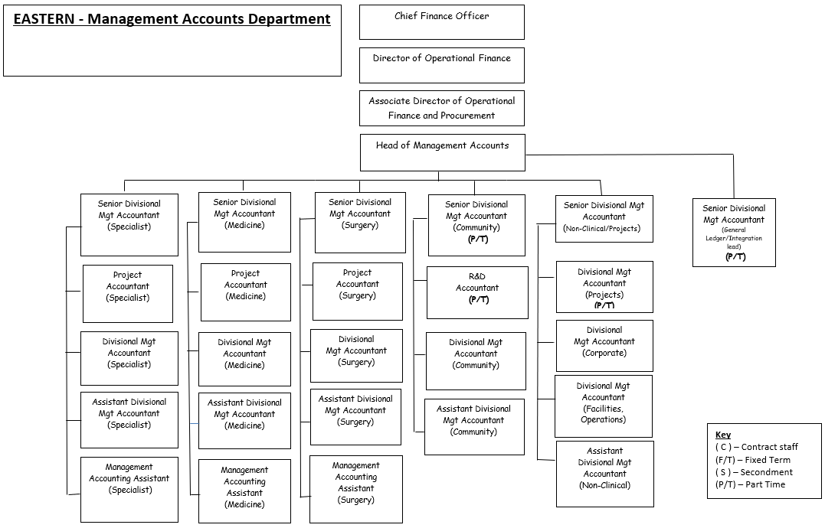

5. KEY RESULT AREAS/PRINCIPAL DUTIES AND RESPONSIBILITIES

Corporate Responsibilities

- Provide expert financial advice to all levels of Senior Management within the Trust in support of the delivery of their financial duties (to include budget setting for directorate, business planning, monthly performance monitoring, opportunities for savings, Value for Money and benchmarking).

- Assimilation, interpretation and presentation of highly complex financial and non-financial information, including performance indicators, to multi-disciplinary teams of clinical staff and senior managers from within and outside the organisation.

- Participate fully in the Department of Health annual Reference Cost exercise, meeting agreed targets and deadlines as specified by the Performance Accountant. E.g. provision and analysis of benchmarking information in suitable/desired formats which will be made up of several different components (including financial and clinical data).

- Support in the identification of cash releasing efficiency savings (CRES/FRP) schemes and corporate savings initiatives within the Directorate and Trust as a whole. Participation in meetings providing accounting expertise, costings and detail of any realised funds.

- Ensure all aspects of the Trusts financial policies including Trust Standing Financial Instructions and Standing Orders are adhered to; value for money secured and financial stability achieved. For example, the writing of a Budget manual to explain principles of budgeting to budget holders across the Trust; supporting the implementation of Electronic Staff Records across the Trust.

- Undertake ad-hoc projects and service development. To undertake/provide support to specific trust wide projects as required by Associate DOF, for example, implementation of the new ESR system, costing of new business cases affecting the trust, development of quarterly review templates, preparation of bids for the purposes of external tendering.

- To interpret national policies, guidance and professional accounting standards to support and guide the Directorate(s), Clinicians and Managers at all levels of the Organisation. To provide advice, guidance and support the planning of services, delivery of financial training, financial control, and effective utilisation of resources and best financial management practice in accordance with NHS Financial Framework and DOH/Monitor Guidance.

- To be able to manage difficult/unpredictable situations which may arise; such as where clinical needs conflict with financial protocols. Knowledge of many disciplines (i.e. payroll, commissioning, provider services, audit).

Directorate Responsibilities

- Compose and present a monthly report on the financial position of the Directorates, identifying all key variances (including income by speciality and expenditure) and actions being taken to address them. This will include explanation of significant variance movements at the fortnightly Directorate 1 to 1’s with the Chief Exec. And others members of the Executive Team and at the Directorate Quarterly Reviews.

- To continually review the existing financial information sent to budget managers. This will require identifying best practice and ensuring that this, as a minimum standard, is available to all budget holders.

- Assist in the preparation, formulation and evaluation of multi-faceted business cases, accounting for any potential changes to income and/or expense. Ensuring they meet both the trusts’ strategic aims and the Directorates’ annual plans taking into account the impact over the next 5 years. Analysing any potential risks and variations to plan, estimating consequently financial implications. Considering both Directorate and Trust wide implications. For example, considering the implications and affects on all areas of the Trust when planning for a new Consultant.

- Respond appropriately to budget holders queries, investigating all areas of concern, within an agreed timescale. To have a knowledge and understanding of the complexity of the services provided by the Directorates and the ability to demonstrate strong working relationships with all members of the Directorate’s Senior Management Team.

- Critically appraise the relative cost effectiveness of the services provided through the use of benchmarking data, analysing the relative position of a service in relation to the national tariff and exploring other qualitative and quantitative data.

- Review and monitoring of Directorate income budgets and targets. Developing the skill required to continually analyse and investigate variances and ensure that any implications of changes are incorporated into the year-end forecast for the end of the financial year.

- Assist the Directorate Manager and Departmental Managers in delivering financial balance. Actively informing managers of significant variance to plan and offering advice and guidance.

- To compile and be responsible for the monthly Directorate forecast projecting both income and expense. Using a wide range of financial data. To interpret and provide analysis of highly complex financial trends, making informed assumptions based on Directorate and specialist knowledge. Forecasting will include planning for the future risk and benefits for both income and expenses areas e.g. income – patient type/healthcare resource group/purchase; expenditure – pay; salary tax, NI, expenses – consultant, nurse etc; non-pay – drugs, medical equipment, reserves.

- Prepare expense, income and activity budgets for the Annual Planning cycle. Carry out periodic reviews of budgets to reflect current operational practice, in conjunction with the Directorate team.

- Ensure processes are in place to continually monitor and update Service Level Agreements for the areas of responsibility.

- Update the Financial Management Information System(s) (FMIS) as necessary to ensure accurate and up to date reporting.

- To understand, interpret and implement the Department of Health Reference Cost Guidance (clinical procedure costs) and Department of Health/Monitor guidance (e.g. Payment by Results) to ensure that the Trust can deliver activity within the nationally agreed pricing framework and consider their likely impact on Directorate.

- Lead the Directorate budget setting/review process in conjunction with the Directorate Manager, providing advance and guidance. Ensuring that departmental budgets are developed to take account of service pressures within the constraints of the funding available.

- Assist in the completion of Directorate returns, both internal and external e.g. Cater, AHP and benchmarking exercises. Writing the finance element of the Directorate’s quarterly review report and presenting to the Chief Executive and other members of the Trust Executives.

General Responsibilities

- To manage the team ensuring recruitment, retention and discipline of staff, maintaining and improving the morale and effectiveness of staff, including staff appraisals, sickness monitoring and Health & Safety. Fully participate in the roll out of the annual appraisals of the DMA/Trainee DMA and support post incorporating the Knowledge and Skills Framework.

- Act as a mentor, identifying and providing adequate training and continuous professional development programmes for junior staff who are undertaking Professional Accountancy Training.

- Play a full and active role in the development of the Management Accounts Section. Ensures requirements relating to personal and information security and confidentiality at work are maintained.

- Plan and manage the workload of the team to achieve the section’s objectives.

- To support the development and implementation of Financial Awareness Training to non-finance staff within the Trust (including an understanding of financial systems, complying with Standing Financial Instructions, guidance on budgeting, contracting matters and the efficient use of resources).

- To provide finance training for non-financial managers within the Trust e.g. by teaching on the Introductory Diploma in Management Course, Introduction to Budget Holding Course, Advanced Budget Management Technique Course.

- Contribute to the development of Trust wide systems to support payment by results (PBR), in particular working with clinicians to improve the methodology of calculating Healthcare Resource Groups (HRG) costs. Advise on the content, structure and appropriateness of peripheral IT systems within the Directorate(s) that impact on the Finance Department.

- To initiate, review and develop information systems within the department as required to supplement the FMIS. To include databases, spread sheets and accounting systems. To assist in the planning and implementation of new information systems e.g. Electronic Staff Records system, Consultant Contracts, new quarterly review template.

- To be a nominated person of authority for Trust financial purposes, including the signing of cheques, chaps and BACS payments which can be in excess of several millions of pounds. Participation in tender opening responsibility.

- Deputise for the Principal Management Accountant as necessary.

- To develop and improve financial procedures, systems and processes in conjunction with Standing Financial Instructions and National Guidance.

- Be aware and meet agreed deadlines.

- Ensure that the objectives of the section are fully communicated.

- Perform such other duties as may be directed from time to time by Senior Finance Managers.

- This is a description of the job as it is at present constituted. It is the practice of the organisation periodically to examine employees’ job descriptions and to update them to ensure that they relate to the job as then being performed, or to incorporate whatever changes are being proposed. This produced is jointly conducted by each Manager in consultation with those working directly for him or her. You will, therefore, be expected to participate fully in such discussions. It is the Trust’s aim to reach agreement to reasonable changes but, if agreement is not possible, Management reserves the right to insist on changes to your job description after consultation with you.

- Our aim is to provide an individual service which meets the patients’ requirements and is timely, accurate and appropriate to personal and clinical needs.

- We also aim to promote an organisation culture which values staff by helping them to be knowledgeable and confident in their individual roles.

- The Trust is a non-smoking employer. Staff and patients are, therefore, encouraged not to smoke. The post holder will be expected to adhere to this policy.

Other Responsibilities

- To take part in regular performance appraisal
- To undertake any training required in order to maintain competency including mandatory training i.e. Fire, Manual Handling.
- To contribute to and work within a safe working environment
- The post holder is expected to comply with Trust Infection Control Polices and conduct him/herself at all times in such a manner as to minimise the risk of healthcare associated infection.

THE TRUST - PURPOSE AND VALUES

We are committed to serving our community by being a high quality specialist Hospital with consultant-led services. We aim to co-ordinate our services with primary and community care, and to develop a limited number as Sub-Regional Referral Centres with appropriate levels of research, development and educational involvement. Where appropriate, and consistent with our services, we may provide services aimed at preventing disease and debilitation.

We aim to make all our services exemplary in both clinical and operational aspects. We will show leadership in identifying healthcare needs to which we can respond and in determining the most cost-effective way of doing so. We will share our knowledge with neighbouring healthcare agencies and professionals.

We recruit competent staff whom we support in maintaining and extending their skills in accordance with the needs of the people we serve. We will pay staff fairly and recognise the whole staff’s commitment to meeting the needs of our patients.

We are committed to equal opportunity for all and encourage flexible working arrangements including job sharing.

GENERAL

This is a description of the job as it is now. We periodically examine employees' job descriptions and update them to ensure that they reflect the job as it is then being performed, or to incorporate any changes being proposed. This procedure is conducted by the Manager in consultation with the jobholder. You will, therefore, be expected to participate fully in such discussions. We aim to reach agreement on reasonable changes, but if agreement is not possible, the Trust reserves the right to insist on changes to your job description after consultation with you.

The RD&E is a totally smoke-free Trust. Smoking is not permitted anywhere on Trust property, including all buildings, grounds and car parks. For help to quit call 01392 207462.

As an employee of the Trust, it is a contractual duty that you abide by any relevant code of professional conduct and/or practice applicable to you. A breach of this requirement may result in action being taken against you (in accordance with the Trust’s disciplinary policy) up to and including dismissal.

The post holder is expected to comply with Trust Infection Control Policies and conduct him/her at all times in such a manner as to minimise the risk of healthcare associated infection.

6. JOB DESCRIPTION AGREEMENT

Job Holder’s Signature

Date:

Manager’s Signature

Date:
ROYAL DEVON & EXETER NHS FOUNDATION TRUST
PERSON SPECIFICATION

POST: Senior Directorate Management Accountant
BAND: 8a
REQUIREMENTS | E/D* | How tested? Application Form/Interview Test | MET | NOT  MET
QUALIFICATIONS/SPECIAL TRAINING:
Chartered/Certified Qualified Accountant (CCAB/equivalent to post graduate qualification) | E
KNOWLEDGE/SKILLS:
A good knowledge and experience of computer based management accounting systems | E
Excellent knowledge of Microsoft Office applications | E
Good communication, presentation and interpersonal skills both orally and in writing. | E
Good negotiations and influencing skills | E
Strong numerical skills, ability to understand and interpret complex financial information | E
Detailed understanding of the NHS and Trust financial regime and accounting standards | E
Excellent organisational and time management skills. | E
Good people management and motivation skills | E
EXPERIENCE:
At least 3 years experience in a finance environment | E
2 years in a management account or similar role | E
Experience of budgetary control | E
2 years experience within the Finance function of the NHS | D
Experience of managing a team | D
PERSONAL REQUIREMENTS:
Ability to respond quickly to changes in work priorities at short notice | E
Ability to communicate complex and contentious information effectively, using verbal, written, or presentation skills; with all disciplines and seniorities. | E
Ability to deliver to tight timescales and under pressure, including the maintenance of good working papers/records | E
Ability work individually and as part of a team. | E
Ability to concentrate for prolonged periods whilst dealing with interruptions. | E
Ability to prepare complex business cases. | E
OTHER REQUIREMENTS:
Current Driving Licence | D
* Essential/Desirable

HAZARDS:
Laboratory Specimens Proteinacious Dusts |  | Clinical contact with patients |  | Performing Exposure Prone Invasive Procedures
Blood / Body Fluids |  | Dusty environment |  | VDU Use | X
Radiation |  | Challenging Behaviour | X | Manual Handling
Solvents |  | Driving |  | Noise (0ver 85dB)
Respiratory Sensitisers |  | Food Handling |  | Working in isolation
Handling Cytotoxic Drugs |  | Vibration or electrical work |  | Night working

