
JOB DESCRIPTION

1. JOB DETAILS

Job Title: Medical Technical Officer

Band: Band 3

Reports to: Laboratory Manager

Department / Directorate: Department of Clinical Chemistry/Diagnostic Division.

2. JOB PURPOSE

To assist in the analysis of pathology samples by preparation of instrumentation, reagents and pathological samples.
To take an active role in the materials management of the department, receipting, storing and stock controlling laboratory consumables.
To take an active role in the flow of specimens through the laboratory.
To assist in the coordination of work carried out by the laboratory.
General laboratory duties as required by the laboratory manager or designated deputy.
To provide from line support and administration of POCT activities in the Trust and associated community locations.

3. DIMENSIONS/ KEY WORKING RELATIONS

Head of Dept – Blood Sciences
Laboratory Manager
Deputy Laboratory Manager
Clinical Scientists
Senior Technical and Scientific Staff
Biomedical Scientists
Medical / Nursing Staff
External NHS agencies.
Members of the Public
Lead MTO

- ORGANISATIONAL CHART:

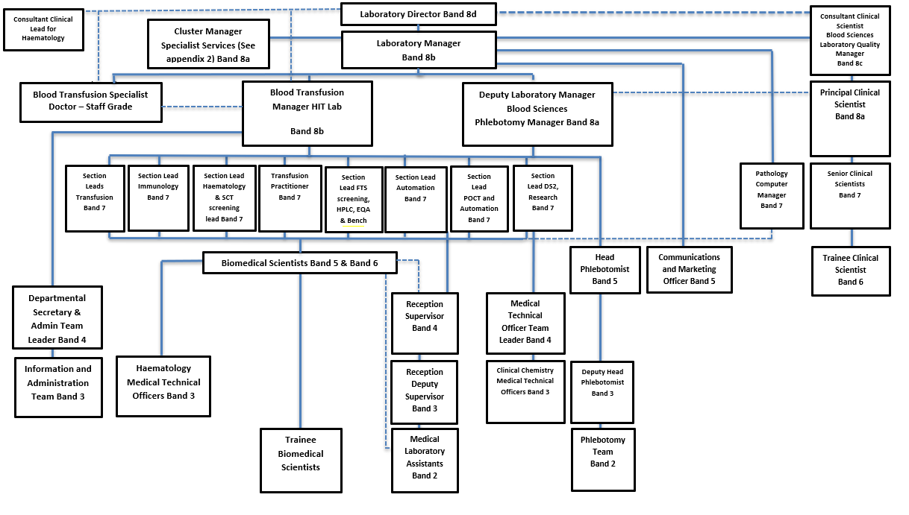

5. KEY RESULT AREAS/PRINCIPAL DUTIES AND RESPONSIBILITIES:

- Maintenance and preparation of main instrumentation to a state of readiness for analysis.
- Take an active role in the coordination and prioritisation of specimens through the pre-analytical and analytical process.
- Carry out pipette checks to ensure accuracy of devices.
- Arrange for faulty pipettes to be serviced and repaired.
- Loading and unloading of samples onto automated Clinical Chemistry analysers, ensuring all work is complete and all abnormal results are brought to the attention of a Biomedical Scientist.
- Ensure recording of stock levels and preparation of analyser consumables; keep stock control records (cIMS & Optimal) up to date.
- Carry out Sectionstock checks. as required
- Prepare and book out reagents for night shift.
- Ensure the safe receipt, unpacking and storage of perishable analyser reagents as per manufacturers’ instructions.
- Move and store all deliveries in a safe manner and in accordance with manual handling protocols.
- Ensure all research samples received on dry ice are dealt with appropriately.
- Responsible for barcode printing system including:
  - Design of new labels using the Bar-one design software as required.
  - Ensure research number labels are printed in a timely fashion and that the quality of print is adequate.
  - Ensure the Zebra printer is maintained and stocks of ribbons and labels do not fall below minimum levels.
  - Distribute labels to appropriate research centres and FTS clinics.
- Maintenance of freezer & study databases
- Maintenance and stock control of consumables for the Millipore pure water system.
- Analysis of External Quality Assurance Scheme samples request data.
- Recording, packaging and dispatching of deep frozen samples to external reference laboratories.
- Where required undertake appropriate Medical Laboratory Assistant duties including the following:
    - Telephone enquiries (including giving results) from clinicians and other service users.
    - Use of EPIC system to enter request form data onto the laboratory information system.
    - Receive label and centrifuge pathology samples.
- Assist in the training of existing and new members of staff.
- To take part in regular performance appraisal.
- To undertake any training required in order to maintain competency including mandatory training, i.e. Fire, Manual Handling.
- To contribute to and work within a safe working environment.
- The post holder will be willing to take part in remunerated Saturday and Sunday morning rotas.
- Co-ordinate receipt and processing of large research batches.
- Prepare and perform multidisciplinary analysis of research samples as appropriate (label, defrost, sort, analyse and report).
- Manage and audit research -80°C freezer
- Assist in the delivery of and any necessary training of all staff for tasks relating to R&D work.
- Design and print study barcodes and laboratory stock labels as needed.
- Attend weekly CommCell & regular MTO/research meetings with senior laboratory staff, to maintain knowledge of current and future research activities
- Collate and return results to research centers accurately and in a timely manner.
- Maintain database of all R&D work performed.
- Liaise with section seniors to ensure sufficient reagents are in stock as appropriate for R&D activities.
- Following the Trust protocol ensure the daily safe disposal of clinical waste bags.
- Adhere to COSHH regulations in the handling of biological and chemically hazardous materials.
- Adhere to the Departmental Health & Safety Policy and follow departmental procedures and guidelines on quality procedures.
- Adhere to the Departmental Policy on Patient Data Confidentiality.
- Follow the Departmental Procedure for dealing with spillage of biological fluids of hazardous chemicals.
- To assist in Project Support for POCT
- Responsible for distribution of IQC and EQA samples, collation of returned data from the appropriate software for reporting on by POCT Managers.
- Stock control and dispatch of consumables for POCT to client sites, including maintaining an electronic stock inventory and month end reconciliation. Alerting POCT managers when stock consumables need to be purchased.
- Carry out procedures for IQC and EQA sample testing on in-house POCT devices.
- General office and administration of duties associated with POCT activities.
- Manage client telephone and email enquiries and update POCT managers with necessary information and troubleshoot where appropriate.
- Work with the POCT managers to ensure the POCT service offers the highest standards as required by our accreditation bodies.
- Carry out POCT audits.
- Perform blood fridge mapping exercises
- Carry out stool extraction in preparation for analysis
- Receipt, Unpackaging, and labelling of QFIT samples in preparation for analysis
- Unpackaging & receipt of daily R&D and Specialist services samples using integrated laboratory IT systems.

Other Responsibilities:
To take part in regular performance appraisal.
To undertake any training required in order to maintain competency including mandatory training, i.e. Fire, Manual Handling
To contribute to and work within a safe working environment
The post holder is expected to comply with Trust Infection Control Policies and conduct him/herself at all times in such a manner as to minimise the risk of healthcare associated infection.
Prioritise own workload.
Follows all protocols and routines relevant to own area of work.

THE TRUST - PURPOSE AND VALUES

We are committed to serving our community by being a high quality specialist Hospital with consultant-led services. We aim to co-ordinate our services with primary and community care, and to develop a limited number as Sub-Regional Referral Centres with appropriate levels of research, development and educational involvement. Where appropriate, and consistent with our services, we may provide services aimed at preventing disease and debilitation.

We aim to make all our services exemplary in both clinical and operational aspects. We will show leadership in identifying healthcare needs to which we can respond and in determining the most cost-effective way of doing so. We will share our knowledge with neighbouring healthcare agencies and professionals.

We recruit competent staff whom we support in maintaining and extending their skills in accordance with the needs of the people we serve. We will pay staff fairly and recognise the whole staff’s commitment to meeting the needs of our patients.

We are committed to equal opportunity for all and encourage flexible working arrangements including job sharing.

The Trust is committed to recruiting and supporting a diverse workforce and so we welcome applications from all sections of the community, regardless of age, disability, sex, race, religion, sexual orientation, maternity/pregnancy, marriage/civil partnership or transgender status The Trust expects all staff to behave in a way which recognises and respects this diversity, in line with the appropriate standards.

GENERAL

This is a description of the job as it is now. We periodically examine employees' job descriptions and update them to ensure that they reflect the job as it is then being performed, or to incorporate any changes being proposed. This procedure is conducted by the Manager in consultation with the jobholder. You will, therefore, be expected to participate fully in such discussions. We aim to reach agreement on reasonable changes, but if agreement is not possible, the Trust reserves the right to insist on changes to your job description after consultation with you.

The RD&E is a totally smoke-free Trust. Smoking is not permitted anywhere on Trust property, including all buildings, grounds and car parks. For help to quit call 01392 207462.

As an employee of the Trust, it is a contractual duty that you abide by any relevant code of professional conduct and/or practice applicable to you. A breach of this requirement may result in action being taken against you (in accordance with the Trust’s disciplinary policy) up to and including dismissal.

The post holder is expected to comply with Trust Infection Control Policies and conduct him/her at all times in such a manner as to minimise the risk of healthcare associated infection.

PERSON SPECIFICATION

POST: Medical Technical Officer
BAND: 3
REQUIREMENTS | At  Recruitment | At 2nd KSF  Gateway
QUALIFICATIONS / TRAINING  - Educated to level NVQ3 or equivalent. | E | E
KNOWLEDGE / SKILLS  - Extensive knowledge of laboratory procedures.  - Ability to troubleshoot laboratory sampling issues.  - IT literacy and data handling experience.  - Good knowledge of MS Office applications  - Excellent keyboard skills  - Excellent organisational skills | D  D  E  E  E  E | E  E  E  E  E  E
EXPERIENCE  - Experience of working as part of a team. | D | E
PERSONAL ATTRIBUTES  - Excellent interpersonal skills.  - Ability to prioritise and work on own initiative.  - Enthusiasm and willingness to learn.  - Good timekeeping  - Ability to accommodate the physical aspects of the role.(In compliance with Manual Handling directives) | E  E  E  E  E | E  E  E  E  E
OTHER REQUIREMENTS  - Willingness to undertake NVQ Level 3 course in Laboratory & Associated Technical Activities.  - Willingness (with warning) to accept flexible working hours | E  E | E  E
* Essential/Desirable

HAZARDS:- Updated 31st May 2013
Laboratory Specimens | √ | Clinical contact with Patients |  | Dealing with violence & aggression of patients/relatives
Blood / Body Fluids | √ | Dusty Environment |  | VDU Use (occasional) | √
Radiation / Lasers |  | Challenging Behaviour |  | Manual Handling | √
Solvents | √ | Driving |  | Noise / Vibration
Respiratory Sensitisers |  | Food Handling |  | Working in isolation
Cytotoxic Drugs |  | Electrical work |  | Night Working

