

JOB DESCRIPTION

JOB DETAILS
Job Title | Medical Laboratory Assistant  Clinical Support Worker
Reports to | Blood Sciences Laboratory Manager
Band | Band 2
Department/Directorate | Blood Sciences.  Specialist Services

JOB PURPOSE
To assist in the provision of the scientific service commitment of the laboratory in line with Trust objectives and commensurate with grade and responsibilities.

To take receipt, check and prepare samples for analysis for the Departments of Clinical Chemistry, Haematology, Immunology and Blood Transfusion, under the direction of the Reception Supervisor.

To provide an efficient confidential and courteous telephone enquiry service to laboratory users, clinicians and patients.

To carry out data entry of all patient demographics and test requirements for laboratory specimens.

KEY RESULT AREAS/PRINCIPAL DUTIES AND RESPONSIBILITIES
- To have individual accountability to sort, examine request details and label pathological specimens for Departments of Clinical Chemistry, Haematology, Immunology and Blood Transfusion, ensuring traceability.
- Data entry of requesting data via the laboratory form scanning software and Trust Order Communications system.
- Liaise with GP’s, Consultants and Nursing staff in the event requesting problems/enquiries.
- Recording, packaging and dispatching of samples to be analysed by external reference laboratories
- Input all results obtained from external reference laboratories
- Preparation (centrifugation), serum aliquoting and distribution of pathological samples to appropriate laboratory areas.
- General cleaning and disinfection of all reception work areas.
- Maintenance and sterilisation of centrifuges.
- Filing and retrieval of specimens & request forms.
- Provide a first line telephone enquiry service including:
- Give results from Clinical Chemistry, Immunology and Haematology analyses.
- Provide advice on appropriate specimen requirements and other queries.
- Telephone urgent or significantly abnormal results in a timely manner.
- Document advanced warning of urgent specimens
- Redirect other enquiries to the appropriate recipient.
- Provide a fast track urgent specimen service to ensure rapid preparation for analysis.
- Take receipt of samples from prioritised Oncology patients (Waiting Patients) and ensure they are processed rapidly by means of the urgent specimen procedure.
- Load pre-analytical and analytical platforms with samples and reagents in liaison with BMS staff.
- Ensure Chloros disinfectant is prepared freshly when required.
- Assist in the re-provision of laboratory/reception consumables.
- Record all incidents and accidents in accordance with Trust policy.
- Discard samples and replace bin liners in accordance with laboratory policy.
- Recycle RSD archive racks.
- Assist in the training of new members of staff.
- Following the Trust protocol ensure the daily safe disposal of clinical waste bags.
- Adhere to COSHH regulations in the handling of biological and chemically hazardous materials.
- Adhere to the Departmental Health & Safety Policy and follow departmental procedures and guidelines on quality procedures.
- Adhere to the Departmental Policy on Patient Data Confidentiality.
- Follow the Departmental Procedure for dealing with spillage of biological fluids of hazardous chemicals.
- To take part in regular performance appraisal.
- To undertake any training required in order to maintain competency including mandatory training, i.e. Fire, Manual Handling.
- To contribute to and work within a safe working environment.
- The post holder will be willing to take part in remunerated Saturday and Sunday rotas.
- The post holder will be willing to participate in early and late shifts rotas.
- Provide a summary of CPD activity for annual appraisal.

KEY WORKING RELATIONSHIPS
The post holder is required to deal effectively with staff of all levels throughout the Trust as and when they encounter on a day to day basis.
In addition, the post holder will deal with the wider healthcare community, external organisations and the public.
This will include verbal, written and electronic media.
Of particular importance are working relationships with:

Internal to the Trust | External to the Trust
- Head of Dept  - Laboratory Manager  - Deputy Laboratory Manager  - Clinical Scientists  - Senior Technical and Scientific Staff  - Biomedical Scientists  - Medical / Nursing Staff | - External NHS agencies.  - Members of the Public  - Suppliers

ORGANISATIONAL CHART
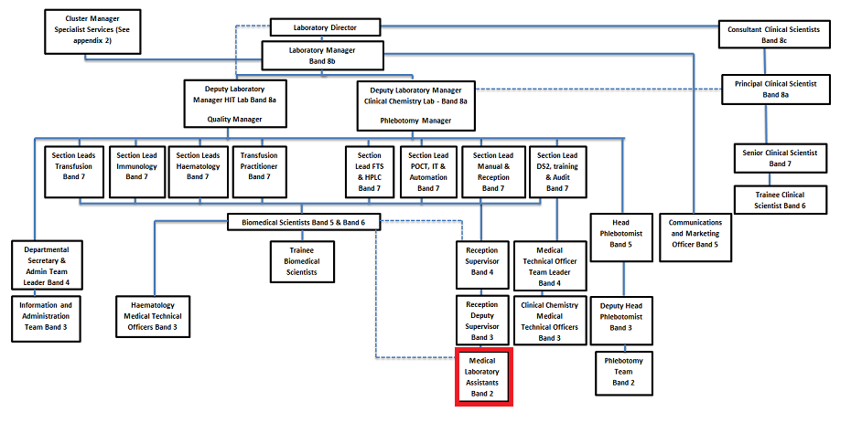

FREEDOM TO ACT
Well-established procedures, supervision close by/ standard operating procedures, someone available for reference.
Follows defined procedures/ works on own initiative, supervision available.

COMMUNICATION/RELATIONSHIP SKILLS
Provide & receive routine information orally to inform work colleagues and patients.

Relays test results to clinicians and other staff.

Uses all available methods of communication effectively, clearly and politely.

Contributes towards the integrity and reputation of the department by ensuring harmonious relationships between self and managers, colleagues, patients and other staff groups.

Answering the telephone and dealing with callers’ requests/questions appropriately.

ANALYTICAL/JUDGEMENTAL SKILLS
Judgements involving straightforward facts or situations some requiring analysis.

Resolves day to day issues eg mislabelled and lost specimens.

PLANNING/ORGANISATIONAL SKILLS
To prioritise routine, urgent and emergency specimen analysis on a day to day basis.

Organises own work.

PATIENT/CLIENT CARE
Provide basic clinical technical services.

Preparation of specimens for diagnostic testing.

POLICY/SERVICE DEVELOPMENT
Follows policies in own role, may be required to comment.

Follows departmental policies, may comment on proposals for change.

FINANCIAL/PHYSICAL RESOURCES
Personal duty of care in relation to equipment, resources/ safe use of equipment other than equipment used personally; maintain stock control.

Careful use of laboratory equipment/ cleaning equipment for use by others; orders supplies

HUMAN RESOURCES
Demonstrate own activities to new or less experienced employees.
Demonstrates own duties.
Provides advice & guidance, basic training.

INFORMATION RESOURCES
Data entry, text processing, storage of data.

Enters laboratory test results.

To enter requests for specimen testing.

To enter patient identification data and results into the laboratory computer for storage and printing of results.

To observe the strictest confidence regarding all information to which there is access within the RDUH by working in accordance with the data protection act and Trust policy on information governance.

RESEARCH AND DEVELOPMENT
Occasionally participate in R&D; to prepare samples and collect data for clinical trials.

Assisting with any data collection required for audits.

PHYSICAL SKILLS
Physical skills obtained through practice/ highly developed physical skills, accuracy important; manipulation of fine tools, materials.

Keyboard skills/ hand eye co-ordination, speed and accuracy required when inoculating specimens & pipetting accurately.

Manual dexterity and hand-eye co-ordination with speed and accuracy when dealing with specimens.

Manipulation of small tools, tubes, pipettes and complicated apparatus is required. Working rapidly at busy times.

PHYSICAL EFFORT
Frequent light/moderate effort for several short periods.

Bending & lifting boxes of media / lifts waste bins, trays, racks.

Sitting, standing in restricted position; frequent light effort for several short periods per shift; occasional moderate effort for several short periods per shift.

Sitting at analyser for long periods, repetitive movements processing specimens, bending and lifting supplies, use of trolleys.

MENTAL EFFORT
Frequent concentration work pattern predictable/ occasional prolonged concentration.

Concentration required for processing specimens, may be prolonged.

Frequent high level of concentration required for specimen checking, testing and performing a widely variable range of diagnostic tests and tasks, some complex, and computer data input for prolonged periods.

Working accurately at all times, especially under pressure at busy times. Coping with frequent interruption.

EMOTIONAL EFFORT
Exposure to distressing or emotional circumstances is rare.

Limited contact with patients and clients.

WORKING CONDITIONS
Frequent unpleasant conditions.

Works within the responsibilities given by the Health and Safety at Work Act (1974) to ensure that agreed safety procedures are carried out to maintain a safe environment for self, colleagues and visitors.

Exposure to contained or controlled infectious materials, body fluids and chemicals of varying hazard.

Risk of exposure to uncontained hazards e.g. spillage of harmful chemicals.

Coping with a busy environment with some noise.

Use of Display Screens (VDU).

Use of PPE as required.

OTHER RESPONSIBILITIES
Take part in regular performance appraisal.

Undertake any training required in order to maintain competency including mandatory training, e.g. Manual Handling

Contribute to and work within a safe working environment

You are expected to comply with Trust Infection Control Policies and conduct him/herself at all times in such a manner as to minimise the risk of healthcare associated infection

As an employee of the Trust, it is a contractual duty that you abide by any relevant code of professional conduct and/or practice applicable to you.

A breach of this requirement may result in action being taken against you (in accordance with the Trust’s disciplinary policy) up to and including dismissal.

You must also take responsibility for your workplace health and wellbeing:
- When required, gain support from Occupational Health, Human Resources or other sources.
- Familiarise yourself with the health and wellbeing support available from policies and/or Occupational Health.
- Follow the Trust’s health and wellbeing vision of healthy body, healthy mind, healthy you.
- Undertake a Display Screen Equipment assessment (DES) if appropriate to role.

GENERAL
This is a description of the job as it is now. We periodically examine employees' job descriptions and update them to ensure that they reflect the job as it is then being performed, or to incorporate any changes being proposed. This procedure is conducted by the manager in consultation with the jobholder. You will, therefore, be expected to participate fully in such discussions. We aim to reach agreement on reasonable changes, but if agreement is not possible, we reserve the right to insist on changes to your job description after consultation with you.

Everyone within the Trust has a responsibility for, and is committed to, safeguarding and promoting the welfare of vulnerable adults, children and young people and for ensuring that they are protected from harm, ensuring that the Trusts Child Protection and Safeguarding Adult policies and procedures are promoted and adhered to by all members of staff.

PERSON SPECIFICATION

Job Title | Band 2 Medical Laboratory Assistant - Blood Sciences

Requirements | Essential | Desirable
QUALIFICATION/ SPECIAL TRAINING  A minimum of 4 GCSE’s at grade C or above (or equivalent) including Maths & English Language. | E
KNOWLEDGE/SKILLS  Ability to troubleshoot laboratory sampling issues.  IT literacy and data handling experience.  Good knowledge of MS Office applications  Excellent keyboard skills  Excellent organisational skills  Clerical experience | E  E  E | D  D  D
EXPERIENCE  Experience of working as part of a team.  Healthcare/scientific background  Inputting of data to computer systems | E | D  D
PERSONAL ATTRIBUTES  Excellent interpersonal skills.  Ability to prioritise and work on own initiative.  Enthusiasm and willingness to learn.  Good timekeeping  Ability to accommodate the physical aspects of the role. (In compliance with Manual Handling directives) | E  E  E  E  E
OTHER REQUIREMENTS  Willingness (with warning) to accept flexible working hours | E

FREQUENCY

(Rare/ Occasional/ Moderate/ Frequent)
WORKING CONDITIONS/HAZARDS |  | R | O | M | F
Hazards/ Risks requiring Immunisation Screening
Laboratory specimens | Y |  |  |  | X
Contact with patients |  | R
Exposure Prone Procedures | N
Blood/body fluids | Y |  |  |  | X
Laboratory specimens | Y |  |  |  | X
Hazard/Risks requiring Respiratory Health Surveillance
Solvents (e.g. toluene, xylene, white spirit, acetone, formaldehyde and ethyl acetate) | Y |  | X
Respiratory sensitisers (e.g isocyanates) | N
Chlorine based cleaning solutions  (e.g. Chlorclean, Actichlor, Tristel) | Y |  | X
Animals | N
Cytotoxic drugs | N
Risks requiring Other Health Surveillance
Radiation (>6mSv) | N
Laser (Class 3R, 3B, 4) | N
Dusty environment (>4mg/m3) | N
Noise (over 80dBA) | N
Hand held vibration tools (=>2.5 m/s2) | N
Other General Hazards/ Risks
VDU use ( > 1 hour daily) | Y |  |  |  | X
Heavy manual handling (>10kg) | N
Driving | N
Food handling | N
Night working | Y |  |  |  | X
Electrical work | N
Physical Effort | N
Mental Effort | Y |  |  |  | X
Emotional Effort | Y | X
Working in isolation | Y |  |  |  | X
Challenging behaviour | N

