

JOB DESCRIPTION

JOB DETAILS
Job Title | Senior Research Nurse/Practitioner
Reports to | Team Lead/Research Nurse Specialist
Band | 6
Department/Directorate | Research & Development

JOB PURPOSE
The Senior Research Nurse/Practitioner will be responsible for coordinating and
managing the delivery of a portfolio of clinical trials and the management of clinical
research staff within the relevant specialties. The post holder will be responsible for all In-
Patient trials, although some work within other specialities may be required at times to
assist in the smooth running of the department.

The post holder will provide specialist knowledge, skills and experience within clinical research, and act as a resource to advise and support those involved in clinical trials at all levels. The post-holder will be able to autonomously plan, implement, organise and manage concurrent research projects. S/he will develop networks with Multidisciplinary Teams across the Trust and other appropriate local and national agencies. S/he will coordinate and manage the relevant study portfolio and deliver recruitment accrual in line with performance and monitoring objectives.

As a Senior Research Nurse/Practitioner s/he will be responsible for the implementation and monitoring of the clinical requirements associated with research to ensure optimum delivery of clinical trials. S/he will ensure that research will be conducted in accordance with the Research Governance Framework and Good Clinical Practice guidelines to provide assurance that the rights, safety and well-being of trial participants are protected. S/he will ensure that all research procedures are conducted according to study protocols and will be accountable for the recruitment, data collection and care of research participants with a focus on providing a quality experience.
KEY RESULT AREAS/PRINCIPAL DUTIES AND RESPONSIBILITIES
- Responsible for the operational delivery of the clinical research team work-plan within the relevant specialties.
- Keep up to date with research management issues through liaison with other Research Specialists /Team leaders and link with national networks.
- Ensure the health, safety and security of the clinical research team within sphere of responsibility.
- Lead in the delivery of education and training regarding research for the wider Multidisciplinary Team and act as an ambassador for research.
- Contribute to the development and implementation of clinical and research policies, procedures and SOPs.
- Facilitate and maintain effective communication within the research team and between the multidisciplinary clinical team. Promote a blame free culture in reporting incidents and where appropriate support local investigation of incidents.
- Take a leading role in the care of research participants within the relevant sphere of practice and use opportunities to provide health promotion and patient education.
- Use relevant clinical knowledge to screen and identify patients suitable for clinical research using inclusion and exclusion criteria and utilising NHS records, screening clinics, visiting wards and outpatients and using Trust IT systems and databases.
- Act as a specialist resource and role model for all aspects of Research Clinical Practice in order to optimise patient care and clinical practice this may include carrying out physical assessments, conducting sample retrieval and processing, providing or coordinating interventions and treatments, clinical monitoring.
- Undertake all mandatory training and take part in personal development reviews.
- Be responsible for the safe and accurate collection of research data through clinical procedures such as venepuncture, history taking, standard observations (height, weight, BP, RR, HR, SpO2 temperature) and other assessments such as ECG, physical examinations, disease specific outcome measures, questionnaires, rated scales, qualitative interviewing as required by the protocol.
- Monitor treatment toxicity/side effects and initiate changes to treatment as required by the protocol. Escalate any concerns to the Principle Investigator or relevant physician and act as a support to other members of the team.
- Centrifuge, process track and ship samples in line with protocol requirements.
- Ensure the safe administration of any treatments and drugs given within the context of a clinical trial.
- Monitor treatment toxicity/side effects and initiate changes to treatment as required by the protocol. Escalate any concerns to the Principle Investigator or relevant physician.
- Ensure accurate patient trial documentation, including the use of electronic data capture systems and ensure relevant information is recorded in patients’ medical notes and case report form in a timely manner.
- Refer to other specialists as required in order to provide optimal care of the participant.
- Monitor clinical standards within the research team and escalate any persistent issues to the Team Lead.
- Treat all persons encountered during the course of duties with respect and courtesy and maintain a standard of conduct which best represents the clinical trials team and the Trust.
- Work within the relevant professional code of conduct (if applicable) demonstrating accountability for own actions and awareness of own limitations.
- Provide cover for other Research Nurses/ Practitioners as required, within sphere of competency.
- Proactively seek feedback from participants and their families during their research involvement.
- Identify resource implications for individual studies and the portfolio of studies within speciality
- Ensure research equipment is maintained in an effective working and good clinical order.
KEY WORKING RELATIONSHIPS
The post holder is required to deal effectively with staff of all levels throughout the Trust as and when they encounter on a day to day basis
In addition, the post holder will deal with the wider healthcare community, external organisations and the public.
This will include verbal, written and electronic media.

Of particular importance are working relationships with:
Lead Research Nurse / Practitioner
Research Nurse Specialist /Team Lead
Clinical Research Team
South West Peninsula Clinical Research Network
Research and Development Team
Principal Investigators
Trust multidisciplinary team
Study participants and their families
Clinical trials pharmacy team
Diagnostic services
Study sponsors and Clinical Research Associates.

ORGANISATIONAL CHART
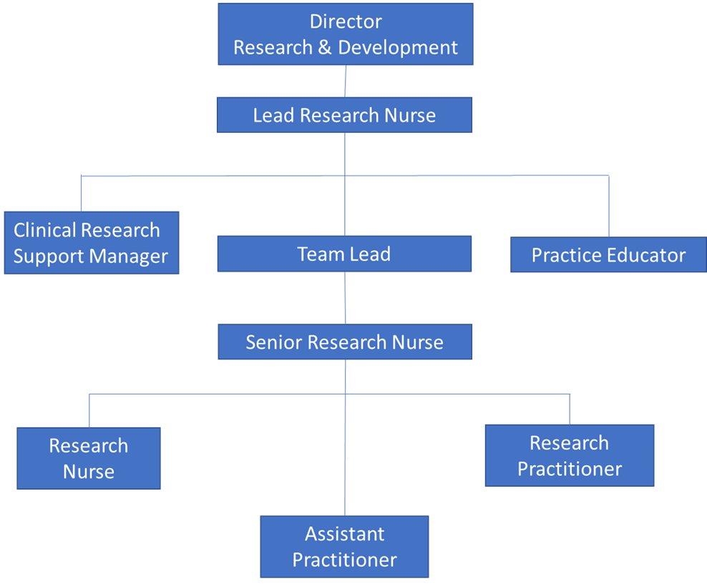
FREEDOM TO ACT
- The post–holder will be able to work autonomously whilst ensuring that all research procedures are conducted according to study protocols and Standard Operating Procedures (SOP), both Trust and study specific.
- The post holder will work autonomously within general policies and procedures guided by national policy and regulations and the Trust’s own policies.
- Promote a blame free culture in reporting incidents and where appropriate support local investigation of incidents.
COMMUNICATION/RELATIONSHIP SKILLS
- Facilitate and maintain effective communication within the research team and between the multidisciplinary clinical team.
ANALYTICAL/JUDGEMENTAL SKILLS
- Clinical knowledge within a relevant sphere of practice is required to enable screening against specified inclusion/exclusion criteria for recruitment.
- Post-holder will need to have relevant clinical knowledge and the ability to critically evaluate participant’ progression through research pathways in order to respond and refer appropriately.
- Critical research evaluation and the ability to conduct feasibility will be key requirements when working on complex research protocols.
- Engage in early evaluation of Expressions of Interest (EOI) received with Principal Investigator and team lead to ensure feasibility of study at site is properly assessed.
- Work with the lead clinician and senior research nurse/team lead to review complex clinical trial protocols and to develop a balanced portfolio of studies for each speciality that the post holder works across.
PLANNING/ORGANISATIONAL SKILLS
- Be responsible for managing and organising own day-to-day activities and workload, liaising with the senior research nurse and working within the team to ensure the portfolio remains covered at times of leave.
- Deputises for Research Team Lead on an ad hoc basis.
- Supports the planning of both short-term and long-term research projects.
- Works with the Senior PRC Team to understand and plan the portfolio of studies that may be open, in follow up or in set up at any one time.
- The post–holder will be able to work autonomously whilst ensuring that all research procedures are conducted according to study protocols and Standard Operating Procedures (SOP), both Trust and study specific.
- If working alone the post-holder will adhere to the Trust’s Lone Worker SOP and the speciality’s Working Instructions.
PATIENT/CLIENT CARE
  - Ensure the environment is suitable for patient care and research processes, recognising the importance of privacy, dignity and diversity.
  - Demonstrate professional development and an in-depth knowledge of current clinical and research practice.
  - Provide on-going advice and information to patients and their carers/families with regard to their participation in clinical research in order to facilitate effective informed consent.
  - Where appropriate receive and document written informed consent from research subjects for their participation in research studies and support other members of the team with best practice.
  - Ensure Trust policies are applied to support reporting of complaints and concerns by research participants that may be related to their participation in research and to ensure these complaints are appropriately managed and acted upon in accordance with requirements of the UK Policy Framework for Health and Social Care Research.
POLICY/SERVICE DEVELOPMENT
- Promote a culture of continuous improvement and transformation, enabling all change management activity, providing expertise, advice and guidance to staff and working with staff groups and change champions as required.
- To be confident to suggest improvement and transformation and being able to act upon these changes.
FINANCIAL/PHYSICAL RESOURCES
- Frequent requirement to exert moderate physical effort. Research offices are not based where patients are seen or recruited and the research team members are required to work across multiple sites at the RDE Wonford and where necessary Heavitree.
- Contribute to the accurate costing for clinical trials and appropriate negotiation of required financial support to deliver clinical trials.
- Ensure that participants can claim appropriate travel and other expenses and completing invoices in a timely and accurately. Have an awareness of the income stream relevant to Clinical Trials and work within, local and Trust wide financial and budgetary guidelines.
- Ensure accurate costings for clinical research activity during study set up. Utilise planning tools such as the intensity toolkit.
HUMAN RESOURCES
- Supervise junior members of the research staff as applicable (e.g. Research Nurse/Practitioner, Research Assistant Practitioner, Research HCA, and Research Administrator).
- Support senior staff in recruitment and interviewing processes in line with Trust practices and procedures.
- Take an active role in the mentoring and supervision of student nurses and junior staff
- Provides teaching in practice to other staff and students through clinical supervision and facilitation.
- Assist in the delivery of education and training regarding research for the wider Multidisciplinary Team and act as an ambassador for research
- Act as line manager for junior members of the research staff as applicable (e.g. Research Nurse/Practitioner, Research Assistant Practitioner, Research HCA, and Research Administrator). This will include clinical supervision and mentorship to members of staff and students.
  - Ensure all staff within sphere of responsibility have access to essential training and achieve 100% compliance.
  - Lead the recruitment of new junior personnel and ensure that an appropriate and safe skill mix is maintained. Work with the Team Lead to promote retention of staff.
- Be responsible for the deployment of HR policies including proactively managing sickness and performance in line with the Trust policy.
- Ensure that staff participate in Good Clinical Practice (GCP) training.
- Lead in the recruitment of Research Nurses/Practitioners within the relevant team.
- Assist the Team Lead with the training and development of clinical research practitioners and administrators to ensure retention of staff and workforce development where possible.
INFORMATION RESOURCES
- Ensure clear, accurate and concise records are kept for research projects in accordance with all regulatory requirements including the Data Protection Act.
- Ensure that data entry is accurate.
- Respond to data queries generated by the study coordinating team within a timely manner.
- Demonstrate awareness of the Ethics Committee Procedures through prompt reporting of Serious Adverse Events, submission of Trust application, protocols, advertisements and amendments.
RESEARCH AND DEVELOPMENT
- Demonstrate awareness of R&D/CRF facilities within the Trust and their working relationships.
- Demonstrate awareness of the Ethics Committee Procedures through prompt reporting of Serious Adverse Events, submission of Trust application, protocols, advertisements and amendments.
- Manage research performance within the relevant specialty in relation to team activities and study timelines.
- Collaborate with other Trusts and organisations within the region to improve research delivery.
- Take a leading role in the delivery of a clinical trial portfolio relevant to the specialty and ensure a balanced portfolio of studies.
- Ensure that the delivery of studies meet requirements with regards to the Department of Health’s Research Governance Framework for Health & Social Care and the EU Clinical Trials Directive by implementing quality systems.
- Be responsible for the Expression of Interest / Study Selection process for the relevant specialty. Review and assess trial protocols, consider all potential trials in terms of capacity and capability and viable recruitment period. Identify and work with the Team Lead to resolve resource implications in delivering and facilitating clinical research.
- Monitor and plan in advance the research workload within the specialty and manage team performance. Ensure that study complexity is considered when delegating roles within the team.
- Act as an expert resource and provide complex advice regarding study set up, recruitment planning and study delivery.
- Be responsible for promoting and overseeing the appropriate referral and recruitment of patients to clinical research studies. Work with investigators and support the clinical research team to develop strategies to overcome barriers to recruitment and to solve other problems relating to specific studies.
- Act as Principal Investigator (PI) for suitable studies and promote the non-medic PI role.
- Coordinate and run study visits including off site whilst adhering to the lone worker policy.
- Work with other departments within the Trust to ensure that trial specific investigations and procedures are undertaken as required by the trial protocol, in order to establish eligibility and safety of patients within clinical trials.
- Work with the team lead and research facilitators to ensure accurate costing for clinical trials and appropriate negotiation of required financial support to deliver clinical trials.
- Ensure clear, accurate and concise records are kept for research projects in accordance with all regulatory requirements including the Data Protection Act.
- Ensure that data is transcribed accurately where required and assist with the maintenance of the Trial Master File.
- Respond to data queries generated by the study coordinating team within a timely manner
- Ensure the recording & reporting of adverse and serious adverse events that occur whilst the participant is in the clinical trial to the trial co-coordinator/Principal Investigator (PI) and R&D office in line with the study protocol, local policies and regulatory requirements.
- Assess and evaluate the progress of on-going clinical trials for which the post holder has responsibility, maintaining accurate records of the status of studies and providing regular updates to the department on the status of the studies. This will involve ensuring that EDGE (Local Patient Management System) is updated with key trial data and validated efficiently.
- Identify and resolve study performance issues, escalating on-going issues to the Team Lead where required.
- Promote collaborative working across the network and with other clinical researchers, within the CRN and NIHR structure.
- Appraise research findings that inform and influence practice, policy and service provision and demonstrate the ability to make research and clinical judgments based on this appraisal.
- Co-operate with external and internal audit, data monitoring and quality assurance by working with R&D, sponsors, study monitors and external bodies.
- Assist in study close down and the preparation of results of research for presentation as posters, abstracts, papers or scientific presentations.
- The role requires flexibility as the research offices are not necessarily based where the patients are recruited or seen for their clinical research appointments.
- Attending Investigator Meetings can mean traveling around the country or even abroad. Travel arrangements are made and costs covered by the sponsors and commercial companies but flexibility is required in order to accommodate attending these meetings.
- The post-holder maybe required respond to an incidence driven recruitment strategy and this may be achieved through use of a bleep, group WhatsApp, text, and phone call.

PHYSICAL SKILLS
- The post holder will be required to use their excellent IT skills including MS Office, Google docs, internet, databases etc. in order to monitor activity, systems and processes and to produce reports including in time-bound circumstances.
- Standard keyboard skills are required for the inputting and manipulating of data and/or information on computer databases.
PHYSICAL EFFORT
- Requirement to exert moderate physical effort.
- Research offices and teams may not be based where patients are seen or recruited, research team members are required to work across multiple sites at the RDE Wonford and where necessary Heavitree.
MENTAL EFFORT
- Data accuracy and IT skills are essential to this role and combining clinical skills with these demands can be mentally difficult. Undertaking data entry is a requirement for this role and can often require long periods of concentration.
- There can be occasional requirements for frequent intense concentration when performing IT training for a new study requiring mastering a series of IT programmes.
EMOTIONAL EFFORT
- Occasional indirect exposure to distressing/emotional circumstances.
- On occasion the post holder maybe required to undertake discussions about research with participants and their families during times of emotional distress
WORKING CONDITIONS
- If working alone the post-holder will adhere to the Trust’s Lone Worker SOP and the speciality’s Working Instructions
- Covering a multi Trust site portfolio or performing home visits will mean the post-holder is required to ensure they can commit to this requirement.
- Carrying out home visits where required with the challenges this can raise.
- Working on VDU imputing complex data.
OTHER RESPONSIBILITIES
Take part in regular performance appraisal.

Undertake any training required in order to maintain competency including mandatory training, e.g. Manual Handling

Contribute to and work within a safe working environment

You are expected to comply with Trust Infection Control Policies and conduct him/herself at all times in such a manner as to minimise the risk of healthcare associated infection

As an employee of the Trust, it is a contractual duty that you abide by any relevant code of professional conduct and/or practice applicable to you. A breach of this requirement may result in action being taken against you (in accordance with the Trust’s disciplinary policy) up to and including dismissal.

You must also take responsibility for your workplace health and wellbeing:
- When required, gain support from Occupational Health, Human Resources or other sources.
- Familiarise yourself with the health and wellbeing support available from policies and/or Occupational Health.
- Follow the Trust’s health and wellbeing vision of healthy body, healthy mind, healthy you.
- Undertake a Display Screen Equipment assessment (DES) if appropriate to role.

APPLICABLE TO MANAGERS
Leading the team effectively and supporting their wellbeing by:
- Championing health and wellbeing.
- Encouraging and support staff engagement in delivery of the service.
- Encouraging staff to comment on development and delivery of the service.
- Ensuring during 1:1’s / supervision with employees you always check how they are.
DISCLOSURE AND BARRING SERVICE CHECKS
This post has been identified as involving access to vulnerable adults and/or children and in line with Trust policy successful applicants will be required to undertake a Disclosure & Barring Service Disclosure Check.
GENERAL
This is a description of the job as it is now. We periodically examine employees' job descriptions and update them to ensure that they reflect the job as it is then being performed, or to incorporate any changes being proposed. This procedure is conducted by the manager in consultation with the jobholder. You will, therefore, be expected to participate fully in such discussions. We aim to reach agreement on reasonable changes, but if agreement is not possible, we reserve the right to insist on changes to your job description after consultation with you.

Everyone within the Trust has a responsibility for, and is committed to, safeguarding and promoting the welfare of vulnerable adults, children and young people and for ensuring that they are protected from harm, ensuring that the Trusts Child Protection and Safeguarding Adult policies and procedures are promoted and adhered to by all members of staff.

PERSON SPECIFICATION

Job Title | Senior Research Nurse/Practitioner

Requirements | Essential | Desirable
QUALIFICATION/ SPECIAL TRAINING  Registered Nurse  Relevant Healthcare Degree  Research Training (e.g. GCP, degree module, informed consent)  Postgraduate Diploma or equivalent experience  Management or Leadership Qualification | E  E  E  E  D
KNOWLEDGE/SKILLS  In depth knowledge of clinical trials & research methodologies  Pertinent clinical skills including venipuncture  In-depth knowledge of data collection and data entry for clinical trials  Computer literacy including ability to work with databases  Ability to organise and prioritise own workload and work to tight deadlines  Ability to make independent decisions  Understand the significance of research and use of validated results to improve practice  Critical appraisal skills  Knowledge of Research Governance Framework and Good Clinical Practice Guidelines  Good leadership skills and proven managerial ability | E  E  E  E  E  E  E  E  E  D
EXPERIENCE  Experience of clinical research within the NHS setting  Broad and recent clinical experience relevant to the post  Proven record of meeting participant recruitment targets  Line Management experience within the NHS  Experience of delivering commercial and academic research | E  E  E  D  D
PERSONAL ATTRIBUTES  Ability to work autonomously  Ability to work cohesively as a member of a multidisciplinary team  High level of interpersonal and communication skills  Flexible and adaptable  Willingness to learn, instigate and develop efficient working systems  Willingness to undertake any necessary training and development to enhance work performance  Commitment to openness, honesty and integrity in undertaking the role | E  E  E  E  E  E  E
OTHER REQUIREMENTS  Willingness and ability to work across sites including community | E

FREQUENCY

(Rare/ Occasional/ Moderate/ Frequent)
WORKING CONDITIONS/HAZARDS |  | R | O | M | F
Hazards/ Risks requiring Immunisation Screening
Laboratory specimens | Y
Contact with patients | Y
Exposure Prone Procedures | Y
Blood/body fluids | Y
Laboratory specimens | Y
Hazard/Risks requiring Respiratory Health Surveillance
Solvents (e.g. toluene, xylene, white spirit, acetone, formaldehyde and ethyl acetate) | N
Respiratory sensitisers (e.g isocyanates) | N
Chlorine based cleaning solutions  (e.g. Chlorclean, Actichlor, Tristel) | N
Animals | N
Cytotoxic drugs | N
Risks requiring Other Health Surveillance
Radiation (>6mSv) | N
Laser (Class 3R, 3B, 4) | N
Dusty environment (>4mg/m3) | N
Noise (over 80dBA) | N
Hand held vibration tools (=>2.5 m/s2) | N
Other General Hazards/ Risks
VDU use ( > 1 hour daily) | Y
Heavy manual handling (>10kg)
Driving | Y
Food handling | N
Night working | N
Electrical work | N
Physical Effort
Mental Effort | Y
Emotional Effort | Y
Working in isolation
Challenging behaviour | Y

