

JOB DESCRIPTION

JOB DETAILS
Job Title | Medical Technical Officer
Reports to | Blood Sciences Laboratory Manager
Band | Band 3
Department/Directorate | Blood Sciences.  Specialist Services

JOB PURPOSE
- To assist in the analysis of pathology samples by preparation of instrumentation, reagents and pathological samples.
- To take an active role in the materials management of the department, receipting, storing and stock controlling laboratory consumables.
- To take an active role in the flow of specimens through the laboratory.
- To assist in the coordination of work carried out by the laboratory.
- General laboratory duties as required by the laboratory manager or designated deputy.

KEY RESULT AREAS/PRINCIPAL DUTIES AND RESPONSIBILITIES
- Maintenance and preparation of main instrumentation to a state of readiness for analysis.
- Take an active role in the coordination and prioritisation of specimens through the pre-analytical and analytical process.
- Carry out pipette checks to ensure accuracy of devices.
- Arrange for faulty pipettes to be serviced and repaired.
- Loading and unloading of samples onto automated analysers, ensuring all work is complete and all abnormal results are brought to the attention of a Biomedical Scientist.
- Ensure recording of stock levels and preparation of analyser consumables; keep stock control records up to date.
- Carry out Section stock checks as required.
- Prepare and book out reagents for night shift.
- Ensure the safe receipt, unpacking and storage of perishable analyser reagents as per manufacturers’ instructions.
- Move and store all deliveries in a safe manner and in accordance with manual handling protocols.
- Analysis of External Quality Assurance Scheme samples request data.
- Recording, packaging and dispatching of deep-frozen samples to external reference laboratories.
- Where required undertake appropriate Medical Laboratory Assistant duties including the following:
    - Telephone enquiries (including giving results) from clinicians and other service users.
    - Use of EPIC system to enter request form data onto the laboratory information system.
    - Receive label and centrifuge pathology samples.
- Assist in the training of existing and new members of staff.
- To take part in regular performance appraisal.
- To undertake any training required in order to maintain competency including mandatory training, i.e. Fire, Manual Handling.
- To contribute to and work within a safe working environment.
- The post holder will be willing to take part in remunerated Saturday and Sunday morning rotas.
- Collate and return results to research centres accurately and in a timely manner.
- Following the Trust protocol ensure the daily safe disposal of clinical waste bags.
- Adhere to COSHH regulations in the handling of biological and chemically hazardous materials.
- Adhere to the Departmental Health & Safety Policy and follow departmental procedures and guidelines on quality procedures.
- Adhere to the Departmental Policy on Patient Data Confidentiality.
- Follow the Departmental Procedure for dealing with spillage of biological fluids of hazardous chemicals.
- Maintenance and stock control of consumables for the Millipore pure water system
- Perform blood fridge mapping exercises
- Carry out stool extraction in preparation for analysis
- Receipt, Unpackaging, and labelling of QFIT samples in preparation for analysis
- Complete general housekeeping to keep laboratory equipment and environment clean and tidy

Section Specific - R&D
- Ensure all research samples received on dry ice are dealt with appropriately.
- Responsible for barcode printing system including:
  - Design of new labels using the Bar-one design software as required.
  - Ensure research number labels are printed in a timely fashion and that the quality of print is adequate.
  - Ensure the Zebra printer is maintained and stocks of ribbons and labels do not fall below minimum levels.
  - Distribute labels to appropriate research centres and FTS clinics.
- Maintenance of freezer & study databases.
- Unpackaging & receipt of daily R&D and Specialist services samples using integrated laboratory IT systems.
- Manage and audit research -80°C freezer
- Co-ordinate receipt and processing of large research batches.
- Prepare and perform multidisciplinary analysis of research samples as appropriate (label, defrost, sort, analyse and report).
- Assist in the delivery of and any necessary training of all staff for tasks relating to R&D work.
- Design and print study barcodes and laboratory stock labels as needed.
- Attend weekly CommCell & regular MTO/research meetings with senior laboratory staff, to maintain knowledge of current and future research activities
- Maintain database of all R&D work performed.
- Liaise with section seniors to ensure sufficient reagents are in stock as appropriate for R&D activities.

Section Specific - POCT
- To assist in Project Support for POCT
- Responsible for distribution of IQC and EQA samples, collation of returned data from the appropriate software for reporting on by POCT Managers.
- Stock control and dispatch of consumables for POCT to client sites, including maintaining an electronic stock inventory and month end reconciliation. Alerting POCT managers when stock consumables need to be purchased.
- Carry out procedures for IQC and EQA sample testing on in-house POCT devices.
- General office and administration of duties associated with POCT activities.
- Manage client telephone and email enquiries and update POCT managers with necessary information and troubleshoot where appropriate.
- Work with the POCT managers to ensure the POCT service offers the highest standards as required by our accreditation bodies.
- Carry out POCT audits.

Section Specific – Blood Transfusion

- Label and book in samples
- Answer telephone and take requests
- Remove cool packs from returned blood transport boxes that are empty of blood
- Book in batch products as and when they arrive
- Run routine samples on the analysers
- Make batch products and platelets available for staff collecting products.
- Identify blood units that are not required for a planned transfusion and de-reserves and return to stock.
- Scan request forms from the previous day and file on the computer
- Record the temperature of the Diamed/BioRad incubators.
- Check cold room for uncollected Anti-D and raise any case with a BMS to investigate why the product has not been collected and given.
- Order platelets on OBOS for the morning road run.
- De-reserve uncollected units from the remote Haemobanks that are past their de-reservation date.
- Enter the red cell stocks and wastage on the Blood Stocks Management Scheme web site.
- Check temperature logger validity stickers for the loggers in the cold room and if required reset them.
- De-reserve any batch products that have passed their de-reservation date.

Section Specific - Haematology and Immunology
- Preparation of samples and reagents for manual testing, including:
  - Blood film stains
  - Malaria screens
  - Glandular Fever testing
  - Sickle cell screen
  - Cytospin preparation
  - Erythrocyte Sedimentation Rate analysis
  - Immunofluoresence
  - Protein electrophoresis
- Is able to maintain and operate automated analysers including instruments for the analysis of:
  - Full Blood Count
  - HbA1C
  - Coagulation studies
  - Protein electrophoresis
  - Plasma Viscosity
- Is able to interact with the clinical team for the collection and processing of cryoglobulin samples.

KEY WORKING RELATIONSHIPS
The post holder is required to deal effectively with staff of all levels throughout the Trust as and when they encounter on a day to day basis.
In addition, the post holder will deal with the wider healthcare community, external organisations and the public.
This will include verbal, written and electronic media.
Of particular importance are working relationships with:

Internal to the Trust | External to the Trust
- Head of Dept  - Laboratory Manager  - Deputy Laboratory Manager  - Clinical Scientists  - Senior Technical and Scientific Staff  - Biomedical Scientists  - Medical / Nursing Staff | - External NHS agencies.  - Members of the Public  - Suppliers

ORGANISATIONAL CHART
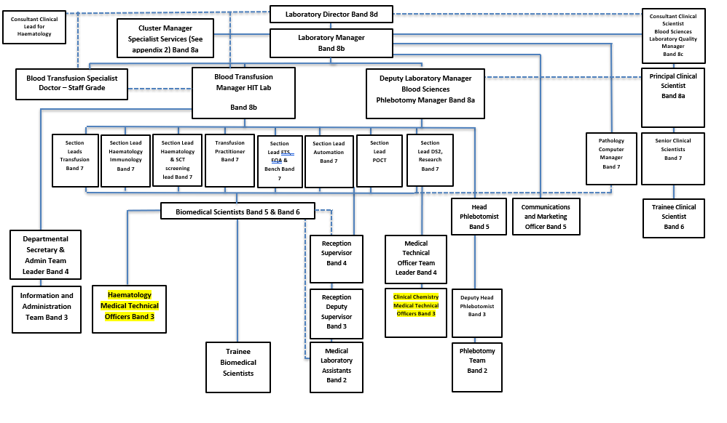

FREEDOM TO ACT
Works under own initiative to help prioritise routine, urgent and emergency specimen analysis on a day to day basis.

Works without continuous supervision within defined field of competence following department standard operating procedures and protocols.

COMMUNICATION/RELATIONSHIP SKILLS
Provide and receive complex or sensitive information; provide advice, instruction, training to staff.

Reports to and is managed by Biomedical Scientists.

Uses all available methods of communication effectively, clearly and politely.

Deals with enquiries from clinical and non-clinical staff and gives results to laboratory users.

Contributes towards the integrity and reputation of the department by ensuring harmonious relationships between self and managers, colleagues, patients and other staff groups.

Answering the telephone and dealing with callers’ requests/questions appropriately.

To participate in departmental meetings. To be active in the departments’ change and improvement processes

ANALYTICAL/JUDGEMENTAL SKILLS
Resolves day to day issues e.g. basic analyser troubleshooting, issues with specimens.

Setting up, maintenance, calibration and quality control of analysers together with reception, preparation and analysis of specimens.

Operation and maintenance of a wide range of non-analytical equipment.

Performing manual and automated diagnostic tests on patient’s specimens using a wide variety of manual and automated techniques.

PLANNING/ORGANISATIONAL SKILLS
To plan and prioritise routine, urgent and emergency specimen analysis on a day to day basis.

Organises own work.

Day to day operation of analysers including maintenance, calibration, checking, troubleshooting and repair.

As directed by a Biomedical Scientist monitor and maintain adequate stocks of all consumables.

PATIENT/CLIENT CARE
Prepares specimens for diagnostic testing.

The quality and accuracy of work impacts on results and therefore impacts directly on patient care.

POLICY/SERVICE DEVELOPMENT
The post holder has no direct responsibility for policy and service development.

Follows laboratory policies, may comment on proposals for change/proposes changes to SOPs.

Works with senior staff and consultants to maintain an up to date, high quality service.

There is a requirement to be involved in the scheduled audit of the service for the duties contained within this job description.

Under the direction of senior staff works to ensure department complies with the requirements of ISO15189.

Following set laboratory procedures and applying mandatory professional and accreditation standards at all times and for all tasks.

FINANCIAL/PHYSICAL RESOURCES
Safe use of highly complex and expensive equipment following agreed standard operating procedures after appropriate training.

Helps maintain adequate stocks of consumables and testing kits, ensuring that senior staff members are alerted to order items as required.

HUMAN RESOURCES
Demonstrates own duties/ co-ordinates other clinical support workers, provides advice & guidance, basic training.

INFORMATION RESOURCES
To observe the strictest confidence regarding all information to which there is access within the RDUH by working in accordance with the data protection act and Trust policy on information governance.

To enter requests for specimen testing.

To enter patient identification data and results into the laboratory computer for storage and printing of results.

RESEARCH AND DEVELOPMENT
Occasionally participate in R&D; to prepare samples and collect data for clinical trials.

Assisting with any data collection required for audits.

Contribute to the maintenance of fully traceable and auditable records for all blood and blood products kept and transfused, including issue of blood products to the community on a named-patient basis in accordance with NICE guidelines.

PHYSICAL SKILLS
Manual dexterity and hand-eye co-ordination with speed and accuracy when dealing with specimens.

Manipulation of small tools, tubes, pipettes and complicated apparatus is required. Working rapidly at busy times.

PHYSICAL EFFORT
Sitting, standing in restricted position; frequent light effort for several short periods per shift; occasional moderate effort for several short periods per shift.

Sitting at analyser for long periods, repetitive movements processing specimens, bending and lifting supplies, use of trolleys.

Manual dexterity and hand-eye co-ordination with speed and accuracy when performing tests.

Manipulation of small tools, tubes, pipettes and complicated apparatus is required.

Working rapidly at busy times.

MENTAL EFFORT
Frequent high level of concentration required for specimen checking, testing and performing a widely variable range of diagnostic tests and tasks, some complex, and computer data input for prolonged periods.

Working accurately at all times, especially under pressure at busy times. Coping with frequent interruption.

EMOTIONAL EFFORT
Exposure to distressing or emotional circumstances is rare.

Limited contact with patients and clients.

WORKING CONDITIONS
Works within the responsibilities given by the Health and Safety at Work Act (1974) to ensure that agreed safety procedures are carried out to maintain a safe environment for self, colleagues and visitors.

Exposure to contained or controlled infectious materials, body fluids and chemicals of varying hazard.

Risk of exposure to uncontained hazards e.g. spillage of harmful chemicals.

Coping with a busy environment with some noise.

Use of Display Screens (VDU).

Use of PPE as required.

OTHER RESPONSIBILITIES
Take part in regular performance appraisal.

Undertake any training required in order to maintain competency including mandatory training, e.g. Manual Handling

Contribute to and work within a safe working environment

You are expected to comply with Trust Infection Control Policies and conduct him/herself at all times in such a manner as to minimise the risk of healthcare associated infection

As an employee of the Trust, it is a contractual duty that you abide by any relevant code of professional conduct and/or practice applicable to you.

A breach of this requirement may result in action being taken against you (in accordance with the Trust’s disciplinary policy) up to and including dismissal.

You must also take responsibility for your workplace health and wellbeing:
- When required, gain support from Occupational Health, Human Resources or other sources.
- Familiarise yourself with the health and wellbeing support available from policies and/or Occupational Health.
- Follow the Trust’s health and wellbeing vision of healthy body, healthy mind, healthy you.
- Undertake a Display Screen Equipment assessment (DES) if appropriate to role.

GENERAL
This is a description of the job as it is now. We periodically examine employees' job descriptions and update them to ensure that they reflect the job as it is then being performed, or to incorporate any changes being proposed. This procedure is conducted by the manager in consultation with the jobholder. You will, therefore, be expected to participate fully in such discussions. We aim to reach agreement on reasonable changes, but if agreement is not possible, we reserve the right to insist on changes to your job description after consultation with you.

Everyone within the Trust has a responsibility for, and is committed to, safeguarding and promoting the welfare of vulnerable adults, children and young people and for ensuring that they are protected from harm, ensuring that the Trusts Child Protection and Safeguarding Adult policies and procedures are promoted and adhered to by all members of staff.

PERSON SPECIFICATION

Job Title | Band 3 MTO - Blood Sciences

Requirements | Essential | Desirable
QUALIFICATION/ SPECIAL TRAINING  Educated to level NVQ3 or equivalent. | E
KNOWLEDGE/SKILLS  Extensive knowledge of laboratory procedures.  Ability to troubleshoot laboratory sampling issues.  IT literacy and data handling experience.  Good knowledge of MS Office applications  Excellent keyboard skills  Excellent organisational skills | E  E  E  E | D  D
EXPERIENCE  - Experience of working as part of a team. | E
PERSONAL ATTRIBUTES  - Excellent interpersonal skills.  - Ability to prioritise and work on own initiative.  - Enthusiasm and willingness to learn.  - Good timekeeping  - Ability to accommodate the physical aspects of the role. (In compliance with Manual Handling directives) | E  E  E  E  E
OTHER REQUIREMENTS  - Willingness to undertake NVQ Level 3 course in Laboratory & Associated Technical Activities.  - Willingness (with warning) to accept flexible working hours | E  E

FREQUENCY

(Rare/ Occasional/ Moderate/ Frequent)
WORKING CONDITIONS/HAZARDS |  | R | O | M | F
Hazards/ Risks requiring Immunisation Screening
Laboratory specimens | Y |  |  |  | X
Contact with patients |  | R
Exposure Prone Procedures | N
Blood/body fluids | Y |  |  |  | X
Laboratory specimens | Y |  |  |  | X
Hazard/Risks requiring Respiratory Health Surveillance
Solvents (e.g. toluene, xylene, white spirit, acetone, formaldehyde and ethyl acetate) | Y |  | X
Respiratory sensitisers (e.g isocyanates) | N
Chlorine based cleaning solutions  (e.g. Chlorclean, Actichlor, Tristel) | Y |  | X
Animals | N
Cytotoxic drugs | N
Risks requiring Other Health Surveillance
Radiation (>6mSv) | N
Laser (Class 3R, 3B, 4) | N
Dusty environment (>4mg/m3) | N
Noise (over 80dBA) | N
Hand held vibration tools (=>2.5 m/s2) | N
Other General Hazards/ Risks
VDU use ( > 1 hour daily) | Y |  |  |  | X
Heavy manual handling (>10kg) | N
Driving | N
Food handling | N
Night working | Y |  |  |  | X
Electrical work | N
Physical Effort | N
Mental Effort | Y |  |  |  | X
Emotional Effort | Y | X
Working in isolation | Y |  |  |  | X
Challenging behaviour | N

