Job Description

Job Details
Job Title: | Apprentice Podiatrist
Responsible to: | Specialist Podiatrist
Professionally Responsible to: | Podiatry Professional Lead
Grade: | Band 5 (Annex 21) 37.5 hours per week
Unit: | Podiatry Service
Location: | Based at Barnstaple Health Centre covering North Devon Community

Job Purpose
This is a development role via the Podiatry Apprenticeship standard. You will work towards successful completion of a BSc (Hons) degree in podiatry and recognition by the Health Care Professions Council (HCPC) as an Allied Health Professional AHP Podiatrist.

You will develop and maintain knowledge, skills and competencies related to the role of a Podiatrist through your apprenticeship within the service as well as through completion of the Podiatry Apprenticeship training programme. This includes working in clinic and community care settings, and delivery of direct person-centred care. Whilst undertaking this training you will work within the service as a Podiatry Apprentice, where your role will reflect your learning.

The Podiatry Apprenticeship Programme combines and integrates academic and work-based learning through close collaboration between employers and education providers. For the BSc you can expect to spend a minimum of 20% of your time accessing e-learning and a further 40% working in practice, under the direct supervision of a clinical mentor. As a Podiatry Apprentice you will be based as an employee within working in a variety of clinical settings. This will enable you to gain a wide appreciation of many health and care contexts, which will enable you to fulfil all the requirements of the BSc (Hons) Podiatry programme.

On successful completion of the programme you will be equipped with the appropriate knowledge, skills, attitudes and behaviours to ensure competence at the point of qualification. You will have the capability to continue to meet Health and Care Professions Council regulatory standards and the College of Podiatry professional standards throughout your professional career.

The academic part of the training will be provided by the University of Plymouth where you will undertake modules as detailed below:

Introduction to podiatric practice
Human anatomy and physiology
Professional and inter-professional working
Person centred care
Systemic disorders of the lower limb
Musculoskeletal conditional and applied biomechanics in the foot and lower limb
Project studies
Development maturation of the lower limb
Pharmacology
Minor surgery
Complex Podiatric medicine
Leadership and critical education
Critical thinking and problem solving in clinical practice

Dimensions
The Northern Devon Podiatry Service operates over the North Devon locality within community, primary and secondary care settings. The Podiatry Service provides podiatric care to those high-risk patients that fall within our criteria in both clinical environments and the home.

The main specialisms of care within the Service include:

- High risk Foot care
- Specialist Diabetic clinics
- Nail Surgery
- Wound care
- MSK
- Self-management programmes for patients

Organisational Chart
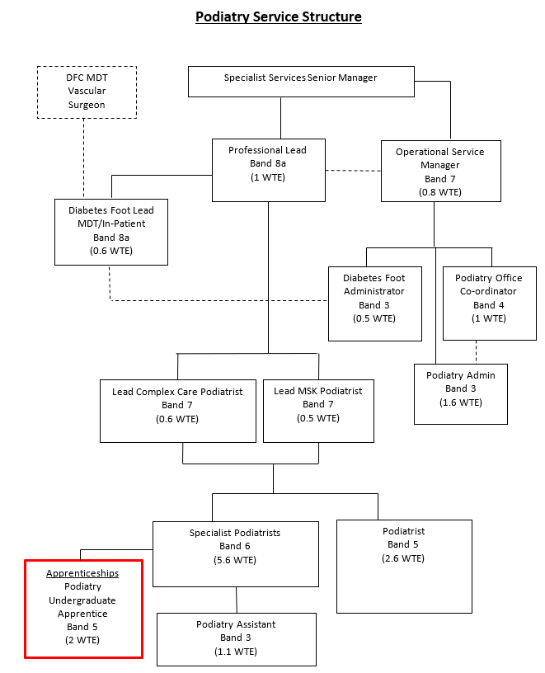

Main Tasks/Duties and Areas of Responsibility
The Podiatry Apprentice will be based in the Podiatry Department at Barnstaple Health Centre and will be required to attend Plymouth University and clinical placements as set in the degree programme.
KEY RESPONSIBILITIES
- To attend Plymouth University and clinical placements as set out in the degree programme
- To complete and pass academic modules and clinical placements to the required standard in order to progress through the programme
- To ensure timely achievement of assignments and assessments in accordance with the academic programme requirements.
- To gain experience during the period of the Apprenticeship in a wide range of clinical areas.
- To participate in tripartite reviews, with the University and the employer. These are a requirement of the apprenticeship.
- To complete and pass the End Point Assessment.
- To organise and manage a clinical caseload, which will include gaining knowledge and experience of providing podiatric care for patients with a variety of conditions including diabetic, rheumatological and biomechanical problems
- To gain knowledge and skills assess, diagnose, develop and implement individualised treatment programmes for patients with a wide variety of clinical needs including acute or chronic neuropathies, chronic diseases, vascular problems and wound management.
- To provide appropriate education to patients with diverse foot pathology, utilising analytical and reasoning skills in this process in order to empower the patient and others to participate in the patient’s self-care.
- To gain experience during the period of apprenticeship in a wide range of clinical areas including diabetes, rheumatology, biomechanics, tissue viability, nail surgery and wound management.
PATIENT AND CLINICAL CARE
- To provide foot care to patients within agreed competencies and training as delegated by the Podiatrist
- To carry out treatments using equipment for which adequate training has been given
- To be actively involved in the provision of Foot health education advice to patients, relatives and carers
- To assist in minor surgery sessions within the scope of instructions laid down by the Podiatrist.
- To understand the implications of medication and medical conditions on care and treatment planning and relate this to the patient, family or carer as appropriate.
- To monitor the changing needs of the patient and where necessary refer the patient back to the Podiatrist if their podiatric or medical condition needs to be reviewed.
- Assessing the condition and risk status of the feet of an individual with diabetes and discussing the results of the examination with the individual and/or carer and explain any specific problems(s), which may require further tests or treatment and implement these referrals
- Recognise signs of infection in wounds and post operatively, understand the implications, advise accordingly and use appropriate dressings.
- To prioritise clinical time to best manage clinical caseload, ensuring clinics are appropriately booked in order to maximise delivery of appropriate and effective care, liaising closely with clinical and support staff to achieve this
- To plan own workload around such activities as domiciliary visits.
- To be responsible for the assessment and diagnosis of new and existing patients in line with departmental protocols using judgements involving complex facts requiring the comparison of a range of options.
- To provide appropriate and effective care plans based on analysis of information gained from assessments
- To deliver care based on selection of appropriate treatments and clinical aids available

Health and Safety
- To be responsible for the Health and Safety of self, colleagues, patients and carers
- To report any accidents, near misses and defects in equipment following Trust guidelines
- To ensure that Health and Safety legislation is complied with at all times including workplace risk assessments, individual patient risk assessments, policies such as control of infection, sharps policy and lone working guidelines, fire, resuscitation and manual handling policy
- To be responsible for the security and safe use (includes the use of identified personal protective equipment) and daily maintenance of equipment
- To attend mandatory training in line with Trust policy

To assess and manage risk as per Trust guidelines when working alone or in a changing busy environment where events may be unpredictable which occurs frequently on a daily basis
- To carry out assessments and treatments of podiatric conditions with moderate physical effort on a daily basis
- To deal with the Health and Safety implications of frequent exposure to
difficult working conditions on a daily basis e.g. unpleasant strong odours,
blood, sepsis, vomit gangrene etc and the occasional exposure to verbal and
potential violent aggression
- To comply with Health and Safety regulations with regard to COSSH e.g. acids glues grinding dust in both outpatient clinic, minor operation unit, ward and orthotics laboratory.

Training, Education, Professional Responsibilities, Research and Audit

- To attend University and clinical placements as set out in the degree programme
- To complete and pass academic modules and clinical placements to the required standard in order to progress through the programme
- To ensure timely achievement of assignments and assessments in accordance with the academic programme requirements
- To gain experience during the period of the Apprenticeship in a wide range of clinical areas
- To participate in tripartite reviews, with the University and the employer. These are a requirement of the apprenticeship
- To complete and pass the End Point Assessment
- To organise and manage a clinical caseload, which will include gaining knowledge and experience of providing podiatric care for patients with a variety of conditions including diabetic, rheumatological and biomechanical problems
- To gain knowledge and skills assess, diagnose, develop and implement individualised treatment programmes for patients with a wide variety of clinical needs including acute or chronic neuropathies, chronic diseases, vascular problems and wound management.
- To provide appropriate education to patients with diverse foot pathology, utilising analytical and reasoning skills in this process in order to empower the patient and others to participate in the patient’s self-care.
- To gain experience during the period of apprenticeship in a wide range of clinical areas including diabetes, rheumatology, biomechanics, tissue viability, nail surgery and wound management.
- Maintain accurate written records of activity and contribute input into trust information systems as directed
- To main accurate records of all patient consultations and related work carried out at each clinical session including computerised data collection
- To ensure that all information relating to clients and staff gained through employment with the Trust is kept confidential

Communication and Working Relationships

Key Liaisons:
Patients/carers/relatives
Service Manager - Podiatry
Trust Apprentice Educational Lead
Lead Podiatrists
Podiatrists and Podiatry assistants
Admin/clerical staff
Other AHP’s
District Nurses/Auxiliaries/support staff
Specialist Nurses
Ambulance liaison
Trust staff at all levels
Neighboring Trust staff
Consultants
GP’s and practice staff
Public Health workers/school nurses
Computer/information services staff
NHS Supplies
Modern Matrons
Other statutory Agency staff
Education Establishments
Nursing/Residential homes
- To work collaboratively with GPs, consultants, other Allied Health Professionals and other agencies e.g. Social Services, nursing homes, other NHS Trusts to ensure appropriate delivery of specialist patient care
- To deal sensitively with patients, most of whom present with complex clinical conditions or multiple pathologies and frequently have physical, psychological and emotional conditions e.g. high levels of anxiety or aggression or confusion caused by pain, spreading infection, hearing loss, learning difficulties, physical difficulties, amputation, limited mobility, dementia, terminal illness

To encourage productive relationships with all podiatry staff, Trust staff and outside agencies

This job description is not substantive and will be reviewed by the jobholder and appropriate manager/professional lead as changes and developments are identified.

HAZARDS:
Laboratory Specimens  Proteinacious Dusts | X | Clinical contact with patients | X | Performing Exposure  Prone Invasive Procedures
Blood/Body Fluids | X | Dusty Environment | X | VDU Use | X
Radiation |  | Challenging Behaviour | X | Manual Handling | X
Solvents | X | Driving | X | Noise | X
Respiratory Sensitisers | X | Food Handling |  | Working in Isolation | X
Cytotoxic drugs |  | Night working

Reviewed June 2022
Person Profile

Job Title: | Apprentice Podiatrist
Grade: | Band 5 (Annex 21)
Department: | Podiatry Department

CRITERIA REQUIRED | ESSENTIAL | Desirable
Qualifications & Training | Five GCSE’s including Maths, English and Science. Functional skills level 2 Maths and English will be considered.  104 UCAS points (equivalent to A levels at BCC including a biological subject  Applicants are expected to demonstrate evidence of recent academic achievement (relevant recent qualifications required) such as they may be deemed capable of study at degree level
Specific Knowledge & Skills | Able to convey tasks and actions to colleagues and service users  Able to assist patients to achieve safe working environments for treatments to be carried out  Ability to perform treatments in a variety of settings such as clinics, patient own homes and hospital sites  Fine motor dexterity which will become more advanced throughout the apprenticeship to enable use of instruments in podiatry treatment  Ability to use information systems to input data and clinical treatment. | Knowledge and understanding of NHS priorities.  Good IT skills
Special Experience | Approachable and flexible  Good communication skills (written and verbal)  Be able to prioritise tasks and manage time effectively  Ability to work under pressure  Ability to assimilate new concepts and approaches to care  Ability to hear distressing news from patients when discussing treatment plans and during consultations when patients share their life experiences  Ability to engage positively with service users  Ability to complete apprenticeship work outside working paid hours  Ability to work effectively as a team member  Physically capable of performing the role and responsibilities expected of the post holder  Self-motivated  Working knowledge of Microsoft Office packages e.g. Word, Excel, PowerPoint and Outlook | Previous experience in a healthcare setting
Physical Skills & Effort | Post holder must be able to work under pressure and respond to change.  Ability to travel around the locality as requested, independently and efficiently.
Emotional Effort | To have a responsible and caring attitude.
Mental Effort | Understanding of the demands of studying part-time alongside employment  Insight into how to reflect and evaluate own strengths and development needs, seeking advice where appropriate
Requirements due to Working Environment | Ability to share workspace with others  Work in an environment which may be unpleasant, malodorous, dirty due to blood sepsis etc  Busy clinical environment  To work within Health and Safety guidelines to manage: Lone working, aggressive behaviour in the workplace.

