
JOB DESCRIPTION

This post has been identified as involving access to vulnerable adults and/or children and in line with Trust policy successful applicants will be required to undertake a Criminal Records Bureau Disclosure Check.

The Trust is committed to recruiting and supporting a diverse workforce and so we welcome applications from all sections of the community, regardless of age, disability, gender, race, religion, sexual orientation, maternity/pregnancy, marriage/civil partnership or transgender status. The Trust expects all staff to behave in a way which recognises and respects this diversity, in line with the appropriate standards.

1. JOB DETAILS

Job Title: Reporting Radiographer (Planar Imaging)

Band: 7

Responsible to: Superintendent/ Lead Reporting Radiographer (General)

Accountable to: Radiology Services Manager

Department / Directorate: Medical Imaging / Diagnostics

2. JOB PURPOSE

- To have responsibility for Image Interpretation of planar x-ray images
- To produce high quality Image reports
- To produce high quality diagnostic images whilst maintaining the highest standards of patient care
- To participate in the training and education of junior members of staff, radiography students and other clinical colleagues
- To act as clinical expert radiographer for Trauma Radiography and liaison between Medical Imaging and the Emergency Department
- To participate in the training and supervision of trainee Reporting Radiographers
- To remain professional at all times and adhere to all Trust and Departmental policy and procedures
- To participate in the 7 day working rota for clinical and reporting duties

3. DIMENSIONS/ KEY WORKING RELATIONS

- Superintendent Radiographers
- Radiographers
- Radiology Services Manager
- Departmental Nursing Staff
- Consultant Radiologists
- Radiology Registrars
- Departmental administrative, clerical and support staff
- Emergency Department staff of all grades

4: ORGANISATIONAL CHART:
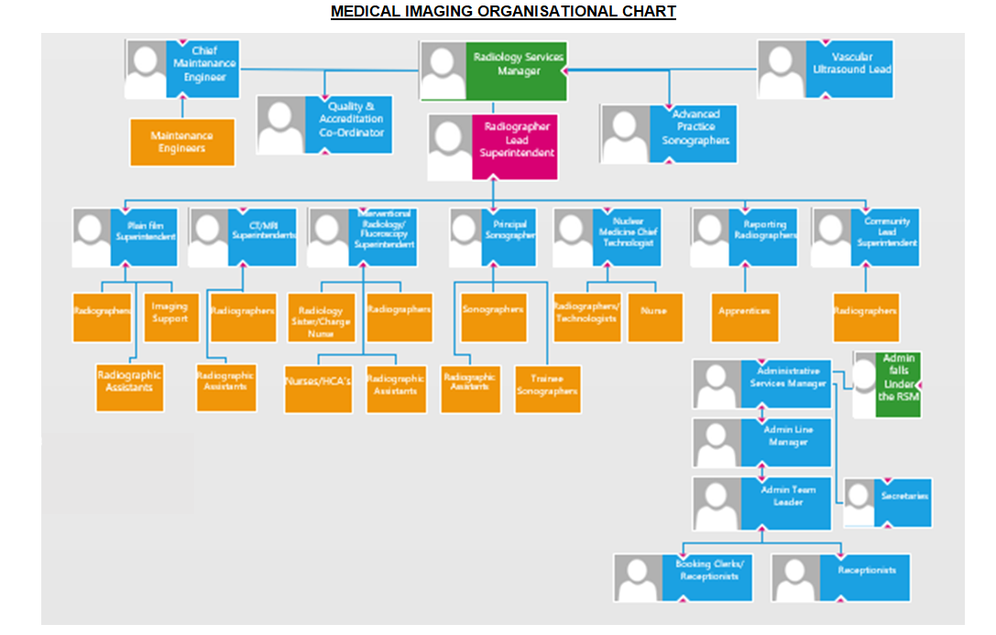
5. KEY RESULT AREAS/PRINCIPAL DUTIES AND RESPONSIBILITIES:

Leadership & Management

- On a daily basis be able to apply organisational and planning skills in the allocating and re allocating of time and resources to meet rapidly changing operational and clinical requirements
- To be responsible for his/her actions and patient workload and be able to work unsupervised as well as part of a multidisciplinary team
- To enable colleagues to perform their duties in a supportive and professional environment
- As required, to supervise the work of other qualified staff, students and Assistant Practitioners performing duties within the imaging department
- To be familiar with and adhere to all departmental policies and procedures
- To act as a senior and specialist radiographer and make recommendations on matters pertaining to planar imaging, using specialist skills, knowledge and professional judgement when required
- To act as role model for radiographers throughout the department and ensure the highest quality professional standards are maintained
- To act as expert radiographer for Trauma Radiography providing a liaison point between Medical Imaging and the Emergency Department
- To undertake regular audit into reporting sensitivity and specificity of Reporting Radiographers
- To participate in the departmental reject analysis evaluation, providing teaching where necessary to improve clinical standards
- To deputise for the Superintendent as required
- To undertake Leadership and management development to enhance own skills and expertise
- To perform appraisals and PDRs as required

Professional & Clinical

- To perform general radiographic imaging procedures to a high standard
- To competently undertake reporting on A&E trauma, non-trauma and GP referred planar images according to a defined scope of practice
- To provide clear, accurate, and informative clinical reports on planar images according to a defined scope of practice
- To be accountable for own professional actions, and check the quality and validity of any reports before they are finished
- To have regard to workload pressures of professional colleagues and support and assist as required
- To have a flexible approach to the working day, responding to changing pressures in service demand
- To be aware of legislation relevant to radiation protection, and to work to ‘best practice’ guidelines at all times, minimising radiation exposure to patients, staff and visitors
- To be able to competently use the Radiology Information System for accurate documentation of completed examinations and for Reporting
- To be aware of the need for the highest level of patient care at all times, with particular reference to the hazards posed by cross infection and exposure to radiation
- To be familiar with and adhere to all departmental clinical documentation procedures
- To be mindful of the need for the correct care and use of complex equipment with particular reference to problems of manoeuvring of large machines in a precise manner within confined clinical areas
- To actively participate in the departmental Learning From Discrepancy Meetings and disseminate learning where appropriate
- To attend Multi-Disciplinary Team meetings where required
- There will be frequent and sustained periods of concentration during imaging interpretation activities
- To maintain a high standard of professional conduct and appearance at all times
- To develop imaging protocols compliant with IR(ME)R 2017 and IRR 2017 in conjunction with senior colleagues
- Be competent in all routine diagnostic techniques, using highly developed physical skills to provide images of diagnostic quality in a timely manner. Be able to accurately position patients with minimum discomfort to facilitate accurate diagnostic images promoting a ‘right first time’ approach
- Provide professional guidance to referrers on appropriate referral pathways commensurate with departmental procedures
- Assess the Radiation risk to the patient and ensure it is kept as low as reasonably practicable (the ALARP principle) and assess any additional risks involved within your modality
- Respond to the changing needs of the department on a daily basis by providing a flexible approach to the working day, thus maintaining the existing excellent standard of service and the continuing promotion of good working relationships
- To adhere to the Trust uniform policy at all times
- To undertake any other duty commensurate with grade as directed by the Superintendent Radiographer

Communication

- To communicate, in a concise and appropriate manner, complex information regarding imaging procedures, including relevant risks and benefits, to patients and relatives, as well as other hospital staff.
- To effectively and efficiently communicate clinical findings that require urgent action according to departmental procedures
- To be able to provide reassurance and overcome patient concerns and barriers of understanding in order to obtain the level of cooperation required to achieve a successful outcome.
- To work and communicate efficiently with other members of staff throughout the trust and beyond to assist in the provision of an efficient diagnostic imaging service to the Trust.
- To ensure that the Superintendent Radiographer/Radiology Services manager is made aware of any matter which does or has the potential to affect the provision of the diagnostic imaging service

Training, education & CPD

- To ensure maintenance of general technical and professional skills and participation in Continuous Professional Development to such a level required to remain eligible for registration by the Health Professions Council
- To deliver teaching and training to radiographers, students, non-medical referrers, and other Trust employees as required within own area of expertise
- To lead and actively participate in departmental audit presenting findings as appropriate
- To undertake secondary duties as agreed with the Superintendent
- To assist in the delivery of work experience and return to practice programmes offered by the Department, having an up to date awareness of the most appropriate training schemes and programmes available
- To participate in the practical training of student radiographers, and support and assist junior members of the radiographic staff in their duties, cascading necessary information and training as required

Quality systems & organisational arrangements

- To be aware of and adhere to, all relevant Trust wide and Departmental policies and procedures
- To be aware of legislation relevant to patient confidentiality and to work to ‘best practice’ guidelines at all times
- To have a flexible approach to working hours, and be prepared to participate fully in such shift, extended working day and on call working rotas as may be required
- To be prepared to carry out duties appropriate to role and grade in any area of the Radiology department if exceptional circumstances make this necessary
- To attend and participate fully in Departmental meetings
- To work closely with the Superintendent Radiographer in the monitoring and evaluation of existing processes and procedures associated with diagnostic imaging, participating fully in the development and introduction of revised improved methods of service delivery
- To be prepared to participate in research and on-going audit activities within diagnostic imaging, and to suggest appropriate subjects for activities for consideration by the Division of Radiology and departmental audit and research co-ordinators
- To regularly review documents as required on Q-Pulse, ensuring compliance with any changes necessary

Other Responsibilities

- To participate in performance appraisal of self and others
- To undertake any training required in order to maintain competency including mandatory training, i.e. Fire, Manual Handling, Basic Life Support
- To contribute to and work within a safe working environment
- The post holder is expected to comply with Trust Infection Control Policies and conduct him/herself at all times in such a manner as to minimise the risk of healthcare associated infection
- To take an active role in the department’s research and audit, occasionally taking a lead role in specialist audit
- To take an active role in the department’s quality control procedures and equipment testing

THE TRUST - PURPOSE AND VALUES

We are committed to serving our community by being a high quality specialist Hospital with consultant-led services. We aim to co-ordinate our services with primary and community care, and to develop a limited number as Sub-Regional Referral Centres with appropriate levels of research, development and educational involvement. Where appropriate, and consistent with our services, we may provide services aimed at preventing disease and debilitation.

We aim to make all our services exemplary in both clinical and operational aspects. We will show leadership in identifying healthcare needs to which we can respond and in determining the most cost-effective way of doing so. We will share our knowledge with neighbouring healthcare agencies and professionals.

We recruit competent staff that we support in maintaining and extending their skills in accordance with the needs of the people we serve. We will pay staff fairly and recognise the whole staff’s commitment to meeting the needs of our patients.

We are committed to equal opportunity for all and encourage flexible working arrangements including job sharing.

GENERAL

This is a description of the job as it is now. We periodically examine employees' job descriptions and update them to ensure that they reflect the job as it is then being performed, or to incorporate any changes being proposed. This procedure is conducted by the Manager in consultation with the jobholder. You will, therefore, be expected to participate fully in such discussions. We aim to reach agreement on reasonable changes, but if agreement is not possible, the Trust reserves the right to insist on changes to your job description after consultation with you.

The RD&E is a totally smoke-free Trust. Smoking is not permitted anywhere on Trust property, including all buildings, grounds and car parks. For help to quit call: 01392 207462.

As an employee of the Trust, it is a contractual duty that you abide by any relevant code of professional conduct and/or practice applicable to you. A breach of this requirement may result in action being taken against you (in accordance with the Trust’s disciplinary policy) up to and including dismissal.

The post holder is expected to comply with Trust Infection Control Policies and conduct him/her at all times in such a manner as to minimise the risk of healthcare associated infection.

PERSON SPECIFICATION
POST: Radiographer Assistant Practitioner (Bank)
BAND: 4
REQUIREMENTS | At  Recruitment | At 2nd KSF  Gateway
QUALIFICATIONS / TRAINING  BSc in Diagnostic Radiography or equivalent  Post Graduate qualification in Clinical Reporting  Current Registration with the Radiographers board of the Health Professions Council  Evidence of commitment to ongoing CPD  Leadership or management qualification | E  E  E  E  D | E  E  E  E  E
KNOWLEDGE / SKILLS  Proven skills in performing a wide range of general radiographic examinations to a high clinical and professional standard.  Be aware of and able to implement the requirements of the IR(ME)R regulations with regard to radiation protection.  To be able to demonstrate knowledge of IT skills | E  E  E | E  E  E
EXPERIENCE  Proven ability to work as part of a multidisciplinary team.  Experience of mentoring and supervising student/ junior radiographers.  Experience of independent reporting of images  Extensive experience of working within NHS radiographic imaging department | E  E  E  E | E  E  E  E
PERSONAL ATTRIBUTES  Ability to communicate well with all grades and disciplines of staff, patients and relatives.  Be reflective in thinking and outlook and be available as a source of advice, coping with multiple demands during the working day.  High personal and professional standards  Demonstrate compassionate and caring attitude towards patients and colleagues  Lead by example, demonstrating high personal and professional standards | E  E  E  E  E | E  E  E  E  E
OTHER REQUIREMENTS  Be prepared to deal with distressing and emotional situations on a daily basis. For example, badly injured or intoxicated patients. Patients or relatives who may be abusive or aggressive.  To be physically able to safely and competently position and manoeuvre patients and equipment as a routine part of the daily duties, including wheelchairs, beds, stretchers and mobile x-ray units. | E  E | E  E
* Essential/Desirable

HAZARDS IDENTIFIED (tick as appropriate):
Laboratory specimens  Proteinacious Dusts |  | Clinical contact with  patients | √ | Performing Exposure  Prone Invasive Procedures
Blood / Body Fluids | √ | Dusty environment |  | VDU use | √
Radiation | √ | Challenging Behaviour | √ | Manual handling | √
Solvents |  | Driving |  | Noise
Respiratory Sensitisers |  | Food handling |  | Working in isolation | √

