

JOB DESCRIPTION

JOB DETAILS
Job Title | Project and Service Change Manager
Reports to | Senior Project Manager
Band | Band 7
Department/Directorate | Corporate PMO, Corporate Services

JOB PURPOSE
The post holder will lead work as part of the Corporate Programme management Office (CPMO) to lead and facilitate in the (re)design and implementation of improved clinical and non-clinical services which are high quality, safe, effective and financially sustainable.

The post holder will lead allocated project management and change management work associated with the delivery of the Trusts corporate programmes in order to meet its key strategic objects. The key focus will be the Delivering Best Value Programme
KEY RESULT AREAS/PRINCIPAL DUTIES AND RESPONSIBILITIES
The post holder will fulfil all tasks and work as part of a team. To meet the needs of the service, the post holder may be required to work in other areas as appropriate as directed by the line manager and will be responsible for a team of project staff.

Key responsibilities include:

- Work with the Senior Leadership Team and engage with multi-disciplinary clinical and non-clinical teams to lead on service improvement activity and ensure alignment of service improvement activity with the strategic objectives of the Royal Devon
- Work collaboratively across the organisation and embed a culture of continuous service improvement that will contribute to the delivery and sustainability of organisational priorities and the Trust’s strategic objectives
- Proactively promote a positive image of Trust-wide change management and project management and its benefits to patients, staff, the Trust and the wider health and social care community
- Manage complex service improvement activities / projects through effective project management and appropriate documentation
- Use and be expert in improvement science tools and techniques e.g. process and swim-lane mapping, facilitation, demand and capacity analysis, lean principles, 5s, human dimensions of change
- Use a standardised approach to diagnose, implement and sustain change
- Using knowledge and expertise design and facilitate service improvement events to identify opportunities for redesign and sustainable improvement
- Responsible for leading the design, implementation and delivery of service improvement activity within the Trust’s DBV Strategy objectives
- Co-ordinate and maintain cooperation between all stakeholders, reporting potential barriers, to ensure the outcome of the project is met
- Maintain and develop external service improvement networks and benchmarking
- Line manage junior member(s) of the team
KEY WORKING RELATIONSHIPS
Areas of Responsibility: Trust-wide
No. of Staff reporting to this role: Will have line management responsibility for Project Support staff

Of particular importance are working relationships with:

Internal to the Trust | External to the Trust
- Senior Responsible Officers (SROs), Project Sponsors and Owners i.e. Exec Directors, Divisional Directors, operational managers, Directors of Nursing, Medical Directors and Heads of Department  - Transformation Team members  - Trust clinical staff (medical, nursing and allied professionals)  - Administrative teams  - Support services i.e. IM&T, Finance, Estates and Facilities teams  - Patients and carers, service users  - Corporate services such as: Communications & Engagement, Business Intelligence, HR and Governance Unit staff | - External stakeholders i.e. CCG, GPs, other local NHS Providers and voluntary sector organisations

ORGANISATIONAL CHART
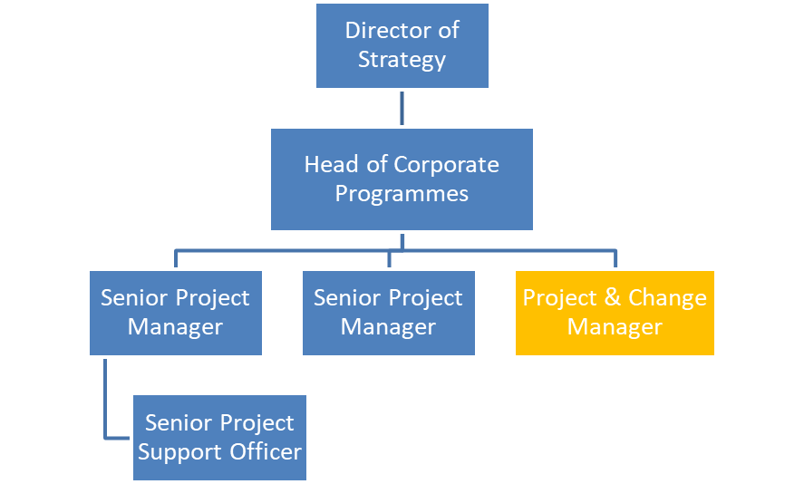

FREEDOM TO ACT
- The post holder will have significant discretion to work without reference to supervisor/line manager and take responsibility for their duties.
- The post holder will be guided by broad occupational policies and regulations and will decide on how expected results are best achieved.
COMMUNICATION/RELATIONSHIP SKILLS
- The post holder will demonstrate excellent communication skills with the ability to negotiate in complex situations at a high level across the Trust and the whole Health System. Utilise these skills to influence on quality, cost and service deliverables where there are large scale challenges.
- Establish effective communication and engagement channels to ensure all key stakeholders are aware of service improvement activities / project progress
- Ensure effective communications are in place to communicate both operational and strategic issues to all staff groups
- Engage and involve all relevant staff in the planning, implementation and evaluation of service change on a daily basis
- Effectively disseminate information to all key stakeholders ensuring that two-way feedback channels are established
- Liaise with Comms and Engagement staff where necessary to ensure effective communications plans are developed for highly political or sensitive projects

ANALYTICAL/JUDGEMENTAL SKILLS
- The post holder will be required to analyse complex performance data and trends in order to assess and interpret the impact on project plans.
- The post holder will be responsible for identifying solutions to overcome barriers to change and evidencing improved outcomes from changes implemented.
- The post holder will be responsible for determining how potential conflicting information will affect project priorities.

PLANNING/ORGANISATIONAL SKILLS
- The post holder will need to manage their own day to day activities as well as delegating and re-allocating work to team members.
- The post holder will be the lead person responsible for the planning and organising of a broad range of complex programmes which form part of the overall project plans to achieve project outcomes. The adjustments and formulation of these plans will have an impact beyond the post holders own area of work.
- Manage complex service improvement activities / projects through effective project management and appropriate documentation
- Develop an understanding of project management tools and techniques
- Work with the Project Support Officer(s) to ensure compliance with Programme / Project Governance and Management Policy
- Use a structured and standardised approach to project management and demonstrate an ability to meet deadlines
- To be aware of any implications of clinical, corporate, governance and quality assurance where service changes are proposed or implemented

PATIENT/CLIENT CARE
The post holder is required to put the patient, as the first priority, at the centre of all activities. The postholder may come into contact with patients as part of their normal duties, but not delivering direct patient care.

POLICY/CHANGE MANAGEMENT
The post holder will work within organisational policy but will also have responsibility for implementing policy and for the development of discrete policy relevant to the development and management of introducing project plans.

FINANCIAL/PHYSICAL RESOURCES
- The post holder will ensure that projects are established and managed in a financially responsible manner.
- The post holder will have financial responsibility up to their authorised limit.
- Work with finance leads to advise budget holders so they can ensure that service improvements are cost effective and financially sustainable
- Identify and record any cost and efficiency savings that can be achieved as a result of service redesign

HUMAN RESOURCES
- Collaborate with all appropriate persons involved with Change management Projects to ensure any potential HR issues relating to the work are identified and resolved with the appropriate policies
- Develop an understanding of the impact of manpower issues relating to some project work
- The post holder has day to day management responsibility for a group of staff and therefore will be involved in the management of staff issues.

INFORMATION RESOURCES
- The post holder will be responsible for maintaining project information systems and will have to collate information and opinions on project plans, gathering data in order to make decisions for the future.
- The post holder will need to input, store, modify, analyse, process and present the information.
- The post holder will develop reports based on relevant project information to use to inform key stakeholders of ongoing developments.

RESEARCH AND DEVELOPMENT
- Undertake surveys, audits, or research to support change management thinking
- Establish monitoring and evaluation systems for measuring the impact of service change

PHYSICAL SKILLS
Standard keyboard skills are required, with additional ability to operate and interact with a number of
systems at the same time.

PHYSICAL EFFORT
A combination of sitting, standing and walking with little requirement for physical effort. The post requires travelling, meetings in various venues and office based work.

MENTAL EFFORT
- There will be an occasional requirement for prolonged concentration when reading, interpreting and developing policy documents, reports and project plans.
- The post holder may be interrupted to deal with staffing or project issues.

EMOTIONAL EFFORT
There will be occasional exposure to distressing or emotional circumstances where the post holder may have to part unwelcome news to staff, or effectively influence and negotiate with stakeholders in difficult circumstances.

WORKING CONDITIONS
- Office conditions where exposure to unpleasant conditions is rare.
- VDU use ( > 1 hour daily)

OTHER RESPONSIBILITIES
Take part in regular performance appraisal.

Undertake any training required in order to maintain competency including mandatory training, e.g. Manual Handling

Contribute to and work within a safe working environment

You are expected to comply with Trust Infection Control Policies and conduct him/herself at all times in such a manner as to minimise the risk of healthcare associated infection

As an employee of the Trust, it is a contractual duty that you abide by any relevant code of professional conduct and/or practice applicable to you. A breach of this requirement may result in action being taken against you (in accordance with the Trust’s disciplinary policy) up to and including dismissal.

You must also take responsibility for your workplace health and wellbeing:
- When required, gain support from Occupational Health, Human Resources or other sources.
- Familiarise yourself with the health and wellbeing support available from policies and/or Occupational Health.
- Follow the Trust’s health and wellbeing vision of healthy body, healthy mind, healthy you.
- Undertake a Display Screen Equipment assessment (DES) if appropriate to role.

APPLICABLE TO MANAGERS ONLY
Leading the team effectively and supporting their wellbeing by:
- Championing health and wellbeing.
- Encouraging and support staff engagement in delivery of the service.
- Encouraging staff to comment on development and delivery of the service.
- Ensuring during 1:1’s / supervision with employees you always check how they are.

GENERAL
This is a description of the job as it is now. We periodically examine employees' job descriptions and update them to ensure that they reflect the job as it is then being performed, or to incorporate any changes being proposed. This procedure is conducted by the manager in consultation with the jobholder. You will, therefore, be expected to participate fully in such discussions. We aim to reach agreement on reasonable changes, but if agreement is not possible, we reserve the right to insist on changes to your job description after consultation with you.
Everyone within the Trust has a responsibility for, and is committed to, safeguarding and promoting the welfare of vulnerable adults, children and young people and for ensuring that they are protected from harm, ensuring that the Trusts Child Protection and Safeguarding Adult policies and procedures are promoted and adhered to by all members of staff.

The Royal has the opportunity to offer unique and varied careers across our services combining the RD&E’s track record of excellence in research, teaching and links to the university.
This is

PERSON SPECIFICATION

Job Title | Project & Service Change Manager

Requirements | Essential | Desirable
QUALIFICATION/ SPECIAL TRAINING  Degree qualification or equivalent experience  Masters or equivalent experience  Recognised service improvement or change management training  Project management training e.g. Prince 2 or equivalent experience  Teaching qualification or equivalent experience | X  X | X  X  X
KNOWLEDGE/SKILLS  Expertise in key and current service improvement tools and techniques  Knowledge of managing successful projects and experience delivering projects  Ability to analyse complex problems, develop and implement practical and workable solutions with a focus on outcomes  Innovative, strategic thinker - able to anticipate, problem solve and make decisions  Good understanding of strategic issues affecting the Trust, local and national health services arising from government policy  Ability to influence and negotiate across organisations constructively challenging the status quo  Excellent leadership and influencing skills, ability to enthuse, motivate and involve individuals and teams  High Level of organisational, self-motivation, flexibility in approach and attitude, and ability to think and plan creatively  Excellent people management skills, proven ability to engage, coach, mentor and motivate others  Excellent interpersonal skills, personal presentation and communication skills in complex situations  Computer literate and competent with Microsoft applications  Excellent written and verbal skills, as well as presentation, facilitation and training skills  Awareness of NHS information systems | X  X  X  X  X  X  X  X  X  X  X | X  X
EXPERIENCE  Minimum of 3 years’ experience in an operational or service improvement role within the NHS or similar industry  Experience of designing and delivering service change projects  Proven experience and success of project management  Experience in supporting and facilitating large groups via workshops and multidisciplinary meetings  Experience of working collaboratively across agencies and organisations to facilitate successful partnership working  Experience of training others in service improvement tools and techniques  Experience of carrying out audits / research  Ability to produce business cases to secure funding for improvements  Experience of producing and delivering reports explaining complex issues  Experience of producing and delivering presentations to varied audiences  Experience of coaching both individuals and larger groups  Experience of supervising/mentoring teams or staff  Basic experience of financial management | X  X  X  X  X  X  X  X | X  X  X  X  X
PERSONAL ATTRIBUTES  Proven track record as an excellent team player  Self-motivated and able to manage own work load and meet deadlines.  A flexible approach to working - self-aware and sensitive to impact on others  Sound judgemental skills and experience working with diverse groups  Commitment to improving patient services through improvement methodology / techniques while sustaining a clear approach and a focus on delivering tangible outcomes and benefits  Sense of commitment to openness, honesty and integrity in undertaking the role. | X  X  X  X  X  X
OTHER REQUIREMENTS  Car driver and use of own vehicle  Ability to occasionally work outside of office hours |  | X  X

FREQUENCY

(Rare/ Occasional/ Moderate/ Frequent)
WORKING CONDITIONS/HAZARDS |  | R | O | M | F
Hazards/ Risks requiring Immunisation Screening
Laboratory specimens | N
Contact with patients | N
Exposure Prone Procedures | N
Blood/body fluids | N
Laboratory specimens | N
Hazard/Risks requiring Respiratory Health Surveillance
Solvents (e.g. toluene, xylene, white spirit, acetone, formaldehyde and ethyl acetate) | N
Respiratory sensitisers (e.g isocyanates) | N
Chlorine based cleaning solutions  (e.g. Chlorclean, Actichlor, Tristel) | N
Animals | N
Cytotoxic drugs | N
Risks requiring Other Health Surveillance
Radiation (>6mSv) | N
Laser (Class 3R, 3B, 4) | N
Dusty environment (>4mg/m3) | N
Noise (over 80dBA) | N
Hand held vibration tools (=>2.5 m/s2) | N
Other General Hazards/ Risks
VDU use ( > 1 hour daily) | Y |  |  |  | x
Heavy manual handling (>10kg) | Y | x
Driving | N
Food handling | N
Night working | N
Electrical work | N
Physical Effort | Y | x
Mental Effort | Y |  |  |  | x
Emotional Effort | Y | x
Working in isolation | Y | x
Challenging behaviour | Y |  | x

