JOB DESCRIPTION

1. JOB DETAILS

Job Title: Private & Overseas Patient Administrator

Band: 4

Reports to: Private Healthcare Business Manager

Department / Directorate: Corporate Division

2. JOB PURPOSE

To provide a comprehensive administrative service for private patients and overseas visitors in order to support the work of the area. This will include responsibility for the invoicing of these patients and responding to queries.

The post holder will be responsible for ensuring the following:

- Private patients receive high quality, professional administration and billing.
- Private patients benefit from excellent customer service
- Invoices are accurate and raised in a timely manner
- Managing the outpatient invoicing process including raising invoices, collating information from all departments and systems, and resolving any queries from patients and insurance companies

3. DIMENSIONS/ KEY WORKING RELATIONS

Internal Working Relationships:

- Private Healthcare Business Manager
- Deputy Private Healthcare Manager
- Consultants and their private secretaries
- Private & Overseas Patient Administrators
- Senior nursing teams
- Finance department
- Site management team
- Divisional Director
- Cluster Managers

External Working Relationships:

- Self-funding and insured patients
- Overseas Visitors
- Patient’s relatives and carers
- Private Medical Insurance Companies
- Private Consulting Rooms/Hospitals
- GPs

- ORGANISATIONAL CHART:

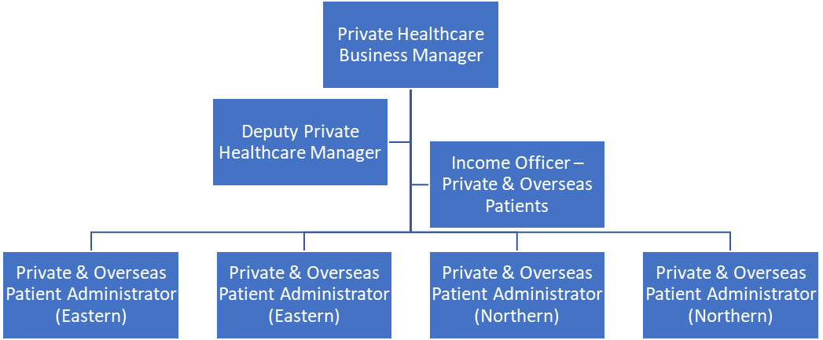

5. KEY RESULT AREAS/PRINCIPAL DUTIES AND RESPONSIBILITIES:

Principle Responsibilities:
- Support the Trust strategy for the development of Private Patient Services across the Trust.
- Support awareness of and compliance with the policy for the management of private patients within the Trust.
- Working in partnership with Private Healthcare Business Manager, Cluster Managers and Multi-Disciplinary Teams, ensure that a high-quality service and clinical excellence is delivered to private patients.
- Develop knowledge of private patient administrative procedures and specialist knowledge of private patient terminology and processes to enable initial problem solving with non-routine issues.
- Process patient records through accurately inputting financial and personal data into Trust computer systems and spreadsheets
- Support projects to improve processes and outcomes within the Private Patient service so that the services are patient centred as well as cost effective.
- Develop positive working relations with colleagues and provide support to them on Private Patient matters.
- Support the information needs of the service and ensure appropriate timely data collection occurs to support these needs.
- Ensure that billing of patients is accurate and professional every time to prevent loss of income to the Trust.
- Develop and support processes for identifying Overseas Visitors within the Trust and prevent misuse of NHS services
- Provide advice and support to Overseas Visitors, assessing their eligibility in line with current guidance, and raise invoices as required.
- Ordering stationery and other items, following Trust procedures

Relationships & Reputation Management:
- Establish and develop positive relationships with consultants and colleagues
- Provide expert advice and guidance to patients and staff about private patients and overseas visitors
- Act as a point of contact for the Service; building strong relationships with external stakeholders including insurance companies, ensuring a professional and seamless service for private patients.
- Represent the Trust at regional and national meetings as required and identify best practice from other Trusts
- Liaise with private and overseas patients with regard to costs of treatment
- Liaise with patients with regard to queries, exercise judgement when analysing and resolving problems and provide timely responses to queries

Financial Management:
- To work with consultants, Senior Management and administration teams within the Trust to ensure income capture is maximised
- To identify any changes in process that significantly affects costs and report to Private Healthcare Business Manager
- To liaise with Private Medical Insurance companies as required to obtain pre-authorisation, extend cover or prevent shortfalls in payment.
- Ensure deposits are taken for all elective procedures prior to admission
- Ensure elective overseas visitors are invoiced and have paid prior to treatment in accordance with the Charging Regulations
- Analyse, investigate and resolve financial queries and discrepancies

Governance responsibilities:
- Comply with the Trust’s Standing Financial Instructions (SFIs) and Standing Orders (SOs).
- Comply with all Trust policies and procedures.
- Convey in accordance with the Trust’s Confidentiality and Data Protection policy commercially sensitive information to Health Insurance Commissioners, Trust staff, Members of the Public, Patients and their representatives.

Operational responsibilities:
- Ensure that private patient work is booked effectively with the relevant department, including theatres, wards and clinics.
- Maintain accurate records of all private patient activity, including ensuring that all bookings are entered accurately onto Trust systems.
- Ensure the collection of all supporting data to enable invoices to be issued to Insurers and self-funded patients.
- Develop and format spreadsheets and databases as required to improve the smooth running of the service.
- Provide regular performance monitoring information and ad hoc reports as necessary.
- Develop positive working relations with clinical and non-clinical colleagues and provide high quality management support.
- Ensure that corporate image and customer care standards are developed and maintained when communicating with all customers.
- Interview overseas visitors when required and assess information provided to establish whether they are chargeable

Other Responsibilities:
- To take part in regular performance appraisal
- To undertake any training required in order to maintain competency including mandatory training, e.g. Manual Handling
- To contribute to and work within a safe working environment
- To complete staff surveys as required

The post holder is expected to comply with Trust Infection Control Policies and conduct him/herself at all times in such a manner as to minimise the risk of healthcare associated infection.

As an employee of the Trust, it is a contractual duty that you abide by any relevant code of professional conduct and/or practice applicable to you. A breach of this requirement may result in action being taken against you (in accordance with the Trust’s disciplinary policy) up to and including dismissal.

This post has been identified as involving access to vulnerable adults and/or children and in line with Trust policy successful applicants will be required to undertake a Disclosure & Barring Service Disclosure Check

GENERAL

This is a description of the job as it is now. We periodically examine employees' job descriptions and update them to ensure that they reflect the job as it is then being performed, or to incorporate any changes being proposed. This procedure is conducted by the manager in consultation with the jobholder. You will, therefore, be expected to participate fully in such discussions. We aim to reach agreement on reasonable changes, but if agreement is not possible, we reserve the right to insist on changes to your job description after consultation with you.

Everyone within the Trust has a responsibility for, and is committed to, safeguarding and promoting the welfare of vulnerable adults, children and young people and for ensuring that they are protected from harm, ensuring that the Trusts Child Protection and Safeguarding Adult policies and procedures are promoted and adhered to by all members of staff.

Northern Devon Healthcare NHS Trust and the Royal Devon and Exeter NHS Foundation Trust continue to develop our long-standing partnership with a view to becoming a single integrated organisation across Eastern and Northern Devon. Working together gives us the opportunity to offer unique and varied careers across our services combining the RD&E’s track record of excellence in research, teaching and links to the university with NDHT’s innovation and adaptability.

PERSON SPECIFICATION

POST: Private & Overseas Patient Administrator

BAND: 4

REQUIREMENTS | At  Recruitment
QUALIFICATIONS / TRAINING  Minimum GCSE (or equivalent) grade A-C in English and Mathematics  Educated to ‘A’ Level standard or equivalent  NVQ Level 3 in Business Administration or equivalent  Evidence of continuous professional development | E  E  E  E
KNOWLEDGE / SKILLS  In depth knowledge of NHS and Private Healthcare  Awareness and understanding of Overseas Visitors Charging Regulations  Good organisational skills and attention to detail  Ability to collate and review information  Has good insight and the ability to respond well to constructive criticism  Working knowledge of healthcare service delivery issues  Excellent interpersonal, communication and people skills  Competent IT skills including Word, Excel, PowerPoint, databases and e-mail.  Ability to manage own time and meet deadlines  Good report writing/written communication skills  Excellent telephone manner  High levels of accuracy  Ability to cope with interruptions and resume work without issue  Ability to handle complex enquiries from patients, some of whom may be distressed and anxious about their care  Able to work independently and with minimum supervision | D  D  E  E  D  E  E  E  E  E  E  E  E  E  E
EXPERIENCE  Experience of working within a Private Hospital  NHS Private Patient experience  Experience of working with Overseas Visitors  Experience of supporting and implementing change management, including service improvement and redesign  Experience of advising other staff at a more senior level than the post holder  Experience of working in a finance-based environment, including preparation of invoices | D  D  D  D  D  D
PERSONAL ATTRIBUTES  Remain calm in stressful situations  Demonstrates ambition and clear personal career planning  High levels of initiative and determination demonstrated by ability to identify problems and troubleshoot  Ability to manage the impact of competing pressures and conflicting priorities  Confident and assertive while maintaining interpersonal sensitivity  Customer focussed | E  E  E  E  E  E
OTHER REQUIREMENTS:

* Essential/Desirable

HAZARDS:- Updated 31st May 2013
Laboratory Specimens |  | Clinical contact with Patients |  | Dealing with violence & aggression of patients/relatives | X
Blood / Body Fluids |  | Dusty Environment |  | VDU Use (occasional) | X
Radiation / Lasers |  | Challenging Behaviour | X | Manual Handling | X
Solvents |  | Driving |  | Noise / Vibration
Respiratory Sensitisers |  | Food Handling |  | Working in isolation
Cytotoxic Drugs |  | Electrical work |  | Night Working

COMPETENCY REQUIREMENTS
To be completed for all new positions. It is essential that we keep accurate up to date information on the essential training requirements of the role. Please tick which of these essential learning s is applicable to this role, this will be required to update ESR.(NB those that are mandatory for all staff with no variation on frequency are pre-populated with a tick)
Safeguarding Children | Group 1 |  | Blood Transfusion |  | BDS18 collection | □ | Consent Training | □
 | Group 2 | □ |  |  | BDS 19 & 20  Preparing & Administering | □ | VTE Training | □
 | Group 3 | □ |  |  | BDS 17 Receipting | □ | Record management and the nhs code of practice | □
 | Group 4 | □ |  |  | Obtaining a blood sample for transfusion | □ | The importance of good clinical record keeping | □
 | Group 5 | □ |  |  | Annual Update | □ | Antimicrobial Prudent Prescribing | □
 | Group 6 | □ |  |  |  |  | Control & Restraint Annual | □
Not mapped this one |  | □ | Safeguarding Adults Awareness |  | Clinical Staff | □ | Mental Capacity/DOL’s | □
 | Group 8 | □ |  |  | Non Clinical Staff | 
Manual Handling – Two Year |  | ☑ | Falls, slips, trips & falls |  | Patients | □
Equality & Diversity – One-Off requirement |  | ☑ |  |  | Staff/Others | 
Fire | Annual | □ | Investigations of incidents, complaints and claims |  |  | □
 | Two Yearly |  | Conflict Resolution – 3 yearly |  |  | 
Infection Control/Hand Hygiene | Annual requirement | □ | Waterlow |  |  | □
 | One-Off requirement |  | PUCLAS |  |  | □
Information Governance |  | ☑ | Clinical Waste Management | Application principles for clinical staff |  | □
Harassment & Bullying (Self Declaration – One off requirement) |  | ☑ | Clinical Waste Management | Application principles for housekeeping |  | □
 |  |  | Clinical Waste Management | Application principles for portering and waste |  | □

