
JOB DESCRIPTION

This post has been identified as involving access to vulnerable adults and/or children and in line with Trust policy successful applicants will be required to undertake an Enhanced Disclosure Check.

The Trust is committed to recruiting and supporting a diverse workforce and so we welcome applications from all sections of the community, regardless of age, disability, gender, race, religion, sexual orientation, maternity/pregnancy, marriage/civil partnership or transgender status. The Trust expects all staff to behave in a way which recognises and respects this diversity, in line with the appropriate standards.

1. JOB DETAILS

Job Title: Senior Clinical Scientist (Clinical Chemistry)

Band: Band 7

Reports to: Consultant Clinical Scientist

Department / Directorate: Specialist Services / Diagnostics

2. JOB PURPOSE

To provide a comprehensive, high-quality, efficient and cost-effective, scientific, clinical technical and clinical advisory biochemistry service, as an independent advanced practitioner, under the overall direction of the Consultant Clinical Scientist and Laboratory Director.

To maintain an area of highly specialised knowledge and take responsibility for the provision of scientific services in that area, acting as an expert in that field.

Main duties include research and development, clinical liaison, result interpretation, development of policies and procedures, performance monitoring and external quality assurance, method and equipment evaluation, training of technical, nursing and medical staff.

3. DIMENSIONS/ KEY WORKING RELATIONS

- Clinical Heads of Department – Clinical Chemistry & Haematology.
- Clinical Lead for Pathology
- Blood Sciences Laboratory Manager
- Cluster Manager Diagnostic Services
- Associate Medical Director, Specialist Services
- Divisional Director, Specialist Services
- Business Manager, Specialist Services
- Clinical Scientists
- Senior Technical and Scientific Staff
- Departmental Technical, Scientific and Administrative Staff
- Medical / Nursing Staff
- Senior Trust Management.
- Primary Care Practitioners
- Care Commissioning Groups
- Specialist Commissioning Groups
- External NHS agencies.
- Members of the Public.
- Private Healthcare Sector
- In-Vitro Diagnostics Industry
- Peninsula Purchasing and Supply Alliance

The services carry out a full range of both routine and specialised automated and manual analyses for the Trust Community and tertiary referred populations.

The combined budget of Blood Sciences has a current value of £10.2 million.

The services generate £900K income, from none-core externally referred activity.

The Department manages the combined Chemistry / Haematology sample reception and associated data processing involving more than 700,000 patient requests per annum.

The Department produces approximately 6 million test results per annum.

The Departments employ 85 members of staff.

The Departments provides a full Clinical Chemistry, Haematology, Immunology and Blood Transfusion analytical service on a 24/7 basis.

The Department provides the 7 day a week, Trust wide Phlebotomy service.

The Department is responsible for the provision of a pre-natal Down’s and Sickle Cell Screening service to the local Trust and eight other Trusts across the South of England.

The Department manages a number of Critical Care Blood Gas analysers in satellite laboratory placements across emergency areas within the Trust.

The Department manages the Trust Point of Care Testing (POCT) quality management programme for all Trust point of care activity.

The Department provides a full analytical service supporting the Trust R&D department.

The Department provides a managed Central Laboratory service for a number of National and Pan European R&D studies.

The Department provides an extensive tertiary referral service to several other Trusts.

A full clinical interpretive service is offered.

- ORGANISATIONAL CHART:

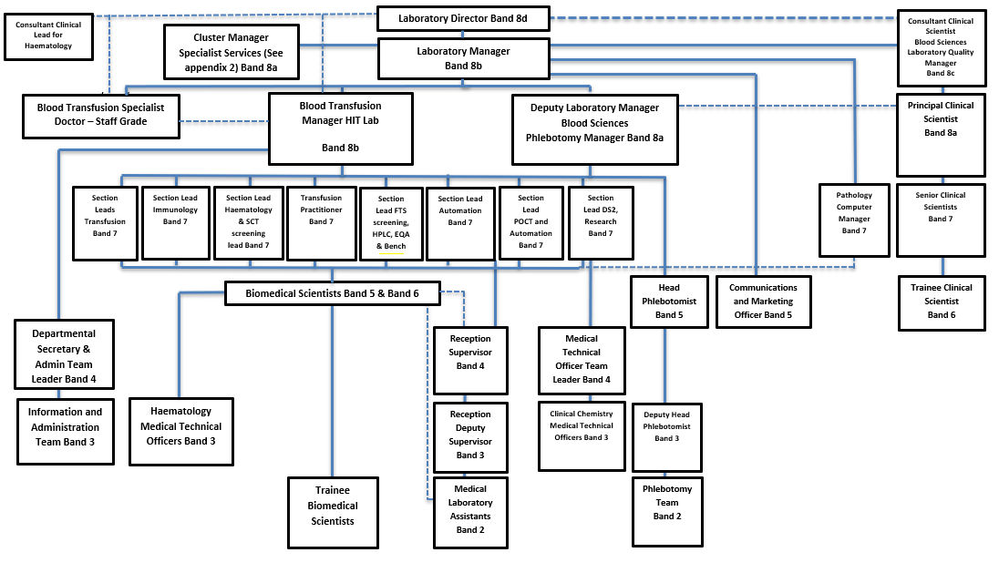

5. KEY RESULT AREAS/PRINCIPAL DUTIES AND RESPONSIBILITIES:

As a Senior Clinical Scientist in an independent practitioner role –

- To provide effective delivery of a comprehensive, efficient and effective Clinical Biochemistry service.
- Take a Clinical and Scientific lead role in a particular area of the laboratory commensurate with departmental needs and post holder’s expertise.
- To be aware of and contribute to the strategic planning for the future provision of the Clinical Biochemistry and Blood Sciences service in keeping with the needs of the Trust, health commissioners and patient needs.
- Contribute to training of all trainee Clinical Scientists within the department and contribute to the organisation, delivery and supervision of teaching and training of the scientific and technical staff of the laboratory and of other health care professional as required.
- To contribute to the development of the service on an ongoing basis by the evaluation and introduction of appropriate new technologies.

CLINICAL

- To offer clinical guidance and scientific advice to hospital clinicians and General Practitioners on the selection, performance and interpretation of tests in order to facilitate the diagnosis, treatment, monitoring and understanding of disease in individual patients and groups of patients.
- To participate in the rota for the clinical validation of reports. To ensure analytical correctness determining the reason for incorrect results; by interpreting highly complex sets of results in the light of patient’s clinical details and general clinical knowledge, by adding written comments on differential diagnoses, adding additional tests and recommending further investigations.
- To independently discuss, advise and challenge clinicians, including senior medical staff, on the highly complex interpretation of biochemistry investigations e.g. advising on differential diagnoses, monitoring and therapy changes.
- To assess and approve or decline requests for complex and expensive investigations referred to other centres. To interpret such results when they are returned, taking into account the clinical information and other laboratory results.
- To develop close professional links with the clinical users of the service, by initiating joint clinical meetings and attending other meetings as required.
- To ensure collaboration with users of the service in order to promote and maintain an efficient, responsive and cost-effective Biochemistry service. To initiate changes in laboratory and hospital policies to achieve cost-effectiveness and compliance with external guidance (e.g. NSFs, NICE)
- To contribute to the selection of instrumentation and analytical methods used within the Department and to ensure that they are fully evaluated and scientifically validated, before being adopted for routine use.
- To maintain an up to date knowledge of the analytical methods used in the Department, their limitations, sources of interference or error.
- To provide advice and guidance to all Biomedical Scientist staff on appropriate action to be taken in implementing and investigating problems with analytical procedures throughout the department.
- To utilize highly complex and specialised deductive skills to troubleshoot analytical procedures where problems occur.

Research & Development
- To undertake relevant R&D projects that will further the Departments reputation and commitment to clinical excellence. Where appropriate, oversee the introduction of R&D techniques into routine use.
- Write up results of own research as academic posters, presentations and peer reviewed papers, to be delivered to a range of audiences.
- To work in close collaboration with the Laboratory Manager and R&D lead to plan, cost and put into practice R&D projects.
- To write R&D proposals for internal, Trustwide, commercial and external projects. These must include all financial, scientific and logistical considerations.
- For own projects and those of collaborators, analyse and interpret the results of research, draw conclusions and generate original ideas based on outcomes.

Professional
- To maintain an up-to-date very high level of analytical and clinical knowledge in all areas of clinical biochemistry. This includes scrutiny and evaluation of original research literature.
- To participate in continuing professional development activities and to keep appropriate records of these activities in order to achieve the above.
- To maintain professional registration with the Health and Care Professions Council
- Make presentations as required at local, regional, national and international conferences and similar events.

Teaching and Learning Support
- Contribute to the Clinical Scientist training programme in the department and supervise trainee programme
- Contribute to teaching within the Peninsula Medical School.
- Design and deliver a Study Support Unit (SSU) for the Peninsula Medical School.
- Be involved in the assessment of student knowledge and assist in the supervision of student projects.
- Present information on research progress and outcomes to bodies supervising research, eg steering groups.

Other Responsibilities:

To take part in regular performance appraisal

To undertake any training required in order to maintain competency including mandatory training, i.e. Fire, Manual Handling

To contribute to and work within a safe working environment

The post holder is expected to comply with Trust Infection Control Policies and conduct him/herself at all times in such a manner as to minimise the risk of healthcare associated infection

THE TRUST - PURPOSE AND VALUES

We are committed to serving our community by being a high quality specialist Hospital with consultant-led services. We aim to co-ordinate our services with primary and community care, and to develop a limited number as Sub-Regional Referral Centres with appropriate levels of research, development and educational involvement. Where appropriate, and consistent with our services, we may provide services aimed at preventing disease and debilitation.

We aim to make all our services exemplary in both clinical and operational aspects. We will show leadership in identifying healthcare needs to which we can respond and in determining the most cost-effective way of doing so. We will share our knowledge with neighbouring healthcare agencies and professionals.

We recruit competent staff whom we support in maintaining and extending their skills in accordance with the needs of the people we serve. We will pay staff fairly and recognise the whole staff’s commitment to meeting the needs of our patients.

We are committed to equal opportunity for all and encourage flexible working arrangements including job sharing.

The Trust is committed to recruiting and supporting a diverse workforce and so we welcome applications from all sections of the community, regardless of age, disability, sex, race, religion, sexual orientation, maternity/pregnancy, marriage/civil partnership or transgender status The Trust expects all staff to behave in a way which recognises and respects this diversity, in line with the appropriate standards.

GENERAL

This is a description of the job as it is now. We periodically examine employees' job descriptions and update them to ensure that they reflect the job as it is then being performed, or to incorporate any changes being proposed. This procedure is conducted by the Manager in consultation with the jobholder. You will, therefore, be expected to participate fully in such discussions. We aim to reach agreement on reasonable changes, but if agreement is not possible, the Trust reserves the right to insist on changes to your job description after consultation with you.

The RD&E is a totally smoke-free Trust. Smoking is not permitted anywhere on Trust property, including all buildings, grounds and car parks. For help to quit call 01392 207462.

As an employee of the Trust, it is a contractual duty that you abide by any relevant code of professional conduct and/or practice applicable to you. A breach of this requirement may result in action being taken against you (in accordance with the Trust’s disciplinary policy) up to and including dismissal.

The post holder is expected to comply with Trust Infection Control Policies and conduct him/her at all times in such a manner as to minimise the risk of healthcare associated infection.

PERSON SPECIFICATION
POST: Senior Clinical Scientist
BAND: 7
REQUIREMENTS | At  Recruitment | At 2nd KSF  Gateway
QUALIFICATIONS / TRAINING  - HCPC State Registration as a Clinical Scientist  - Masters Degree or assessed equivalent level of knowledge and expertise in the speciality of Clinical Chemistry.  - Part 1 Examination for Membership of Royal College of Pathologists.  - OR relevant PhD | E  E  D  D | E  E  E  E
KNOWLEDGE / SKILLS  - In depth theoretical knowledge of Clinical Chemistry.  - To have a thorough scientific and clinical knowledge of all aspects of human biochemistry.  - Excellent oral and written communication and presentation skills.  - Excellent teaching skills.  - Highly developed analytical (technical) skills in Clinical Chemistry.  - Well-developed deductive and intuitive abilities  - Proven track record in leading on service development and delivery in a specialist area  - Able to advise clinicians on investigation and interpretation of biochemical and metabolic processes in complex situations also utilising data from other specialities.  - To have an extensive knowledge of routine and specialised analytical methods, quality assurance and problem solving. | E  E  E  E  E  E  E  E  E | E  E  E  E  E  E  E  E  E
EXPERIENCE  - Experience of working as part of a large analytical team in a busy environment  - Experience of delivering teaching to clinicians, Medical Students and Healthcare Professionals  - To have developed an expertise in one or more specialised analytical or clinical areas.  - Strong evidence of personnel management experience. | D  D  D  D | E  E  E  E
PERSONAL ATTRIBUTES  - Demonstration of Continuing Professional Development at agreed level of participation  - Smart appearance and professional attitude  - Ability to act on own initiative  - Ability to supervise a team  - Able to establish and maintain effective networks with professional, clinical and managerial colleagues both within the Trust and in the wider scientific and medical network  - Able to develop and take responsibility for professional guidelines and policies impacting across the Trust and Health Community.  - Able to develop and take responsibility for professional guidelines and policies impacting across the Trust and Health Community.  - Strong motivational skills | E  E  E  E  E  E  E  E | E  E  E  E  E  E  E  E
OTHER REQUIREMENTS  - Enthusiasm and willingness to actively help develop the Department of Blood Sciences | E | E
* Essential/Desirable

HAZARDS IDENTIFIED (tick as appropriate):
Laboratory specimens  Proteinacious Dusts | x | Clinical contact with  patients |  | Performing Exposure  Prone Invasive Procedures
Blood / Body Fluids | x | Dusty environment |  | VDU use | x
Radiation |  | Challenging Behaviour |  | Manual handling
Solvents | x | Driving |  | Noise
Respiratory Sensitisers |  | Food handling |  | Working in isolation

