

JOB DESCRIPTION

JOB DETAILS
Job Title | Post grad  Trainee Biomedical Scientist (Blood Sciences)
Reports to | Senior Biomedical Scientists
Band | AfC Band 5, Annex 21
Department/Directorate | Pathology, Scheduled Care, Diagnostics

Job Purpose:
To contribute to the provision of a high quality, accurate and timely diagnostic service for the Blood Sciences departments (Biochemistry, Haematology and Blood Transfusion). Service is provided 24 hours per day, 7 days per week.

The post holder will be appointed at Band 5 Annex 21.

The post is a fixed term for the duration of the training to achieve HCPC registration. There will be regular review of training progress during the contract and if the post holder does not progress as required, completing and passing the necessary courses (BSc Biomedical Science modules through distance learning, IBMS registration portfolio to be on course to attain the required qualification and HCPC registration), the contract will be terminated.

It is anticipated but not guaranteed that there will be a band 5 HCPC registered post as a cross disciplinary trained BMS upon attainment of HCPC registration. Where a post is not available the post holder, subject to the agreement by the Pathology Service Manager, the fixed term may be extended with the post holder remaining at Band 5 Annex 21 until such time as a post becomes available.

KEY RESULT AREAS/PRINCIPAL DUTIES AND RESPONSIBILITIES
To work towards achieving best possible results in degree modules, if relevant for the role

To complete registration portfolio (including a work-based project) at the same time as degree modules, if degree is not completed

To undertake work-based training in all areas of Blood Sciences until assessed and signed as competent

KEY WORKING RELATIONSHIPS

The post holder will provide, prepare and receive information verbally, in writing and electronically which is required by work colleagues, users of the service e.g.

- Medical staff

- Nursing staff

- Consultant staff

- Other Trust departments staff
- Clinical Service Managers and the general public.

The post holder is required to deal effectively with staff of all levels throughout the Trust, the wider Healthcare community, external organisations and the public. This will include verbal, written and electronic media.

ORGANISATIONAL CHART
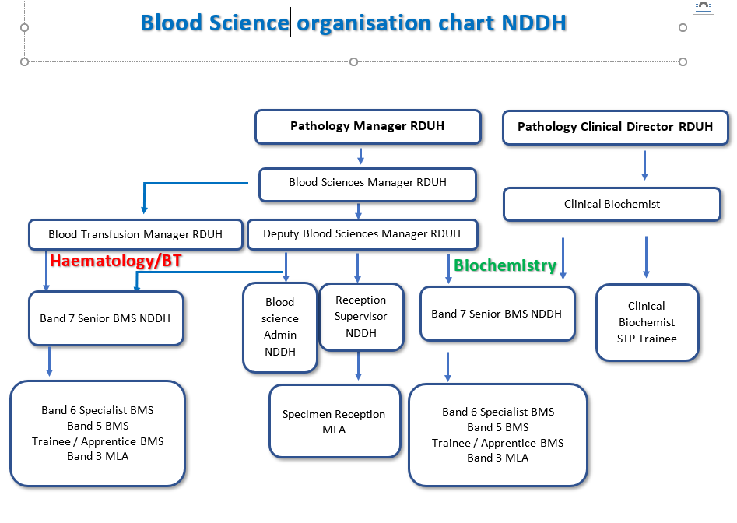

FREEDOM TO ACT
To plan and prioritise routine, urgent and emergency specimen analysis on a day to day basis

Work with supervision before achieving competencies. To ask for advice where necessary

Works autonomously within defined field of competence following operating procedures and protocols

To respond to unpredictable events which require work patterns to be changed a short notice

COMMUNICATION/RELATIONSHIP SKILLS

Reports to and is managed by the laboratory manager

Works under the guidance of competent biomedical scientists BMS and discipline-specific training officers

Uses all available methods of communication effectively, clearly and politely

An awareness of own limitations whilst undergoing training and where to seek help/advice

Deals with enquiries from clinical and non-clinical staff, patients and others, and gives results to laboratory users and other advice as appropriate and trained

Answering the telephone and dealing with callers’ requests/questions appropriately

Consultation with senior staff / consultant haematologists/principal biochemist as required about actions required during troubleshooting process.

To take part in-house and external training as required

To work with colleagues and senior staff to maintain an up to date, high quality service

The post holder will contribute towards the integrity and reputation of the department by effective and harmonious relationships with patients, colleagues and hospital personnel

ANALYTICAL/JUDGEMENTAL SKILLS
To train and became competent to
- analyse specimens of bodily fluids and solids for their chemical/biochemical composition and identification of microorganisms.
- perform work of a technical nature as per training plan to achieve HCPC registration and bench competency.
- prepare a wide range of stains, buffers and other laboratory chemicals from raw ingredients using precision weighing and measuring techniques to ensure optimal performance of tests performed with them
- operate and maintain a wide range of non-analytical equipment, including centrifuges, weighing balances and microscopes.

- perform manual and automated diagnostic tests on patients’ specimens using a wide variety of manual and automated techniques - some highly specialised - and entering results into computer system
- follow suitable training and competency assessment,
- judge whether the results fall within accepted reference ranges, needs to be referred to senior colleagues, or be referred urgently to requesting clinicians and whether further testing needs to be initiated
- check and validate quality control performance for all tests both automated and manual
- ensure that all results produced are accurate and precise

- perform final validation and reporting, both paper and electronically, results for investigations to hospital doctors, wards and units as well as General Practitioners and midwives

- discuss all types of results with doctors/nurses after competency completed

PLANNING/ORGANISATIONAL SKILLS
Assists in the day to day organisation of all aspects of routine work

Assists and performs MLA duties as required

Works within the responsibilities given by the Health and Safety at Work Act (1974) to ensure that agreed safety procedures are carried out to maintain a safe environment for self, colleagues and visitors

Ensures safe practice to minimise the risks of infection to patients and staff in accordance with national and Trust policy, in particular to be aware of their responsibilities as listed in the Infection Control Operational Policy

Under supervision to provide day to day operation of analysers including clinical chemistry analysers, cell counters, coagulation analysers, and blood grouping analysers – including maintenance, calibration, checking, troubleshooting and repair

Monitoring and maintaining adequate stocks of blood, all blood products and reagents required for analyses.

RESPONSIBILITY FOR PATIENT/CLIENT CARE
The quality and accuracy of your work impacts on results and therefore impacts directly on patient care.

POLICY/SERVICE DEVELOPMENT
The post holder has no direct responsibility for policy and service development

Follows laboratory policies, may comment on proposals for change/proposes changes to SOPs

Works with senior staff and consultants to maintain an up to date, high quality service

There is a requirement to be involved in the scheduled audit of the service for the duties contained within this job description

Under the direction of senior staff works to ensure department complies with the requirements of ISO15189:2012

Following set laboratory procedures and applying mandatory professional and accreditation standards at all times and for all tasks

Rotation around routine and specialised sections within Blood Sciences as delegated by Senior BMS

FINANCIAL/PHYSICAL RESOURCES
Safe use of equipment, other than equipment used personally; safe use of expensive or highly complex equipment

Sets up equipment for others to use, uses expensive equipment for analysis work

Helps maintain adequate stocks of consumables and testing kits including gloves, glassware, testing kits, reagents and chemicals and ensuring that stock is requisitioned when needed. Ensures senior staff are alerted to order items as required

Keeping accurate logs of all materials received and used – what, when, where and by whom

Keeping associated maintenance and reagent logs and records

HUMAN RESOURCES
Assists medical support workers and students in areas where trained and competent

Attendance at statutory fire/health and safety/manual handling training

Attendance of training as identified and agreed at yearly development and review interviews

Works to improve professional and technical skills by attending appropriate courses, meetings and conferences as agreed through the D&R process of continuous professional development

Takes part in and contributes to laboratory meetings and education sessions

Takes part in an annual joint review (appraisal) with designated senior member of staff

INFORMATION RESOURCES
To use the laboratory computer in accordance with Trust policies in the provision of information to appropriate persons

To observe the strictest confidence regarding all information to which there is access within the Royal Devon University Healthcare NHS Foundation Trust by working in accordance with the data protection act and Trust policy on information governance

To enter requests for specimen testing. To enter patient identification data and results into the laboratory computer for storage and printing of results

RESEARCH AND DEVELOPMENT
Occasionally participate in R&D; to prepare samples for clinical trials; equipment testing/adaptation

Assisting with any data collection required for audits

Maintenance of fully traceable and auditable records for all blood and blood products kept and transfused

PHYSICAL SKILLS
Highly developed physical skills, accuracy important; manipulation of fine tools, materials and complex machinery

Hand-eye co-ordination and accuracy required when performing tests; scalpels and needles used to process certain specimens

Receipt, checking and barcode-labelling of incoming patient blood specimens’ quality and labelling accuracy and ensuring that urgent specimens are dealt with promptly

PHYSICAL EFFORT
Sitting, standing in restricted position; frequent light effort for several short periods per shift; occasional moderate effort for several short periods per shift

Sitting at microscope for long periods, repetitive movements processing specimens, bending and lifting supplies, use of trolleys

Level of physical fitness to allow manual dexterity, low risk manual handling and good hand-eye co-ordination

Working rapidly at busy times

MENTAL EFFORT
Frequent prolonged concentration

Concentration required for tasks such as microscope work and electrophoresis

High level of concentration required for specimen checking, testing and performing a widely variable range of diagnostic tests and tasks, some highly complex and specialised, and computer data input for prolonged periods

Working accurately at all times, especially under pressure at busy times

Coping with frequent interruption

EMOTIONAL EFFORT
Exposure to distressing or emotional circumstances is rare

Limited contact with patients and clients

Awareness of necessity for absolute confidentiality
Clear communication of detailed and sensitive information following training and competency assessment to users, patients and colleagues

WORKING CONDITIONS
Frequent unpleasant conditions
Exposure to contained or controlled infectious materials, body fluids and chemicals of varying hazard
Risk of exposure to uncontained hazards e.g. spillage of harmful chemicals
Coping with high temperatures and some noise
Use of Display Screens (VDU)
Use of PPE as required
OTHER RESPONSIBILITIES
Take part in regular performance appraisal.

Undertake any training required in order to maintain competency including mandatory training, e.g. Manual Handling

Contribute to and work within a safe working environment

You are expected to comply with Trust Infection Control Policies and conduct him/herself at all times in such a manner as to minimise the risk of healthcare associated infection

As an employee of the Trust, it is a contractual duty that you abide by any relevant code of professional conduct and/or practice applicable to you. A breach of this requirement may result in action being taken against you (in accordance with the Trust’s disciplinary policy) up to and including dismissal.

You must also take responsibility for your workplace health and wellbeing:
- When required, gain support from Occupational Health, Human Resources or other sources.
- Familiarise yourself with the health and wellbeing support available from policies and/or Occupational Health.
- Follow the Trust’s health and wellbeing vision of healthy body, healthy mind, healthy you.
- Undertake a Display Screen Equipment assessment (DES) if appropriate to role.

GENERAL
This is a description of the job as it is at present constituted. It is the practice of this organisation periodically to examine employees' job descriptions and to update them to ensure that they relate to the job as then being performed, or to incorporate whatever changes are being proposed. This procedure is jointly conducted by each manager in consultation with those working directly to him or her. You will, therefore, be expected to participate fully in such discussions. It is the organisations' aim to reach agreement to reasonable changes, but if agreement is not possible management reserves the right to insist on changes to your job description after consultation with you.

We are committed to serving our community. We aim to co-ordinate our services with secondary and acute care.

We aim to make all our services exemplary in both clinical and operational aspects. We will show leadership in identifying healthcare needs to which we can respond and in determining the most cost-effective way of doing so. We will share our knowledge with neighbouring healthcare agencies and professionals.

We recruit competent staff whom we support in maintaining and extending their skills in accordance with the needs of the people we serve. We will pay staff fairly and recognise the whole staff’s commitment to meeting the needs of our patients.

The Trust operates a 'non-smoking' policy. Employees are not able to smoke anywhere within the premises of the Trust or when outside on official business.

All employees must demonstrate a positive attitude to Trust equality policies and Equality Scheme. Employees must not discriminate on the grounds of sex, colour, race, ethnic or national beliefs, marital status, age, disability, sexual orientation, religion or belief and will treat patients, colleagues and members of the public with dignity and respect.

If the post holder is required to travel to meet the needs of the job, we will make reasonable adjustments, if required, as defined by the Equality Act 2010.

SAFEGUARDING
To be fully aware of and understand the duties and responsibilities arising from the Children’s Act 2004 and Working Together in relation to child protection and safeguarding children and young people as this applies to the worker’s role within the organisation.
To also be fully aware of the principles of safeguarding as they apply to vulnerable adults in relation to the worker’s role, which will include recognising the types and signs of abuse and neglect and ensuring that the worker’s line manager is made aware and kept fully informed of any concerns which the worker may have in relation to safeguarding adults and/or child protection.
Everyone within the Trust has a responsibility for, and is committed to, safeguarding and promoting the welfare of vulnerable adults, children and young people and for ensuring that they are protected from harm, ensuring that the Trusts Child Protection and Safeguarding Adult policies and procedures are promoted and adhered to by all members of staff.

HEALTH AND SAFETY AT WORK
The employer will take all reasonably practical steps to ensure your health, safety and welfare while at work. You must familiarise yourself with the employer's Health & Safety policy, and its safety and fire rules. It is your legal duty to take care for your own health and safety as well as that of your colleagues.

INFECTION CONTROL – ROLE OF ALL STAFF
It is the responsibility of all members of staff to provide a high standard of care to patients they are involved with. This includes good infection prevention practice.

All staff have a responsibility to comply with Infection Prevention and Control policies and procedures, this includes:
- Attending mandatory and role specific infection prevention education and training.
- Challenging poor infection prevention and control practices.
- Ensuring their own compliance with Trust Infection Prevention and Control policies and procedures for example, standard precautions, hand hygiene, prevention & management of inoculation incidents

CONFIDENTIALITY
You may not disclose any information of a confidential nature relating to the employer or in respect of which the employer has an obligation of confidence to any third party other than where you are obliged to disclose such information in the proper course of your employment or as required by law. Any failure to comply with this term of your employment will be treated as an act of misconduct under the employer's disciplinary procedure.

PERSON SPECIFICATION

Job Title | Trainee Biomedical Scientist (Blood Sciences)-post grad

Requirements | Essential | Desirable
QUALIFICATION/ SPECIAL TRAINING  IBMS Accredited degree completed  Other specific training required in a medical laboratory | E  D
KNOWLEDGE/SKILLS  Basic knowledge in the disciplines of Biochemistry and Haematology / Blood Transfusion.  Awareness of analytical instrumentation operation and trouble-shooting  IT usage, both PC and mainframe as currently used  Workload planning skills  Good interpersonal skills  Knowledge of Health and Safety and COSHH requirements  Knowledge of quality assurance procedures  Good communication skills verbal and electronic/paper, as well as using a range of tools/media  Ability to work both in a team and under own initiative  Ability to produce consistently high standards of work and to suggest improvements where needed  Ability to adapt to changes in methodologies technology, processes, any work variable  Awareness of need for Continuing Professional Development (CPD) | D  D  D  E  E  E  D  E  E  E  E  E
EXPERIENCE  NHS laboratory experience | D
PERSONAL ATTRIBUTES  Is of smart and tidy appearance at all times  Able to work as a team member  Good interpersonal skills  Good communication skills using a range of media | E  E  E  E
OTHER REQUIREMENTS  The post holder must demonstrate a positive commitment to uphold diversity and equality policies approved by the Trust.  Ability to travel to other locations as required | E  E

Complete the table below as appropriate
FREQUENCY

(Rare/ Occasional/ Moderate/ Frequent)
WORKING CONDITIONS/HAZARDS |  | R | O | M | F
Hazards/ Risks requiring Immunisation Screening
Laboratory specimens | Y/N |  |  |  | Y
Contact with patients | Y/N
Exposure Prone Procedures | Y/N
Blood/body fluids | Y/N |  |  |  | Y
Hazard/Risks requiring Respiratory Health Surveillance
Solvents (e.g. toluene, xylene, white spirit, acetone, formaldehyde and ethyl acetate) | Y/N |  |  |  | Y
Respiratory sensitisers (e.g isocyanates) | Y/N
Chlorine based cleaning solutions  (e.g. Chlorclean, Actichlor, Tristel) | Y/N |  |  |  | Y
Animals | Y/N
Cytotoxic drugs | Y/N
Risks requiring Other Health Surveillance
Radiation (>6mSv) | Y/N
Laser (Class 3R, 3B, 4) | Y/N
Dusty environment (>4mg/m3) | Y/N
Noise (over 80dBA) | Y/N |  |  |  | Y
Hand held vibration tools (=>2.5 m/s2) | Y/N
Other General Hazards/ Risks
VDU use ( > 1 hour daily) | Y/N |  |  |  | Y
Heavy manual handling (>10kg) | Y/N |  |  | Y
Driving | Y/N
Food handling | Y/N
Night working | Y/N
Electrical work | Y/N
Physical Effort | Y/N |  |  | Y
Mental Effort | Y/N |  |  |  | Y
Emotional Effort | Y/N |  |  |  | Y
Working in isolation | Y/N
Challenging behaviour | Y/N

