JOB DESCRIPTION

1. JOB DETAILS

Job Title: Administration Officer – EPIC Training

Band: Band 4

Reports to: EPIC Training Manager

Department / Directorate: People and Culture, EPIC Programme

2. JOB PURPOSE

Responsible for providing coordinated administration and clerical support for the EPIC Training team who are responsible for scheduling, planning, coordinating and delivering the Epic application training to RDUH Trust Staff.

To be the key contact within the Training Team, for Trust wide managers and staff, answering queries and offering advice and guidance with regards to EPIC development and training curriculum

Lead on specific engagement activities, as directed by the Training Manager, core to the promotion of EPIC Training opportunities.

3. DIMENSIONS/ KEY WORKING RELATIONS

The post-holder will be a member of the EPIC Training Team, working across the RD&E sites.

Key working relationships

The jobholder will need to forge effective working relationships with staff at all levels across the Trust.
Of particular importance is the need to establish effective working relationships with:

Internal to the Trust | External to the Trust
- All managers and staff  - Clinical and non-clinical staff  - RD&E Talent and Learning Team  - Procurement  - Estates and Facilities team  - Communications and Engagement  - EPIC Programme Implementation Team | - Students  - Other NHS organisations  - Epic application experts and implementation team other suppliers of goods or services to the EPIC training team  - Colleagues in other NHS and Social Care organisations

- ORGANISATIONAL CHART:

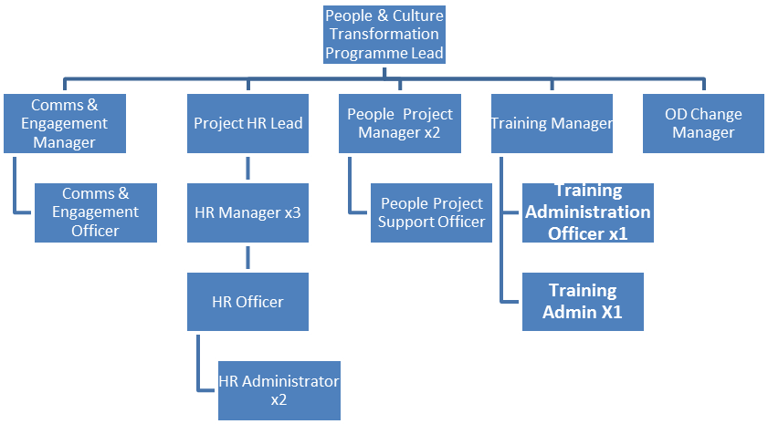

5. KEY RESULT AREAS/PRINCIPAL DUTIES AND RESPONSIBILITIES:

Communication
- Work with the EPIC Training Team to ensure that there is effective communication of plans and resource (training facilities, trainers and materials) availability;
- Ensure that there is a published and up to date programme of activities and training availability;
- Key contact for Training queries across the Trust advising on EPIC training curriculum and answering any queries
- Provide telephone support and face to face meetings with Trust staff, communities, programme team members and 3rd party providers.
- Liaise with EPIC Programme staff to ensure that all enquiries related to training are documented effectively and responded to in a timely manner;
- Ensure that any issues that cannot be resolved are escalated to the appropriate EPIC Programme teams;
- Attend various meetings as required as part of the EPIC Training Team, providing administrative support to senior managers within the EPIC Programme including attendance at meetings to document action plans
- Lead on specific engagement activities, as directed by the Training Manager, core to the promotion of Training opportunities in line with EPIC training curriculum.
- Negotiate with and persuade Programme staff on the use of Training resources; identifying those who have priority.

Analysis and judgement
- Prepare and present analysis of training delivery and raise any risks or issues highlighted through testing to the appropriate level;
- Preparation of complex data, including reports in evidence to support EPIC training activities
- Monitor capacity and demand for learning placements identifying and reporting where specific programmes need additional placements
- Production of reports for discussion to shape the delivery offered to meet demand
- Investigate issues raised and document these for the EPIC Training manager
- Log issues as they arise and update administration systems accordingly;
- Manage calendars and schedules for the EPIC Training Team;
- Resolving conflicting diary appointments and schedules.

Planning
- Be responsible for own area of work, working autonomously to plan and organise workload to meet multiple and often conflicting deadlines;
- Assist the EPIC Training Manager in the production and updating of the EPIC Training strategy and EPIC Training Plan;
- Plan and deliver one off projects, including the gathering of views from a number of internal and external stakeholders
- Management, planning of the EPIC Training events calendar & promotion of trust wide EPIC training
- Chase colleagues in the EPIC Training Team to provide information in a timely fashion to enable deadlines to be met;
- Planning the booking of training sessions which will involve co-ordinating rooms and diaries.

Policy and Service
- The post holder will prioritise their own workload;
- Working within a framework of policies and procedures, maintain appropriate documentation to support the processes;
- The post holder will have a duty of care in relation to all equipment and resources used in the course of their work;
- Undertake any other duties commensurate with the grade as required by their line manager.

Management
- Central contact for Trust staff and communities providing advice and guidance to line managers on the Training and process to follow
- Oversee and management of training sessions, including co-ordinating rooms and scheduled EPIC training courses
- Co-ordinate the availability of facilities ensure they are fully functional to support EPIC training
- Provide cover for colleagues in the event of sickness, leave or other periods of absence;
- Contribute to and work within safe working environment acting promptly in accordance with Trust Health and Safety policies and procedures in the event of risk to self and others;
- Recognise the importance of people’s rights and act in accordance with legislation and Trust policies and procedures;
- Work with the EPIC Principal Trainers in developing and updating application training programmes.

Physical skills
- Advanced keyboard skills.

Mental Effort
- There is a frequent requirement for concentration for planning training, checking documents and maintaining systems.

Financial
- Ordering materials and hold responsibility for maintaining stock control on behalf of the EPIC Training Manager.
- Develop and maintain department expenses for budget control highlighting requests above budgets agreed

Information
- Maintain the chosen LMS system for the EPIC Training Team, ensuring that it is accurate and up to date;
- Ensure the training system is kept up to date and accurate for all EPIC training for staff across the Trust and communities
- Support completion of chosen LMS system including facilitation of self-directed learner events and development of documents and training material
- Document and prepare training materials for the EPIC Training Team;
- Manage resource scheduling for the EPIC Training Team; this will include room booking and materials availability;
- Collation of EPIC course requests and ‘learning required’ summary from from enquiries and training
- All staff have a responsibility for data quality and for ensuring all data, both written and electronic, is recorded accurately and in a timely manner.

Research and Development
- Contribute to the process of service change to ensure effective use of Epic in the organisation;
- Understand the business processes used and engage with colleagues and the Application Design and Delivery teams;
- Assist in the specification of system and process changes to support the delivery of effective Epic training.

Freedom to Act
- Work in accordance with all local policies and procedures and national requirements, use own initiative to deal with routine issues but be aware that non-routine enquiries should be escalated and referred to the line manager or the appropriate member of the EPIC Programme Team.

Other
- There may be a requirement to work occasional evenings and weekends to meet deadlines and to participate in a 24/7 and/or on call rota at go-live and during the subsequent optimisation phase.
- Undertake additional, specific project work in support of the EPIC programme under the direction of the Programme Director, Programme Manager, Transformation Programme Leads, Application Design and Delivery Lead and/or Configuration Managers.
- Act as an ambassador for the Trust’s EPIC Programme at all times;

Other Responsibilities:
- Take part in regular performance appraisal;
- Undertake any training required in order to maintain competency including mandatory training, e.g. Manual Handling;
- Contribute to, and work within, a safe working environment;
- The post holder is expected to comply with Trust Infection Control Policies and conduct him/herself at all times in such a manner as to minimise the risk of healthcare associated infection;
- As an employee of the Trust, it is a contractual duty that you abide by any relevant code of professional conduct and/or practice applicable to you. A breach of this requirement may result in action being taken against you (in accordance with the Trust’s disciplinary policy) up to and including dismissal.

THE TRUST – Vision and Values Our vision is to provide safe, high quality seamless services delivered with courtesy and respect. To achieve our vision we expect all our staff to uphold our Trust values.
Our Trust values are:

Honesty, Openness & Integrity
Fairness,
Inclusion & Collaboration
Respect & Dignity

We recruit competent staff that we support in maintaining and extending their skills in accordance with the needs of the people we serve. We will pay staff fairly and recognise the whole staff’s commitment to meeting the needs of our patients.

We are committed to equal opportunity for all and will consider flexible working arrangements.

We are committed to recruiting and supporting a diverse workforce and welcome applications from all sections of the community, regardless of age, disability, gender, race, religion, sexual orientation, maternity/pregnancy, marriage/civil partnership or transgender status. We expect all staff to behave in a way which recognises and respects this diversity, in line with the appropriate standards.

GENERAL
This is a description of the job as it is now. We periodically examine employees' job descriptions and update them to ensure that they reflect the job as it is then being performed, or to incorporate any changes being proposed.
This procedure is conducted by the Manager in consultation with the jobholder. You will, therefore, be expected to participate fully in such discussions. We aim to reach agreement on reasonable changes, but if agreement is not possible, we reserve the right to insist on changes to your job description after consultation with you.
The RD&E is a totally smoke-free Trust. Smoking is not permitted anywhere on Trust property, including all buildings, grounds and car parks. For help to quit, please contact our Specialist Stop Smoking Advisor on 01392 406133.

PERSON SPECIFICATION

POST: Administration Officer – EPIC Training
BAND: Band 4
REQUIREMENTS | At  Recruitment
QUALIFICATIONS / TRAINING  - Education to ‘A’ level standard or equivalent  - Project management qualification or equivalent experience of working within a Project | E  D | E  D
KNOWLEDGE / SKILLS  - Knowledge of Apprenticeships and apprenticeship programme  - Advanced keyboard skills  - Working knowledge of various IT systems - Microsoft Office  - Ability to plan and organise activities on a daily basis and to meet changing needs of service  - Experience of working with databases to record and extract data  - Excellent communication skills  - Report writing skills  - Ability to learn how to use new software systems very quickly and efficiently | D  E  E  E  E  E  E  E | D  E  E  E  E  E  E  E
EXPERIENCE  - Experience of and confidence in working with senior individuals  - Experience of co-ordinating meetings or events  - Recent experience of communicating across health and other organisation  - Dealing with customers – internal and external  - Dealing with members of the public, customers internal and external.  - Recent work within a learning environment | E  E  E  E  E  D | E  E  E  E  E  E
PERSONAL ATTRIBUTES  - Self-motivated  - Able to work on own initiative and take responsibility for decisions  - Able to work under pressure and with competing priorities  - Attention to detail  - Innovative and flexible  - Confidence to talk to audiences | E  E  E  E  E  E | E  E  E  E  E  E
OTHER REQUIREMENTS  - Required to, and capable of, moving and lifting equipment within safe guidelines | E | E
* Essential/Desirable

HAZARDS IDENTIFIED (tick as appropriate):
Laboratory specimens  Proteinacious Dusts |  | Clinical contact with  patients |  | Performing Exposure  Prone Invasive Procedures
Blood / Body Fluids |  | Dusty environment |  | VDU use | ✓
Radiation |  | Challenging Behaviour |  | Manual handling | ✓
Solvents |  | Driving | ✓ | Noise
Respiratory Sensitisers |  | Food handling |  | Working in isolation

