JOB DESCRIPTION

Job Title: Clinical Support Worker Higher Level (Community)

Band: 3

Responsible To: Nurse Specialist (Community)

Accountable To: Community Nurse Team Manager Senior Nurse Community (Professional Lead)

Section/Department/Directorate: Community Nursing - Health and Social Care Directorate

Job Purpose:

The post holder will work as part of the community nursing team providing nursing care to patients in the home environment or appropriate care setting.

The post holder will work under the direction of the Nurse (Community) and Nurse Specialist (Community) and registered nurse.

The post holder may contribute in the assessment of care needs and the delivery of planned care under delegation and direction of the registered nurse.

Context:

- The post holder will work under the direction of the Nurse (Community) and the Nurse Specialist (Community) using their skills and knowledge. • Lone working
- Remote working without direct supervision

The Clinical Support Worker Higher Level will be based in the community setting.

The post holder will fulfil all tasks and work as part of a team. To meet the needs of the service the post holder may be required to work in other areas as appropriate and under the direction of line manager or appropriate manager.

Key Working Relationships:

Patients, Relatives and Carers Community Nursing Team
Senior Nurse Community
Community Services Managers
Community Matron
Adult Health and Social Care
Community Hospitals
General Practitioners and other members of the Primary Health Care Team
Palliative Care Teams
Continuing Healthcare
Safeguarding Lead/Team and Care Home Educators
Rapid Intervention Centre/Rapid Response
Statutory and Voluntary Agencies
Secondary Care Providers including Discharge Teams
Specialist Nurses
Out of Hours Services
Adult Mental Health Teams
Public Health Teams
Other Agencies/Providers

The post holder is required to deal effectively with staff of all levels throughout the Trust, the wider healthcare community, external organisations and the public. This will include verbal, written and electronic media.

Organisational Chart

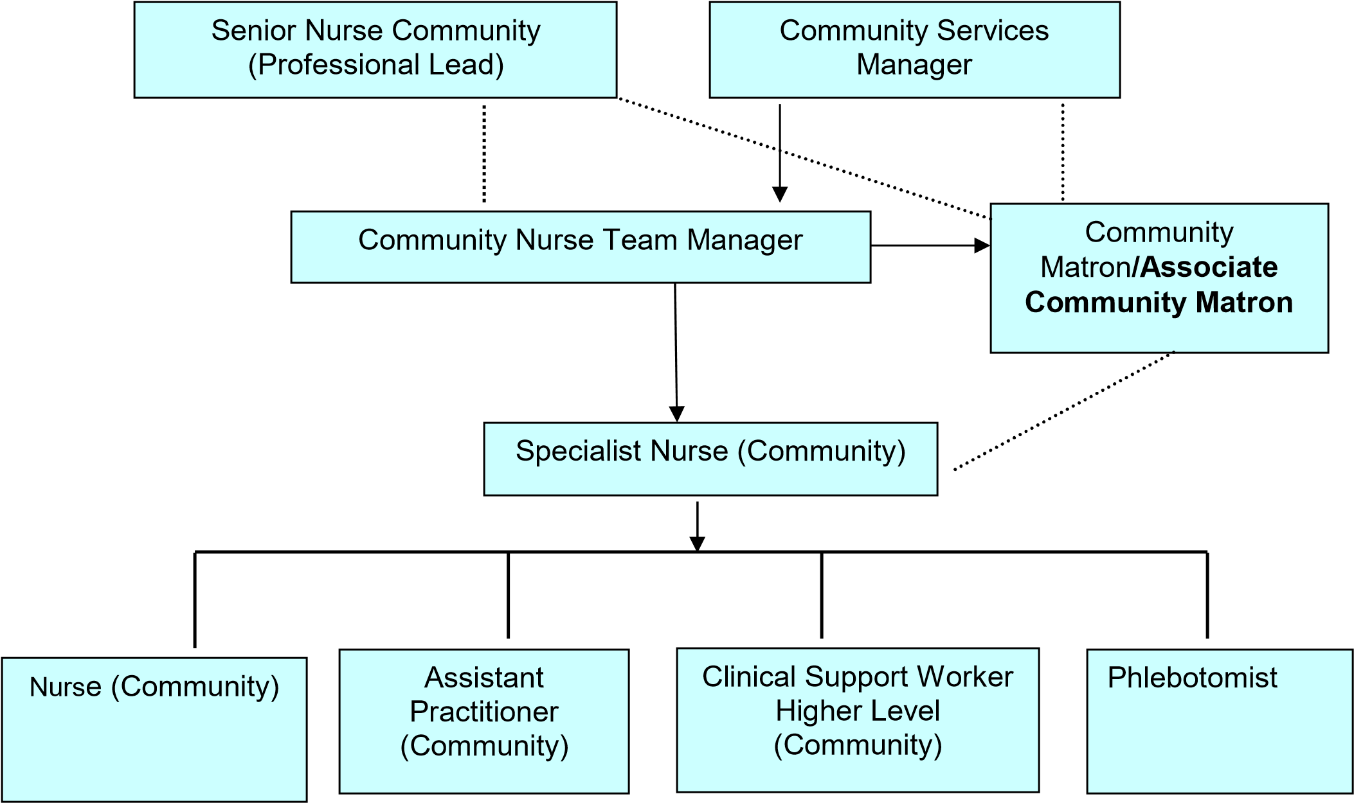

Direct Line Mangement

Key Working Relationship

Key Result Areas/Principal Duties and Responsibilities

Communication and Relationship Skills
Communicating and building relationships with patients, relatives, carers and professional partners to ensure patient care is focal and managed effectively.

Act at all times in a manner which illustrates compassion, respect for privacy, dignity and confidentiality.

Understand the implications of the Mental Capacity Act and acts to assess capacity as appropriate.

Understand the safeguarding adult’s issues and act within the guidance of the policy to keep adults in their care safe.

Able to keep accurate contemporaneous documentation using and supporting the organisation’s documentation.

This role requires excellent communication skills, verbal, written and use of IT.

Analytical and Judgement Skills

Straight forward job related facts using judgement to review the delegated task/patient condition and feedback appropriately.

Act appropriately in complex situations and escalate.

Planning and Organisational Skills

The post holder will be expected to:

Work without the direct supervision of the registered nurse.

Prioritises own workload.

Undertakes delegated clinical activities as directed by the registered nurse.

Liaising with other providers where appropriate regarding care provision.

Physical Skills

A range of clinical skills including e.g. dexterity and accuracy for injections, wound care and venepuncture. This is not an exhaustive list.

Responsibility for Patient and Client Care

Implement and evaluate delegated clinical care; implement planned programmes of care.

Demonstrate clinical competence developed through continual professional development, reflective practice and maintain a skills portfolio relevant to the service specification.

Undertake training to develop a range of knowledge and skills in order to deliver a high quality nursing service.

To recognise and appropriately address risk factors to patients, families and carers within their healthcare setting and escalate the risk to the registered nurse/health professional.

To recognise, record and report all changes in the patient’s condition to the appropriate professional at the earliest opportunity.

To report any untoward incidents, complaints and clinical emergencies to the appropriate professional within the appropriate timescale including safeguarding.

To support good health for all patients within their local community.

Prevention of adverse effects on health and wellbeing.

Responsibility for Policy and Service Development

To work to Trust Policies, Procedures and Standard Operating Procedures (SOP).

To maintain Trust Standards of Clinical Governance.

Responsibility for Financial and Physical Resources

Support the efficient use of resources.

Assist with maintaining stocks and supplies.

Responsibility for Human Resources

Training, supervising and supporting new unregistered staff through care certificate.

Individual responsibility for ensuring attendance at mandatory training.

Participate in supervision and appraisal with line manager to support professional development focussing on the individual skill set and competency.

Responsibility for Information Resources

Inputting, storing and providing information in relation to patient records.

Accurately completing and maintaining effective patient’s records including addressing confidentiality issues.

Completing activity data using Trust agreed data collection sets.

Inputting and storing information on relevant IT systems.

Responsibility for Research and Development

Contribute to developing own and team evidence based nursing practice, including research and involvement in the audit process.

Decision Making

Work within organisational Policies, Procedures and Standard Operating Procedures (SOP).

Acts on own initiative to take decisions alone when required, and escalates to the registered nurse or nurse specialist (community) as appropriate.

Can identify through risk assessment when to escalate to: Registered Nurse, Nurse Specialist
(Community), Community Nurse Team Manager, Community Services Manager, Senior Nurse Community and if required the use of the on-call escalation process and other healthcare professionals.

Physical Effort

Daily work involves frequent driving, sitting/standing, walking and moving equipment, manual handling in restricted positions.

Working hours negotiated according to service need.

Use if IT equipment.

Mental Effort

Understanding of specific procedures which are evidenced based:

Community procedures

Clinical observations

Basic life support

Implementing, reviewing and evaluating patient care.

Infection control

Accurately completing and maintaining effective patient’s records including addressing confidentiality issues.

Frequent requirement for short periods of concentration; work pattern is unpredictable and subject to interruption i.e. calls being prioritised, other work colleagues, patient/relative or carers needs.

Ability to use and concentration for long periods using IT.

Emotional Effort

Caring for patients at end of life, chronic conditions and their families, carers and friends. This includes supporting patient’s relatives and carers in dealing with emotional circumstances.

May, rarely, be required to instigate emergency procedures i.e. finding a collapsed patient and commencing basic life support.

Working with patients who have mental health problems, learning disabilities and challenging behaviour.

Ability to cope and deal with areas of conflict.

Working Conditions
Frequent daily contact with:
- Body fluids e.g. faeces and vomit
- Smells
- Infections
- Dust
- Occasional exposure to unpleasant working environment
- Driving hazards
- Transportation of samples in own vehicle
- Visual Display Units (VDU)

GENERAL:

This is a description of the job as it is at present constituted. It is the practice of this organisation periodically to examine employees' job descriptions and to update them to ensure that they relate to the job as then being performed, or to incorporate whatever changes are being proposed. This procedure is jointly conducted by each manager in consultation with those working directly to him or her. You will, therefore, be expected to participate fully in such discussions. It is the organisations' aim to reach agreement to reasonable changes, but if agreement is not possible management reserves the right to insist on changes to your job description after consultation with you.

We are committed to serving our community. We aim to co-ordinate our services with secondary and acute care.

We aim to make all our services exemplary in both clinical and operational aspects. We will show leadership in identifying healthcare needs to which we can respond and in determining the most cost-effective way of doing so. We will share our knowledge with neighbouring healthcare agencies and professionals.

We recruit competent staff that we support in maintaining and extending their skills in accordance with the needs of the people we serve. We will pay staff fairly and recognise the whole staff’s commitment to meeting the needs of our patients.

The Trust operates a 'non smoking' policy. Employees are not able to smoke anywhere within the premises of the Trust or when outside on official business.

All employees must demonstrate a positive attitude to the Trust’s equality policies and Equality Scheme. Employees must not discriminate on the grounds of sex, colour, race, ethnic or national beliefs, marital status, age, disability, sexual orientation, religion or belief and will treat patients, colleagues and members of the public with dignity and respect.

If the post holder is required to travel to meet the needs of the job, we will make reasonable adjustments, if required, as defined by the Disability Discrimination Act 2010.

SAFEGUARDING:

To be fully aware of and understand the duties and responsibilities arising from the Children’s Act 2004 and Working Together in relation to child protection and safeguarding children and young people as this applies to the worker’s role within the organisation.

To also be fully aware of the principles of safeguarding as they apply to vulnerable adults in relation to the worker’s role which will include recognising the types and signs of abuse and neglect and ensuring that the worker’s line manager is made aware and kept fully informed of any concerns which the worker may have in relation to safeguarding adults and/or child protection.

Everyone within the Trust has a responsibility for, and is committed to, safeguarding and promoting the welfare of vulnerable adults, children and young people and for ensuring that they are protected from harm, ensuring that the Trusts Child Protection and Safeguarding Adult policies and procedures are promoted and adhered to by all members of staff.

HEALTH AND SAFETY AT WORK:

The employer will take all reasonably practical steps to ensure your health, safety and welfare while at work. You must familiarise yourself with the employer's Health & Safety policy, and its safety and fire rules. It is your legal duty to take care for your own health and safety as well as that of your colleagues.

INFECTION CONTROL - ROLE OF ALL STAFF:

It is the responsibility of all members of staff to provide a high standard of care to patients they are involved with. This includes good infection prevention practice.

All staff have a responsibility to comply with Infection Prevention and Control policies and procedures, this includes:

- Attending mandatory and role specific infection prevention education and training.
- Challenging poor infection prevention and control practices.
- Ensuring their own compliance with Trust Infection Prevention and Control policies and procedures for example, standard precautions, hand hygiene, prevention & management of inoculation incidents

CONFIDENTIALITY:

You may not disclose any information of a confidential nature relating to the employer or in respect of which the employer has an obligation of confidence to any third party other than where you are obliged to disclose such information in the proper course of your employment or as required by law. Any failure to comply with this term of your employment will be treated as an act of misconduct under the employer's disciplinary procedure.

JOB DESCRIPTION AGREEMENT

Job holder’s Signature: .....................................................................................

Date: .....................................................................................

Manager’s Signature: .....................................................................................

Date: .....................................................................................

PERSON SPECIFICATION

POST Clinical Support Worker Higher Level (Community) Band 3
REQUIREMENTS | E/ D | HOW TESTED?  Application Form = A  Interview = I | INTERVIEW COMMENTS | SCORE  (1 Low – 10  High)
QUALIFICATIONS/SPECIAL TRAINING:  - National Vocational Qualification (NVQ) Level 3 or equivalent qualification or commitment to working towards relevant qualification  - Good general education  (numerate/literate)  - Completion of the Care Certificate programme provided by NDHT within  12 weeks of commencing in post | E  E  E | A/I  A/I  A/I
KNOWLEDGE/SKILLS:  - Evidence of developing clinical skills and competencies.  - Basic key board skills, IT skills. | D  E | A/I  A/I
EXPERIENCE:  • Previous experience in a health/social care setting. | E | A/I
PERSONAL REQUIREMENTS:  - Able to effectively work as a team member  - Ability to prioritise work and manage own delegated tasks  - Ability to identify own strength and | E  E  E | A/I  A/I  A/I
JE ref:641 v2 Clinical Support Worker Higher level Band 3 Aug 2016

limitations  - Ability to work in isolation  - Effective communication, interpersona skills both written and oral  - Motivation and enthusiasm for community nursing services | l | E  E  E | A/I  A/I  A/I
OTHER REQUIREMENTS:  - The post holder must demonstrate a positive commitment to uphold diversity and equality policies approved by The Trust  - To be willing to work throughout the Trust  - Flexible working re working in a range of clinical settings and environments and shift patterns  - Ability to travel in the community |  | E  E  E  E | A/I  A/I  A/I  A/I
 |  |  | HAZARDS :
Laboratory Specimens Proteinacious Dusts |  |  | Clinical contact with patients |  | X | Performing Exposure  Prone Invasive Procedures
Blood/Body Fluids | X |  | Dusty Environment |  |  | VDU Use |  | X
Radiation |  |  | Challenging Behaviour |  | X | Manual Handling |  | X
Solvents |  |  | Driving |  | X | Noise
Respiratory Sensitisers |  |  | Food Handling |  |  | Working in Isolation |  | X

JE ref:641 v2 Clinical Support Worker Higher level Band 3 Aug 2016

