JOB DESCRIPTION

1. JOB DETAILS

Job Title: Projects Accountant

Band: 7

Reports to: Senior Project Accountant / Contracts Manager

Division: Finance

2. JOB PURPOSE

- To be the Finance lead for income projects, as directed by the Senior Project Accountant / Contracts Manager.
- To interpret and present financial information to Clinicians and Managers.
- To take individual responsibility for managing and delivering specific complex financial and management objectives.

3. KEY WORKING RELATIONS

- Director of Finance
- Director of Operational Finance
- Associate Director of Operational Finance and Procurement
- Head of Income and Contracts
- Head of Financial Projects
- Head of Management Accounts
- Senior Directorate Management Accountants / Business Managers
- Directorate Management Accountants
- Performance Accountant
- Management Accounts Assistants
- Directorate Managers
- Clinical Directors
- Executive Directors (incl. Chief Executive, Medial Directors, Director of Operations, Director of Nursing)
- Budget Holders (incl. Clinical Service Managers, Heads of Departments, Senior Matrons)

- ORGANISATIONAL CHART:

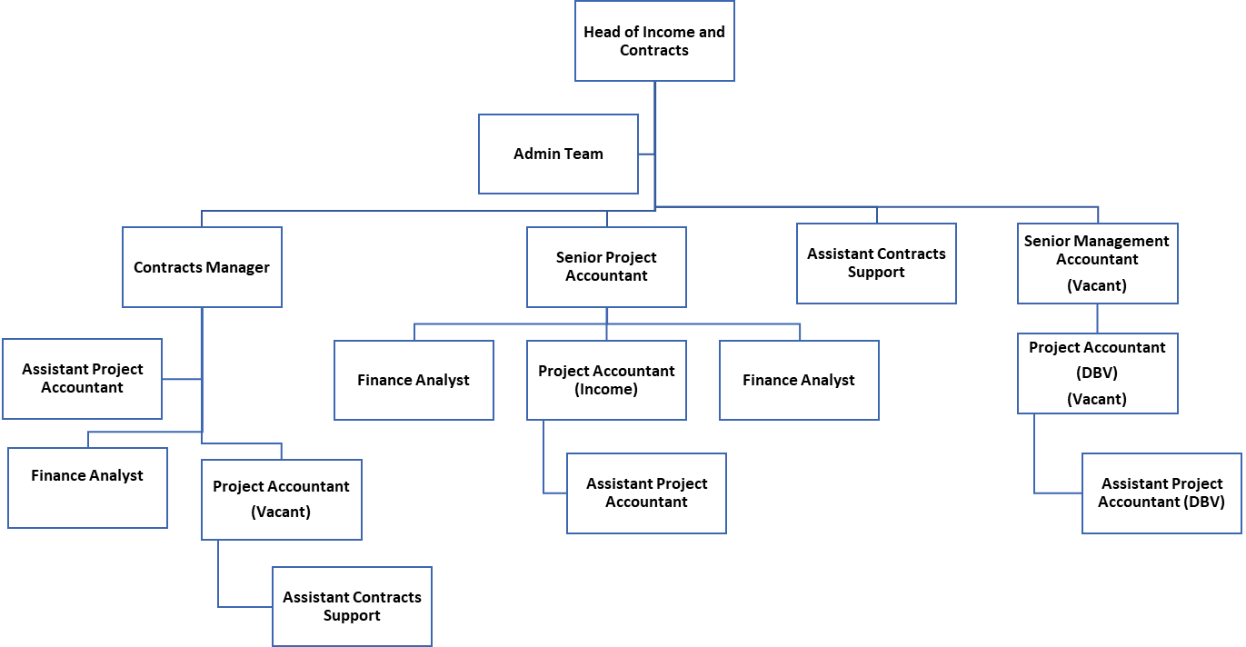

- KEY RESULT AREAS/PRINCIPAL DUTIES AND RESPONSIBILITIES:

Corporate Responsibilities –Income

- To provide support as necessary to both the Senior Project Accountant and the Contracts Manager.
- Responsible for the construction of an activity plan for the Trust by liaising with relevant Cluster Managers, DBMs and Information Analysts.
- Participation in meetings providing income expertise, clinical coding and advice in relation to latest national guidance.
- Assimilation, interpretation and presentation of complex financial and non-financial information, including performance indicators, to multi-disciplinary teams of clinical staff and senior managers from within the organisation.
- Ensure all aspects of the Trust’s Financial Policies including Trust Standing Financial Instructions and Standing Orders are adhered to; value for money secured and financial stability achieved.
- Work to an agreed Project agenda, ensuring that objectives are clearly defined, and that Project Plans are agreed each time.
- To provide support and guide the Division(s), Clinicians and Managers at all levels of the Organisation; guidance and support the planning of services, financial control, and effective utilisation of resources and best financial management practice in accordance with NHS Financial Framework and DoH/Monitor Guidance.
- To assist in managing difficult/unpredictable situations which may arise; such as where clinical needs conflict with financial protocols. Knowledge of many disciplines (i.e. Payroll, Commissioning, provider services, Audit).
- To continually review the existing financial information sent to managers. This will require identifying best practice and ensuring that this as a minimum standard that is available to all budget holders.
- Respond appropriately to queries, investigating all areas of concern, within an agreed timescale.
- To have a knowledge and understanding of the complexity of the services provided by the Divisions.
- Critically appraise the relative cost effectiveness of the services provided through the use of benchmarking data, analysing the relative position of a service in relation to the national tariff and exploring other qualitative and quantitative data.
- Update the Financial Management Information System(s) (FMIS) as necessary to ensure accurate and up to date reporting.

Corporate Responsibilities – Projects

  - Provide a finance lead role in certain Trust projects, where driven by national or local initiatives, to ensure that all developments are fully supported and developed with reliable and robust financial input and advice.
  - Work with non-financial managers up to Executive level to support the construction of business cases ensuring all aspects of finance are included and all areas to be impacted are covered.
  - Play an active member of the project delivery team assigned to ensuring all areas of Finance are updated, including the impact on Service Line Reporting.

General Responsibilities

  - Act as a mentor, identifying and providing adequate training and continuous professional development programmes for junior staff who are undertaking Professional Accountancy Training.
  - Play a full and active role in the development of the Income and Contracts section.
  - Ensures requirements relating to personal and information security and confidentiality at work are maintained.
  - Plan and manage the workload to assist in the achievement of the Section’s objectives.
  - To support the development and implementation of Financial Awareness Training to non-finance staff within the Trust (including an understanding of financial systems, complying with Standing Financial Instructions, guidance on budgeting, contracting matters and the efficient use of resources).
  - To provide finance training for non-financial managers within the Trust e.g. by teaching on the Introduction to Income.
  - To assist in the review and development of the information systems within the department as required to supplement the FMIS. To include databases, spread sheets and accounting systems.
  - To assist in the planning and implementation of new information systems e.g. Electronic Staff Records System, consultant Contracts, new quarterly review template.
  - Be aware and meet agreed deadlines
  - Ensure that the objectives of the section are fully communicated.
  - Perform such other duties as may be directed from time to time by Senior Finance Managers.

THE TRUST - PURPOSE AND VALUES

We are committed to serving our community by being a high-quality specialist Hospital with consultant-led services. We aim to co-ordinate our services with primary and community care, and to develop a limited number as Sub-Regional Referral Centres with appropriate levels of research, development and educational involvement. Where appropriate, and consistent with our services, we may provide services aimed at preventing disease and debilitation.

We aim to make all our services exemplary in both clinical and operational aspects. We will show leadership in identifying healthcare needs to which we can respond and in determining the most cost-effective way of doing so. We will share our knowledge with neighbouring healthcare agencies and professionals.

We recruit competent staff that we support in maintaining and extending their skills in accordance with the needs of the people we serve. We will pay staff fairly and recognise the whole staff’s commitment to meeting the needs of our patients.

We are committed to equal opportunity for all and encourage flexible working arrangements including job sharing.

GENERAL

This is a description of the job as it is now. We periodically examine employees' job descriptions and update them to ensure that they reflect the job as it is then being performed, or to incorporate any changes being proposed. This procedure is conducted by the Manager in consultation with the jobholder. You will, therefore, be expected to participate fully in such discussions. We aim to reach agreement on reasonable changes, but if agreement is not possible, the Trust reserves the right to insist on changes to your job description after consultation with you.

The RD&E is a totally smoke-free Trust. Smoking is not permitted anywhere on Trust property, including all buildings, grounds and car parks. For help to quit call: 01392 207462.

As an employee of the Trust, it is a contractual duty that you abide by any relevant code of professional conduct and/or practice applicable to you. A breach of this requirement may result in action being taken against you (in accordance with the Trust’s disciplinary policy) up to and including dismissal.

The post holder is expected to comply with Trust Infection Control Policies and conduct him/her at all times in such a manner as to minimise the risk of healthcare associated infection.

PERSON SPECIFICATION

POST: Projects Accountant
BAND: 7
REQUIREMENTS | At  Recruitment | At PDR
QUALIFICATIONS / TRAINING  Professional Accountancy Qualification (CCAB Recognised – Postgraduate Diploma level) or equivalent experience.  Professional Accountancy Qualification (CCAB Recognised) or equivalent experience. | E  D | E  E
KNOWLEDGE / SKILLS  A good knowledge and experience of computer-based management accounting systems and Microsoft Office applications  Good communication, presentation and interpersonal skills both orally and in writing  Good negotiation and influencing skills  Strong numerical skills, ability to understand and interpret complex financial information  Detailed understanding of the NHS and Trust financial regime and accounting standards  Excellent organisation and time management skills  Good people management and motivation skills | E  E  E  E  D  E  D | E  E  E  E  E  E  E
EXPERIENCE  Management Accounting experience  Experience of budgetary control  Experience within the Finance function of the NHS  Experience in identifying savings, implementing change and realising the benefits | E  D  D  D | E  E  E  E
PERSONAL ATTRIBUTES  Good Communicator  Confident  Self Motivated  Team Worker  Ability to act on advice without reference to Manager to achieve agreed objectives | E  E  E  E  E | E  E  E  E  E
OTHER REQUIREMENTS  Hold a Driver’s Licence | D | E
* Essential/Desirable
HAZARDS IDENTIFIED (tick as appropriate):
Laboratory specimens  Proteinacious Dusts |  | Clinical contact with  Patients |  | Dealing with violence & aggression of  patients/relatives
Blood / Body Fluids |  | Dusty environment |  | VDU use | X
Radiation |  | Challenging Behaviour |  | Manual handling
Solvents |  | Driving |  | Noise
Respiratory Sensitisers |  | Food handling |  | Working in isolation

