

JOB DESCRIPTION

The Trust is committed to recruiting and supporting a diverse workforce and so we welcome applications from all sections of the community, regardless of age, disability, gender, race, religion or sexual orientation. The Trust expects all staff to behave in a way which recognises and respects this diversity, in line with the appropriate standards.

1. JOB DETAILS

Job Title: Procurement Assistant

Band: 2

Reports to: Procurement Admin Team Manager

Department / Directorate: Procurement / Finance

2. JOB PURPOSE

  - To act as an ambassador for the Procurement Department and promote benefits to all customers
  - Working as part of a small team, process orders placed by all areas of the Trust using the Trust’s approved procurement system (ERP/UNIT 4) in an effective and efficient manner according to the performance standards set within the department.
  - To proactively manage the procurement and expediting of travel and accommodation arrangements for all procurement customers in accordance with Trust Policy.
  - Deal with a high volume of customer and supplier queries primarily over the telephone and e-mails to ensure that goods and services are selected, ordered and received in appropriate timescales.
  - Keeping statistical data regarding the team’s workload up to date.
  - Support the procurement team to deliver a fully operational and effective purchasing and supply service for the Royal Devon University Healthcare NHS Foundation Trust as well as other organisations to whom a procurement service may be contracted, delivering ongoing cost efficiencies and benefits to the Trusts and their customers.
  - Carry out operational tasks associated with the procurement of goods and services and effectively contribute towards the Trust’ value for money and cash releasing saving targets, as well as those of other organisations to whom the service is contracted.

Key Working Relationships
  - Reporting to the Procurement Admin Team Manager accountable to the Head of Procurement
  - Required to forge effective and professional working relationships with staff at all levels, both inside and outside of the Organisation, particularly with the following:
- Procurement and Logistics staff
- Clinical staff
- Estate staff
- Projects and Support managers
- Payments staff
- Management Accountants as appropriate
- Order requisitioners and staff throughout the Trusts
- Suppliers of goods, services or capital items

3. DIMENSIONS

- To assist as necessary, the Procurement team in processing orders and requests for new products to be added onto the Trust’s catalogue.
- Develop productive working relationships with customers generally up to managerial level seeking to influence the customer choice towards standardised products and in accordance with Trust Policies where these apply.
- Build collaborative relationships and achieve positive performance against quality and value for money targets.
- Provide an advice and enquiry service to the Royal Devon University Healthcare NHS Foundation Trust on routine procurement issues.
- Request and analyse quotations for low value purchase activity.

4. ORGANISATIONAL CHART

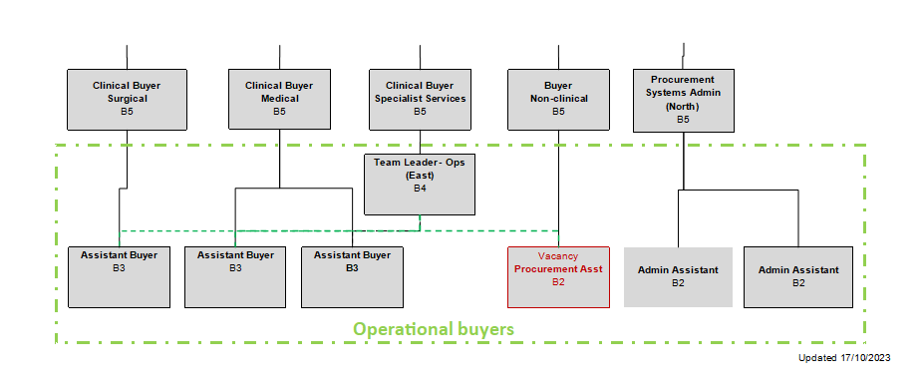

5. KEY RESULT AREAS/PRINCIPAL DUTIES AND RESPONSIBILITIES

- To ensure that all orders, invoice queries and new product requests within a designated area of responsibility are processed in line with procedures.
- To carry out operational tasks associated with the procurement of goods and services and effectively contribute towards the Trust’ value for money and cash releasing saving targets, as well as those of other organisations to whom the service is contracted.
- To organise travel arrangements, including transportation, accommodation and car hire for approved end users using the Click travel system, Procurement Credit Card or other appropriate methods.
- To take telephone calls from customers and suppliers, answer enquiries regarding products, services, supplier information, orders etc, discuss quotes received etc.
- To liaise with the Buyers on Standing Order and Blanket Order to understand the Trust’s requirements and create requisitions / orders under the supervision of the Buyers.
- Contribute to the Trust’s cash releasing programme year on year.
- To take responsibility for allocated departments within the Trust and to visit on a regular basis to enable good relations between the department and Procurement.
- To perform administrative duties to support the smooth running of the department as appropriate.
- To process the orders within 48 hours of the order being generated onto the ERP/UNIT 4 system. Orders may include Charitable Funds orders and Cheque with Order payments which need to be forwarded to Cash management for the cheque to be raised.
- To run the ERP/UNIT 4 overdue reports weekly and expedite or assist with the expedition of orders when goods have not been delivered as planned.
- To actively seek opportunities to compare products requested for suitable alternatives looking to maximise savings when ever possible.
- When required, to liaise with Cash Management to resolve any invoice queries.
- Under direction, to assist the line manager to implement changes that will enhance the service and raise suggestions to improve Procedures and processes.
- To undertake any other duties commensurate with the grade as may be required by any of the Procurement Senior Team.

Other Responsibilities:

To take part in regular performance appraisal
To undertake any training required in order to maintain competency including mandatory training, i.e. Fire, Manual Handling
To contribute to and work within a safe working environment
The post holder is expected to comply with Trust Infection Control Policies and conduct him/herself at all times in such a manner as to minimise the risk of healthcare associated infection.

GENERAL
This is a description of the job as it is at present constituted. It is the practice of this organisation periodically to examine employees' job descriptions and to update them to ensure that they relate to the job as then being performed, or to incorporate whatever changes are being proposed. This procedure is jointly conducted by each manager in consultation with those working directly to him or her. You will, therefore, be expected to participate fully in such discussions. It is the organisations' aim to reach agreement to reasonable changes, but if agreement is not possible management reserves the right to insist on changes to your job description after consultation with you.

We are committed to serving our community. We aim to co-ordinate our services with secondary and acute care.

We aim to make all our services exemplary in both clinical and operational aspects. We will show leadership in identifying healthcare needs to which we can respond and in determining the most cost-effective way of doing so. We will share our knowledge with neighbouring healthcare agencies and professionals.

We recruit competent staff whom we support in maintaining and extending their skills in accordance with the needs of the people we serve. We will pay staff fairly and recognise the whole staff’s commitment to meeting the needs of our patients.

The Trust operates a 'non-smoking' policy. Employees are not able to smoke anywhere within the premises of the Trust or when outside on official business. For help to quit call 01392 207462.

All employees must demonstrate a positive attitude to Trust equality policies and Equality Scheme.

Employees must not discriminate on the grounds of sex, colour, race, ethnic or national beliefs, marital status, age, disability, sexual orientation, religion or belief and will treat patients, colleagues and members of the public with dignity and respect.

If the post holder is required to travel to meet the needs of the job, we will make reasonable adjustments, if required, as defined by the Equality Act 2010.

SAFEGUARDING
To be fully aware of and understand the duties and responsibilities arising from the Children’s Act 2004 and Working Together in relation to child protection and safeguarding children and young people as this applies to the worker’s role within the organisation.
To also be fully aware of the principles of safeguarding as they apply to vulnerable adults in relation to the worker’s role, which will include recognising the types and signs of abuse and neglect and ensuring that the worker’s line manager is made aware and kept fully informed of any concerns which the worker may have in relation to safeguarding adults and/or child protection.
Everyone within the Trust has a responsibility for, and is committed to, safeguarding and promoting the welfare of vulnerable adults, children and young people and for ensuring that they are protected from harm, ensuring that the Trusts Child Protection and Safeguarding Adult policies and procedures are promoted and adhered to by all members of staff.

HEALTH AND SAFETY AT WORK
The employer will take all reasonably practical steps to ensure your health, safety and welfare while at work. You must familiarise yourself with the employer's Health & Safety policy, and its safety and fire rules. It is your legal duty to take care for your own health and safety as well as that of your colleagues.

INFECTION CONTROL - ROLE OF ALL STAFF
It is the responsibility of all members of staff to provide a high standard of care to patients they are involved with. This includes good infection prevention practice.
All staff have a responsibility to comply with Infection Prevention and Control policies and procedures, this includes:
- Attending mandatory and role specific infection prevention education and training.
- Challenging poor infection prevention and control practices.
- Ensuring their own compliance with Trust Infection Prevention and Control policies and procedures for example, standard precautions, hand hygiene, prevention & management of inoculation incidents
CONFIDENTIALITY
You may not disclose any information of a confidential nature relating to the employer or in respect of which the employer has an obligation of confidence to any third party other than where you are obliged to disclose such information in the proper course of your employment or as required by law. Any failure to comply with this term of your employment will be treated as an act of misconduct under the employer's disciplinary procedure.

THE TRUST - PURPOSE AND VALUES

We are committed to serving our community by being a high-quality specialist Hospital with consultant-led services. We aim to co-ordinate our services with primary and community care, and to develop a limited number as Sub-Regional Referral Centres with appropriate levels of research, development and educational involvement. Where appropriate, and consistent with our services, we may provide services aimed at preventing disease and debilitation.

We aim to make all our services exemplary in both clinical and operational aspects. We will show leadership in identifying healthcare needs to which we can respond and in determining the most cost-effective way of doing so. We will share our knowledge with neighbouring healthcare agencies and professionals.

We recruit competent staff whom we support in maintaining and extending their skills in accordance with the needs of the people we serve. We will pay staff fairly and recognise the whole staff’s commitment to meeting the needs of our patients.

We are committed to equal opportunity for all and encourage flexible working arrangements including job sharing.

JOB DESCRIPTION AGREEMENT
Job holder’s Signature: .....................................................................................
Date: .....................................................................................
Manager’s Signature: .....................................................................................
Date: .....................................................................................

PERSON SPECIFICATION

POST: Procurement Assistant
BAND: 2
REQUIREMENTS | At Recruitment | PDR
QUALIFICATIONS/SPECIAL TRAINING:  5 GCSE including Maths and English or equivalent good general standard of education.  IT Literate | E  E | E  E
KNOWLEDGE/SKILLS:  Experience in an Office Environment  Ability to analyse data, interpret, evaluate to determine best value for money  Good written and verbal communication skills  Computer literacy inc Microsoft Office Applications (Word, Excel, Outlook)  Ability to prioritise workload  Ability to identify opportunities for cost reductions | E  E  E  E  E  D | E  E  E  E  E  E
EXPERIENCE:  Recent experience of working with modern systems and use of office equipment  Basic working knowledge and understanding of procurement,  Knowledge of how to book accommodation and transport.  Conversant with NHS Terms & Conditions of Contract | E  D  D  D | E  E  E  E
PERSONAL REQUIREMENTS:  Good interpersonal skills  Good organisational skills  Good telephone manner  Good and assertive communication skills  Accurate and numerate  Ability to Prioritise  Flexible / Enthusiastic Approach  Proactive, Punctual and Reliable  Team Player | E  E  E  E  E  E  E  E  E | E  E  E  E  E  E  E  E  E
OTHER REQUIREMENTS

* Essential/Desirable

Hazards within the role, used by Occupational Health for risk assessment
Laboratory Specimens Proteinacious Dusts |  | Clinical contact with patients |  | Performing Exposure Prone Invasive Procedures
Blood / Body Fluids |  | Dusty environment |  | VDU Use | X
Radiation |  | Challenging Behaviour |  | Manual Handling | X
Solvents |  | Driving |  | Noise
Respiratory Sensitisers |  | Food Handling |  | Working in isolation
Handling Cytotoxic Drugs

