JOB DESCRIPTION – Diagnostic Radiographer Apprentice

This post has been identified as involving access to vulnerable adults and/or children and in line with Trust policy successful applicants will be required to undertake an Enhanced Disclosure Check.

1. JOB DETAILS

Job Title: Apprentice Diagnostic Radiographer

Band: Annex 21 of Band 5

Reports to: Superintendent Radiographer

Department / Directorate: Medical Imaging / Specialist Services

2. JOB PURPOSE

To put our patients first by working as one team, leading, listening and striving for the best

To Work within the Radiology department as a trainee Radiographer under the Diagnostic Radiographer Apprenticeship programme and complete the full BSc Diagnostic Radiography qualification at the associated Higher Education Institution

Work under the supervision of a Registered Practitioner

As part of the multi-disciplinary team, the post holder will provide a key role in providing imaging, care and support to individuals as specified in standard radiographic protocols, or written care or service plans, in a range of environments.

The Apprentice Diagnostic Radiographer will be based in Medical Imaging at the Royal Devon and Exeter (Wonford) Hospital. They will also be allocated to work in the Community site hospitals and the Heavitree site as and when required. The post holder will be also be required to take part in the extended working day and 7 day service to enable them to make the most of their training and participate fully in the service delivery.

Apprentices will be contracted to work 37.5 hours per week, divided into 80% workplace based and 20% protected study time. Study time will be either within the department or at the associated Higher Education Institution (HEI). Attendance of training at the HEI is considered to be essential and annual leave must be arranged outside these sessions. The post holder will be expected to discuss their planned study with their mentor or superintendent radiographer each week.

The post holder will fulfil all tasks and work as part of a team responsible for providing an efficient imaging service in the Diagnostic Imaging Department. To meet the needs of the service, the post holder may be required to work in other areas and hospitals as appropriate, as directed by the line manager. It may be necessary to attend other Imaging Departments to gain sufficient experience in some modalities.

The post holder will have a close working relationship with staff across a variety of professional boundaries in order to maintain efficient links with other wards and Departments throughout the Trust.

3. KEY WORKING RELATIONSHIPS

- Superintendent Radiographers
- Radiology Services Manager
- Consultant Radiologists
- Radiography Apprentice Mentors
- Diagnostic radiographers across all modalities
- Radiographic assistants
- Imaging Support Workers
- Departmental administrative, clerical and support staff
- Departmental nursing staff
- Medical Physics Department
- Radiology Engineers
- RD&E staff across the trust at all levels
- Patients, relatives and carers
- University of Exeter Staff

The post holder is required to deal effectively with staff of all levels throughout the Trust, the wider Healthcare community, external organisations and the public. This will include verbal, written and electronic media.

4. DIMENSIONS

The Department of Medical Imaging processes approximately 300,000 examinations per year, including General, Theatres and Mobile, MRI, CT, Ultrasound, Fluoroscopy, Intervention and Nuclear Medicine. Work is generated from within the RD&E NHS Trust, regional and national referral sources
- ORGANISATIONAL CHART
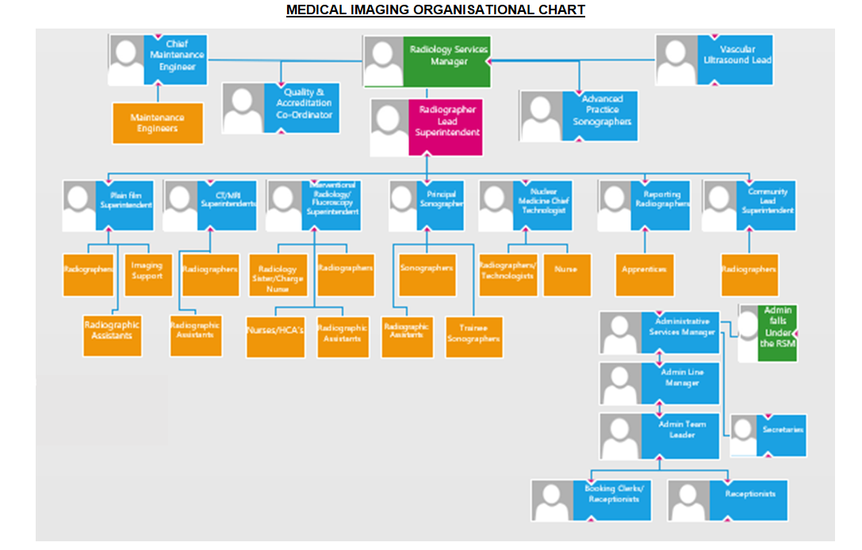
6 Principal Duties and Responsibilities

To work as part of a team responsible for providing an efficient imaging service.

Attend mandatory block weeks for the Diagnostic Radiographer Apprenticeship programme at the University of Exeter.

Make a commitment to study both within working hours and at home during the duration of the apprenticeship course.

Attend virtual tutorials and webinars and complete all e-learning as instructed by the University of Exeter.

To perform a range of radiographic imaging procedures, as detailed within the apprenticeship programme, within the Diagnostic Imaging department under the supervision of a qualified radiographer at all times.

To ensure that the Ionising Radiation Regulations 2017, IRMER 2017 and associated codes of practice and guidance notes together with the Health and Safety at Work Act are understood and adhered to in respect of staff, patients and members of the public.

Works within the boundaries of existing competence, adhering to the NDHT Radiation Safety Policy and national and local standard operating procedures/protocols.

To immediately report any fault errors to the supervising radiographer. To make appropriate entries in the fault log.

7 Communication and Relationship Skills

This role requires excellent communication skills including verbal, written and use of IT

Able to exchange information with patients/clients requiring support, tact and reassurance.

Form professional relationships with patients/clients and communicates and cooperates with them in a way that respects their views, autonomy and culture.

Constructively manage barriers to effective communication and works cooperatively with patients and team members.

Understand the implications of the Mental Capacity Act and acts to assess capacity as appropriate.

Understand the safeguarding adult’s issues and act within the guidance of the policy to keep adults within their care safe.

Able to keep accurate contemporaneous documentation using and supporting the organisation’s documentation.

Report effectively to the relevant team on patients’ progress.

Communicate with other staff and agencies as appropriate in written and oral format to report on patient progress.

Attend meetings and feedback relevant information.

Assist in obtaining valid patient consent and work within a legal framework with patients who lack capacity to consent to treatment.
To provide patients with an explanation of their procedure prior to commencing the examination.

To communicate effectively, empathically and persuasively with patients in order to facilitate accurate positioning of patients and obtain diagnostic images. This will include dealing with patients (and their relatives or carers) who may have communication difficulties e.g. deafness or who speak a foreign language.

To give advice to other healthcare workers and professionals on general radiation protection issues and be able to explain the general risks of radiation to patients whilst knowing when to defer to a qualified radiographer.

8 Analytical and Judgement Skills

Carries out delegated assessment of patients and their condition and monitors the patient’s response to intervention.

Undertake delegated risk assessments providing accurate feedback to the team as necessary

Recognise the need for further advice, guidance and support as appropriate.

To acquire knowledge and learn to apply this in a practical setting e.g. assessing the patient’s clinical need and level of cooperation (especially elderly and trauma patients), prior to performing any radiographic procedures in order to ensure the highest possible quality diagnostic image is produced at first attempt with minimal radiation risk to the patient.

To use all equipment in accordance with manufacturer’s instructions, recognising and reporting faults occurring to any equipment to a senior radiographer in that area.

To liaise and discuss requests with the supervising radiographers to ensure appropriate clinical procedures are performed within departmental protocols and national guidelines.

9 Planning and Organisational Skills

Be able to plan and successfully undertake the academic components of the Diagnostic Radiographer Apprenticeship course whilst continuing to achieve clinical competencies.
The post holder will be expected to:

To plan and undertake their continued studies both in the workplace and at home.

To assist staff to ensure the department is working effectively at all times by contributing towards good control of workflow and maximising the use of all available x-ray rooms and facilities.

Prioritise own tasks under the appropriate delegation of the registered practitioner.

To actively participate in departmental meetings.

Participate in the regular QA testing of all protective equipment used in the department (as required by IRR 2017), including protective lead aprons, screens and other such related equipment.

10 Physical Skills
A range of clinical skills including; dexterity and accuracy for diagnostic imaging.

Ability to undertake training to provide high quality diagnostic images within the defined scope of practice.

Be able to help to move patients using a range of manual handling aids and hoists as required.
To use Radiography systems in accordance with departmental protocols ensuring patient data and images are correctly inputted and correlated.

11 Responsibility for Patient and Client Care

To work within clearly a defined accountability framework.

To demonstrate clinical competence developed through continual professional development, reflective practice and maintenance of a skills portfolio relevant to the service specification.

To recognise and appropriately address risk factors to patients/clients and carers within their healthcare setting and feedback appropriately to the registered practitioner

To ensure that the department’s identification policy is adhered to and that all patients are correctly identified prior to undergoing irradiation.

To report any incidents, untoward incidents, complaints and near misses to self, patients or carers to the appropriate professional within the stated timescales and record these on datix.

12 Responsibility for Policy and Service Development

To work to Trust Policies, Procedures and Standard Operating Procedures (SOP).

To maintain Trust Standards of Clinical Governance.

To support Professional Standards of Practice

The post holder will work in accordance with departmental policies, protocols and procedures.

13 Responsibility for Financial and Physical Resources

The post holder has no budgetary responsibilities but is responsible for the safe and correct use of expensive image acquisition equipment.

Support the efficient use of resources including; maintaining stocks and supplies and ordering equipment & resources as agreed or directed.

Ensure safe and efficient use of stock and equipment including; ensuring equipment is checked appropriately and any defects reported

Demonstrate and instruct the use of equipment to ensure safety.

14 Responsibility for Human Resources

Supporting peers, including bank and agency staff in the clinical area.

Maintaining own professional development and attending training, including all mandatory training to enhance the role within the clinical area.

Be prepared to share knowledge and experience both formally and informally.

Take a flexible approach in supporting colleagues during times of workload pressures.

Participate in the training and induction of other staff/students as appropriate.

Participate in supervision and appraisal process, identifying own areas of development, & undertaking relevant activities to meet objectives set in Personal Development Review Plan.

Keep a record of own training and development, maintain a portfolio, working to sustain acquired competencies for the post.

15 Responsibility for Information Resources

Inputting, storing and providing information on relevant IT systems and patient records.

Accurately completing and maintaining effective patient records including confidentiality issues.

To be able to work with the departments’ PACS system and Radiology Information (CRIS) system.

16 Responsibility for Research and Development

The post holder will be required to contribute to developing his / her own team’s evidenced based practice including research.

To engage in active participation in data collection for audit and quality assurance purposes.

17 Decision Making

Adhere to professional and organisational standards of practice, policies and procedures and work within guidelines under the supervision of a qualified (HCPC Registered) radiographer.

Work alone at times in a variety of settings, under the direction of the Registered Practitioner with access to support and supervision.

May be required to take decisions alone and then escalate to the Radiographers.

18 Physical Effort

Daily work involves frequent sitting/standing, walking, moving equipment and manual handling.

Imaging procedures may necessitate working in restricted positions or limited space.

Moving & handling of patients and equipment in order to perform diagnostic imaging procedures. The post holder will learn to position / transfer and manoeuvre the patients’ body in order to obtain high quality, diagnostic images.

Undertake training to use and manipulate equipment on a daily basis to produce diagnostic images.

18 Mental Effort

The post holder will sometimes be expected to cover the duties of colleagues in posts of the same pay band or lower and within the range of the post holders knowledge and skills.

There will be periods of occasional intense concentration when dealing with very ill, critical or badly injured patients.

Must be able to produce high quality images or contribute to procedures as standard on patients with variable levels of mobility and understanding whilst keeping radiation doses to a minimum under the As Low As Reasonably Practicable (ALARP) principle.

Must be willing to undertake the training involved in this post in order to become a qualified Diagnostic Radiographer. Being able to undertake some study in own time whilst continuing to work within the Diagnostic Imaging Department.

Work in an unpredictable pattern when required

Read and decipher patient information.

Help patients to make appropriate choices.

Help to encourage / motivate patients for positioning and image acquisition.

Have the ability to communicate with the appropriate response and manner to both patients and carers/family during emotional times.

Ability to use and concentrate for long periods using IT.

20 Emotional Effort

There will be occasional periods of emotional intensity when dealing with very ill, critical or badly injured patients in the emergency department, fluoroscopy or cross sectional imaging rooms. This may include supporting patients, relatives and carers in dealing with emotional circumstances.

Working with patients with mental health, learning disabilities and challenging behaviour.

Ability to cope and deal with areas of conflict.

21 Working Conditions

Frequent contact with bodily fluids, infection and unpleasant smells. Occasional aggressive behaviour / verbal abuse from patients and relatives.

Due to risks from ionising radiation, the post holder must adhere to the Ionising Radiation Regulations 2017 (IRMER 17), Ionising Radiation Regulations 2017 (IRR 17) and associated codes of practice and guidance notes, and the Health and Safety at Work

PERSON SPECIFICATION

POST: Apprentice Diagnostic Radiographer
BAND: Annex 21

REQUIREMENTS | At Recruitment
QUALIFICATIONS/SPECIAL TRAINING:  A-level Science grade B minimum  Level 3 qualification (ie: NVQ 3, QCF 3)  GCSE English and Maths grade C or 4 (or equivalent ie: functional skills)  Willingness / commitment to undertake the training required for this post. | E  E  E  E
KNOWLEDGE/SKILLS:  Good Knowledge of the Radiology Management system.  Knowledge of relevant national standards, e.g IR(ME)R 2017, IRR’17 and associated codes of practice  Sound knowledge of a range of clinical presentations and how to escalate concerns.  Knowledge of correct assessments of patients and their condition and monitors the patient’s response to intervention.  To be able to demonstrate a basic knowledge of IT skills  Knowledge of accountability, relevant SOP’s policies and importance of patient documentation.  Knowledge of client conditions related to the setting.  Health, safety and risk awareness.  Safeguarding and MCA understanding.  Demonstrates a commitment to lifelong learning.  Knowledge / understanding of promoting patient’s independence. | D  D  D  D  E  D  D  D  E  D
EXPERIENCE:  Proven experience of working in an appropriate health care setting.  Experience of working directly with patients providing care or treatment interventions. | D  D
PERSONAL REQUIREMENTS:  Flexible approach to duties and ability to participate in shift/extended day schedules when required.  Ability to communicate well with all grades and disciplines of staff, patients and relatives.  Be reflective in thinking and outlook and be available as a source of advice, coping with multiple demands during the working day.  Highly motivated and committed to delivering the service.  Ability to remain calm in a busy environment  Good hand/eye co-ordination skills and aptitude for precision  Good communication skills, written and verbal.  Ability to work autonomously.  Ability to work under pressure and with flexibility.  Empathetic and demonstrates patient focus.  Able to manage own emotions and cope in sometimes difficult situations with patients or their relatives.  Basic computer skills.  Understand the need for professional conduct.  Demonstrate understanding of the boundaries of their existing competence and authority levels for delegation of tasks.  Competent listening and observation skills.  Positive interpersonal skills.  Good co-ordination/organisation skills.  Ability to work positively and professionally as part of a team.  Able to contribute to the training of other staff/students.  Willingness/commitment to undertake training.  Understands and demonstrates commitment to the Trust’s values. | E  E  E  E  E  E  E  E  E  E  E  E  E  E  E  E  E  E  D  E  E
OTHER REQUIREMENTS:  Be prepared to deal with distressing and emotional situations on a daily basis, for example, seriously ill or injured patients; patients and relatives that maybe aggressive or abusive.  To be physically able to safely and competently position and manoeuvre patients and equipment as a routine part of the daily duties, including wheelchairs, beds, stretchers and mobile x-ray units and to wear lead rubber protective clothing for prolonged periods, such as during fluoroscopy sessions in theatre.  The post holder must demonstrate a positive commitment to uphold the trust values at all times.  Flexible working in a range of clinical settings, environments and shift patterns.  Ability to travel to meet needs of the job. | E  E  E  E  E
* Essential/Desirable

Hazards within the role, used by Occupational Health for risk assessment
Laboratory Specimens Proteinacious Dusts |  | Clinical contact with patients | √ | Performing Exposure Prone Invasive Procedures
Blood / Body Fluids | √ | Dusty environment |  | VDU Use | ✓
Radiation | √ | Challenging Behaviour |  | Manual Handling | ✓
Solvents |  | Driving |  | Noise
Respiratory Sensitisers |  | Food Handling |  | Working in isolation
Handling Cytotoxic Drugs

