ROYAL DEVON & EXETER NHS FOUNDATION TRUST

JOB DESCRIPTION

1. JOB DETAILS

Job Title: Site Practitioner

Band: 7

Reports to: Lead Nurse / Head of Patient Flow

Accountable to: Lead Nurse / Head of Patient Flow

2. JOB PURPOSE

Working within the Operations Support Division at the RD&E and managed by the Lead Nurse / Head of Patient Flow and Clinical Matron for Operations, the team of Site Practitioners provide 24 hour support to the organisation to ensure the effective patient flow of both elective and emergency patients in single sex accommodation, from admission to discharge throughout the Trust. Out of hours the Site Practitioner will co-ordinate the Hospital Out of Hours service.

The post holder will;
- Provide 24 hour support to ensure the effective flow of patients from admission to discharge throughout the Trust, assisting the organisation to achieve 18 week referral to treatment and ED 4 hour breach targets.
- Provide day-to-day management and leadership, ensuring the effective flow of emergency and elective patients.
- Provide advanced practice, leadership and professional support out-of-hours, ensuring clinical teams deliver safe and effective care, and ensuring patients are cared for in the right place, at the right time, and by the appropriate staff.
- Work with clinicians and colleagues to deliver a quality patient- focused service.
- Provide clinical expertise to the Hospital Out of Hours service.
- Co-ordinate the Hospital Out of Hours service to ensure clinical priority for patient care.
- Play a proactive role in quality of service provision.
- Ensure the patient flow between ED, AMU and the medical wards is maximised to reduce delays and/or breaches and improve patient experience.

3. KEY WORKING RELATIONSHIPS

- Director of Operations
- Divisional Director of Operations
- Director of Nursing
- Assistant Directors of Nursing
- Clinical Matrons
- Clinical Nurse Managers
- AHP Leads and Divisional Management teams
- Ward Nursing teams
- On call management teams
- On call medical teams
- SPOA

ORGANISATIONAL CHART
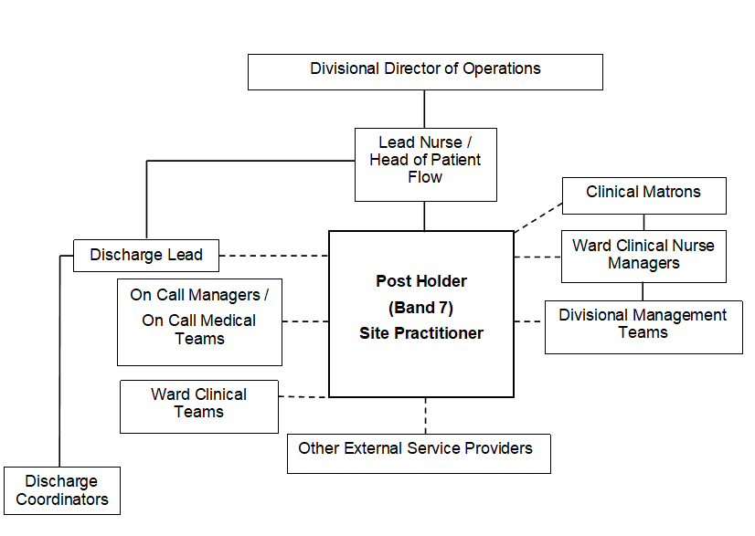

Denotes:
Line Management Responsibility Liaison Relationship

denot

5. KEY RESULT AREAS/PRINCIPAL DUTIES AND RESPONSIBILITIES

Day to Day Management
- Be responsible for the placement of patients to ensure they are cared for in the right place, by the right team with the right skills.
- Manage clinical and non-clinical emergency situations e.g. met calls, cardiac arrests, fire calls and notification of major incidents, until appropriate support arrives.
- Through board and ward rounds, manage the availability of beds and external repatriations in and out of other hospitals (according to the Repatriation Policy).
- Be a point of contact for capacity escalation in ED.
- Co-ordinate the movement of patients for ward moves, Trust deep cleans and infection control matters, with patient flow becoming more challenging in times of COVID and Norovirus outbreaks.
- Utilising the resources of the Operational team, ensure a daily management plan is devised to ensure that patient flow meets the demand and capacity needs of the Trust, and ensures effective and timely bed utilisation.
- Through EPIC manage the allocation of beds from emergency areas to base wards and escalation areas.
- Be responsible for providing frequent information updates to the Operational Management team, Clinical Matrons, Clinical Nurse Managers, Clinicians and Divisional Teams, on operational delivery and liaise and influence where necessary, to enable the smooth management of patient flow.
- Be responsible for presenting the information at the daily bed management meeting providing advice and support to the attendees on achieving the daily management plan which is currently provided on MS Teams.
- Provides support for HMP and out of area patients, and play a key role in the management of significant events and major incidents.
- Be a point of contact for Mental Health Act administration, accepting Mental Health paperwork on behalf of the organisation, Vulnerable Adults and security issues with information on all stored in the Operations Control Room (E221).
- Support the Staff Bank in the effective communication and allocation of temporary staffing.
- To participate in the development of projects as delegated by the Lead Nurse / Head of Patient Flow and Clinical Matron for Operations

Out of Hours
- Co-ordinate the Hospital Out of Hours service.
- Be the first point of contact for clinical and operational issues, escalating to the Lead Nurse / Head of Patient Flow and Clinical Matron for Operations where necessary.
- Liaise closely with On Call / Medical Teams, Clinical Matrons and Divisional Teams, ensuring continuity of care and, in conjunction with the Lead Clinician, support the deployment of clinical resources within the Trust.
- Supporting in the filtering for On Call Pharmacist, obtaining emergency drugs, verification of death, risk assessments, security issues when security is not on site, transport and transfers to community hospitals, clinical issues and professional support.
- Co-ordinate the allocation of staff out of hours in the absence of the on-call Clinical Matrons.

Professional Leadership
- When necessary, practice at an advanced level in accordance with agreed protocols and competencies.
- Effectively co-ordinate and manage emergency referrals and admissions across the Trust.
- Contribute to the development and review of protocols and competencies to underpin the agreed boundaries of practice.
- Work within agreed protocols and guidelines with reference to all clinical care.
- Support staff to work within the agreed antibiotic protocol.
- Out of hours, and act as patients advocate in all matters relating to his / her care, treatment and welfare.
- Contribute to and support the development and implementation of Care Pathways and Nurse-Led Discharge under the direction of the Lead Nurse / Head of Patient Flow, Clinical Matron for Operations and Director of Nursing.
- Ensure accurate and relevant electronic documentation is kept in accordance with legal requirements including trust and NMC Guidelines.
- Provide leadership for the Site Management Team and ensure the staff within are able to provide the services required in planned and co-ordinated way minimizing reactive working and promoting a systematic approach to patient flow management.
- To be a good role model for staff.
- Mentor / facilitate staff in their development across the organisation.
- Ensure that within the Team the statutory requirements and directives of the NMC are promoted and adhered to including revalidation.
- Establish the lead in creating an environment that encourages innovation from staff within the trust, put into practice and impact evaluated.
- Contribute to the education and training strategies to meet the needs of the changing service and personal development needs of staff.
- Support any staff requesting experiential placements within the Site Management Team.

Service & Professional Development
- Ensure development plans are in place to develop the skills and meet the demands of the service.
- Contribute to the development and review of policies and protocols to underpin the effective flow of patients from admission to discharge.
- In agreement with the Lead Nurse / Head of Patient Flow and Clinical Matron for Operations, develop, as required, clinical and operational skills.
- To define and discuss own development needs through the IPR process.
- To be familiar with the policies and procedures of the Trust, Divisions and own environment and work within those parameters.
- To promote all health and Safety guidelines thereby reducing risks within the Trust

Other Responsibilities
  - To take part in regular performance appraisal.
  - To undertake any training required in order to maintain competency including mandatory training, i.e. Fire, Manual Handling.
  - To contribute to and work within a safe working environment.
  - The post holder is expected to comply with Trust Infection Control Policies and conduct him/herself at all times in such a manner as to minimise the risk of healthcare associated infection.
THE TRUST - PURPOSE AND VALUES

We are committed to serving our community by being a high quality specialist Hospital with consultant-led services. We aim to co-ordinate our services with primary and community care, and to develop a limited number as Sub-Regional Referral Centres with appropriate levels of research, development and educational involvement. Where appropriate, and consistent with our services, we may provide services aimed at preventing disease and debilitation.

We aim to make all our services exemplary in both clinical and operational aspects. We will show leadership in identifying healthcare needs to which we can respond and in determining the most cost-effective way of doing so. We will share our knowledge with neighbouring healthcare agencies and professionals.

We recruit competent staff whom we support in maintaining and extending their skills in accordance with the needs of the people we serve. We will pay staff fairly and recognise the whole staff’s commitment to meeting the needs of our patients.

GENERAL

This is a description of the job as it is now. We periodically examine employees' job descriptions and update them to ensure that they reflect the job as it is then being performed, or to incorporate any changes being proposed. This procedure is conducted by the Manager in consultation with the jobholder. You will, therefore, be expected to participate fully in such discussions. We aim to reach agreement on reasonable changes, but if agreement is not possible, the Trust reserves the right to insist on changes to your job description after consultation with you.

The RD&E is a totally smoke-free Trust. Smoking is not permitted anywhere on Trust property, including all buildings, grounds and car parks. For help to quit call 01392 207462.

As an employee of the Trust, it is a contractual duty that you abide by any relevant code of professional conduct and/or practice applicable to you. A breach of this requirement may result in action being taken against you (in accordance with the Trust’s disciplinary policy) up to and including dismissal.
ROYAL DEVON & EXETER NHS FOUNDATION TRUST

PERSON SPECIFICATION

POST: Site Practitioner
BAND: 7

REQUIREMENTS | E / D* | MET | NOT  MET
QUALIFICATIONS/SPECIAL TRAINING:
1st Level Registered Nurse | E
Broad clinical experience relevant to the post | E
Relevant professional or management qualification at degree level or equivalent experience | E
Post graduate qualification or relevant experience equivalent to Masters level | D
KNOWLEDGE/SKILLS/ABILITIES:
Ability to manage complex clinical and operational situations that involve staff from all levels within an organisation and across a range of professional boundaries | E
Good organisational and personal effectiveness skills | E
Ability to think strategically and plan ahead | E
Previous experience of practising at an advanced level or willingness to develop relevant competencies | E
Excellent communicator | E
Good knowledge and navigator of EPIC | E
I.T skills to include Microsoft Word, Excel, Microsoft Outlook Email | E
Ability to prioritise work and manage deadlines | E
Ability to work for and as part of a team | E
Ability to work independently and on own initiative | E
EXPERIENCE:
Significant experience within an acute setting | E
Experience of managing/supervising teams | E
Proven success in the management of change | E
PERSONAL REQUIREMENTS:
Self Starter | E
Team worker, able to relate to all grades of staff | E
Able to work and remain calm in a busy environment | E
Methodical with attention to detail | D
Sense of humour | E
Reason for decision to appoint / not appoint

* Essential/Desirable

ROYAL DEVON & EXETER NHS FOUNDATION TRUST

PERSON SPECIFICATION

POST: Site Practitioner
BAND: 7

HAZARDS:
Laboratory Specimens Proteinacious Dusts |  | Clinical contact with patients | X | Performing Exposure Prone Invasive Procedures
Blood / Body Fluids | X | Dusty environment |  | VDU Use | X
Radiation |  | Challenging Behaviour | X | Manual Handling | X
Solvents |  | Driving |  | Noise
Respiratory Sensitisers |  | Food Handling |  | Working in isolation
Processing Chemistry |  | Handling Cytotoxic Drugs

