JOB DETAILS

Job Title: EBRT Team Lead Radiographer / IGRT Specialist Practitioner

Band: 7

Reports to: Radiotherapy Services Manager

Department/Directorate: Radiotherapy Department / Specialist Services Division

Job Purpose:

The post holder will be an experienced therapeutic radiographer who will play a key role in the operational management and continuing development of the external beam radiotherapy (EBRT) service. They will act as an expert practitioner and provide clinical leadership across all aspects of the service to ensure the delivery of timely and high-quality patient care.

The post holder is responsible for:

- Demonstrating a high level of clinical expertise and leadership in the supervision and support of the day to day delivery of the external beam radiotherapy service

- Ensuring the provision of a high quality, safe and efficient service for patients with emphasis on compliance against national policies, procedures and regulations plus national waiting times targets at all times

- Playing a key role in the strategic development and implementation of novel radiotherapy imaging and treatment techniques and technologies; taking a leading role in the development and implementation of IGRT techniques and protocols

- Contributing to the development, maintenance and audit of the local Quality Management System

- Staff management, to include supervision, recruitment, training and competency assessment, appraisal and performance management

- Participation in flexible hours working to support the department’s extended day working pattern, the on-call rota for emergency treatment referrals and the provision of a bank holiday service

The post holder is expected to work closely with all members of the wider multi-disciplinary team, to include Clinical Oncologists, Radiotherapy Clinical Scientists, Technicians and Engineering plus other relevant professional groups in the provision of a high standard of patient care. They will also be required to deputise for the Operational Lead Radiographers as the need arises.

Key Working Relationships:

Radiographers, Radiotherapy Assistant Practitioners and Radiotherapy Helpers
Radiotherapy Services Manager; Operational Lead Radiographers
Patients and their carers
Clinical Oncologists and Specialist Registrars
Radiotherapy Physicists and Technicians
Student Radiographers / trainee Physicists
Admin and Clerical Staff
Nursing staff, Cancer Nurse Specialists, other AHPs involved in patient care

Organisational Chart:

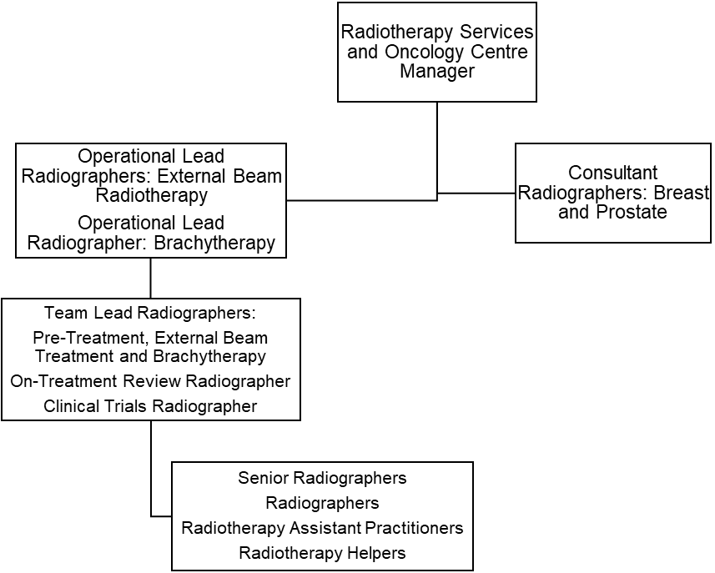

Principal Duties and Responsibilities:

Clinical

- Act in a team lead role capacity for the external beam radiotherapy service, providing technical expertise and leadership for all members of the wider radiotherapy team
- Set and maintain a high standard of patient care and clinical accuracy in all aspects of the service, demonstrating an ability to resolve highly complex issues with problem solving skills and effective autonomous decision-making
- Take responsibility for the safe use of highly complex and expensive equipment
- Maintain and continually develop knowledge of radiotherapy pre-treatment and treatment techniques and practices in order to participate in the development and implementation of these within the department
- Maintain and continually develop knowledge of verification imaging procedures and protocols in order to be responsible for the acquisition, comparison, assessment and manipulation of images used for the accurate verification of radiotherapy treatments
- Communicate effectively with Oncology Consultants and Registrars regarding highly complex treatment information to ensure the safe and accurate delivery of radiotherapy planning and treatment
- Demonstrate effective critical thinking to determine the suitability and efficacy of treatment prescriptions, treatment set-ups and departmental procedures and protocols
- Be able to justify and authorise the patients’ treatment, using own theoretical knowledge and clinical experience, on the basis of clinical condition and in accordance with IRMER; recognise when it might be appropriate to withhold patient treatment
- Demonstrate the ability to resolve highly complex treatment issues, using problem solving skills and effective, autonomous decision-making, including in absence of the relevant Consultant
- Communicate effectively with the multidisciplinary team in order to facilitate the highest standard of patient care and treatment delivery
- Communicate effectively with the patient, often having to use skills of persuasion, empathy and reassurance in order to deliver or receive complex/highly sensitive information whilst maintaining patient confidentiality and dignity at all times and ensuring that accurate records of any communications are produced when appropriate; overcome any barriers to effective communication that might exist
- Ensure that all patients receive accurate information and documentation relating to their treatment, potential side-effects and management of side-effects prior to the onset of treatment
- Ensure that the patient gives informed consent prior to treatment
- Provide a supportive and confidential environment for patients and their carers; provide the same for all members of the wider team
- Provide support to terminally ill patients and/or their carers, often on a daily basis
- Develop and maintain an advanced knowledge of the ARIA record & verify system, providing training in the system to other team members as required
- Develop and maintain knowledge of the Activity Capture data system, providing training in the system to other team members as required
- Use a high level of skill to manipulate and position the patient in order to achieve an accurate treatment set-up
- Maintain a high level of concentration at all times, given the need to deliver highly complex treatments with minimal tolerance margins
- Use appropriate manual handling techniques and equipment to ensure safety for both the patient and all members of the team, including themselves
- Maintain a professional and reassuring manner when exposed to bodily fluids or foul odours caused by tissue necrosis or treatment reactions, often on a daily basis
- Ensure that all treatment equipment is safe and accurate to operate
- Undertake appropriate machine checks prior to the clinical use of equipment and report any variances immediately
- Ensure that equipment is available for QA and maintenance at the agreed times, thus complying with local arrangements to ensure safety and to reduce the potential for hazards associated with radiation exposure; lead the negotiations for such arrangements with the multi-disciplinary team
- Demonstrate specialist knowledge of treatment side-effects and their management; take responsibility for the referral of patients for clinical assessment by a Consultant (or representative) prior to continuation of treatment when side effects become acute
- Plan pre-treatment and treatment workloads according to the needs of patients and the availability of appropriate staff
- Participate in the management of radiotherapy machine scheduling, taking particular care to minimise delays and breaks in treatment in accordance with Trust policy and clinical guidelines
- Ensure that patients receiving concurrent modalities of treatment are managed in accordance with the appropriate time intervals between implementation of each modality
- Calculate and check specialised dose calculations and complex planning data relating to the delivery of treatment
- Undertake the data entry, checking and/or authorisation of complex treatment data in the computerised patient information system (ARIA)
- Maintain highly accurate treatment and statistical records
- Ensure that all completed treatments are appropriately summarised and that the treatment details are accurately filed in the patients’ electronic records
- Participate in the delivery of the on-call service for emergency referrals
- Work flexible hours, to include bank holiday working and overtime as necessary, to support service delivery

Managerial

- Participate in the daily operational management of the external beam treatment service, to include the allocation of workload, prioritisation of demands and accommodation of unplanned events
- Participate in staff rostering, to include the assurance of appropriate skill mix in each clinical area
- Take responsibility for own safe use of highly expensive, highly complex radiotherapy treatment equipment and the supervise others doing the same
- Ensure that highly complex equipment is available to provide the service safely and efficiently, liaising with the Medical Physics and Engineering team as necessary
- Be responsible for communicating equipment breakdowns and faults to the Engineering and Physics teams, ensuring correct procedures are followed for the safety of staff and patients
- Provide professional and clinical leadership to both the radiotherapy team and the wider radiotherapy workforce
- Set and maintain high standards of quality for all aspects of work undertaken in the external beam radiotherapy service, ensuring that staff have the appropriate skills and knowledge for their assigned duties
- Lead in the development of IGRT clinical protocols and in their implementation in practice, to include documentation of protocols, development and delivery of training programmes and audit of outcomes
- Use effective time management skills and managerial strategies to organise daily clinical sessions and own designated workload
- Participate in the recruitment and selection of students and junior staff
- Participate in the review of staff through PDR, PDP and performance management
- Be aware of national waiting times targets, and collaborate in the development of strategies that ensure these targets are met
- Have knowledge of legislation relating to the safe use of ionising radiation (IRR, IRMER), ensuring compliance (own and wider team) across the service and promptly reporting areas of non-compliance
- Demonstrate a good understanding of Trust and national policy relating to COSHH, infection control and information governance; contribute to ensuring compliance with policy within the radiotherapy service
- Deputise for the Operational Leads as required

Teaching, Training and Research

- Provide specialist clinical training, supervision, mentoring and performance review for Radiographers, Assistant Practitioners, Helpers, new members of staff and other healthcare professionals within the area of accountability
- Participate in the induction of new staff and mentor staff within the area of accountability
- Participate in student appraisal and validation of suitability to practice; be responsible for the supervision of students in the treatment area in conjunction with the student appraisers
- Lead in the development of IGRT training programmes, the delivery of training and competency assessment for Radiographers and Student Radiographers
- Encourage and support other members of the team to undertake CPD and personal / professional development
- Prepare and deliver tutorials/presentations to other healthcare professionals
- Participate in the collection of data for clinical trials as requested
- Initiate in-house research and technical developments where appropriate

Quality

- Support the Radiotherapy Services Manager in setting, monitoring and developing standards of care
- Demonstrate expert knowledge in the management of the departmental Quality Management System (QMS)
- Take a leading role in developing the quality strategies and processes that will improve the care of patients
- Produce evidence based protocols and procedures for inclusion in the QMS and implement these in the treatment area in accordance with the national guidance and governance standards
- Undertake review of QMS procedures and protocols, to include routine internal auditing of procedures and protocols
- Identify and report non-conformities within the departmental QMS, and address these issues appropriately
- Participate in external audit of the QMS and departmental visits by regulatory bodies e.g. HSE, CQC
- Undertake error reporting and full investigation, including root cause analysis
- Participate in effective clinical risk management
- Ensure clinical practice is based on validated research
- Assist, where appropriate, in the collection of data for research or audit purposes
- Demonstrate the work of the department to other professionals or interested parties as required
- Take an active role in the management of waiting times targets

Professional Standards

- Act as a role model for other staff members
- Maintain a professional manner and appearance at all times
- Take professional responsibility for own actions
- Comply with the Society of Radiographers’ Professional Code of Conduct and promote the status of Therapeutic Radiographers as autonomous healthcare professionals
- Maintain and develop knowledge and skills in accordance with the Continuing Professional Development policy to ensure that mandatory professional registration is achieved
- Participate in own regular performance appraisal and personal development planning
- Update and maintain own specialist skills and knowledge in all aspects of external beam radiotherapy; keep up to date with the latest technical and scientific developments and new practices relating to clinical oncology
- Attend suitable seminars, meetings and courses as part of personal development and to further the work of the department
- Be aware of and comply with current regulations governing the administration of ionising radiations
- Undertake essential training as required by the Trust, to include fire training, information governance and manual handling training
- Comply fully with Trust infection control policies, acting at all times in such a manner as to minimise the risks of spread of infection
- Comply fully with the Trust incident reporting procedure
- Be aware of and comply with all other Trust policies
- Ensure that matters of a confidential nature (relating to either the patient or another staff member) are not divulged without the appropriate authority to do so

This post has been identified as involving access to vulnerable adults and/or children and in line with Trust policy successful applicants will be required to undertake a Disclosure & Barring Service Disclosure Check

General

This is a description of the job as it is now. We periodically examine employees' job descriptions and update them to ensure that they reflect the job as it is then being performed, or to incorporate any changes being proposed. This procedure is conducted by the manager in consultation with the jobholder. You will, therefore be expected to participate fully in such discussions. We aim to reach agreement on reasonable changes, but if agreement is not possible, we reserve the right to insist on changes to your job description after consultation with you.

Everyone within the Trust has a responsibility for, and is committed to, safeguarding and promoting the welfare of vulnerable adults, children and young people and for ensuring that they are protected from harm, ensuring that the Trusts Child Protection and Safeguarding Adult policies and procedures are promoted and adhered to by all members of staff.

PERSON SPECIFICATION

POST: EBRT Team Lead Radiographer / IGRT Specialist Practitioner

REQUIREMENTS | Essential | Desirable
Qualifications / Special Training:

Degree in Radiotherapy or equivalent qualification of the College of Radiographers | ✓
HCPC Registration | ✓
Evidence of post-qualification study at MSc level | ✓
Management and Leadership qualification / relevant clinical experience |  | ✓
Evidence of Continuing Professional Development | ✓
Knowledge / Skills:

In depth and up to date knowledge of Radiotherapy pre-treatment, verification imaging and treatment practices | ✓
Expertise in the use of radiotherapy record and software systems | ✓
Ability to contribute to the day to day operational management of the external beam treatment service | ✓
Highly developed specialist knowledge of radiotherapy practice and care of the patient undergoing radiotherapy treatment | ✓
Able to communicate complex or sensitive information using a variety of communication techniques | ✓
Sound understanding of team dynamics; able to lead and motivate a team |  | ✓
Evidence of successful multidisciplinary team working | ✓
Able to question and challenge practice |  | ✓
Understand the principles of quality assurance and audit and their importance in radiotherapy | ✓
Able to problem-solve and make autonomous decisions | ✓
Able to develop and implement new and relevant protocols |  | ✓
Understand the significance of radiotherapy research / audit and the use validated results to improve practice |  | ✓
Knowledge and application of the legislative regulations relating to the use of ionising radiation (IRR, IRMER) | ✓
Understand the principles of governance in radiotherapy |  | ✓
Knowledge of cancer patient pathways | ✓
Experience:

Significant post-qualification clinical experience at senior level | ✓
Good understanding of the operational management of a radiotherapy treatment service | ✓
Evidence of ability to support and supervise other staff | ✓
Experience of involvement in service improvements | ✓
Evidence of involvement in recruitment and selection |  | ✓
Evidence of involvement in staff performance management and appraisal |  | ✓
Experience of managing waiting times for radiotherapy | ✓
Personal Attributes:

Enthusiastic, highly motivated and committed to developing the service | ✓
Able to work under pressure and deal with sensitive or stressful situations | ✓
Excellent time management and organisational skills; ability to prioritise effectively | ✓
Assertive, self-motivated and reliable; able to work autonomously | ✓
Proven ability to communicate with people over a wide range of professional and organisational backgrounds | ✓
Committed to providing a high quality service to patients and their carers | ✓
Other Requirements:

Strong commitment to own further professional development | ✓
Willingness to participate in service development | ✓
Able to lead in staff and student development | ✓
Willingness to participate in flexible working hours, on call and bank holiday rotas | ✓

Hazards within the role, used by Occupational Health for risk assessment
Laboratory Specimens  Proteinacious Dusts |  | Clinical contact with patients | X | Performing Exposure  Prone Invasive Procedures | X
Blood/Body Fluids | X | Dusty Environment |  | VDU Use | X
Radiation | X | Challenging Behaviour |  | Manual Handling | X
Solvents |  | Driving |  | Noise
Respiratory Sensitisers | X | Food Handling |  | Working in Isolation

