
1234
JOB DESCRIPTION

1. JOB DETAILS

Job Title: Secretary

Band: 3

Responsible To: Administrative Line Manager/Department Line Manager

Accountable To: Administrative Line Manager/Department Line Manager

Department/Division: Research & Development

2. JOB PURPOSE
- To provide a good quality professional secretarial service to senior managers
- To provide support/cover to other secretaries within the team
- Specifically, this post will work with colleagues and team leaders to ensure that they provide a professional, efficient, accurate and timely service
- Ensure the professional image of the Trust is maintained at all times

3. KEY WORKING RELATIONS (Examples below are not exhaustive)
- Senior Management Teams
- Trust Executive members
- Non-Executive Directors
- Board of Governors
- Consultants and other members of the medical team
- Senior Nursing staff and other ward staff
- Administration and secretarial teams across the Trust
- External NHS organisations
- External organisations/providers

4. DIMENSIONS
- The post holder will be part of the HealthTech Research Centre in Sustainable Innovation (HRC), providing secretarial support to primarily the Directors, Chief Operating Officer and Senior Project Manager.
- The post holder will work 22.5 hours per week over three days.
- The role supports hybrid working, with an agreed balance of on-site and remote working in line with service needs.
- The post holder will use a range of Trust IT systems on a daily basis, including Microsoft Office applications and SharePoint for document production, communication and records management
Specific area of work and parameters of the post may be added here.

- The post holder will be part of a Trust Administration team. This post may involve some evening/weekend working as required.

5. ORGANISATIONAL CHART

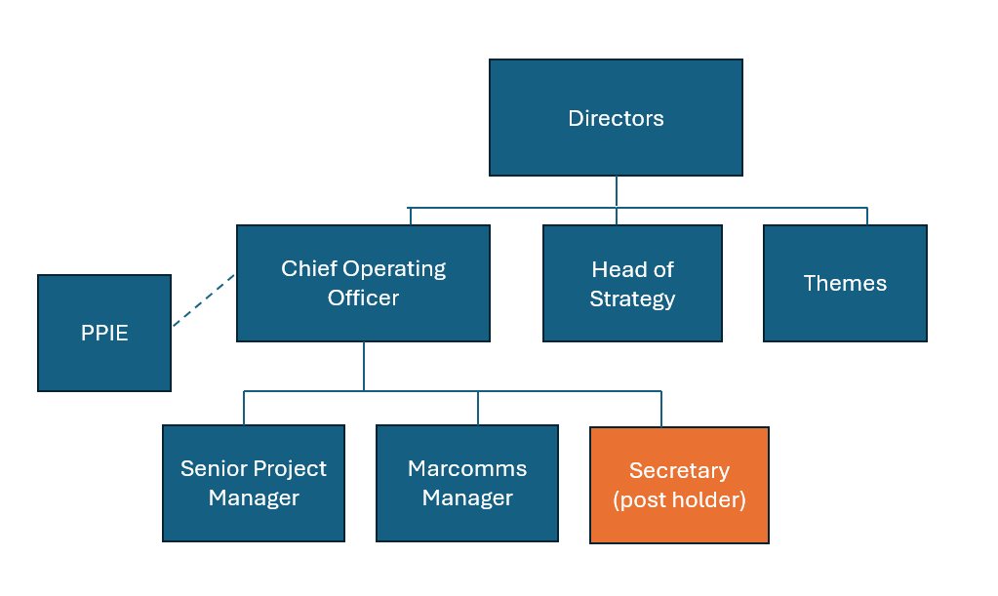

6. KEY RESULT AREAS/PRINCIPAL DUTIES AND RESPONSIBILITIES:
Administrative functions
- To manage Senior Managers and team diaries
- To organise and co-ordinate meetings including sourcing of suitable venue, time, equipment.
- To provide minute/note taking at meetings, ensuring typed notes are circulated to attendees within the timeframes stipulated within Trust policies/standard operating procedures.
- To ensure that all documentation is produced to an excellent standard. This may include audio typing and personal dictation.
- To maintain records and filing systems in line with Trust policies.
- To operate an effective bring forward system, ensuring necessary range of papers are available to management team.
- To undertake photocopying and distribution of papers as required.
- To set up and maintain accurate and effective filing systems both paper based and electronic filing systems.

Service delivery/improvement
- To work with the team to ensure adequate cover is in place during periods of leave
- Contribute to the NHS service improvement/modernisation agenda e.g. service redesign
- Work as part of the team in developing processes within the department to meet the demands of a growing service
- Participate in team and directorate meetings as required
- Contribute to audits regarding departmental procedures
- To have a flexible approach to working hours to meet the demands of the service
- Adhere to the Trust Access Policy and Health Records Policy and appropriate standard operating procedures, Key Performance Indicators, government targets and standard operational policies

Communication
- To communicate with staff, external organisations and colleagues in a courteous, professional and timely manner at all times
- To deal with all day to day correspondence within the department – initiating appropriate responses in order to provide, staff and other parties with required information in a friendly and professional manner
- To contact staff when meetings need to be rescheduled
- Make and receive telephone calls both external and internal according to Trust standards
- Take messages, ensuring they are actioned and/or received by the correct recipient
- Communicate effectively including discussion and written communication
- Proactively manage email communication in line with the RD&E’s Email Best Practice guidance
- Provide excellent customer care, in a calm and professional manner – some situations may be challenging
- Organise and/or support meetings through effective communication

Governance
- Undertake training as required to maintain competency/comply with trust policies
- Work within Trust policies – including those for confidentiality, data protection, health and safety fire protection, and annual appraisal
- Adhere to the Trust Access Policy, Key Performance Indicators, government targets and standard operational policies and procedures

Resource Management
- Provide cover in periods of absence as directed by department manager, this may involve moving to other areas
- Monitor use of supplies and stationery and ensure this is done efficiently and cost effectively in line with the needs of the service

Additional Responsibilities
- The post holder will be expected to carry out any other duties as required, commensurate with their pay band
- The post holder will be required to facilitate and support new starters to carry out their role
- The post holder will understand the limitations of the role and how to access support

OTHER RESPONSIBILITIES

Take part in regular performance appraisal.

Undertake any training required in order to maintain competency including mandatory training, e.g. Manual Handling

Contribute to and work within a safe working environment

You are expected to comply with Trust Infection Control Policies and conduct him/herself at all times in such a manner as to minimise the risk of healthcare associated infection

As an employee of the Trust, it is a contractual duty that you abide by any relevant code of professional conduct and/or practice applicable to you. A breach of this requirement may result in action being taken against you (in accordance with the Trust’s disciplinary policy) up to and including dismissal.

You must also take responsibility for your workplace health and wellbeing:
- When required, gain support from Occupational Health, Human Resources or other sources.
- Familiarise yourself with the health and wellbeing support available from policies and/or Occupational Health.
- Follow the Trust’s health and wellbeing vision of healthy body, healthy mind, healthy you.
- Undertake a Display Screen Equipment assessment (DES) if appropriate to role.

GENERAL

This is a description of the job as it is now. We periodically examine employees' job descriptions and update them to ensure that they reflect the job as it is then being performed, or to incorporate any changes being proposed. This procedure is conducted by the manager in consultation with the jobholder. You will, therefore, be expected to participate fully in such discussions. We aim to reach agreement on reasonable changes, but if agreement is not possible, we reserve the right to insist on changes to your job description after consultation with you.

Everyone within the Trust has a responsibility for, and is committed to, safeguarding and promoting the welfare of vulnerable adults, children and young people and for ensuring that they are protected from harm, ensuring that the Trusts Child Protection and Safeguarding Adult policies and procedures are promoted and adhered to by all members of staff.

At the Royal Devon, we are committed to reducing our carbon emissions and minimising the impact of healthcare on the environment, as outlined in our Green Plan available on our website. We actively promote sustainable practices and encourage colleagues to explore and implement greener ways of working within their roles.

PERSON SPECIFICATION

POST: Secretary
BAND: 3
REQUIREMENTS | Essential / Desirable at:
 | Recruitment | 1st PDR or (award of) increment
QUALIFICATIONS / TRAINING:  Minimum of 3 qualifications, to include GCSE grade A-C/4-9 or equivalent in Maths and English  RSA III Typing or equivalent  Audio Typing qualification or equivalent experience  NVQ Level 3 in Business Admin or equiv.  Clinical Document Management (CDM)  ECDL, CLAIT or equivalent | E  E  E  E  D  D | E  E  E  E  E  E
KNOWLEDGE / SKILLS:  Excellent planning & organisational skills  Ability to prioritise workload to respond to changing demand  Ability to co-ordinate complex diary management  Ability to liaise and communicate with staff at all levels  Motivation and negotiation skills  Excellent interpersonal & communication skills inc. demonstrating empathy & sensitivity to patients and relatives  Ability to promote good working liaisons (staff, patients, relatives)  Extracting information / Listening Skills  Ability to handle complex enquiries - distressed & anxious patients  Ability to deal with challenging behaviour  Ability to provide excellent customer care  Knowledge of IT databases and computer systems  Comprehensive PC skills - databases, word-processing, email, Excel  Understanding of hospital IT systems  Knowledge of PAS or equivalent information system  Analytical skills & ability to problem solve  Proven strong administration skills  Accurate data entry  Excellent telephone manner  Accurate Audio Typing  Knowledge of Trust procedures  Able to work independently, with minimum supervision | D  D  D  E  D  E  E  E  E  E  E  E  E  D  D  D  E  E  E  E  D  D | E  E  E  E  E  E  E  E  E  E  E  E  E  E  E  E  E  E  E  E  E  E
EXPERIENCE:  Previous clerical experience  Working in an NHS/clinical environment e.g. hospital, GP surgery, CCG | E  D | E  E
PERSONAL ATTRIBUTES:  Enthusiastic highly motivated & committed to delivering a service  Understand team work and work within a team  Able to plan and organise workload  Able to prioritise own work load and meet deadlines  Ability to work un-supervised  Can remain calm and professional in a busy environment  Empathetic, but able to understand professional boundaries  Smart appearance, adhering to the Uniform Policy  Welcoming friendly and approachable manner  An adaptable approach to work  Flexible approach to working hours  Commitment to continual development to Inc. relevant new systems, policies and procedures  Adheres to relevant Trust policies & procedures  Adheres to confidentiality & data protection requirements | E  E  E  E  E  E  E  E  E  E  D  E  E  E | E  E  E  E  E  E  E  E  E  E  E  E  E  E

Hazards within the role, used by Occupational Health for risk assessment
Laboratory specimens |  | Clinical contact with patients |  | Dealing with violence & aggression of patients/relatives
Blood / Body Fluids |  | Dusty environment |  | VDU Use
Radiation / Lasers |  | Challenging behaviour |  | Manual Handling
Solvents |  | Driving |  | Noise / Vibration
Respiratory sensitisers |  | Food Handling |  | Working in isolation
Cytotoxic drugs |  | Electrical work |  | Night working

