JOB DESCRIPTION

- JOB DETAILS

Job Title: Cluster Support Manager

Grade: 7

Responsible To: Cluster Manager & Pathology Service Manager, Specialist Services

Accountable To: Divisional Business Manager, Specialist Services

Section/Department/Directorate: Specialist Services

- JOB PURPOSE

- To provide managerial leadership with the support of the Divisional Business Manager, Associate Medical Director, Head of Midwifery & Assistant Director of Nursing, Pathology Service Manager and Cluster Managers for Specialist Services in order to: -
- Manage the business activities of Specialist Services in accordance with Trust policies and within allocated resources.
- Support the Divisional Business Manager, Pathology Service Manager and Cluster Managers to continuously develop the most efficient and cost effective structure for the future delivery of those services with the involvement of clinicians, professionals and commissioners.
- Support the Divisional Business Manager, Pathology Service Manager and Cluster Managers to meet performance targets for quality, volume and cost.
- To take a proactive role in continuous improvement of services within the Cluster.
- To be a budget signatory for specialties pay and non-pay budgets, including Procurement of capital equipment.

3. DIMENSIONS/ KEY WORKING RELATIONS

- Divisional Director
- Divisional Business Manager
- Associate Medical Director for specified Cluster(s)
- Head of Midwifery and Assistant Director of Nursing
- Clinical Lead and Clinicians for specified Cluster(s)
- Nursing and Midwifery Leads
- Cluster Managers
- Pathology Service Manager
- Laboratory Managers
- Other Cluster Managers
- Operational Support Team
- HR Department
- Technical Staff
- IM&T Dept
- Divisional Management Accountant
- External Bodies: CCGs, Network and Users

- ORGANISATIONAL CHART:

Pathology Services

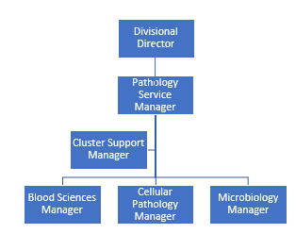

Cancer Services
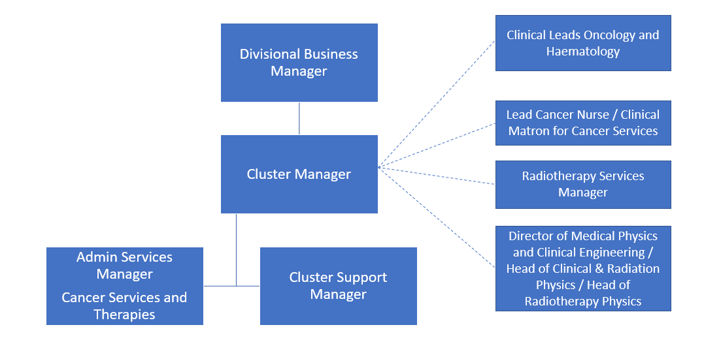

- KEY RESULT AREAS/PRINCIPAL DUTIES AND RESPONSIBILITIES:
- Leadership/Management
- Led by the Cluster Managers, and in conjunction with the Divisional Director, Divisional Business Manager, Pathology Service Manager, Lead Clinicians and Head of Midwifery & Assistant Director of Nursing/Senior Nurse for Specialist Services, helps develop the service strategy into an operational work plan for the specified Clusters, adjusting and developing the plan as required.
- Support an open environment which promotes innovation and a positive approach to service development.
- Support the Cluster Manager & Pathology Service Manager to continuously develop the most efficient and cost-effective structure for the future delivery of specified services with the involvement of clinicians, professionals, users and commissioners. Ensure the efficient and effective day to day management of services within Cancer Services and Pathology.
- Establish and maintain appropriate links with professionals in the health care community involved in developments that affect the services.
- Plan and implement change (in conjunction with clinical staff) in order to improve the quality of service in line with local needs and the NHS policy direction.

- Performance Management
- Monitor waiting times and related standards including the review of complex data/spread sheets and take action to ensure that performance targets for quality and volume are met.
- In conjunction with the Cluster Managers, provide the performance information for the Clusters which contributes to the Divisional report.

- Resource Management
- In conjunction with the Cluster Managers, oversee the management of the financial and physical resources within the Clusters.
- Identify revenue shortfalls and provide and implement business solutions.
- Support the Cluster Managers in the planning and implementation of capital schemes within specified services.
- Ensure the delivery of services agreed with purchasers within the financial constraints.
- Work with the Cluster Managers to deliver against agreed CIP targets and plans.

- Communication:
- Contribute to effective communication channels to ensure all staff in the department are aware of the aims and business of the department and Trust. Create an environment which allows open communication at all levels amongst all staff. Ensure application of principles of Investors in People and Trust values.
- Contribute to the development of effective channels of communication and working relationships with officers of organisations outside the Trust, e.g. CCGs, SCG, other local acute Trusts and Networks.

- Service Agreements:
- Work with the Cluster Managers to ensure that service agreements or amendments are being negotiated to ensure the best outcomes for patients and the Trust.
- Work with the Cluster Managers and Finance Team to monitor delivery of service agreements and ensure that appropriate income is received.

- Quality and User Involvement
- Support the Divisional Business Manager in ensuring application of the Trust’s strategy for clinical governance to deliver appropriate quality and timeliness of service at a specialty level.
- Wherever possible and appropriate, seek the involvement of service users in service planning and monitoring.
- Act upon findings of internal or external audits to continuously improve the quality of the service.
- Addressing both verbal and written complaints in a timely, sympathetic and professional manner.

- Human Resources:
- In conjunction with the Cluster Managers, lead on the effective implementation of good human resource management in the specified services.
- In conjunction with the Cluster Managers, lead on modernisation and workforce role redesign for specified services
- Work with the Cluster Managers and Senior Nurses/Midwives to develop a workforce plan for the Clusters as part of the Divisional workforce plan.
- Ensure that Trust policies are adhered to in relation to recruitment, selection and development of all staff within the specialty including PDRs, mandatory training, absence management, disciplinary and grievance procedures.

- Policies
- Assist in the formulation implementation and subsequent and monitoring of Cluster and Divisional policies and procedures as appropriate.

- Organisation and Development
- In conjunction with the Cluster Managers, organise the structure and work patterns of the Cluster services in order to ensure well defined line management and efficient and appropriate use of staff.

- Audit/Research
- Ensure compliance with audits undertaken by external bodies such as Model Hospital, GIRFT, and CQC etc in a timely fashion.
- Ensure compliance with Trust Research Governance policies.

- Governance
- Working with the Lead Clinicians, Senior Nurses and Senior Scientists to ensure that Clusters have a structure for debating, reviewing and implementing issues relating to the governance of the Clusters
- In the designated Clusters, in conjunction with the Cluster Managers, ensure the implementation of the Trust’s Clinical Governance, Health and Safety and Risk Management policies and plans, and monitor implementation and compliance within the Clusters
- Health and Safety – Ensure adherence to the Trust’s Health and Safety policy and management system. Ensure all staff are aware of its implication and their own roles and responsibilities.
- To undertake any training required in order to maintain competency including mandatory training, i.e. Fire, Manual Handling
- To contribute to and work within a safe working environment

- Corporate and Divisional Responsibility
- Be aware of the Clusters’ place within the Division and the responsibility each part has for the success of the whole. Ensure that effective action is taken to preserve the financial integrity of the Trust.
- Deputise for the Cluster Managers as required.
- Take responsibility for Division wide projects as required

- GENERAL:
- This is a description of the job as it is at present constituted. It is the practice of this organisation periodically to examine employees' job descriptions and to update them to ensure that they relate to the job as then being performed, or to incorporate whatever changes are being proposed. This procedure is jointly conducted by each manager in consultation with those working directly to him or her. You will, therefore, be expected to participate fully in such discussions. It is the organisations' aim to reach agreement to reasonable changes, but if agreement is not possible management reserves the right to insist on changes to your job description after consultation with you.

- We are committed to serving our community by being a high quality specialist Hospital with consultant-led services. We aim to co-ordinate our services with primary and community care, and to develop a limited number as Sub-Regional Referral Centres with appropriate levels of research, development and educational involvement. Where appropriate, and consistent with our services, we may provide services aimed at preventing disease and debilitation.

- We aim to make all our services exemplary in both clinical and operational aspects. We will show leadership in identifying healthcare needs to which we can respond and in determining the most cost-effective way of doing so. We will share our knowledge with neighbouring healthcare agencies and professionals.

- We recruit competent staff whom we support in maintaining and extending their skills in accordance with the needs of the people we serve. We will pay staff fairly and recognise the whole staff’s commitment to meeting the needs of our patients.

- The Trust operates a ‘non smoking' policy. Employees are not able to smoke anywhere within the premises of the Trust or when outside on official business.

The post holder is expected to comply with Trust Infection Control Policies and conduct him/her at all times in such a manner as to minimise the risk of healthcare associated infection.

PERSON SPECIFICATION

POST : Cluster Support Manager

REQUIREMENTS | At Recruitment | At KSF 2nd Gateway
QUALIFICATIONS/SPECIAL TRAINING :  Educated to Masters level or relevant equivalent experience  Post graduate management qualification | D  D | E  E
KNOWLEDGE/SKILLS  Innovative, able to problem solve and make decisions  Working knowledge of intricate healthcare service delivery issues  Ability to influence and negotiate across a broad range of professions and/or organisations as appropriate  Ability to analyse/interpret a range of highly complex data in order to identify solutions to service delivery  Highly effective interpersonal, communication and people management skills when dealing with highly complex, or sensitive information  Detailed knowledge of performance management frameworks and methodologies.  Competent IT skills including Word, Excel, PowerPoint, databases and email  Sound understanding of operational budgetary management within the NHS  Ability to manage own time and meet deadlines | E  D  E  E  E  D  E  D  E | E  E  E  E  E  E  E  E  E
EXPERIENCE:  Experience of working in secondary care within the NHS  Proven experience of change management/project management  Experience in demand and capacity planning | E  E  D | E  E  E
PERSONAL REQUIREMENTS  Remain calm in stressful situations  High level of self-awareness and openness to self-improvement  Awareness of diversity and equality issues within the NHS  Good persuasive and conflict resolution skills. | E  E  E  E | E  E  E  E
OTHER REQUIREMENTS  Flexible to the requirements of the role  Ability to travel to external meetings | E  E | E  E
* Essential/Desirable

HAZARDS :
Laboratory Specimens  Proteinacious Dusts |  | Clinical contact with patients |  | Performing Exposure  Prone Invasive Procedures
Blood/Body Fluids |  | Dusty Environment |  | VDU Use | X
Radiation |  | Challenging Behaviour | X | Manual Handling
Solvents |  | Driving |  | Noise
Respiratory Sensitisers |  | Food Handling |  | Working in Isolation
(NB. Above hazards shown is not an exhaustive list)

