

JOB DESCRIPTION

.

JOB DETAILS
Job Title | Registered Nurse Leg Ulcer Clinic
Reports to | The direct line manager
Band | AFC Pay scale (Subject to formal matching)
Department/Directorate | Community Services

JOB PURPOSE
To assess, provide and review nursing care, advice and information to patients and carers within the leg ulcer clinic environment, occasionally seeing patients in other care settings and their own home.
To provide individualised care and education to patients enabling them to maximise their independence and optimise their quality of life.
To work under the direction of the Leg Ulcer Nurse Specialist band 6 and the Leg Ulcer Manager using their skills and knowledge as a Registered Nurse.
Possible opportunities include, once confident and competent, being able to hold a designated caseload and deputise in the absence of the Nurse Specialist once knowledge, competencies and experience are gained

K
KEY RESULT AREAS/PRINCIPAL DUTIES AND RESPONSIBILITIES
As listed in the following areas:

KEY WORKING RELATIONSHIPS
Areas of Responsibility: (type of work undertaken)

No. of Staff reporting to this role: variable

The post holder is required to deal effectively with staff of all levels throughout the Trust as and when they encounter on a day to day basis
In addition the post holder will deal with the wider healthcare community, external organisations and the public.
This will include verbal, written and electronic media.

Of particular importance are working relationships with:
Internal to the Trust | External to the Trust
- Community Nurses | - Patients
- Podiatry | - Carers
- Vascular Department | - Relevant external agencies
- Other departments as necessary i.e. Dietetics | - General Practitioners

ORGANISATIONAL CHART
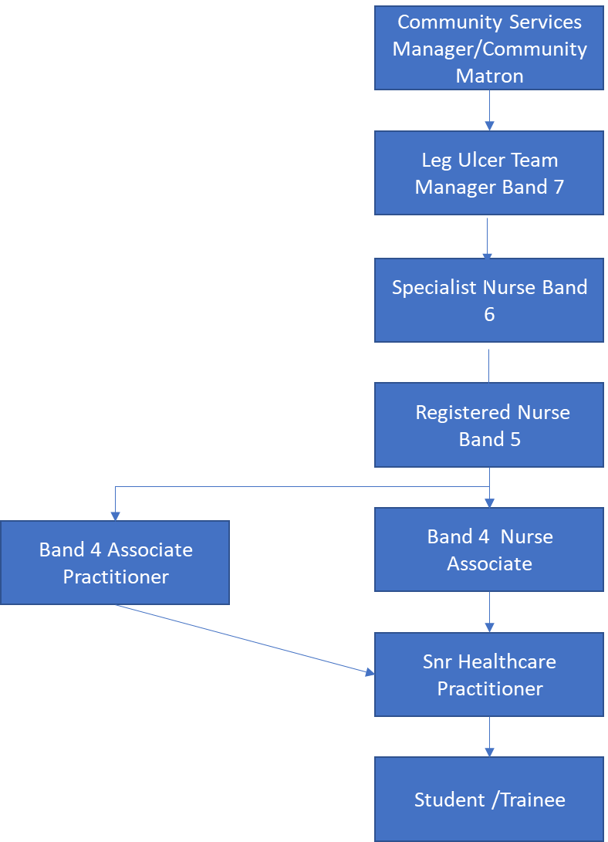

FREEDOM TO ACT
Work is managed rather than directly supervised.
Work within codes of practice and professional guidelines.
Works within organisational Policies, Procedures and Standard Operational Procedures (SOP).
May be responsible to make decisions alone and decide when necessary to refer to the Nurse Specialist .Identify through risk assessment when to escalate to: Nurse Specialist , Leg Ulcer Team Manager , Community Services Manager, Clinical Matron - Community and if required the use of the on-call escalation process and other healthcare professionals.

COMMUNICATION/RELATIONSHIP SKILLS
Communicating and building therapeutic relationships with patients, relatives, carers and professional partners to ensure patient care is focal and managed effectively.

Communicates sensitive information concerning patient’s medical condition, requiring tact, guidance and reassurance skills, overcoming barriers to understanding through negotiation.

Act at all times in a manner which illustrates Trust Values; compassion, respect for privacy, dignity and confidentiality.

Understand the implications of the Mental Capacity Act and acts to assess capacity as appropriate.
Understand the safeguarding adult’s issues and act within the guidance of the policy to keep adults within their care safe.

Able to keep accurate contemporaneous documentation and care plans using and supporting the organisation documentation held in electronic Healthcare records systems.

This role requires excellent and competent communication skills, verbal, written and use of IT.
ANALYTICAL/JUDGEMENTAL SKILLS
Analyse and act appropriately in complex situations and escalate.

Make judgements on a range of facts that require analysis and comparison of options and determine the actions.

PLANNING/ORGANISATIONAL SKILLS
The post holder will be expected to:
Prioritise own workload.
Assess, plan, implement and evaluate programmes of care for individual patients.
Co-ordination with other providers when appropriate regarding care provision.
Ability to manage the day to day organisation of the team and caseload in partnership with the Nurse Specialist and if appropriate manage this in their absence once competent and experienced.

PATIENT/CLIENT CARE
This post holder will assess, plan, implement and evaluate nursing care programmes in the community setting.
Always work within the standards set out in the Nursing and Midwifery Council (NMC) Code: Professional Standards of Practice Behaviour for Nurses and Midwives.
Demonstrate clinical competence developed through continual professional development, reflective practice and maintenance of a personal development plan.
Undertake training to develop a range of knowledge and skills in order to deliver high quality evidenced based nursing care.
Recognise and appropriately address risk factors to patients and carers within their healthcare setting and escalate the risk.
Promote health and wellbeing.
Prevention of adverse effects on health and wellbeing.
To report any untoward incidents, complaints and clinical emergencies to the appropriate professional within the appropriate timescale including safeguarding.
Ensure appropriate delegation and use of resources.
Contribute to quality care delivery through audits, reports and organisational performance data.

POLICY/SERVICE DEVELOPMENT
To work to Trust Policies, Procedures and Standard Operating Procedures (SOP).
To maintain Trust Standards of Clinical Governance.
To maintain Professional Standards of Practice

FINANCIAL/PHYSICAL RESOURCES
Ensure the efficient use of resources i.e. appropriate wound dressing choice, Bandaging, Hosiery that is evidence-based and use of agreed formularies.
Assist with maintaining stocks and supplies.
Liaising with GP Practices regarding provision of resources supplied by them.

HUMAN RESOURCES
Ensure adherence to lone working policy, to include use of a personal alarm. Deputises and takes charge of caseload management if appropriate in the absence of the Nurse Specialist
Training, supervising and supporting all staff, pre and post registration students, QCF /Care Certificate candidates, work experience students, support workers, formal and informal carers.
To support the Nurse Specialist (community) in the completion of appropriate staff supervisions, staff appraisals and Personal Development Plans (PDP).
Individual responsibility for ensuring attendance at mandatory training.
Practice Assessor qualification and responsibility for maintenance of this to support pre-registration students of nursing.
Participate in supervision and appraisal with line manager to support professional development focussing on the individual skill set and competency.
INFORMATION RESOURCES
Inputting, storing and providing information in relation to patient records.
Accurately completing and maintaining effective patient’s records including addressing confidentiality issues.
Completing activity data using Trust agreed data collection sets.
Inputting and storing information on relevant electronic healthcare records systems

RESEARCH AND DEVELOPMENT
Works with senior colleagues to develop further expertise in developing own and team evidence based nursing practice, including research and involvement in the audit process. Make recommendations for and support change within the service.
PHYSICAL SKILLS
A range of highly developed clinical skills including e.g. dexterity and accuracy for application of dressings and specialist Bandaging. Hosiery and wrap application. This list is not exhaustive.

PHYSICAL EFFORT
Daily work involves frequent driving, sitting/standing, walking, use of electronic healthcare records systems and moving equipment, manual handling in restricted positions. Working hours negotiated according to service need.
Use of IT equipment.
Operations and use of equipment related to provision of ulcer care ( electric chairs, ergo kneelers etc)

MENTAL EFFORT
Understanding of a range of procedures which are evidenced based:
Clinic procedures
Clinical observations
Basic life support
Assessing, planning, implementing and evaluating patient care
Infection control
Accurately completing and maintaining effective patient’s records including addressing confidentiality issues.
Work pattern can be unpredictable and subject to interruption i.e. calls being prioritised, other work colleagues, family/patient/carers’ needs.
Ability to use and concentrate for long periods using IT.

EMOTIONAL EFFORT
Caring for patients with chronic conditions and their families, carers and friends. This includes having to break bad news or give distressing news to patients/relatives/carers and dealing with emotional circumstances. Sometimes these patients may be end of life.
Instigates emergency procedures when necessary i.e. finding a collapsed patient and commencing basic life support.
Working with patients who have mental health, learning disabilities and challenging behaviour.
Ability to cope and deal with areas of conflict.
WORKING CONDITIONS
Working Conditions
Frequent daily contact with:
Body fluids – Wounds and Dressings
Smells
Infections
Dust
Occasional exposure to unpleasant working environment
Driving hazards
Transportation of samples in own vehicle
Visual Display Units (VDU)

OTHER RESPONSIBILITIES
Take part in regular performance appraisal.

Undertake any training required in order to maintain competency including mandatory training, e.g. Manual Handling

Contribute to and work within a safe working environment

You are expected to comply with Trust Infection Control Policies and conduct him/herself at all times in such a manner as to minimise the risk of healthcare associated infection

As an employee of the Trust, it is a contractual duty that you abide by any relevant code of professional conduct and/or practice applicable to you. A breach of this requirement may result in action being taken against you (in accordance with the Trust’s disciplinary policy) up to and including dismissal.

You must also take responsibility for your workplace health and wellbeing:
- When required, gain support from Occupational Health, Human Resources or other sources.
- Familiarise yourself with the health and wellbeing support available from policies and/or Occupational Health.
- Follow the Trust’s health and wellbeing vision of healthy body, healthy mind, healthy you.
- Undertake a Display Screen Equipment assessment (DES) if appropriate to role.

APPLICABLE TO MANAGERS ONLY
DISCLOSURE AND BARRING SERVICE CHECKS
This post has been identified as involving access to vulnerable adults and/or children and in line with Trust policy successful applicants will be required to undertake a Disclosure & Barring Service Disclosure Check.
GENERAL
This is a description of the job as it is now. We periodically examine employees' job descriptions and update them to ensure that they reflect the job as it is then being performed, or to incorporate any changes being proposed. This procedure is conducted by the manager in consultation with the jobholder. You will, therefore, be expected to participate fully in such discussions. We aim to reach agreement on reasonable changes, but if agreement is not possible, we reserve the right to insist on changes to your job description after consultation with you.

Everyone within the Trust has a responsibility for, and is committed to, safeguarding and promoting the welfare of vulnerable adults, children and young people and for ensuring that they are protected from harm, ensuring that the Trusts Child Protection and Safeguarding Adult policies and procedures are promoted and adhered to by all members of staff.

Northern Devon Healthcare NHS Trust and the Royal Devon and Exeter NHS Foundation Trust continue to develop our long standing partnership with a view to becoming a single integrated organisation across Eastern and Northern Devon. Working together gives us the opportunity to offer unique and varied careers across our services combining the RD&E’s track record of excellence in research, teaching and links to the university with NDHT’s innovation and adaptability.
This is

PERSON SPECIFICATION

Job Title | Registered Nurse Leg Clinic

Requirements | Essential | Desirable
QUALIFICATION/ SPECIAL TRAINING  Registered Nurse current NMC registration  Current up-to-date Mandatory Training | Yes  Yes
KNOWLEDGE/SKILLS  Leg Ulcer Competency Training  Wound Care Training | Yes  Yes
EXPERIENCE  Experience of working with Leg Ulcers /Wound Care  Experience working within a Leg Ulcer Clinic environment  Experience working within Lower Limb Therapy Services | Yes  Yes | Yes
PERSONAL ATTRIBUTES  self manager- ability to work on own –  good interpersonal skills,  good communication skills  Ability to be empathetic  Handle difficult or emotional situations  Good organisational skills  Able to work as a team member. | Yes  Yes  Yes  Yes  Yes  Yes  Yes  YES
OTHER REQUIREMENTS  The post holder must demonstrate a positive commitment to uphold diversity and equality policies approved by the Trust.  Full driving license and access to own vehicle - Ability to cover multiple clinic sites across North Devon. | Yes  Yes

FREQUENCY

(Rare/ Occasional/ Moderate/ Frequent)
WORKING CONDITIONS/HAZARDS |  | R | O | M | F
Hazards/ Risks requiring Immunisation Screening
Laboratory specimens | Y/N | Y
Contact with patients | Y/N
Exposure Prone Procedures | Y/N | Y
Blood/body fluids | Y/N |  |  | Y
Laboratory specimens | Y/N | Y
Hazard/Risks requiring Respiratory Health Surveillance
Solvents (e.g. toluene, xylene, white spirit, acetone, formaldehyde and ethyl acetate) | Y/N | R N NRR | RRRR
Respiratory sensitisers (e.g isocyanates) | Y/N | N
Chlorine based cleaning solutions  (e.g. Chlorclean, Actichlor, Tristel) | Y/N | OO | Y Y
Animals | Y/N | N
Cytotoxic drugs | Y/N | N
Risks requiring Other Health Surveillance
Radiation (>6mSv) | Y/N | N
Laser (Class 3R, 3B, 4) | Y/N | N
Dusty environment (>4mg/m3) | Y/N | N
Noise (over 80dBA) | Y/N | N
Hand held vibration tools (=>2.5 m/s2) | Y/N | N
Other General Hazards/ Risks
VDU use ( > 1 hour daily) | Y/N |  |  |  | Y
Heavy manual handling (>10kg) | Y/N |  | Y
Driving | Y/N |  | Y
Food handling | Y/N | N
Night working | Y/N | N
Electrical work | Y/N | N
Physical Effort | Y/N |  |  | Y
Mental Effort | Y/N |  |  | Y
Emotional Effort | Y/N |  | Y
Working in isolation | Y/N |  |  |  | Y
Challenging behaviour | Y/N | Y

