

JOB DESCRIPTION

- JOB DETAILS

Job Title: Clinical Medical Secretary

Band: Band 3

Responsible To: Administrative Line Manager

Accountable To: Clinical Lead for SHOs (Consultant)

Department/Directorate: Surgical Services

2. JOB PURPOSE

- To provide a comprehensive secretarial and administrative service to the junior medical workforce in order to support the work of the clinical area including being present at ward rounds and board rounds taking responsibility for any follow up actions, as appropriate
- To facilitate the smooth flow of patients through the department by implementing administrative systems to discharge processes.
- As this is an emerging role, work with managers to support the development of this role and job description.

- KEY WORKING RELATIONSHIPS

- Clinical Director/Lead Clinicians/Consultants, Trust Doctors and Doctors in training
- Senior matrons on the ward
- Pharmacists
- Radiology department
- Medical Secretaries
- Administrative Services Manager
- Other clinical staff
- Patients and their relatives
- GPs
- Directorate Management team
- Clerical and other secretarial staff
- Specialist nurses
- Nursing staff and other ward staff
- Other members of the multi-professional clinical team
- Health Records & IM&T Departments

4. ORGANISATIONAL CHART

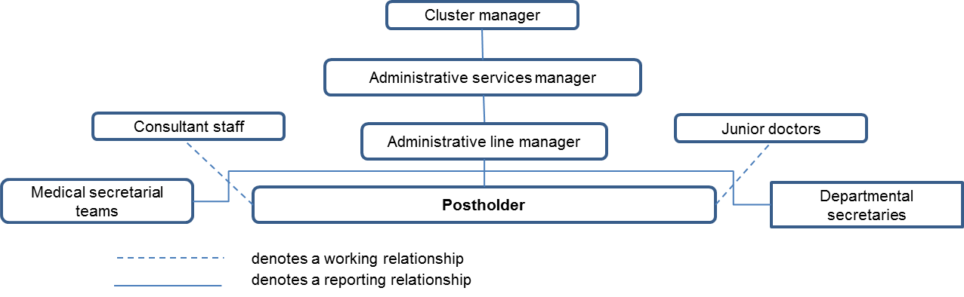

5. KEY RESULT AREAS/PRINCIPAL DUTIES AND RESPONSIBILITIES

Service delivery and improvement
- To ensure a full and efficient secretarial service is provided to the junior doctor teams. This will include audio typing and ensuring that all documentation (for example discharge summaries, ward rounds and TTOs) are produced accurately and in a timely manner.
- To be present at ward rounds and board rounds and take any appropriate actions, including updating investigations.
- To request and follow up on results as appropriate using relevant IT programmes and liaise with other departments in order to achieve this.
- To maintain accurate medical records and files in line with Trust policies.
- To monitor white card referrals and ensure they are actioned.
- To monitor the white board and start the TTO process in advance of patient discharge.
- To monitor the care of outliers under the care of the junior doctor team.
- To liaise with clinicians and other departments, both within and outside the Trust, to facilitate timely, safe discharge or transfer of patients.
- To contribute to the NHS service improvement by participating fully in new projects and developments such as service redesign work, proposing beneficial changes to working practices and procedures.
- To assist other secretaries and members of the admin team in the achievement of a quality service in line with best practice guidelines.

Communication
- To communicate with patients in a courteous, professional and timely manner at all times
- To receive telephone calls and accept messages on behalf of members of the clinical team and taking appropriate action where necessary.
- To manage email communication in a timely way and in line with the RD&E’s Email Best Practice guidance.
- To liaise with appropriate personnel in the multidisciplinary team to gather and co-ordinate patient information so that it is accessible in a timely manner.

Governance
- To undertake training as required to maintain competency/comply with Trust policies.
- To work within Trust policies – including those for confidentiality, data protection, health and safety fire protection, and annual appraisal.
- To comply with HR policies particularly in relation to mandatory (essential) training.
- To monitor any overdue CDM documents and ensure doctors validate in a timely fashion.

Other Responsibilities:
- To take part in regular performance appraisal
- To undertake any training required in order to maintain competency including mandatory training, e.g. Manual Handling
- To contribute to and work within a safe working environment
- In addition the post holder will be expected to be flexible and to carry out any other duties as required commensurate with the role responsibilities.

As an employee of the Trust, it is a contractual duty that you abide by any relevant code of professional conduct and/or practice applicable to you. A breach of this requirement may result in action being taken against you (in accordance with the Trust’s disciplinary policy) up to and including dismissal.

The post holder is expected to comply with Trust Infection Control Policies and conduct him/her at all times in such a manner as to minimise the risk of healthcare associated infection.

THE TRUST – Vision and Values

Our vision is to provide safe, high quality seamless services delivered with courtesy and respect. To achieve our vision we expect all our staff to uphold our Trust values. Our Trust values are:

Honesty, Openness & Integrity
Fairness,
Inclusion & Collaboration
Respect & Dignity

We recruit competent staff that we support in maintaining and extending their skills in accordance with the needs of the people we serve. We will pay staff fairly and recognise the whole staff’s commitment to meeting the needs of our patients.

We are committed to equal opportunity for all and encourage flexible working arrangements including job sharing.

We are committed to recruiting and supporting a diverse workforce and welcome applications from all sections of the community, regardless of age, disability, gender, race, religion, sexual orientation, maternity/pregnancy, marriage/civil partnership or transgender status. We expect all staff to behave in a way which recognises and respects this diversity, in line with the appropriate standards.

GENERAL

This is a description of the job as it is now but note that this is currently an emerging new role. We will periodically examine employees' job descriptions and update them to ensure that they reflect the job as it is then being performed, or to incorporate any changes being proposed. This procedure is conducted by the Manager in consultation with the jobholder. You will, therefore, be expected to participate fully in such discussions. We aim to reach agreement on reasonable changes, but if agreement is not possible, we reserve the right to insist on changes to your job description after consultation with you.

The RD&E is a totally smoke-free Trust. Smoking is not permitted anywhere on Trust property, including all buildings, grounds and car parks. For help to quit call: 01392 207462.

PERSON SPECIFICATION

POST: Clinical Medical Secretary
BAND: 3

REQUIREMENTS | At Recruitment | 2nd Gateway
QUALIFICATION
Minimum GCSE or equivalent in English and Mathematics | E | E
RSA III Typing or equivalent  Audio Typing qualification or equivalent  NVQ Level 3 in business administration or equivalent qualification or demonstrated equivalent experience | E  D  E | E  E  E
KNOWLEDGE/SKILLS:
Accurate audio typing | E | E
PAS computer system | E | E
Medical terminology or willingness to learn | D | E
Intermediate PC skills including databases, word-processing and email, including Microsoft Excel  Confident telephone manner | E  E | E  E
EXPERIENCE:
Experience of working in an NHS environment | E | E
Previous administration experience | E | E
Previous experience of working with the public | D | E
Previous secretarial experience | E | E
Contribution to service development | D | E
PERSONAL REQUIREMENTS:
Proven experience of adaptability in the workplace | E | E
Excellent interpersonal/Communication skills | D | E
A flexible approach to work  Ability to work as part of a team and independently  Able to prioritise own workload and meet deadlines | E  E  E | E  E  E
Remain calm and professional in a busy environment  Adhere to data protection and confidentiality requirements | E  E | E  E
* Essential/Desirable

HAZARDS:
Laboratory Specimens Proteinacious Dusts |  | Clinical contact with patients |  | Performing Exposure Prone Invasive Procedures
Blood / Body Fluids |  | Dusty environment |  | VDU Use | X
Radiation |  | Challenging Behaviour | X | Manual Handling | X
Solvents |  | Driving |  | Noise
Respiratory Sensitisers |  | Food Handling |  | Working in isolation | X

