JOB DETAILS

Job Title: Lead Treatment Review Radiographer

Band: 7

Reports to: Radiotherapy Services Manager

Department/Directorate: Radiotherapy Department / Specialist Services Division

Job Purpose:

Exeter Oncology Centre uses highly specialised radiotherapy planning and treatment equipment to facilitate the delivery of approximately 1,800 courses of external beam treatment per annum.

To help ensure that the highest standards of patient care are delivered the post holder will be required to:

- Lead the radiographer-led on treatment review and follow up process, taking responsibility for the management of their own caseload.

- Provide specialist information and support for patients undergoing radiotherapy treatment using a variety of communication methods.

- Work closely with the Radiotherapy Services Manager, Operational Lead Radiographers and other appropriate Healthcare Professionals to ensure that the radiotherapy patient review service is established and advanced through the development and implementation of appropriate patient pathways and evidence-based protocols.

- Liaise effectively with all key members of the multidisciplinary team, using excellent communication skills to facilitate streamlining of the patient pathway and to ensure that the physical and psychosocial needs of the patient are met.

- Manage the training and development of other staff in the department who are involved in support and review activities to ensure that a consistently high standard of care is delivered to all patients.

- Maintain excellent clinical skills, participating in the day to day clinical delivery of safe and accurate radiotherapy planning and treatment activities as required, to include the provision of leadership and supervision to more junior staff, assistant practitioners and students and deputising for the Operational Lead Radiographers as necessary.

- Participate in working flexible hours to support the department’s extended day working pattern, bank holiday working and the on-call rota for emergency treatment referrals.

Key Working Relationships:

Internal:

Radiotherapy Services Manager
Clinical Lead Specialist Radiographers
Radiographers, Radiotherapy Assistant Practitioners and Helpers
Clinical Oncologists and Specialist Registrars
Radiotherapy Physicists and Technicians
Student Radiographers
Admin and Clerical Staff
Nursing staff, Cancer Nurse Specialists, other AHPs involved in site-specific patient care
Patients and their carers

External:

Healthcare Professionals relevant to the individual patient’s care e.g. GPs, District Nurses
Macmillan
Relevant Professional bodies
FORCE Cancer Charity / other charities or agencies that provide patient information, support and/or care
Other radiotherapy professionals on a national basis

Dimensions:

- Provision of high quality, accurate and timely patient care in a safe environment
- Management and ongoing development of the on-treatment patient review process
- Provision of comprehensive patient information and support
- Delivery of competency training and assessment to other members of the team; monitoring of service standards in practice
- Development, maintenance and audit of protocols within the departmental Quality Management System
- Responsibility for the effective organisation of staff and workload, considering factors necessary for the maintenance of accuracy and safety, quality and efficiency
- Maintenance of expertise in radiotherapy planning, treatment and verification procedures
- Provision of clinical leadership, teaching and supervision for more junior staff
- Management of a sectional team as designated
- Participation in student training and assessment
- Participation in the recruitment of radiotherapy staff
- Participation in staff assessment and development through the PDR process

Organisational Chart:

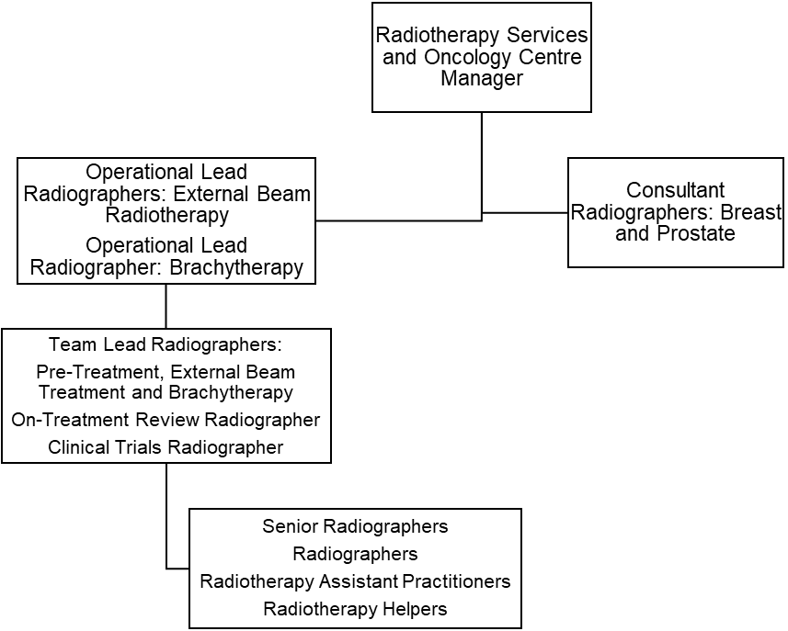

Key Result Areas/Principal Duties and Responsibilities:

Clinical: Treatment Review

- Lead and manage the radiographer-led review and follow up service for radiotherapy patients
- Develop, implement and continually review evidence-based treatment review protocols for inclusion in the Quality Management System
- Develop and implement training and competency packages for other members of the radiotherapy team
- Keep up to date with Trust policies, national guidance documents and developing clinical practices, ensuring that these are embedded in service delivery and protocols
- Provide a supportive and confidential environment for patients, their carers and other staff members
- Ensure that all patients receive accurate information and documentation relating to their treatment, potential side-effects and management of side-effects prior to the onset of treatment
- Communicate effectively with the patient, often having to use skills of persuasion, empathy or reassurance to deliver or receive complex/highly sensitive information whilst maintaining patient confidentiality and dignity at all times
- Ensure that accurate records of any communications are maintained
- Demonstrate specialist knowledge in the assessment of treatment side effects, initiating management strategies for these in line with evidence based departmental protocols
- Implement and maintain a programme of holistic needs assessment for all radiotherapy patients
- Adopt a multidisciplinary approach to patient care, collaborating with and/or signposting to other healthcare professionals or agencies as appropriate
- Communicate effectively with planning and/or treatment Radiographers to facilitate the highest standards of patient care and treatment delivery
- Communicate effectively with the wider multi-disciplinary team, both within and outside of the Trust, to facilitate the highest standards of patient care and treatment delivery
- Participate in the development and review of patient information leaflets
- Demonstrate an ability to utilise resources effectively and efficiently, negotiating with the Radiotherapy Services Manager when additional resource requirements are identified
- Collate and present data to provide evidence of productivity, quality and target outcomes
- Provide specialist advice to other healthcare professionals on all aspects of radiotherapy and associated patient care
- Demonstrate and promote the work of the department to other professionals or interested parties as appropriate

Clinical: Radiotherapy Treatment Service Delivery

- Participate in the safe and accurate delivery of radiotherapy planning and treatment procedures without the need for direct clinical supervision, maintaining a high standard of care for all patients
- Take responsibility for the safe use of highly complex and expensive equipment
- Use a high level of skill to manipulate and position the patient in order to achieve an accurate treatment preparation and patient set-up processes
- Maintain a high level of concentration at all times, given the need to deliver highly complex treatments with minimal tolerance margins
- Ensure that all treatment equipment is safe and accurate to operate before it is used clinically
- Undertake the appropriate machine checks prior to the clinical use any variances immediately
- Ensure that equipment is available for QA and maintenance at the agreed times, thus complying with local arrangements to ensure safety and to reduce the potential for hazards associated with radiation exposure
- Demonstrate the ability to resolve complex treatment issues using problem solving skills and autonomous decision making
- Organise the workload in any given area, taking account of the needs of patients and the availability of appropriate staff
- Participate in the management of radiotherapy machine scheduling, taking particular care to minimise delays and breaks in treatment in accordance with Trust policy and clinical guidelines
- Ensure that patients receiving concurrent modalities of treatment are managed in accordance with the appropriate time intervals between the implementation of each modality
- Process and check complex dose calculations and planning data relating to the delivery of treatment
- Undertake the data entry, checking and/or authorisation of complex treatment data in the computerised patient information systems
- Maintain highly accurate treatment and statistical records
- Demonstrate effective critical thinking to determine the suitability and efficacy of treatment prescriptions, treatment set-ups and departmental procedures and protocols
- Participate in decision making on the changes required for the patients’ treatment plan or the need to withhold patient treatment where appropriate
- Ensure that all completed treatments are appropriately summarised and that the treatment details are accurately filed in the patients’ hospital records
- Communicate effectively with Oncology Consultants and Registrars regarding highly complex treatment information to ensure the safe and accurate delivery of radiotherapy treatment
- Ensure that the patient has given informed consent prior to treatment
- Provide support to unwell and terminally ill patients and/or their carers on a daily basis
- Maintain a professional and reassuring manner when exposed to bodily fluids or foul odours caused by tissue necrosis and reactions to radiotherapy, often on a daily basis
- Participate in the delivery of the on-call service for emergency referrals
- Work flexible hours and overtime as necessary to support service delivery

Managerial

- Organise and manage a team of Radiographers, Assistant Practitioners, Helpers and students in a designated area of the department as requested
- Provide professional and clinical leadership to the wider radiotherapy workforce
- Set and maintain high standards of quality for all aspects of clinical work, ensuring that staff have the appropriate skills and knowledge for their assigned duties
- Demonstrate effective time management skills and managerial strategies in the organisation of daily clinical sessions and/or own designated workload
- Be aware of national waiting times targets, and collaborate in the development of strategies that ensure these targets are met
- Ensure that Clinical Governance issues are identified, appropriately escalated and managed
- Participate in the recruitment and selection of staff
- Participate in the review of staff through PDR and PDP

Teaching, Training and Research

- Provide specialist clinical training, supervision and performance review for Radiographers, Assistant Practitioners, Helpers, new members of staff and other healthcare professionals within the wider cancer services field
- Participate in the induction of new staff and the provision of mentorship to less experienced staff members
- Undertake ongoing student appraisals and validation of suitability to practice
- Prepare and deliver tutorials/presentations to other healthcare professionals on a local and national level
- Participate in the collection of data for clinical trials as requested
- Initiate or participate in in-house research and audit where appropriate

Quality

- Support the Radiotherapy Services Manager in setting, monitoring and developing standards of care
- Demonstrate an understanding of quality strategies and processes to improve the care of patients
- Produce evidence-based protocols and procedures for inclusion in the Quality Management System
- Identify non-conformities and errors and address these issues through the appropriate systems
- Participate in internal audit of the Quality Management System
- Ensure clinical practice is based on validated research
- Assist in the collection of data for research purposes where appropriate
- Participate in effective clinical risk management
- Demonstrate the work of the department to other professionals or interested parties as required

Professional Standards

- Act as a role model for other staff members
- Maintain a professional manner and appearance at all times
- Take professional responsibility for own actions
- Comply with the Society of Radiographers’ Professional Code of Conduct
- Maintain and develop knowledge and skills in accordance with the Continuing Professional Development policy
- Participate in own regular performance appraisal and personal development planning
- Undertake all mandatory training as required by the Trust, to include fire training, information governance and manual handling training
- Comply fully with Trust infection control policies, acting at all times in such a manner as to minimise the risks of spread of infection
- Update own specialist skills and knowledge in all aspects of radiotherapy planning and delivery in order to maintain and develop clinical competence
- Be aware of and comply with current regulations governing the administration of ionising radiations
- Be aware of and comply with all other Trust policies
- Ensure familiarity and compliance with all local and national legislation relating to radiation exposure and/or health and safety issues in order to promote good working practice and a safe environment for staff, patients and their carers
- Comply fully with the Trust incident reporting procedure

This post has been identified as involving access to vulnerable adults and/or children and in line with Trust policy successful applicants will be required to undertake a Disclosure & Barring Service Disclosure Check

General

This is a description of the job as it is now. We periodically examine employees' job descriptions and update them to ensure that they reflect the job as it is then being performed, or to incorporate any changes being proposed. This procedure is conducted by the manager in consultation with the jobholder. You will, therefore be expected to participate fully in such discussions. We aim to reach agreement on reasonable changes, but if agreement is not possible, we reserve the right to insist on changes to your job description after consultation with you.

Everyone within the Trust has a responsibility for, and is committed to, safeguarding and promoting the welfare of vulnerable adults, children and young people and for ensuring that they are protected from harm, ensuring that the Trusts Child Protection and Safeguarding Adult policies and procedures are promoted and adhered to by all members of staff.

PERSON SPECIFICATION

POST: Lead Treatment Review Radiographer

REQUIREMENTS | Essential | Desirable
QUALIFICATIONS/SPECIAL TRAINING:

Degree in Radiotherapy or equivalent qualification of the College of Radiographers | ✓
HCPC Registration | ✓
Evidence of post-qualification study at MSc level | ✓
MSc module in Radiographer-Led Review |  | ✓
Evidence of Continuing Professional Development | ✓
KNOWLEDGE/SKILLS:

Extensive post-qualification clinical radiotherapy experience | ✓
Up to date knowledge of radiotherapy practice | ✓
Ability to lead and motivate a team | ✓
Ability to assume responsibility for the operational management of a treatment unit / treatment floor | ✓
Evidence of multidisciplinary team working | ✓
Understand the principles of quality assurance and audit and their importance in radiotherapy | ✓
Ability to develop and implement new protocols |  | ✓
Ability to problem-solve and make decisions | ✓
Understand the significance of radiotherapy research and use validated results to improve practice | ✓
Ability to collect and analyse statistical information relevant to own areas of practice |  | ✓
Good IT skills | ✓
Ability to communicate complex or sensitive information using a variety of communication techniques | ✓
Knowledge of cancer patient pathways | ✓
Knowledge of the wider cancer / NHS agenda |  | ✓
Presentation skills |  | ✓
EXPERIENCE:

Significant post-qualification clinical experience | ✓
Experience of working at Band 6 supervisory level | ✓
Evidence of ability to train, develop, support and supervise other staff and students |  | ✓
Experience of delivering service improvements |  | ✓
Evidence of involvement in recruitment and selection |  | ✓
Evidence of involvement in staff PDR |  | ✓
PERSONAL REQUIREMENTS:

Ability to work under pressure and deal with sensitive situations | ✓
Good time management and organisational skills; ability to prioritise effectively | ✓
Self-motivated and reliable | ✓
Ability to work autonomously | ✓
Caring and empathetic | ✓
Committed to providing a high-quality service to patients and their carers | ✓
OTHER REQUIREMENTS:

Willingness to develop professionally | ✓
Willingness to participate in service development | ✓
Willingness to participate in staff and student development | ✓
Willingness to participate in flexible hours working, bank holiday working and on call rotas | ✓

Hazards within the role, used by Occupational Health for risk assessment
Laboratory Specimens  Proteinacious Dusts |  | Clinical contact with patients | X | Performing Exposure  Prone Invasive Procedures | X
Blood/Body Fluids | X | Dusty Environment |  | VDU Use | X
Radiation | X | Challenging Behaviour |  | Manual Handling | X
Solvents |  | Driving |  | Noise
Respiratory Sensitisers | X | Food Handling |  | Working in Isolation

