

JOB DESCRIPTION

JOB DETAILS
Job Title | Senior Pharmacy Assistant Technical Officer (Dispensary)
Reports to | Dispensary Manager
Band | 3
Department/Directorate | Pharmacy / Specialist Services

JOB PURPOSE
The post holder will participate in the dispensing of all medicines for pharmacy customers and provide an efficient reception service to patients, staff and visitors.

KEY RESULT AREAS/PRINCIPAL DUTIES AND RESPONSIBILITIES
Dispensary Duties

- Greet and attend to all visitors (including patients) according to dispensary guidelines.

- Undertake computer-based training for the new Epic Electronic Patient Record and Dispensing system and prepare medications for patients use using this system.

- Dispense Royal Devon Inpatient, Outpatient, Discharge and Controlled Drug Medications in preparation for checking, using the Epic Dispensing System. You will also be expected to dispense medication for specialist areas including Devon Partnership Trust, the Hospice and specialty clinics within the Trust.

- Receive CD Prescriptions, Controlled Drug Requisition Books and other documents for onward dispensing or passing to the appropriate staff member/team for further action.

- Holds or willing to undertake Accuracy Checking Pharmacy Support Staff qualification. Accuracy checker on dispensary rota.

- Hand out medicines to patients and ward staff following correct processes.

- Ensure all prescriptions that are not generated within Epic have key relevant data included.

- Receive payment for Outpatient prescriptions or check the relevant exemption when applicable.

- Assist in meeting deadlines.

- Assist in the training of new member of staff including the dispensary team, pharmacists, foundation year pharmacists and pre-registration student technicians. You will also be expected to help in the training of the aseptic team (for dispensary weekend working only).

- Maintain accurate dispensary inventory by stock rotation/monitoring of stock (including date checking) and by keeping accurate computer and paper records.

- Maintain accurate dispensing records and assist with filing and archiving paperwork.

- Maintain clean and tidy dispensing facilities and safe systems of work.

- Answer the dispensary telephone calls and deal with enquiries in the appropriate manner according to departmental procedures.

- Print off and maintain the Dispensary Inbox emails and respond to queries appropriately.

- Assist in general house-keeping duties as and when necessary including:

  - Putting away medicines
  - Replenishing consumable items e.g. bags, bottles, oral syringes, etc.
  - Filing paperwork
  - Cleaning trays and workbenches regularly

KEY WORKING RELATIONSHIPS
Of particular importance are working relationships with:

- Dispensary Manager
- Pharmacists
- Medicines Management Technicians
- Dispensary Team

ORGANISATIONAL CHART
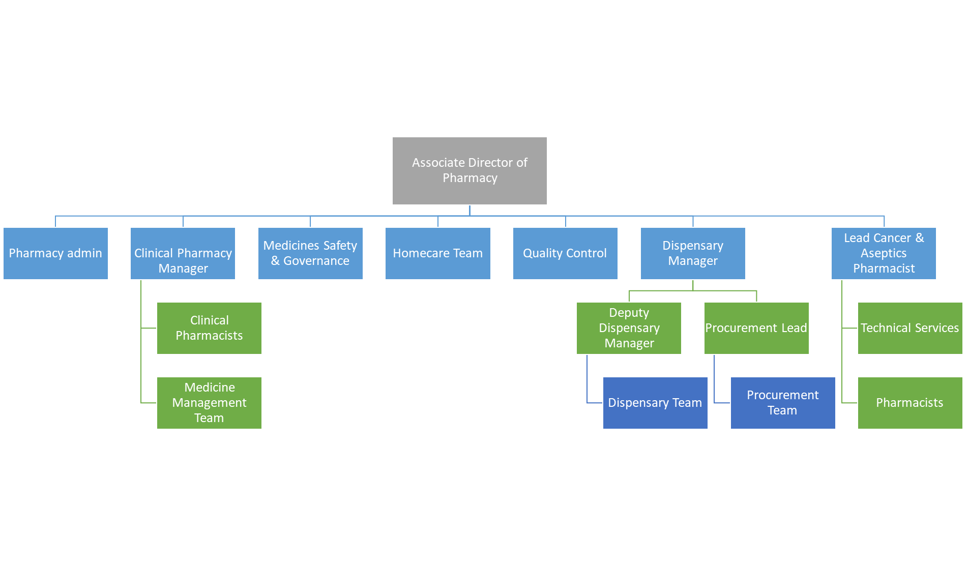

FREEDOM TO ACT
Business continuity planning will need to take place in liaison with line management and issues should be escalated in a timely manner.

COMMUNICATION/RELATIONSHIP SKILLS
The post holder will need to be a skilled communicator, communicating daily with patients and carers on sensitive matters.
ANALYTICAL/JUDGEMENTAL SKILLS
This role will regularly require the post holder to make judgements requiring interpretation and comparison of options.

PLANNING/ORGANISATIONAL SKILLS
Manage day to day activities and plan work effectively
PATIENT/CLIENT CARE
Dispensing prescriptions, taking in outpatient prescriptions and liaising with patients, carers, relatives regarding their prescription, payments and responding to staff queries regarding prescriptions.
POLICY/SERVICE DEVELOPMENT
Awareness and adherence to relavant SOPs and guidelines within pharmacy
FINANCIAL/PHYSICAL RESOURCES
Awareness of financial implications of prescriptions and medicines management
HUMAN RESOURCES
Assist in the training of new member of staff including the dispensary team, pharmacists, foundation year pharmacists and pre-registration student technicians. You will also be expected to help in the training of the aseptic team (for dispensary weekend working only).
INFORMATION RESOURCES
Regular use of electronic systems, ability to competently use Epic dispensing systems, troubleshoot issues and use robotic dispensing interfaces.
RESEARCH AND DEVELOPMENT
PHYSICAL SKILLS
Ability to dispense medications

PHYSICAL EFFORT
Regular lifting boxes.
Standing for long periods dispensing.

MENTAL EFFORT
Concentration for dispensing prescriptions, dealing with interruptions.

EMOTIONAL EFFORT
Undertake reception duties including dealing with staff. Taking in prescriptions forms from outpatients, checking exemption status and collecting prescription charges where appropriate.

WORKING CONDITIONS
Ensure that a clean, tidy and safe working environment is maintained within the Dispensary
Frequent use of VDU throughout day
Dispense medicines in accordance to COSHH regulations. Handling medicines including cytotoxic drugs. Handling potentially hazardous materials that have been returned to the pharmacy or brought in by patients
The post holder will be expected to work flexible hours as required to provide extended hours and weekend / bank holiday working
OTHER RESPONSIBILITIES
To participate in other duties appropriate to grade at the request of the relevant manager.
To participate in flexible working arrangements including late duties, weekends and bank holidays as appropriate.
To take part in regular performance appraisal.
To undertake any training required in order to maintain competency including mandatory training, i.e. Fire, Manual Handling.
To contribute to and work within a safe working environment.
Working in line with the dispensary SOPs and Trust Policies.
The post holder is expected to comply with Trust Infection Control Policies and conduct him/herself at all times in such a manner as to minimise the risk of healthcare associated infection
As an employee of the Trust, it is a contractual duty that you abide by any relevant code of professional conduct and/or practice applicable to you. A breach of this requirement may result in action being taken against you (in accordance with the Trust’s disciplinary policy) up to and including dismissal.

APPLICABLE TO MANAGERS ONLY
DISCLOSURE AND BARRING SERVICE CHECKS
This post has been identified as involving access to vulnerable adults and/or children and in line with Trust policy successful applicants will be required to undertake a Disclosure & Barring Service Disclosure Check.

GENERAL
This is a description of the job as it is now. We periodically examine employees' job descriptions and update them to ensure that they reflect the job as it is then being performed, or to incorporate any changes being proposed. This procedure is conducted by the Manager in consultation with the jobholder. You will, therefore, be expected to participate fully in such discussions. We aim to reach agreement on reasonable changes, but if agreement is not possible, we reserve the right to insist on changes to your job description after consultation with you.

The RD&E is a totally smoke-free Trust. Smoking is not permitted anywhere on Trust property, including all buildings, grounds and car parks. For help to quit call: 01392 207462.

This i

PERSON SPECIFICATION

Job Title | Senior Pharmacy Assistant, Inpatient Dispensary

Requirements | Essential | Desirable
QUALIFICATION/ SPECIAL TRAINING
Relevant dispensing qualification BTEC 2/3 or equivalent e.g. NPA, Boots, Buttercups

GCSE Grade A-C in Mathematics and English

Accuracy Checking Pharmacy Support Staff Qualification

KNOWLEDGE/SKILLS
VDU use

Stock Control systems

Computerised dispensing system

Ability to solve problems

EXPERIENCE
Retail/hospital pharmaceutical work

PERSONAL ATTRIBUTES
Methodical approach

Team worker

Flexible

Honesty/Integrity

Good communicator

Professional attitude
OTHER REQUIREMENTS
Ability to work effectively and accurately in a busy environment

FREQUENCY

(Rare/ Occasional/ Moderate/ Frequent)
WORKING CONDITIONS/HAZARDS |  | R | O | M | F
Hazards/ Risks requiring Immunisation Screening
Laboratory specimens | Y |  | Y
Contact with patients | Y |  |  |  | Y
Exposure Prone Procedures | N
Blood/body fluids | N
Laboratory specimens | Y | Y
Hazard/Risks requiring Respiratory Health Surveillance
Solvents (e.g. toluene, xylene, white spirit, acetone, formaldehyde and ethyl acetate) | Y/N |  | Y
Respiratory sensitisers (e.g isocyanates) | Y |  | Y
Chlorine based cleaning solutions  (e.g. Chlorclean, Actichlor, Tristel) | Y |  | Y
Animals | N
Cytotoxic drugs | Y |  | Y
Risks requiring Other Health Surveillance
Radiation (>6mSv) | N
Laser (Class 3R, 3B, 4) | N
Dusty environment (>4mg/m3) | Y |  | Y
Noise (over 80dBA) | Y |  | Y
Hand held vibration tools (=>2.5 m/s2) | N
Other General Hazards/ Risks
VDU use ( > 1 hour daily) | Y |  |  |  | Y
Heavy manual handling (>10kg) | Y |  | Y
Driving | N
Food handling | N
Night working | N
Electrical work | N
Physical Effort | Y |  |  | Y
Mental Effort | Y |  |  | Y
Emotional Effort | Y |  |  | Y
Working in isolation | N
Challenging behaviour | Y |  |  | Y

