JOB DESCRIPTION

1. JOB DETAILS

Job Title: Infection Prevention and Control Audit & Surveillance Specialist Nurse/Practitioner

Band: Band 6

Reports To: Advanced Nurse Specialist, Infection Prevention and Control Audit and Surveillance Team Band 7 (& Clinical Matron Band 8A)

Department/Directorate: Specialist Services

2. JOB PURPOSE:

- Works as a member of the Infection Prevention and Control (IPC) Team contributing to the delivery of specialist services
- Plans and implements surveillance programmes, provides specialist advice, maintains records.
- Provides supervision to other staff
- Leads clinical audits/surveillance and investigations in own specialist area

3. DIMENSIONS/KEY WORKING RELATIONSHIPS:

As a member of the IPC team, contributes to the delivery of a clinical specialist service Trust wide. Have key working relationships with:

- Director of Infection Prevention and Control (DIPC)
- Clinical Matrons and equivalent therapists
- Clinical Nurse Managers
- Nursing Staff
- Consultants and other medical staff
- Medical Microbiologists
- UK Health Security Agency
- NHS England

4. ORGANISATIONAL CHART

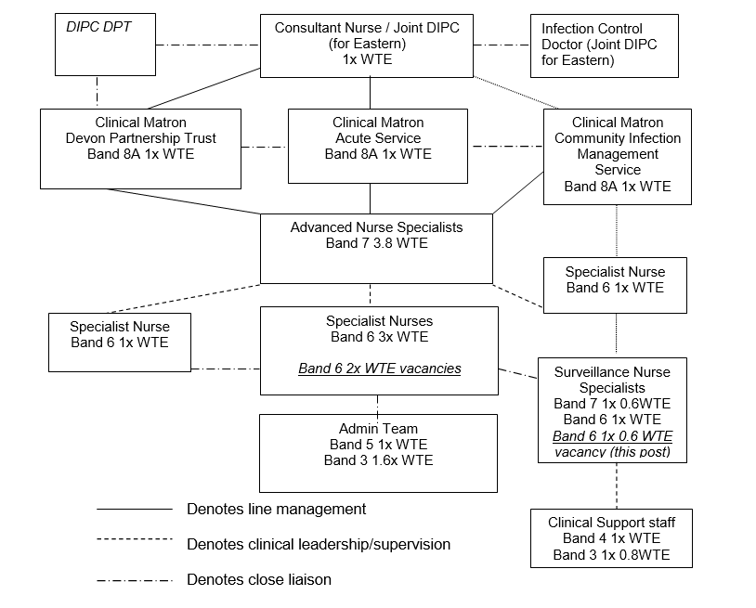

5. KEY RESULT AREAS/PRINCIPAL DUTIES AND RESPONSIBILITIES:

5.1 Clinical Practice

- Provides specialist advice about surveillance to patients and their families/carers, staff and students
- Takes responsibility for his/her own caseload/workload within the designated clinical area and for the assessment and treatment of patients on a day to day basis, without direct guidance from line manager.
- Understands and recognises own limitations and refers to a more experienced specialist when required.
- Provides and receives sensitive /highly sensitive, complex or contentious information to patients, their relatives, members of the public with empathy and reassurance e.g. impact of infection
- Communicates sensitive/highly sensitive complex or contentious information to a range of other health care professionals including nurses, consultants and allied health professionals, acting as a specialist infection surveillance resource
- Develops the skills to assess and interpret specialist information and conditions and takes appropriate action

5.2 Leadership and Management

- Supervises the data collection activities of healthcare assistant and the Infection Prevention & Control practitioner ensuring that deadlines for national surveillance data submission can be achieved, escalating challenges to line manager
- Undertakes personal development review for health care assistants
- Deputises for and supports senior colleague/s in their absence, if required by the lead nurse.
- Contributes to the provision of specialist protocols and policies.
- Responsible for organising own workload within the requirements of the specialist team activities and work plan
- Produces and presents surveillance and audit reports as required
- Provide representation on committees/working groups as required
- Be aware of budgetary limitations and provide highest quality nursing service within those confines,
- Make line manager aware of any concerns regarding the quality of service provided in a constructive manner

5.3 Education

- Provides teaching in practice to other staff and students in relation to surveillance activities
- Acts as a positive role model for other staff and students
- Participates in the planning, delivery and evaluation of in-house education and training programme, for all disciplines of staff.

5.4 Research and Development

- Ensure clinical practice developments are based on best available evidence.
- Review and disseminate new information to relevant staff.
- Evaluate clinical practice in relation to its evidence base and clinical effectiveness
- Use core audit skills to enable the specialist team and other health professionals to improve quality of care
- Collect and collate epidemiological data to enable the team to inform independent or collaborative review of clinical practice

5.5 Professional Development

- Maintain responsibility for own professional and specialist development.
- Participate in regular performance appraisal
- Use reflection to identify and prioritise education/development needs.
- Pursue an on-going programme of professional education/development relevant to the specialty
- Be a member of a professional specialist forum/association, if such exists, and attend regional and national meetings and conferences, when possible.
- Undertake any training required in order to maintain competency including essential training i.e. infection control, fire, moving and handling, resuscitation

5.6 Other Responsibilities

- To take part in regular performance appraisal
- To undertake any training required in order to maintain competency including mandatory training, e.g. Manual Handling
- To contribute to and work within a safe working environment
- The post holder is expected to comply with Trust Infection Control Policies and conduct him/herself at all times in such a manner as to minimise the risk of healthcare associated infection

6. THE TRUST

Our vision is to provide safe, high quality seamless services delivered with courtesy and respect. To achieve our vision, we expect all our staff to uphold our Trust values. Our Trust values are:

Honesty, Openness & Integrity
Fairness,
Inclusion & Collaboration
Respect & Dignity

We recruit competent staff that we support in maintaining and extending their skills in accordance with the needs of the people we serve. We will pay staff fairly and recognise the whole staff’s commitment to meeting the needs of our patients.

We are committed to equal opportunity for all and encourage flexible working arrangements including job sharing. We are committed to recruiting and supporting a diverse workforce and welcome applications from all sections of the community, regardless of age, disability, gender, race, religion, sexual orientation, maternity/pregnancy, marriage/civil partnership or transgender status. We expect all staff to behave in a way which recognises and respects this diversity, in line with the appropriate standards.

7. GENERAL

This is a description of the job as it is now. We periodically examine employees' job descriptions and update them to ensure that they reflect the job as it is then being performed, or to incorporate any changes being proposed. This procedure is conducted by the Manager in consultation with the jobholder. You will, therefore, be expected to participate fully in such discussions. We aim to reach agreement on reasonable changes, but if agreement is not possible, we reserve the right to insist on changes to your job description after consultation with you.

The RD&E is a totally smoke-free Trust. Smoking is not permitted anywhere on Trust property, including all buildings, grounds and car parks.

PERSON SPECIFICATION
Infection Prevention and Control Surveillance Nurse Specialist, Band 6

REQUIREMENTS | At Recruitment
QUALIFICATIONS/ TRAINING:  Registered Nurse / Practitioner  Bachelor’s degree in nursing or health related subject  Specialist post graduate diploma or equivalent courses  Teaching and mentoring qualification or equivalent experience | E  E  D  E
KNOWLEDGE/SKILLS:  Excellent verbal and written communication skills  Ability to manage own case/workload  Understanding of infection surveillance and its purpose within the field of infection prevention  Understanding of the audit cycle and its application within specialist sphere  Ability to critically analyse research  Understanding of principles of change management  Computer literacy  Understanding of a range of surgical procedures  Understanding of invasive devices such as urinary catheters and vascular access devices and the risks of infection associated with such devices  Sound understanding of microbiology | E  E  E  E  E  E  E  E  D  D
EXPERIENCE:  3 years relevant post registration experience e.g. acute care, research nurse, theatre practitioner  Experience of teaching in practice or formal lecturing  Communication and liaison with a range of different health professionals and services | E  E  E
PERSONAL ATTRIBUTES:  Able to work as a team member  Highly motivated and enthusiastic  Enjoys giving attention to detail  Takes responsibility for own professional development  Smart professional appearance | E  E  E  E  E
OTHER REQUIREMENTS:  Hold a drivers licence and willing to travel to the Exeter Nightingale and community sites | D
* Essential/Desirable
HAZARDS October 2023
Laboratory Specimens |  | Clinical contact with Patients | ✓ | Dealing with violence & aggression of patients/relatives | ✓
Blood / Body Fluids | ✓ | Dusty Environment |  | VDU Use (occasional) | ✓
Radiation / Lasers |  | Challenging Behaviour | ✓ | Manual Handling | ✓
Solvents | ✓ | Driving | ✓ | Noise / Vibration
Respiratory Sensitisers | ✓ | Food Handling |  | Working in isolation
Cytotoxic Drugs |  | Electrical work |  | Night Working

