

JOB DESCRIPTION

1. JOB DETAILS

Job Title Senior Clinical Coder Senior Clinical Coder Accredited
NB The post holder will have attained the National Clinical Coding Qualification UK

Band: AfC B5

Reports to: Clinical Coding Service Manager

Department / Directorate: Digital Services

2. JOB PURPOSE

To critically analyse medical, intervention and procedural terminology and other clinical information and assign accurate diagnostic, intervention and procedure codes for all inpatients, day cases and regular day patients using the relevant coding classifications, namely ICD10 and OPCS4, to enable the Trust to meet both its business and clinical information requirements.

3. DIMENSIONS/ KEY WORKING RELATIONS

The post lies within a team of skilled clinical coders whose role is to accurately clinical code patient activity.

• Head of Clinical Coding
• Business Intelligence Development Manager
• Business Intelligence Team staff
• Senior clinical staff and junior doctors/Medical staff
• MyCare config analyst & other staff
• Other administrative Staff

- ORGANISATIONAL CHART

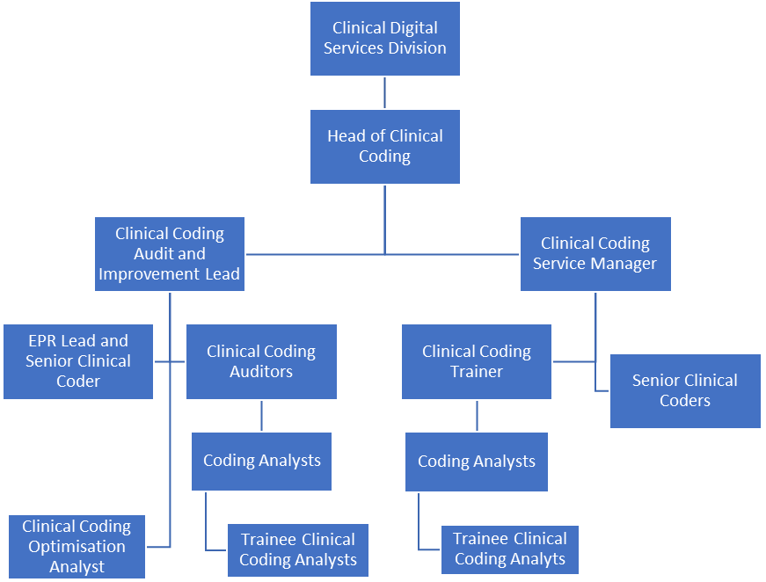

- KEY RESULT AREAS/PRINCIPAL DUTIES AND RESPONSIBILITIES:

Must have taken the National Clinical Coding Qualification and achieved Accredited Clinical Coder (ACC) status.

Must possess a thorough knowledge of Clinical Coding Standards, Local policies, anatomy and physiology, medical terminology and will use these when assigning codes.

Have significant practical coding experience across a range of Specialties and be adaptable to switch between them as necessary, applying appropriate coding conventions.

Undertake clinical coding Refresher training (CCSRC) every 3 years in order to maintain and refresh clinical coding knowledge and skills in line with Terminology and Classification Delivery Service (TCDS) accredited clinical coder continued learning/training requirements.

Continue to undertake all necessary training in order to be able to change and adapt to new coding procedures as required.

Maintain up to date knowledge of all coding standards published by Terminology and Classification Delivery Service (TCDS)

Refer to the electronic version of the ICD10/OPCS4 National Clinical Coding Standards (Reference) books in order to ensure accurate coded data in line with the TCDS published coding standards.

Update personal coding classifications with coding standards as and when standards are published or changes arise.

Maintain an up to date personal portfolio of evidence of clinical coder career progression

Communication and Relationship Skills

Using persuasive and motivational skills, liaise with a wide range of staff including Clinicians and
Divisional Management on the most appropriate ICD10 and OPCS4 clinical codes to represent patient care received within the Trust and feedback to Clinical Coding Managers and coders as necessary.

Participate and represent clinical coding on a solo basis at consultant led weekly MDT discharge summary meetings, to clarify content of the clinical discharge summaries in line with the requirements of the clinical coding process, working directly with the lead consultant and the junior doctors.

Communicate complex Clinical Coding rules to Clinical Coding Officers and Clinicians.

Analytical and Judgemental Skills

Abstract and analyse relevant clinical information from the Trust’s EPR (MyCare) to assign accurate diagnostic, intervention and procedure codes using ICD10/OPCS-4 classifications, following and in-keeping with the national coding standards. This will involve making judgements on complex facts requiring interpretation and comparing options from information provided electronically.

Audit EPR record to ensure good data quality and liaise with the appropriate staff for any queries or corrections arising during the coding process.

Planning and Organisational Skills

Plan and implement workload for Clinical Coding Officers.

Plan and participate in Clinical Coding projects. Represent clinical coding in projects outside of the department that have a Clinical Coding element.

Plan and host the weekly clinical coder’s communications cell meeting in line with the rota.

Physical Effort

Ensure that the coded clinical data is entered onto the Trust’s EPR, for every relevant patient care episode. This will involve continuous sitting in front of a computer (VDU) and inputting information into the relevant systems.

Patient/Client Care

Incidental contact with patients on ward visits.

Policy/Service Development

Have a thorough knowledge and understanding of the Trust’s local coding policies, and liaise with clinical staff in relation to proposing new policies and amendments as appropriate.

Assist the Clinical Coding Manager with complex coding issues to ensure correct coding resolution is reached liaising with clinical staff and following the Trust and TCDS national coding query mechanism

Financial and Physical Resources

Support the Clinical Coding Manager when liaising with Divisional Finance and Cluster Managers and play a role in highlighting scarce documentation which in turn would have a direct impact on finance.

Ordering stationery/stock via the EROS ordering system.

Human Resources

Act as mentor and give on-going support and advice to clinical coding officers, including the checking of the clinical coding officer’s coding as required.

Deputise for senior Members of the Clinical Coding Team including the Clinical Coding Manager as required.

Plan & undertake PDR’s for Clinical Coding Officers.

Information Resources

The post holder will be required to process and codify patient’s notes and input test results into the relevant system if necessary.

Research and Development

Participate in complex clinical coding audits and training sessions – internally and externally – as part of the annual audit schedule.

Participate in feedback sessions with the Clinical Coding Manager/ Clinical Coding Auditor regarding outcomes of internal coding audit.

Freedom to Act

Plan and implement own workload in order to achieve demanding monthly coding deadlines (and sometimes changing deadlines) while ensuring accuracy is maintained. Use judgement and coding experience where necessary to translate cases where information is not always clear.

Self-management and capability to achieve targets as set out by Clinical Coding Assurance Manager.

Use initiative and be proactive to achieve deadlines. This may include contacting clinicians to clarify information. Continue to review, monitor and plan how to resolve all outstanding coding cases.

Maintain confidentiality and discretion and comply with the terms of the Data Protection Act and local Trust policies at all times. Adhere to Health records policy for management and storage of notes.

Mental Effort

The Clinical Coding Process will require frequent periods of prolonged concentration with occasional requirement for intense concentration to code accurately in line with national coding standards and local coding policies.

Emotional Effort

During the Clinical Coding process there will be frequent occasions where the post holder will be exposed to written and or photographic information of a distressing nature.

Other Responsibilities:

To take part in regular performance appraisal

To undertake any training required in order to maintain competency including mandatory training, e.g. Manual Handling

To contribute to and work within a safe working environment

The post holder is expected to comply with Trust Infection Control Policies and conduct him/herself at all times in such a manner as to minimise the risk of healthcare associated infection

As an employee of the Trust, it is a contractual duty that you abide by any relevant code of professional conduct and/or practice applicable to you. A breach of this requirement may result in action being taken against you (in accordance with the Trust’s disciplinary policy) up to and including dismissal.

THE TRUST – Vision and Values

Our vision is to provide safe, high quality seamless services delivered with courtesy and respect. To achieve our vision we expect all our staff to uphold our Trust values. Our Trust values are:

Honesty, Openness & Integrity
Fairness,
Inclusion & Collaboration
Respect & Dignity

We recruit competent staff that we support in maintaining and extending their skills in accordance with the needs of the people we serve. We will pay staff fairly and recognise the whole staff’s commitment to meeting the needs of our patients.

We are committed to equal opportunity for all and encourage flexible working arrangements including job sharing.

We are committed to recruiting and supporting a diverse workforce and welcome applications from all sections of the community, regardless of age, disability, gender, race, religion, sexual orientation, maternity/pregnancy, marriage/civil partnership or transgender status. We expect all staff to behave in a way which recognises and respects this diversity, in line with the appropriate standards.

GENERAL

This is a description of the job as it is now. We periodically examine employees' job descriptions and update them to ensure that they reflect the job as it is then being performed, or to incorporate any changes being proposed. This procedure is conducted by the Manager in consultation with the jobholder. You will, therefore, be expected to participate fully in such discussions. We aim to reach agreement on reasonable changes, but if agreement is not possible, we reserve the right to insist on changes to your job description after consultation with you.

PERSON SPECIFICATION

POST: SENIOR CLINICAL CODER- ACCREDITED

BAND: 5

REQUIREMENTS | At  Recruitment | At PDR
QUALIFICATIONS / TRAINING:  T&CDS NCCQ(UK) Qualification – ACC Status  A Level Biology/Human Biology or GNVQ int. in Health & Social Care or BTEC Certificate in Medical Terminology or have completed the Clinical Coding Foundation Course or other relevant coding experience.  5 GCSE’s/’Levels 7-8 including English and Biology/Human Biology  Certificate/Qualification – Anatomy and Physiology/ Medical Terminology | E  E  E  D | E  E  E  E
KNOWLEDGE / SKILLS  Excellent PC and keyboard skills  Excellent analytical skills  Excellent communication skills both written and verbal  Excellent knowledge of Anatomy & Physiology/Medical Terminology  Proven excellent knowledge of clinical Coding Standards – ICD10 and OPCS4 | E  E  E  E  E | E  E  E  E  E
EXPERIENCE:  Experience within the NHS  Previous working placement in an acute hospital setting  Significant coding experience across a range of specialties | E  E  E | E  E  E
PERSONAL ATTRIBUTES  Ability to work on own as well as part of a team  Positive and flexible approach and manner to all demands/ aspects of the role  Ability to complete work within strict deadlines and work within a busy environment  Ability to communicate with staff across all levels  Positive attitude to changes in processing of clinical coding in line with new work practices and changes in national coding standards  Excellent motivation for continuous training and personal development  Plan and Implement mentorships for Clinical Coding Officers | E  E  E  E  E  E  E | E  E  E  E  E  E  E
OTHER REQUIREMENTS:  Undertake further refresher training in line with T&CDS requirements.  Keep up to date with national changes in coding practices/standards to ensure the quality and the accuracy of the coded data.  Ability to use a keyboard for significant periods during the working day (adhering to H&S guidelines | E  E  E | E  E  E

* Essential/Desirable

HAZARDS- Updated 3th July 2018
Hazards/ Risks requiring Immunisation Screening

Laboratory specimens | N
Contact with patients | N
Exposure Prone Procedures | N
Blood/body fluids | N

Hazards/ Risks requiring Respiratory Health Surveillance
Solvents (e.g. toluene, xylene, white spirit, acetone, formaldehyde and ethyl acetate) | N
Respiratory sensitisers (e.g isocyanates) | N
Chlorine based cleaning solutions  (e.g. Chlorclean, Actichlor, Tristel) | N
Animals | N
Cytotoxic drugs | N

Hazards/ Risks requiring Other Health Surveillance

Radiation (>6mSv) | N
Laser (Class 3R, 3B, 4) | N
Dusty environment (>4mg/m3) | N
Noise (over 80dBA) | N
Hand held vibration tools (=>2.5 m/s2) | N

Other General Hazards/ Risks

VDU use ( > 1 hour daily) | Y
Heavy manual handling (>10kg) | Y
Driving | N
Food handling | N
Night working | N
Electrical work | N
Working in isolation | Y
Challenging behaviour | N

Job Matched (Matched) 18/12/2019 Consistency Checked (Confirmed) 11/04/2019

