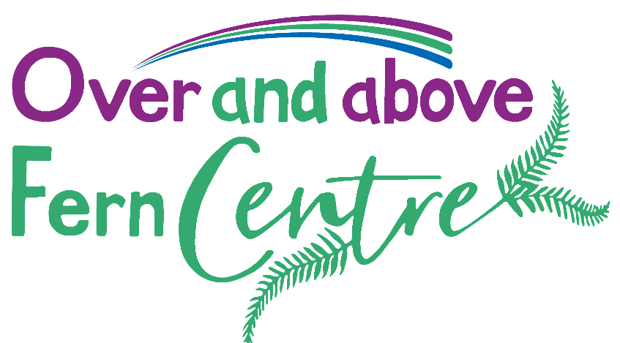

Complementary Therapists Volunteer – The Fern Centre
Massage, Reflexology, Reiki
Department : | Cancer Services
Location: | Fern Centre (North Devon’s Cancer & Wellbeing Centre)
General outline of role: | The Fern Centre is open to all people who are living with a cancer diagnosis – past or present – and aims to be able to provide holistic care, support, advice and information to our visitors.  As a complementary therapist volunteer, you will be responsible for providing a professional, safe, compassionate and caring complementary therapy treatment in line with the Fern Centre policies and guidelines. Each volunteer will be assigned a caseload of clients which may be cancer patients undergoing treatment, patients living with and beyond cancer, relatives or carers, to provide one to one therapy treatments. Our clients are entitled to up to 6 sessions of complementary therapy and all follow ups will be kept with their assigned therapist. All potential clients who are currently undergoing cancer treatment will require clinical approval prior to commencing complementary therapy. The Fern Centre team will ensure this approval is obtained so volunteers can be confident they are acting safely within their volunteer roles. All volunteers must uphold the values of the Fern Centre and the Trust, treating all visitors with kindness and respect.  As part of this role, volunteers may be asked to provide therapy to members of the cancer services staff to aid with staff wellbeing.  Volunteers will be provided with all equipment needed to perform their therapy, including the use of specially designed complementary therapy rooms within the Fern Centre. All massage/reflexology mediums, towels are provided by the centre. Volunteers will also be able to advertise their own businesses within the Fern Centre.  Depending on experience and volunteer preference, there may also be opportunity for therapies to be provided to patients having chemotherapy on the Seamoor Unit. A full Seamoor Unit induction would be undertaken prior to any volunteers starting on the Unit and is not compulsory as part of the volunteer role  Volunteers will be entitled to free on-site car parking.
Key responsibilities and Skills required: | Provide complementary therapy for cancer patients, relatives and carers.  All reiki practitioners must be qualified to a level 2 qualification or higher.  Massage/reflexology complementary therapists must be qualified to a level 3 standard or higher.  Successful candidates must be registered with an appropriate regulatory body and have their own indemnity insurance.  Adhere to trust policy and guidance regarding infection control and health and safety  Conduct in a professional and caring manner at all times.  Complete a full consultation form with the client, offer and deliver the therapy adhering to the particular patient or relative/carer’s needs accordingly.  Volunteers will be required to complete client feedback forms and short audit forms which aids with charitable bid writing and future budgeting of the Centre (training will be provided).  We ask that volunteers commit to 12 months placement at the Fern Centre owing to the recruitment process involved.
Key tasks involved: | Providing professional, safe complementary therapies to clients of the Fern Centre in line with your therapy’s standards of safe practice. Provide therapy sensitively and with care and compassion. To be able to listen to clients with empathy and sensitivity, providing emotional support should the need arise.
Key people the volunteer will be working with: | The Fern Centre Manager will be your main line management contact who will be able to support you day to day. The Fern Centre consists of a small friendly team including our personalised care support manager, counselling team and complementary therapists who will be happy to support you during your shifts. Monthly supervision and CPD opportunities are available.  Volunteers may also work with the Matron for Cancer Services, Seamoor Unit Manager and staff, extended volunteer team, regularly seeing and having direct contact with Patients, relatives and carers. Liaising with the wider teams when signposting and seeking advice and guidance.
Time commitment: | X1 mornings per week, or more if available. Total of 3 clients per shift.
Any specific educational requirements/qualifications: | Qualified to a Level 2 standard of qualification (Reiki)  Qualified to a Level 3 standard of qualification (Massage/Reflexology)  Adhere and have Indemnity with Professional body  Experience in healthcare setting or treating people with cancer or life limiting diseases is desirable but not essential
Workplace training required for role, if appropriate: | Adhere to practice hours accordingly  Complete trust induction and training on an annual basis. Supervision and CPD opportunities are available.
Will driving be required? | No
Will DBS check be required? | Yes

