JOB DESCRIPTION

This post has been identified as involving access to vulnerable adults and/or children and in line with Trust policy successful applicants will be required to undertake an Enhanced Disclosure Check.

The Trust is committed to recruiting and supporting a diverse workforce and so we welcome applications from all sections of the community, regardless of age, disability, gender, race, religion, sexual orientation, maternity/pregnancy, marriage/civil partnership or transgender status. The Trust expects all staff to behave in a way which recognises and respects this diversity, in line with the appropriate standards.

1. JOB DETAILS

Job Title: Biomedical Scientist – Clinical Chemistry Specialist

Band: 5

Reports to: Laboratory Manager - Clinical Chemistry.

Department / Directorate: Department of Clinical Chemistry / Blood Sciences

- JOB PURPOSE

  - To provide a high-quality analytical, advisory and interpretive service to clinicians for the processing of pathological specimens in the specialty of Clinical Chemistry.
  - To ensure departmental quality standards are maintained through adherence to standard operating procedures, implementation of quality control programmes and instrumentation maintenance and troubleshooting.
  - Participate in the Departmental Out-of-Hours shift and on-call services as an autonomous practitioner.

3. DIMENSIONS/ KEY WORKING RELATIONS
Head of Dept – Clinical Chemistry
Laboratory Manager
Deputy Laboratory Manager
Clinical Scientists
Senior Technical and Scientific Staff
Biomedical Scientists
Medical / Nursing Staff
External NHS agencies.
Members of the Public

- ORGANISATIONAL CHART:
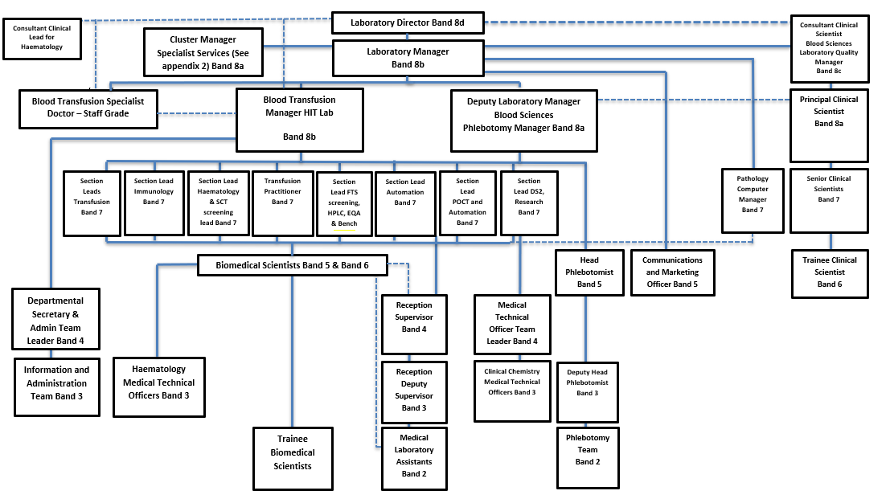

5. KEY RESULT AREAS/PRINCIPAL DUTIES AND RESPONSIBILITIES:

- Take part in staff rotation, providing a high-quality analytical service in all sections, following standard operating procedures including:
- Preparation and biochemical analysis of pathological specimens.
- Interpret analytical results taking appropriate action where necessary including the cascading of further analyses.
- Use the laboratory computer to accurately record patient data and interpret the significance of test results. Where necessary telephone significantly abnormal result directly to clinicians.
- Liaise and co-operate with other members of the analytical team to ensure a timely and efficient service delivery.
- Operation of complex analytical instrumentation:
- Ensure safe and correct use, in compliance with operator manuals and departmental procedures.
- Ensure periodic and as required maintenance procedures are executed on time and in the prescribed manner.
- Troubleshooting, adjustments and repair of instrumentation following technical failures on site and in satellite locations.
- Ensure standard operating procedures are updated and amended to reflect working experience.
- Make instrumentation calibrations and adjustments as and when required.
- Ensure quality of results through the implementation of internal QC systems and act upon the results, identifying and resolving non-compliances, as per departmental procedures.
- Provide analytical advice and information to service users and laboratory support staff regarding results, test requirements, sampling protocols and appropriateness of clinical investigations, following laboratory policies and procedures.
- Ensure stock levels of consumable items are adequate for daily needs within own work area.
- Participate in the Departmental Out-of-Hours shift and on-call services as an autonomous practitioner.
- Self-manage time to maintain the 24 hours availability of a rapid emergency Clinical Chemistry service.
- Liaise with clinicians in order to appropriately prioritise workload.
- Ensure the rapid transmission of clinically significant results to clinicians.
- Process all non-urgent work as urgent workload permits.
- Maintain competence to practice by in-house training activities and participation in CPD.
- Ensure continuous registration with The HCPC is maintained.
- Ensure strict adherence to the HCPC code of practice in all matters concerning conduct at work including patient confidentiality.
- Participate in research and development programs as required.
- Maintain a flexible working approach allowing management and prioritisation of the daily workload.
- Contribute towards the continuing development of the Clinical Chemistry laboratory service.
- Supervise, train and co-ordinate trainee Biomedical Scientists and support staff as required (this may include specific training responsibilities).
- Adhere to all Trust and laboratory employment and Health and Safety policies.
- Adhere to Control of Substances Hazardous to Health (COSHH) Regulations.
- Participate in all Trust mandatory training including manual handling and fire training.
- Participate in annual Individual Performance Review (IPR).
- Ensure safe practices are followed and a safe working environment maintained at all times within the department and externally, in compliance with Trust and departmental policies.

OTHER RESPONSIBILITIES:
- To take part in regular performance appraisal.
- To undertake any training required in order to maintain competency including mandatory training, i.e. Fire, Manual Handling
- To contribute to and work within a safe working environment
- The post holder is expected to comply with Trust Infection Control Policies and conduct him/herself at all times in such a manner as to minimise the risk of healthcare associated infection.
- Prioritises own workload.
- Follows all protocols and routines relevant to own area of work.

THE TRUST - PURPOSE AND VALUES

We are committed to serving our community by being a high-quality specialist Hospital with consultant-led services. We aim to co-ordinate our services with primary and community care, and to develop a limited number as Sub-Regional Referral Centres with appropriate levels of research, development and educational involvement. Where appropriate, and consistent with our services, we may provide services aimed at preventing disease and debilitation.
We aim to make all our services exemplary in both clinical and operational aspects. We will show leadership in identifying healthcare needs to which we can respond and in determining the most cost-effective way of doing so. We will share our knowledge with neighbouring healthcare agencies and professionals.
We recruit competent staff whom we support in maintaining and extending their skills in accordance with the needs of the people we serve. We will pay staff fairly and recognise the whole staff’s commitment to meeting the needs of our patients.
We are committed to equal opportunity for all and encourage flexible working arrangements including job sharing.
The Trust is committed to recruiting and supporting a diverse workforce and so we welcome applications from all sections of the community, regardless of age, disability, sex, race, religion, sexual orientation, maternity/pregnancy, marriage/civil partnership or transgender status The Trust expects all staff to behave in a way which recognises and respects this diversity, in line with the appropriate standards.

GENERAL

This is a description of the job as it is now. We periodically examine employees' job descriptions and update them to ensure that they reflect the job as it is then being performed, or to incorporate any changes being proposed. This procedure is conducted by the Manager in consultation with the jobholder. You will, therefore, be expected to participate fully in such discussions. We aim to reach agreement on reasonable changes, but if agreement is not possible, the Trust reserves the right to insist on changes to your job description after consultation with you.

The RD&E is a totally smoke-free Trust. Smoking is not permitted anywhere on Trust property, including all buildings, grounds and car parks. For help to quit call 01392 207462.

As an employee of the Trust, it is a contractual duty that you abide by any relevant code of professional conduct and/or practice applicable to you. A breach of this requirement may result in action being taken against you (in accordance with the Trust’s disciplinary policy) up to and including dismissal.

The post holder is expected to comply with Trust Infection Control Policies and conduct him/her at all times in such a manner as to minimise the risk of healthcare associated infection.

JOB DESCRIPTION AGREEMENT:

Jobholder’s name: ________________________________

Jobholder’s signature: ________________________________

Date: ________________________________

Manager’s name: ________________________________

Manager’s signature: ________________________________

Date: ________________________________

PERSON SPECIFICATION
POST: Biomedical Scientist
BAND: 5
REQUIREMENTS | At  Recruitment | At 2nd KSF  Gateway
QUALIFICATIONS / TRAINING  Biomedical Sciences degree or equivalent.  State registration with HCPC or awaiting IBMS portfolio assessment. | E  E | E  E
KNOWLEDGE / SKILLS  Good level of technical competence in a Pathology discipline.  Good theoretical knowledge of Clinical Chemistry.  Proven ability to operate Laboratory IT systems.  Ability to work on own initiative and plan day to day activities with minimum requirement for supervision.  Given appropriate training prepared to work autonomously, alone during the out-of-hours periods.  Good communication skills.  Ability to work accurately under pressure and adhere to analytical deadlines.  Comprehensive working knowledge of quality systems and their day to day operation.  Good manual dexterity.  A thorough understanding of governance and its role in the healthcare environment. | E  E  D  E  D  E  E  D  E  D | E  E  E  E  E  E  E  E  E  E
EXPERIENCE  Experience of working in a UK Pathology laboratory  Comprehensive experience of working with large Biochemistry automated pre-analytical and analytical systems. | D  D | E  E
PERSONAL ATTRIBUTES  Excellent interpersonal skills  Good timekeeping  Flexible  Reliable  Teamworker | E  E  E  E  E | E  E  E  E  E
OTHER REQUIREMENTS  Willingness to participate in departmental CPD  Enthusiasm and willingness to learn | E  E | E  E
* Essential/Desirable
HAZARDS IDENTIFIED (tick as appropriate):
Laboratory specimens  Proteinacious Dusts | X | Clinical contact with  patients |  | Performing Exposure  Prone Invasive Procedures
Blood / Body Fluids | X | Dusty environment |  | VDU use | X
Radiation |  | Challenging Behaviour |  | Manual handling | X
Solvents | X | Driving |  | Noise
Respiratory Sensitisers |  | Food handling |  | Working in isolation | X

