

“Our vision is to provide safe, high quality seamless service delivered with courtesy and respect. To achieve our vision, we expect all our staff to uphold our Trust Values”

JOB DESCRIPTION

This post has been identified as involving access to vulnerable adults and/or children and in line with Trust policy successful applicants will be required to undertake an Enhanced Disclosure Check.

The Trust is committed to recruiting and supporting a diverse workforce and so we welcome applications from all sections of the community, regardless of age, disability, gender, race, religion or sexual orientation. The Trust expects all staff to behave in a way which recognises and respects this diversity, in line with the appropriate standards.

1. JOB DETAILS

Job Title: Staff Counsellor
Band: 6

Hours: Part Time 15 hrs (0.4 wte)

Reports to: Service Manager

Department / Directorate: Occupational Health Department

2. JOB PURPOSE

To assist with the provision of Staff Counselling and Support Services within the Occupational Health Service across the Trust.

Key Working Relationships

Occupational Health -
- Occupational Health Physicians
- Occupational Health Service Manager
- Occupational Health Advisers and Practice Nurses
- Occupational Health Physiotherapists
- Staff Counsellors
- Business & Clinical Support Manager and Team
- Admin Services Manager and Team

Multidisciplinary Team -
- Human Resources Team
- Department Managers
- Risk Management
3. DIMENSIONS

The Royal Devon University Healthcare NHS Foundation Trust Occupational Health Service provides a confidential occupational health service to both NHS and non-NHS clients on a regular basis. The department works in conjunction with other NHS Trusts Occupational Health departments in Devon to provide services to regional clients. The department utilises an electronic patient record system which is continually being developed to respond to the needs of the department and clients. Approximately 25000 appointments are handled by the department each year. The core hours are normally between 8.30 am and 5.00 pm but there may be a requirement to work outside of these hours on occasion therefore a degree of flexibility is required with regard to start and finish times.

4. ORGANISATIONAL CHART

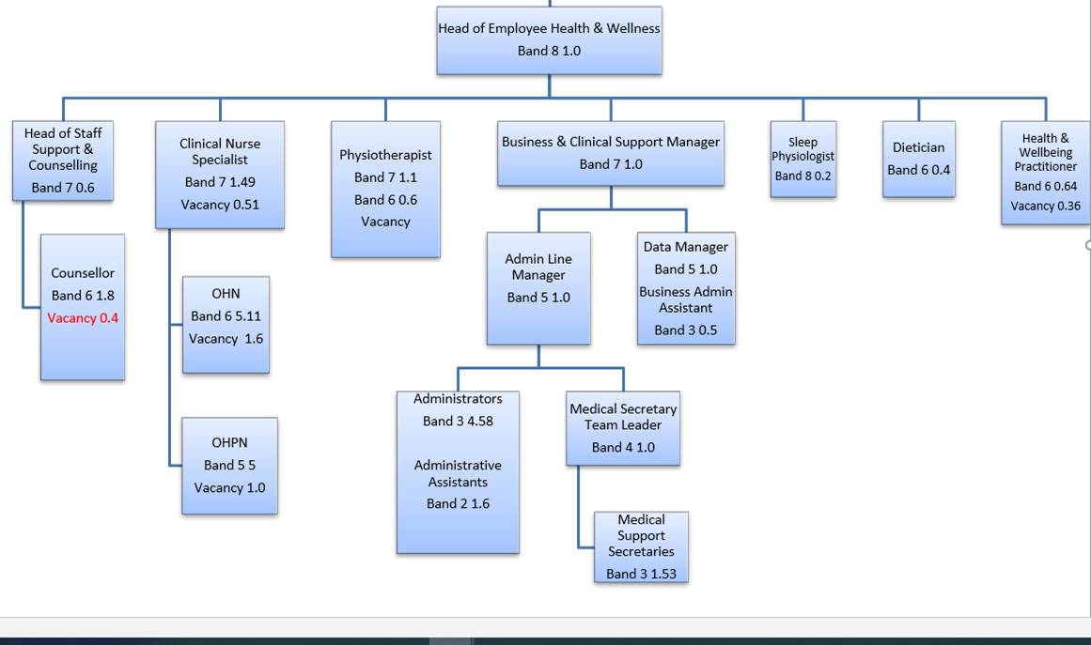

5. KEY RESULT AREAS/PRINCIPAL DUTIES AND RESPONSIBILITIES

Clinical Skills
- Provide one to one counselling to staff on work related issues or personal matters impacting their work.
- Provide counselling face to face, through online platforms and via telephone. Our offices are bases in Exeter and Barnstable and some travel to Trust sites will be required. Some home working may be permitted.
- Undertake telephone triages and assessments.
- Manage own case load, assessment, appointments and record keeping electronically.
- Use clinical judgement in casework regarding appropriate management of referrals.
- Arrange onward referral to an occupational adviser, occupational physician or other professional as appropriate.
- Provide group-work for psycho-education groups for staff.
- Provide day to day support and mentoring of placement counsellors as required.
- Work within the BACP Ethical Framework for the Counselling Professions (2018).
- Participate in planned Health & Wellbeing activities.
- Work within the requirements of national advisory bodies i.e. Department of Health, Health & Safety Executive and National Institute for Health & Care Excellence.
- Work in isolation with minimal supervision. Take responsibility for own safety in line with Trust Lone Worker Policy.
- Establish and maintain communication with people at all levels, including department managers and employees.
- Maintain electronic records contemporaneously of all counselling activities.
- Work under guidance of established protocols and procedures. Use own initiative to deal with routine and non-routine issues and identify when it is appropriate to refer to OH Service Manager.
- Arrange and attend own professional counselling supervision.

Quality Management
- To contribute to the monitoring and use of SEQOHS standards
- To contribute to the implementation of CQUIN targets
- To contribute to the implementation of action plans to improve client standards and services including the use of CORE and service feedback.
- To contribute to the implementation of improvements to working methods and practices.
- To participate in and contribute to changes and improvements within occupational health and the Trust.
- Participate in audit and research programmes.

Financial Management
- To ensure own activity is recorded for management reporting and invoicing purposes
- To contribute to the monitoring and control the use of resources within budgetary limits.
- To contribute to the analysis of staffing requirements against workload activity.
- To assist with developing the financial awareness within the team so that individual staff contribute to the efficient use of resources.

Information Management
- To contribute to the collection, recording and storage of information.
- To make use of relevant information in decision making, problem solving and care management.
- Manage identified reports and inform clinical nurse specialist / business & clinical support manager of any areas of concern that need to be addressed.

Management
- To provide clear instructions and accurate information to colleagues
- Participate in meetings internally or externally relevant to the Occupational Health Service.

Professional Development
- To practice in accordance within the BACP Ethical Framework for the Counselling Professions (2018).
- To maintain BACP Accreditation (or equivalent).
- To contribute to the development of professional knowledge and skills of other staff within the team.
- To develop own knowledge and practice by recognising and taking advantage of all opportunities to learn including participation in clinical supervision.

Other Responsibilities
- To take part in regular performance review.
- To undertake any training required in order to maintain competency including mandatory training, i.e. Fire, Manual Handling, Information Governance.
- To contribute to and work within a safe working environment.
- The post holder is expected to comply with Trust Infection Control Policies and conduct him/herself at all times in such a manner as to minimise the risk of healthcare associated infection.

6. THE TRUST - VISION AND VALUES

Our vision is to provide safe, high quality seamless services delivered with courtesy and respect. To achieve our vision we expect all our staff to uphold our Trust values. Our Trust values are:

Honesty, Openness & Integrity
Fairness,
Inclusion & Collaboration
Respect & Dignity

We recruit competent staff that we support in maintaining and extending their skills in accordance with the needs of the people we serve. We will pay staff fairly and recognise the whole staff’s commitment to meeting the needs of our patients.

We are committed to equal opportunity for all and encourage flexible working arrangements including job sharing.

We are committed to recruiting and supporting a diverse workforce and welcome applications from all sections of the community, regardless of age, disability, gender, race, religion, sexual orientation, maternity/pregnancy, marriage/civil partnership or transgender status. We expect all staff to behave in a way which recognises and respects this diversity, in line with the appropriate standards.

7. GENERAL

This is a description of the job as it is now. We periodically examine employees' job descriptions and update them to ensure that they reflect the job as it is then being performed, or to incorporate any changes being proposed. This procedure is conducted by the Manager in consultation with the jobholder. You will, therefore, be expected to participate fully in such discussions. We aim to reach agreement on reasonable changes, but if agreement is not possible, the Trust reserves the right to insist on changes to your job description after consultation with you.

Royal Devon University Healthcare NHS Foundation Trust is a totally smoke-free Trust. Smoking is not permitted anywhere on Trust property, including all buildings, grounds and car parks. For help to quit call 01392 207462.

As an employee of the Trust, it is a contractual duty that you abide by any relevant code of professional conduct and/or practice applicable to you. A breach of this requirement may result in action being taken against you (in accordance with the Trust’s disciplinary policy) up to and including dismissal.

The post holder is expected to comply with Trust Infection Control Policies and conduct him/her at all times in such a manner as to minimise the risk of healthcare associated infection.

PERSON SPECIFICATION

POST: Staff Counsellor BAND: 6

REQUIREMENTS | At Recruitment | At 2nd KSF Gateway
QUALIFICATIONS/SPECIAL TRAINING:  - Diploma in Counselling & Registered Practitioner  - BACP (or equivalent) Accredited Practitioner  - Qualification in a therapeutic modality recognised by NICE  e.g. CBT or EMDR | E  D  D | E  E  E
KNOWLEDGE/SKILLS:  - Ability to undertake a range of staff support & counselling activities with minimal supervision.  - Counselling assessments; face to face, online or by telephone.  - Knowledge and use of a range of counselling modalities underpinned by theory.  - Ability to work within the BACP Ethical Framework for the Counselling Professions (2018).  - Knowledge of Health & Wellbeing in the workplace  - Solution focussed practice within a limited time frame.  - Knowledge of:  - Health and Safety legislation  - HSE Management Standards for Stress  - Able to demonstrate continuing professional development.  - Good IT skills, including Microsoft Office, Internet & Email.  - Familiarity with Occupational Health Database of eOPAS | E  E  E  E  E  E  E  E  E  D | E  E  E  E  E  E  E  E  E  E
DELIVERING THE SERVICE  - Assess, plan, deliver and evaluate, time limited, solution focused counselling.  - Liaise with the Admin Services team and Business Support team to ensure counselling services are delivered in a timely manner.  - Contribute to service improvements by identifying processes that could streamlined | E  E  E | E  E  E
EXPERIENCE:  - Occupational Health within the NHS  - Manage own caseload and working to tight deadlines  - Delivering Critical Incident Support  - Experience of counselling through; online platforms, via telephone and face to face | D  E  D  E | E  E  E  E
PERSONAL REQUIREMENTS:  - Good team member, able to complement group dynamics  - Ability to prioritise own workload and demonstrate good organisational skills  - Excellent written and oral communication skills  - Reliable  - Motivated  - Good attendance record | E  E  E  E  E  E | E  E  E  E  E  E
OTHER REQUIREMENTS  - Must have a flexible approach to work.  - Adaptable to changing needs of the service | E  E | E  E

Essential/Desirable

Hazards within the role, used by Occupational Health for risk assessment
Laboratory Specimens Proteinacious Dusts |  | Clinical contact with patients |  | Performing Exposure Prone Invasive Procedures
Blood / Body Fluids |  | Dusty environment |  | VDU Use | X
Radiation |  | Challenging Behaviour | X | Manual Handling | X
Solvents |  | Driving | X | Noise
Respiratory Sensitisers |  | Food Handling |  | Working in isolation | X
Handling Cytotoxic Drugs |  |  |  | Sitting still for long periods | X

