ROYAL DEVON & EXETER HOSPITAL

JOB DESCRIPTION

1. JOB DETAILS

Job Title: Section Lead - Blood Transfusion and Transfusion Practitioner

Band: 7

Responsible to: Clinical Director – Diagnostic Services

Accountable to: Transfusion Laboratory Manager

Section/Department/
Directorate: Blood Transfusion

2. JOB PURPOSE

This is a joint laboratory and transfusion practitioner role.
To ensure provision of the scientific service commitment of the laboratory in line with Trust objectives and commensurate with grade and responsibilities.
As the Lead Biomedical Scientist (BMS) for Blood Transfusion the post holder is responsible for the management of the department providing all aspects of the Blood Transfusion service on the RDE site, working with a team of lead BMS staff. The post holder will be responsible for managing the day to day organisation and analytical work of the Blood Transfusion department. The postholder must use a combination of knowledge and skills to ensure that appropriate sample testing and the issue of blood components and products are performed safely, accurately and in a timely manner, for every patient and in compliance with Good Manufacturing Practice (GMP), and the Blood Safety and Quality Regulations (BSQR) 2005, Good Practice Guidelines for Blood Establishments and EU Blood Directives.
The post is responsible for supporting the development, implementation and delivery of safe and effective transfusion processes, policies, procedures and educational programs for laboratory and clinical staff in conjunction with the Trust hospital transfusion team and patient blood management group. The post holder will be expected to support the clinical teams on the ward and other clinical areas with all aspects of the transfusion process.

3. KEY WORKING RELATIONSHIPS

- Clinical Head of Department
- Consultant leads for transfusion
- IV nurses at NDDH
- Laboratory Manager and deputy (Blood Sciences)
- Other Band 7 BMS at the Trust sites (RDE and NDDH)
- Other BMS Grades at the Trust sites (RDE and NDDH)
- MTO and MLA staff at the Trust sites (RDE and NDDH)
- Trust and PCT Clinical/Nursing Staff
- Company Representatives

4. KEY DUTIES AND RESPONSIBILITIES

Laboratory section lead

Communication and relationship skills

Knowledge, training and experience
- To ensure the correct operation, cleaning and maintenance of laboratory surfaces and equipment and all blood component storage facilities (both within the laboratory and in the clinical areas) according to GMP and GPG departmental and manufacturer’s protocols and procedures.
- To advise on equipment and method troubleshooting (including laboratory instrumentation and remote issue blood fridges), and receive reports of situations requiring further action, to work with Laboratory Support to arrange service engineers for fault resolution, reporting and documenting equipment faults and resolutions as per local requirements.
- To supervise and facilitate the maintenance of correct storage of blood components throughout the laboratory and service areas as required, including but not limited to: temperature monitoring (electronic and manual systems) and responding to temperature deviations; arranging and directing stock movement between blood fridges in order to minimise wastage and provide sufficient supplies where needed; initiating blood component recalls as required; correct packing of blood transport containers to local standards.
- To be responsible for maintaining the provision of service within agreed quality and financial parameters.
- To appraise new processes, techniques and equipment and give appropriate advice to the laboratory managers on their implementation.
- To be responsible for the development, maintenance and implementation of the departments IT systems.
- To undertake final clinical approval of results from the laboratory computer system.
- To ensure that the training documentation is up to date and complies with UKAS, HCPC and IBMS regulations, and to ensure adequate training programmes are in place for junior medical, clinical, scientific and support staff.
- To provide managerial support to the transfusion laboratory manager.
- To undertake teaching, competency and induction of new staff, including medical and nursing, in conjunction with the other lead biomedical staff, and be actively involved in staff meetings and seminars.
- To keep abreast of current developments in the field and attend courses and meetings as relevant.
- To continue own personal and professional development by participation in a recognised CPD scheme, and participation in departmental meetings and case presentations.
- To participate in the selection and recruitment of BMS staff in accordance with current Trust policies.
- To be responsible with other laboratory Band 7 s for the selection and recruitment of support staff.
- To ensure all staff within the department have the appropriate training and maintain their competency assessments in all areas.

Analytical and judgemental skills

- To ensure the maintenance of scientific standards and quality assurance in all areas of the department. To establish systems that ensure that for each sample the appropriate requested investigations are performed in a timely manner, and that agreed turnaround times of samples and results are met.
- To ensure that results are correctly verified, and appropriate diagnostic comments added before authorisation.
- To liaise with the NHSBT reference laboratories and clinicians for the follow-up of specialist investigations or the provision or compatible blood components for patients with complicated serology.
- To ensure timely and accurate reporting of manual work results with correct follow-up including input of additional testing requirements, correct report comments, future testing instructions and patient special blood component requirements into the laboratory information system (LIMS).

Planning and organisational skills
- To oversee and (when necessary) participate in the routine processing of specimens and issue of blood components; and to allocate work to the other BMS and MTO staff to ensure a smooth workflow.
- To be actively involved in the timely development of rotas to provide the appropriate numbers and correct skill mix of staff to support essential daily transfusion services, and to ensure continuous 24/7 cover for the whole Haematology and Transfusion laboratory service.
- To ensure a robust rota is in place to provide a 24/7 service.
To ensure adequate supplies of laboratory consumables, reagents; and to ensure adequate supplies of blood component and product stocks

Physical skills
- Concentration required for advanced specialist support with antibody identification.
- Attention to detail required for laboratory skills and manual testing activities.

Responsibility for patient/client care
- To ensure that specialised and urgent specimens are appropriately dealt with.
- To ensure timely and accurate reporting of clinically significant red cell antibodies in antenatal patients with correct follow-up and liaison with the relevant clinical teams responsible for the patient.
- To oversee (in liaison with MTO staff, couriers and transfusion practitioners) the remote issue and collection of blood in the clinical areas as well as the use of contingency blood storage equipment for planned or unexpected downtime.

Responsibility for policy/service development

- To work with the Blood Sciences Quality Management Group to uphold an effective Quality system in Blood Transfusion in accordance with UKAS accreditation requirements (ISO15189).
- To monitor external quality control submission and compliance, and to contribute to audit activities.
- To manage and monitor the External and Internal Quality Assurance schemes in the department.
- To ensure the maintenance of the laboratory Quality Management systems.
- To plan and monitor compliance with the departments audit program.
- To ensure the department complies with the laboratories current change control and validation system.
- To undertake all work in a manner consistent with Trust policies.
- To ensure all work undertaken in the department is compliant with current ISO 15189 standards and ensure compliance with GMP standards, legal compliance with the Blood Safety and Quality Regulations (BSQR) 2005 and any subsequent updates.
- To develop and maintain the departments continuous improvement plan in line with the laboratories overall improvement plan.
- To ensure all non-conformances are reported, investigated and improvement/actions acted on, within the laboratories Quality Management framework.
- To identify and undertake risk assessments in specific clinical areas where transfusion practice may be improved and to explore alternative procedures and therapies using research methodology and ‘Best Practice’ ethos

Responsibility for Financial & Physical Resources
- To ensure that the department is meeting its KPI’s and any contractual deliverables required.
- Responsible for monitoring and ordering consumables, products and components to maintain service provision.

Responsibility for Human Resources
- To be involved in staff recruitment and to conduct appraisals as required. To approve leave requests, monitor sickness absence and act as first line response in disciplinary, grievance and performance matters.
- In liaison with the transfusion laboratory manager ensure that services are delivered within agreed turn around times in an efficient cost effective manner to agreed quality levels.
- To work with the transfusion laboratory manager, and wider Blood Sciences team, in organising staff rotations through the sections and to provide 24/7 cover.
- To be responsible for developing, implementing and maintaining the department’s documentation.
- To manage the day to day scientific work of the department and to provide support where necessary.
- To manage all HR policy aspects of staff for which they act as line manager including performance, sickness and disciplinary.
- To undertake annual PDR and PDP interviews with staff to whom they are line managers.

Responsibility for Information Resources
- To inspect documentation and records including but not limited to QC, QA, cleaning, maintenance, temperature monitoring, equipment service and repair, incident reports etc. to ensure compliance with with the Blood Safety and Quality Regulations (BSQR) 2005 and any subsequent updates.
- To contribute to the maintenance and development of Standard Operating Procedures (SOPs), and to ensure that other staff fulfil their responsibilities in this respect.
- To keep accurate records of all work undertaken, including the development and maintenance of databases, spreadsheets and paper files using information both personally generated and that generated by others.
- To provide statistical information, input data, design and produce reports as necessary.
- To investigate; report and document adverse incidents/near misses in relation to transfusion procedures and record data in accordance with the Trust Governance strategy.
- To produce reviews of activity and any untoward incidents in relation to blood and blood components

Responsibility for Research & Development
- Responsible for ensuring service contributes to clinical trials and activities are compliant with trial requirements and regulatory requirements.

Transfusion practitioner

Communication and relationship skills
- To act as a liaison between the laboratory and clinical teams, working with the consultant leads for transfusion and transfusion laboratory manager.
- Engage and participate in Trust inititatives that involve transfusion, working with the consultant leads for transfusion and transfusion laboratory manager.
- To engage and participate in the HTT and PBMG across both Trust sites and work with the IV nursing team at the Northern site.
- To engage with and participate in transfusion comittee network meetings in the South West.
- To give specialist advice to clinicians, nursing and other scientific staff.
- When necessary to undertake the work of more junior grades.
- To monitor the appropriateness of blood and blood component usage in association with the blood transfusion laboratory and use this data to implement service changes that are effective in both patient management and cost.
- To evaluate the management of patients receiving blood and blood components.

Knowledge, training and experience
- To act as a resource and provide specialist knowledge and expertise in blood transfusion practices and processes for all clinical professionals within the hospital.
- To identify educational needs, develop, maintain and deliver effective training and competency assessment in transfusion related activities for all staff groups involved in transfusion.

Analytical and judgemental skills
- To identify and escalate potential transfusion risks in the clinical areas, to engage and participate in the transfusion risk assessment and governance processes.
- To provide support and advice on transfusion practice at the ward level, including use of the electronic patient record system. Ensure provision of information about transfusion for patients, carers, nursing and medical staff.

Planning and organisational skills
- To support the preparation, provision and presentation of evidence for the assessment of hospital against set standards for transfusion practice.
- To attend meetings with other health care professionals to develop departmental policies.
- To meet with representatives from companies providing materials or services to ensure an efficient and cost effective service is maintained.

Responsibility for patient/client care
- To ensure hospital compliance with traceability working with the laboratory staff, transfusion practitioners and clinical staff.
- To appoint and provide appropriate training for the Transfusion Champions (TC) and to support them in their TC roles.
- To ensure the optimal provision of patient safety and care during blood component transfusion episodes.
- To monitor care given to patients by regularly auditing transfusion practices within the Hospital and using these results, to design, implement and review protocols as appropriate.

Responsibility for policy/service development
- To undertake, (in conjunction with the transfusion laboratory manager, quality manager, transfusion practitioners, laboratory and clinical staff as required), investigation of any incident, error, transfusion reaction or other event which may cause a service delivery or quality failure, and to assist in the implementation and documentation of corrective and preventive actions.
- Responsibility for SABRE and SHOT reporting, where relevant, working with the transfusion laboratory manager.
- To work with the consultant leads for transfusion, transfusion laboratory manager and nursing staff to plan and implement Hospital Transfusion policy, providing vision for nursing within the service.
- In collaboration with the Hospital Transfusion Team and Patient Blood Management Group to develop evidence-based protocols and guidelines covering all aspects of transfusion of blood components and products, and implement these within the Trust.

Responsibility for Information Resources
- To be proficient in the use and functions of the information technology systems within the department and the wider organisation, including relevant administrative functions relating to transfusion activities
- Maintain and develop with the transfusion laboratory manager contingency plans for transfusion.
- To be responsible for ensuring appropriate staff access to the electronic blood tracking system, including maintenance of the system, leading and working with the Blood Sciences administration team.

General

Freedom to Act
- Follows occupational policies
- Manages a team of scientific and support staff providing the transfusion service

Physical Effort
- Sitting at a desk for long periods using a computer workstation
- Standing whilst delivering training sessions
- Using a PC or Laptop for computer work
- Walking to clinical areas within the hospital, driving or other transport to other sites where transfusions take place

Mental Effort
- The role requires periods of concentration working at a computer

Emotional Effort
- Potential exposure to distressing or emotional circumstances as part of the transfusion practitioner roles
- Contact with patients as part of the transfusion practitioner rolw

Working Conditions
- Exposure to contained infectious material, body fluids

5. ORGANISATION CHART

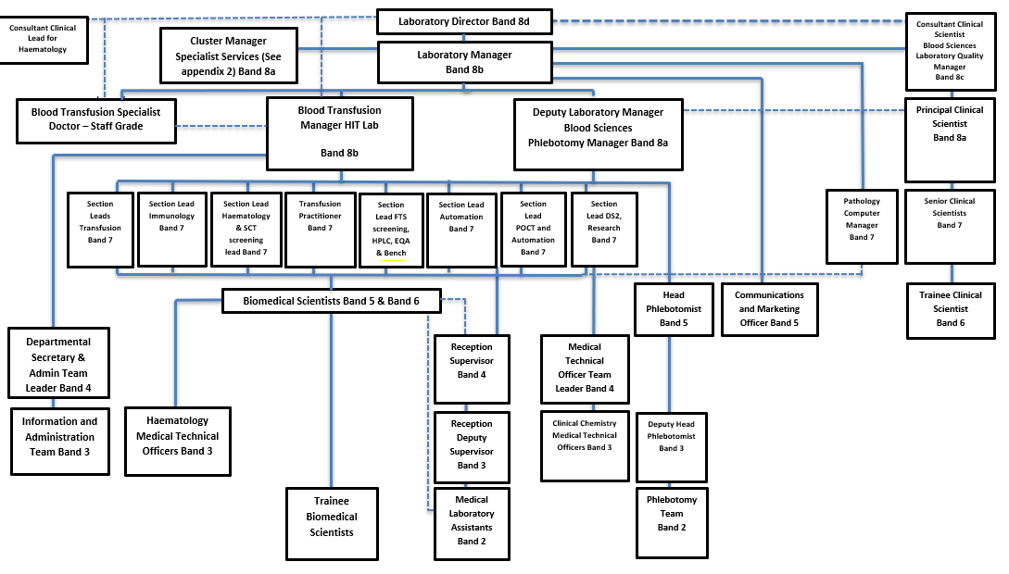

Out of Hours Working

- On occasions it may be necessary to work weekend/bank holiday days.
- It is expected that the post holder will not participate in the night working rota.

Other
- To contribute to and work within a safe working environment.
- The post holder is expected to comply with Trust Infection Control Policies and conduct him/herself at all times in such a manner as to minimise the risk of healthcare associated infection.
THE TRUST - PURPOSE AND VALUES

We are committed to serving our community by being a high quality specialist Hospital with consultant-led services. We aim to co-ordinate our services with primary and community care, and to develop a limited number as Sub-Regional Referral Centres with appropriate levels of research, development and educational involvement. Where appropriate, and consistent with our services, we may provide services aimed at preventing disease and debilitation.

We aim to make all our services exemplary in both clinical and operational aspects. We will show leadership in identifying healthcare needs to which we can respond and in determining the most cost-effective way of doing so. We will share our knowledge with neighbouring healthcare agencies and professionals.

We recruit competent staff whom we support in maintaining and extending their skills in accordance with the needs of the people we serve. We will pay staff fairly and recognise the whole staff’s commitment to meeting the needs of our patients.

GENERAL

This is a description of the job as it is now. We periodically examine employees' job descriptions and update them to ensure that they reflect the job as it is then being performed, or to incorporate any changes being proposed. This procedure is conducted by the Manager in consultation with the jobholder. You will, therefore, be expected to participate fully in such discussions. We aim to reach agreement on reasonable changes, but if agreement is not possible, the Trust reserves the right to insist on changes to your job description after consultation with you.

As an employee of the Trust, it is a contractual duty that you abide by any relevant code of professional conduct and/or practice applicable to you. A breach of this requirement may result in action being taken against you (in accordance with the Trust’s disciplinary policy) up to and including dismissal.

The RD&E is a totally smoke-free Trust. Smoking is not permitted anywhere on Trust property, including all buildings, grounds and car parks. For help to quit call 01392 207462.

As an employee of the Trust, it is a contractual duty that you abide by any relevant code of professional conduct and/or practice applicable to you. A breach of this requirement may result in action being taken against you (in accordance with the Trust’s disciplinary policy) up to and including dismissal.

JOB DESCRIPTION AGREEMENT:

Jobholder’s Signature: ................................................................................

Date: .................................................................................

Manager’s Signature: .................................................................................

Date: .................................
ROYAL DEVON & EXETER NHS FOUNDATION TRUST
PERSON SPECIFICATION
POST: Section Lead - Blood Transfusion
BAND: 7
REQUIREMENTS |  | E/D* | MET | NOT MET
QUALIFICATIONS/SPECIAL TRAINING:
State Registration HCPC  Have a suitable Masters degree or IBMS higher specialist diploma or equivalent.  Evidence of formal management training  Evidence of CPD |  | E  E  D  E
KNOWLEDGE/SKILLS:
Specialist knowledge of laboratory Blood Transfusion  Laboratory governance and accreditation requirements  Laboratory health and safety requirements  Knowledge of clinical transfusion practice |  | E  E  D  D
EXPERIENCE:
Post HCPC registration experience in a Transfusion Laboratory  Experience of maintaining and developing laboratory and/or clinical transfusion computer systems  Experience of Automated Laboratory Equipment  Previous experience of managing staff  Evidence of delivering training within a clinical and/or laboratory team |  | E  D  E  E  E
PERSONAL REQUIREMENTS:
Excellent Team Leader  Good Communication Skills verbal and written  Self motivated and ability to motivate others  Good Attendance Record  Flexibility and ability to prioritise to meet deadlines |  | E  E  E  E  E
OTHER REQUIREMENTS:
Ability to participate in 7 day work pattern  Experience of change management | E  E
Reason to appoint/not appoint
*Essential/Desirable

HAZARDS:
Laboratory Specimens Proteinacious Dusts |  | Clinical contact with patients |  | Performing Exposure Prone Invasive Procedures
Blood / Body Fluids |  | Dusty environment |  | VDU Use | 
Radiation |  | Challenging Behaviour |  | Manual Handling | ✓
Solvents |  | Driving |  | Noise
Respiratory Sensitisers |  | Food Handling |  | Working in isolation | 
Processing Chemistry |  | Handling Cytotoxic Drugs |  | Night Working

