JOB DESCRIPTION

JOB DETAILS

Job Title: Finance Analyst

Band: 6

Responsible To: Senior Project Accountant/ Contracts Manager

Accountable To: Head of Contracting and Income

Department/Directorate: Finance Department

Job Purpose:

- To complete the contract monitoring submissions, in line with national deadlines and guidance.
- Provide support to the Contracts Manager / Senior Project Accountant.
- Provide support for the completion of Trust wide financial duties.
- To provide a key role within the Contracting and Income team by analysing complex financial data, with a view to provide the department and directorates with up to date costing information, forecasts of future activity and conversion of activity data into detailed activity budgets.

Key Working Relationships:

- Head of Contracting and Income
- Contracting and Income Team
- Management Accountants
- Senior Information Analysts
- Chief Management Accountant
- Divisional Business Managers
- Senior Project Accountants
- Head of Financial Management

Structure Chart
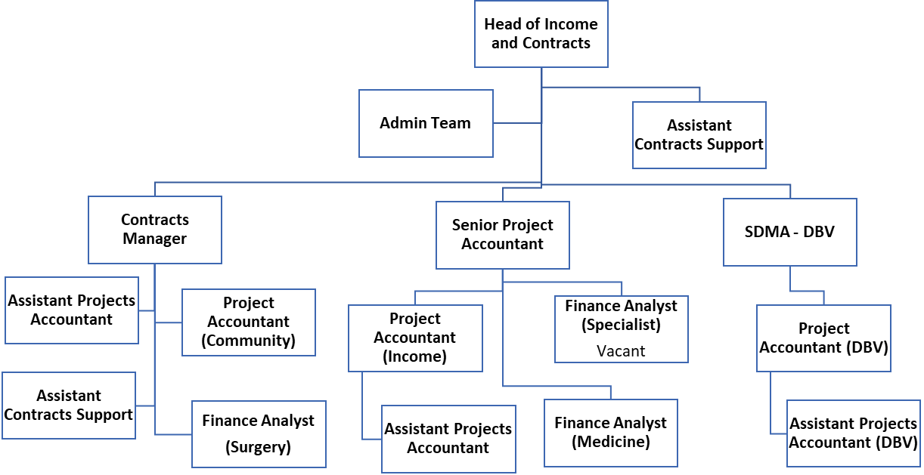
Key Result Areas/Principal Duties and Responsibilities:

Contract Monitoring Submissions

- Responsible for the preparation of contract monitoring submissions, in accordance with National payment systems and Commissioner guidance.
- Responsible for the interpretation and application of the national payments guidance and taking appropriate action in completing the contract monitoring submission.
- To work closely with the Divisions and IM&T to ensure accuracy and consistency of data used.
- Respond to financial queries as they arise, providing advice and guidance & training on sometimes complex/contentious issues to financial and non-financial managers, whilst being aware of trust wide issues.
- Production of a project plan to ensure the contract monitoring submission is completed on time throughout the year. Communicating this plan to DMA’s within the section, monitoring and addressing any variations to the plan.
- Participate fully in SLAM systems user group meetings and annual or more frequent updates. Advise mangers of the relevant departments on the changes to the guidance and ensure that the necessary information is collected and reported in a timely manner.
- Compare activity and income with previous years and/or national averages and investigate any variances that occur, providing analysis of the changes and using own judgement to determine the accuracy/validity of changes. Where necessary manipulate the data in the current income system to provide better monitoring information, whilst ensuring the relevant guidance is adhered to.
- Reconcile the contract monitoring submission to the general ledger; identify any errors/discrepancies that may arise, with a view to resolving them.
- Identify differences between Reference Cost information and the RD&E contracting system and contribute to the development of a plan to align contracts to be based on reference cost information as outlined in the financial flows guidance.
- Maintain the SLAM database to allow the trust to produce accurate full income for patient services. Ensuring that information is up to date and relevant and that patient activity income returns are produced on a regular and timely basis and that all submission deadlines are met.
- Set out a timetable to continually review and update SLAM tables and income profiles to take account of changing operational practices

Corporate

- Support the Contracts Manager /Senior Project Accountant in the provision of regular financial reports for Service Line Reporting (SLR) .
- Assist in the annual budget setting process.
- Using the Trust wide activity pivot tables, update the Trust capacity planning model by CCG ensuring that the information reconciles.
- Develop knowledge of relevant NHS policies and procedures including Payment by Results (PbR).
- Assist in the completion of other returns both internal and external as directed by the Contracts Manager / Senior Project Accountant.
- Provide assistance in meeting statutory responsibilities, liaising with Financial Accounting colleagues, especially regarding the production of Annual Accounts, and other related work.
- Contribute to the budget setting process as required.
- Develop and maintain the capacity planning model using historic patient referrals to forecast future attendances for the medium term, incorporating any changes in national guidance or local practices (for example 18 weeks RTT). Scenario analysis may be required where several options are being considered. This should be completed in conjunction with the contract review group.
- Feed into the trust budget setting process by converting high level activity plans into detailed activity budgets for all specialties, adhering to payment by results guidance at all times.
- Completion of other monitoring reports/returns, both internal and external, as directed by the Contracts Manager/Senior Project Accountant. This will involve designing and formatting spreadsheets for specific purposes often in short timescales.

Financial Projects

- Provide a support role to the Contracts manager / Senior Project Accountant and Financial Development Team by supporting the implementation of a wide range of Finance projects. Opportunities will be given to develop knowledge of other sections and gain experience of other roles within finance.
- As part of the Project Agenda, the post holder will;
  - Investigate and analyse complex accounting problems, seeking explanations for the problem and suggesting appropriate solutions where possible
  - Develop skills in interpreting management information in order to promote improvements, enhance quality, or provide recommendations as required
  - Participate fully in project work, in order to ensure the successful completion of the objectives set for the team as a whole
  - Design and format spreadsheets and databases for specific purposes, and be responsible for introducing, adapting and improving financial systems for use by others.
  - Develop skills and knowledge in a range of finance systems and procedures in order to contribute fully to the section’s objectives.
  - Assist in transferring completed project work, where appropriate, to operational staff, ensuring that procedures are in place and that training requirements are supported as necessary.
- Undertake project work with other Senior Managers, as required, to support the objectives of the Finance Department or the Division, and assess the implications and risks of such projects.
- Prioritise and identify own work schedule, whilst meeting agreed objectives, and use the freedom to do this, within Trust policies and procedures.
- Is aware of, and meets agreed deadlines.

Other Responsibilities:
- Participate fully in the creation of own Personal Development Plan through the Trust’s Review process.
- Supervise and support the assistant project accountant and contracts assistant.
- Perform such other duties as may be directed from time to time by Senior Finance Managers.
- To take part in regular performance appraisal.
- To undertake any training required in order to maintain competency including mandatory training, i.e. Fire, Manual Handling
- To contribute to and work within a safe working environment
- The post holder is expected to comply with Trust Infection Control Policies and conduct him/herself at all times in such a manner as to minimise the risk of healthcare associated infection.

THE TRUST - PURPOSE AND VALUES

We are committed to serving our community by being a high-quality specialist Hospital with consultant-led services. We aim to co-ordinate our services with primary and community care, and to develop a limited number as Sub-Regional Referral Centres with appropriate levels of research, development and educational involvement. Where appropriate, and consistent with our services, we may provide services aimed at preventing disease and debilitation.

We aim to make all our services exemplary in both clinical and operational aspects. We will show leadership in identifying healthcare needs to which we can respond and in determining the most cost-effective way of doing so. We will share our knowledge with neighbouring healthcare agencies and professionals.

We recruit competent staff whom we support in maintaining and extending their skills in accordance with the needs of the people we serve. We will pay staff fairly and recognise the whole staff’s commitment to meeting the needs of our patients.

We are committed to equal opportunity for all and encourage flexible working arrangements including job sharing.

GENERAL

This is a description of the job as it is now. We periodically examine employees' job descriptions and update them to ensure that they reflect the job as it is then being performed, or to incorporate any changes being proposed. This procedure is conducted by the Manager in consultation with the jobholder. You will, therefore, be expected to participate fully in such discussions. We aim to reach agreement on reasonable changes, but if agreement is not possible, the Trust reserves the right to insist on changes to your job description after consultation with you.

The RD&E is a totally smoke-free Trust. Smoking is not permitted anywhere on Trust property, including all buildings, grounds and car parks. For help to quit call 01392 207462.

As an employee of the Trust, it is a contractual duty that you abide by any relevant code of professional conduct and/or practice applicable to you. A breach of this requirement may result in action being taken against you (in accordance with the Trust’s disciplinary policy) up to and including dismissal.

The post holder is expected to comply with Trust Infection Control Policies and conduct him/her at all times in such a manner as to minimise the risk of healthcare associated infection.

PERSON SPECIFICATION

POST : Finance Analyst

REQUIREMENTS | At Recruitment
QUALIFICATIONS/SPECIAL TRAINING :  Professional Accountancy Qualification – (CCAB Recognised – Postgraduate Diploma level)  Professional Accountancy Qualification – (CCAB Recognised – Certificate Level)  Actively Studying towards CCAB qualification  A Levels (Or Equivalent)  GCSE’s (Or Equivalent) | D  E  E  E  E
KNOWLEDGE/SKILLS:  Computer Literate  Use of Modern Accounting Systems including General Ledger  Ability to Analyse complex problems  Experience of producing costing and or income information using a variety of techniques  Experience of completing the annual reference cost or income plan  Advanced IT skills including design, creation & maintenance of complex spreadsheet packages | E  E  E  E  D  E
EXPERIENCE:  Accountancy (Min 3 years)  Min 1 year in management accounts  NHS experience | E  D  D
PERSONAL REQUIREMENTS:  Able to work as a team member  Confident  Good Communicator  Self Motivated | E  D  E  E
OTHER REQUIREMENTS:
* Essential/Desirable

Hazards within the role, used by Occupational Health for risk assessment
Laboratory Specimens  Proteinacious Dusts |  | Clinical contact with patients |  | Performing Exposure  Prone Invasive Procedures
Blood/Body Fluids |  | Dusty Environment |  | VDU Use | X
Radiation |  | Challenging Behaviour |  | Manual Handling
Solvents |  | Driving |  | Noise
Respiratory Sensitisers |  | Food Handling |  | Working in Isolation

