JOB DESCRIPTION

1. JOB DETAILS

Job Title: Fundraising Database Co-ordinator

Band: 4

Responsible To: Head of Fundraising

Accountable To: Head of Fundraising

Department/Division: Strategy

2. JOB PURPOSE

This post will be responsible for a range of administration tasks linked to raising funds for the Trust’s registered charity. The post holder will act as the first point of contact for callers to the fundraising office.

This post will ensure excellent planning, negotiating and organisation to work closely with, and provide high quality personal assistance to, the management team, using own initiative and working without supervision.

The post holder will support campaigns by ensuring the specialist fundraising database, Harlequin, is accurate and allows targeted communication, responding to email requests and telephone queries as well as mobilising volunteer support for various fundraising appeals. You will ensure prompt receipt and processing of all donations and adhere to the Trust’s financial procedures and policies.

The post holder will also be expected to support a range of projects, including charity events and social media campaigns. You may be required to update the charity’s social media platforms on a regular basis and respond to queries from supporters. You will ensure that the charity website is updated with the latest events and news information. You will assist with media enquiries and report these to the appropriate member of staff.

3. KEY WORKING RELATIONS

The post holder is required to deal effectively with staff of all levels throughout the Trust, the wider Healthcare community, patients, external organisations and the public. This will include verbal, written and electronic media.

- Communications and Engagement Teams
- Senior Management Teams
- Administration and secretarial teams across the Trust
- External NHS organisations
- External organisations/providers

4. DIMENSIONS

The Charity Database Co-ordinator will be based in the fundraising department and will provide administrative support to the fundraising team.

The post holder will fulfil all administration tasks and work as part of a team and may be delegated responsibility for supervision of staff in lower bands and be involved in recruitment and selection of admin staff and volunteers. To meet the needs of the service, the post holder may be required to work in other administrative areas as appropriate as directed by the line manager.

5. ORGANISATIONAL CHART

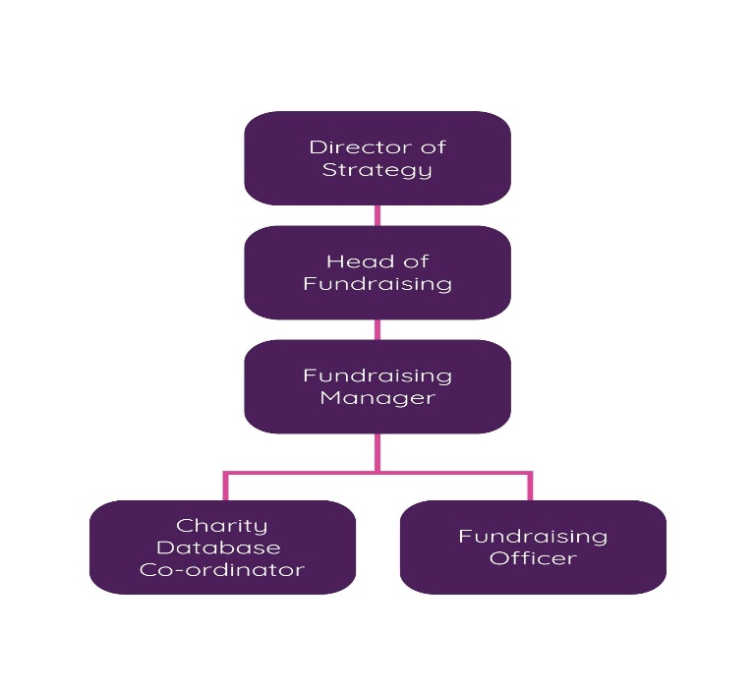

6. KEY RESULT AREAS/PRINCIPAL DUTIES AND RESPONSIBILITIES:

Communication and Relationship Skills
- Act as the first point of contact for callers to the fundraising office, demonstrating the Trust’s values in all contacts
- Ensure all requests or requirements are actioned appropriately in the manager’s absence
- Appropriately deal with all day to day correspondence within the department
- Communicate regarding a variety of enquiries on behalf of staff, patients and members of the public using initiative, and following advice as directed
- Communicate effectively with a wide range of internal and external stakeholders, to coordinate complex events and arrangements. This will include occasions where there may be a barrier to understanding.
- Communicate sensitively with bereaved family members, or members of the public who wish to make a donation.
- Present information to a range of audiences in an accessible format, ensuring that key messages are understood by the target audience, and that any reasonable adjustments are made to support inclusion.
- Make and receive telephone calls both external and internal according to Trust standards
- Communicate effectively including discussion and written communication
- Proactively manage email communication in line with the Trust’s Email Best Practice guidance
- Provide excellent customer care, in a calm and professional manner – some situations may be challenging
- Take accurate messages and ensure that these are passed on in a timely manner to the appropriate person
- Organise and/or support meetings through effective communication
- Take responsibility for preparing letters to acknowledge all donations to the Trust Charitable Fund
- Liaise with the communications and engagement teams to ensure that good news stories are shared internally and externally
- Respond to complaints in a sensitive and thorough manner, escalating to Line Manager if unable to resolve independently

Analytical & Judgemental skills
- Make judgements on facts or situations, some of which require analysis, such as resolving conflicting diary appointments, scheduling of events
- Communicate general issues and those of concern to a senior member of staff and use initiative to escalate or resolve straightforward issues in the absence of the manager
- Answer queries from donors and hospital staff and review data to check for errors, issues and discrepancies
- To carry out routine analysis of information as directed by manager, carrying out research to support analysis of information
- Use multiple computer systems as required within the department

Planning and Organisational Skills
- Have the ability to work using own initiative and manage time effectively to meet deadlines
- Ensure effective and efficient diary management, and to enable management time to prepare and attend meetings
- Manage Managers’ and team diaries, ensuring all absences/meetings are accurately recorded
- Organise own day to day activities and tasks and that of staff in lower banded jobs
- Set up and maintain accurate and effective filing systems both paper based and electronic filing systems
- Supporting the fundraising team with any additional administrative support that is required including at fundraising events
- Organise mail merges, correct data errors, print letters, arrange distribution/postage
- Maintain financial and administrative records of the charity
- Prepare, issue, manage documents and take minutes at meetings
- Plan and arrange charity volunteer cover and meetings as and when required
- To ensure effective bring forward systems, ensuring necessary range of papers are available to the management team
- Ensure that all documentation is produced to an excellent standard
- Maintain current and historical versions of the donor database in an appropriate format
- Ensure records and filing systems are maintained in line with Trust policies

Physical skills
- Use advanced keyboard skills to operate Trust computer systems.
- Display/distribute information about fundraising in the hospital and elsewhere
- Set up information stands at events

Responsibility for Patient/Client Care
- The post holder is required to put the patient, as the first priority, at the centre of all activities
- Responsible for all thank you letters to donors
- Assist patients/donors during regular contact, answering queries and giving advice and guidance

Policy/Service delivery/improvement
- Contribute to continuous improvement in the efficiency and effectiveness of the service provided to donors
- Work as part of the team in developing processes within the department to meet the demands of a growing service
- Participate in team and directorate meetings as required
- Contribute to audits regarding departmental procedures
- Have a flexible approach to working hours to meet the demands of the service
- Adhere to the Charitable Fundraising Policy and processes and appropriate standard operating procedures, Information Governance guidelines, government targets and standard operational policies

Responsibility for Financial and Physical resources
- Monitor use of charity supplies and stationery, including the purchase of items needed for charity events and community fundraising activities, and ensure this is done efficiently and cost effectively in line with the needs of the service
- Maintain appropriate stock records and ensure that stock held by the charity is appropriately managed
- Input of all financial records onto the Harlequin database
- Ensure that all cash handling, banking, donor acknowledgement and receipts are undertaken in accordance with Trust procedures
- Provide cover in periods of absence as directed by department manager, this may involve moving to other areas

Responsibility for Human Resources
- Maintain and update own training relevant to post
- Provide training as necessary on Harlequin and the filing system
- Participate in recruitment processes including being involved in interviews
- Participate in appraisals and support the development of staff in lower bands
- Provide on the job training for new staff and work experience students, taking an active part in the development review of own work, suggesting areas for learning and development in the coming year
- Ensure both planned and unplanned absences of team members are communicated appropriately including back to work interviews being conducted within Trust timeframes, updating both HR and ESR (Electronic Staff Record)
- It is likely that there will be a requirement to supervise one or more staff members. If this is the case this post will include checking of work, authorising annual leave, resolving simple staffing issues, assisting in PDR delivery, supporting with recruitment and ‘return to work’ interviews following staff sickness.
- Support recruitment campaigns by undertaking, or assisting the Head of Fundraising, in advertising of posts, shortlisting of candidates, taking part on focus groups, and coordinating interview arrangements

Responsibility for Information Resources
- Responsible for updating and maintaining social media pages (when necessary) with information about events and fundraising opportunities
- Daily use of IT programmes relevant to the department to process and store information and type up minutes of meetings
- Responsible for accurately maintaining staff and/or donor data

Responsibility for Research and Development
- Comply with Trust requirements and undertake surveys as necessary to own work. Assist the team with any research needs they may have

Decision Making/Freedom to Act
- Work within Trust policies and procedures
- Use initiative to deal with routine matters and complex queries, deciding when it is necessary to refer to the available line manager
- Work is managed rather than supervised and the post holder will organise own workload on a day-to-day basis

Physical/Mental/Emotional Effort
- Concentration required for checking data entry on computer
- Frequent requirement to sit in a restricted position at display screen equipment for the majority of the working day
- Concentration required to ensure accurate inputting of financial information onto the fundraising database
- Exposure to emotional and/or distressing circumstances is possible as some of those who support the charity are patients who have gone through difficult experiences
- Carry fundraising materials and equipment to and from vehicles and locations
- Attend fundraising events to help assemble equipment and prepare for events

Working Conditions
- Use of display screen equipment for substantial proportion of working day
- Working occasionally at weekends and some evenings may be required to support specific fundraising events

Governance
- To comply with HR policies particularly in relation to mandatory (essential) training and Personal Development Reviews to assist all members of the team in being up to date
- Undertake training as required to maintain competency/comply with trust policies
- Work within Trust policies – including those for confidentiality, data protection, health and safety fire protection, and annual appraisal
- Adhere to the Trust Charitable Fundraising Policy and processes, government guidelines and standard operational policies and procedures

Additional Responsibilities
- The post holder will be expected to carry out any other duties as required, commensurate with their pay band
- The post holder will be required to facilitate and support new starters to carry out their role
- The post holder will understand the limitations of the role and how to access support

Trust wide Responsibilities
- To take part in regular performance appraisal
- To undertake any training required in order to maintain competency including mandatory training, e.g. Manual Handling
- To contribute to and work within a safe working environment
- The post holder is expected to comply with Trust Infection Control Policies and conduct him/herself at all times in such a manner as to minimise the risk of healthcare associated infection

As an employee of the Trust, it is a contractual duty that you abide by any relevant code of professional conduct and/or practice applicable to you. A breach of this requirement may result in action being taken against you (in accordance with the Trust’s disciplinary policy) up to and including dismissal.

The post holder is expected to comply with Trust Infection Control Policies and conduct him/her at all times in such a manner as to minimise the risk of healthcare associated infection.

THE TRUST – Vision and Values

Our vision is to provide safe, high quality seamless services delivered with courtesy and respect. To achieve our vision we expect all our staff to uphold our Trust values. Our Trust values are:

Honesty, Openness & Integrity
Fairness,
Inclusion & Collaboration
Respect & Dignity

We recruit competent staff that we support in maintaining and extending their skills in accordance with the needs of the people we serve. We will pay staff fairly and recognise the whole staff’s commitment to meeting the needs of our patients.

We are committed to equal opportunity for all and encourage flexible working arrangements including job sharing.

We are committed to recruiting and supporting a diverse workforce and welcome applications from all sections of the community, regardless of age, disability, gender, race, religion, sexual orientation, maternity/pregnancy, marriage/civil partnership or transgender status. We expect all staff to behave in a way which recognises and respects this diversity, in line with the appropriate standards.

GENERAL

This is a description of the job as it is now. We periodically examine employees' job descriptions and update them to ensure that they reflect the job as it is then being performed, or to incorporate any changes being proposed. This procedure is conducted by the Manager in consultation with the jobholder. You will, therefore, be expected to participate fully in such discussions. We aim to reach agreement on reasonable changes, but if agreement is not possible, we reserve the right to insist on changes to your job description after consultation with you.

Royal Devon University Healthcare NHS Foundation Trust is a totally smoke-free Trust. Smoking is not permitted anywhere on Trust property, including all buildings, grounds and car parks. For help to quit call: 01392 207462.

PERSON SPECIFICATION
POST: Fundraising Database Co-ordinator
BAND: 4
REQUIREMENTS | Essential / Desirable at:
 | Recruitment | 1st PDR or (award of) increment
QUALIFICATIONS / TRAINING:  Educated to ‘A’ level standard or Diploma qualification in relevant subject, or equivalent  Minimum GCSE (or equivalent) grade A-C in English and Maths ILM/CMI Level 3 or NVQ in Business Administration or equivalent  Proven ability/experience of using a range of Microsoft/IT packages | E  E  E  E | E  E  E  E
KNOWLEDGE / SKILLS:  Excellent planning & organisational skills  Ability to prioritise workload to respond to changing demand  Ability to liaise and communicate with patients, staff and members of the public  Motivation and negotiation skills  Ability to promote good working liaisons (staff, patients, relatives)  Extracting information / Listening Skills  Ability to handle complex enquiries  Ability to deal with challenging behaviour  Ability to provide excellent customer care  Knowledge of IT databases and computer systems  Ability to use social media applications such as Facebook/Twitter etc  Analytical skills & ability to problem solve  Proven strong administration skills  Excellent telephone manner  Able to work independently, with minimum supervision  Proven ability to motivate staff and encourage team work  Ability to coach and mentor others  Ability to engage and influence staff within their area of responsibility  Knowledge of appraisal process  Ability to co-ordinate complex diary management  Good decision making skills  Understanding of the basics of finance and health and safety | E  E  E  E  E  E  E  E  E  E  E  E  E  E  E  E  E  E  D  D  D  E | E  E  E  E  E  E  E  E  E  E  E  E  E  E  E  E  E  E  E  E  E  E
EXPERIENCE:  Previous clerical experience  Proven experience within customer care environment  Fundraising or equivalent commercial experience  Cash management  Supervision and the development of staff | E  E  E  E  D | E  E  E  E  E
PERSONAL ATTRIBUTES:  Enthusiastic, highly motivated & committed to delivering a service  Understand team work and able to work within a team  Able to plan and organise workload  Able to prioritise own work load and meet deadlines  Ability to work unsupervised  Can remain calm and professional in a busy environment  Empathetic, but able to understand professional boundaries  Smart appearance, adhering to the Uniform Policy  Welcoming friendly and approachable manner  An adaptable approach to work  Flexible approach to working hours and willingness to travel to other locations as required  Commitment to continual development to inc. relevant new systems, policies and procedures  Adheres to relevant Trust policies & procedures  Adheres to confidentiality & data protection requirements | E  E  E  E  E  E  E  E  E  E  E  E  E  E | E  E  E  E  E  E  E  E  E  E  E  E  E  E

FREQUENCY

(Rare/ Occasional/ Moderate/ Frequent)
WORKING CONDITIONS/HAZARDS |  | R | O | M | F
Hazards/ Risks requiring Immunisation Screening
Laboratory specimens | Y/N
Contact with patients | Y/N
Exposure Prone Procedures | Y/N
Blood/body fluids | Y/N
Laboratory specimens | Y/N
Hazard/Risks requiring Respiratory Health Surveillance
Solvents (e.g. toluene, xylene, white spirit, acetone, formaldehyde and ethyl acetate) | Y/N
Respiratory sensitisers (e.g isocyanates) | Y/N
Chlorine based cleaning solutions  (e.g. Chlorclean, Actichlor, Tristel) | Y/N
Animals | Y/N
Cytotoxic drugs | Y/N
Risks requiring Other Health Surveillance
Radiation (>6mSv) | Y/N
Laser (Class 3R, 3B, 4) | Y/N
Dusty environment (>4mg/m3) | Y/N
Noise (over 80dBA) | Y/N
Hand held vibration tools (=>2.5 m/s2) | Y/N
Other General Hazards/ Risks
VDU use ( > 1 hour daily) | Y/N |  |  |  | X
Heavy manual handling (>10kg) | Y/N
Driving | Y/N |  |  | X
Food handling | Y/N
Night working | Y/N
Electrical work | Y/N
Physical Effort | Y/N
Mental Effort | Y/N |  |  |  | X
Emotional Effort | Y/N |  |  | X
Working in isolation | Y/N |  |  |  | X
Challenging behaviour | Y/N | X

