
“Our vision is to provide safe, high quality seamless service delivered with courtesy and respect. To achieve our vision, we expect all our staff to uphold our Trust Values”

J
O
B

D
E
S
C
R
I
P
T
I
O
N

JOB DETAILS
Job Title | Patient Flow Co-ordinator
Reports to | Admin team leader
Band | Band 3
Care Group | Acute Medical Unit, Medicine Care Group

JOB PURPOSE
The post holder (PFC) will work closely with the Nurse in Charge (NIC) to ensure a smooth flow of patients in and out of the Acute Medical Unit (AMU) Medical Triage Unit (MTU) and Same Day Emergency Care (SDEC 1 & 2)
They will:
- Monitor referrals from the Emergency Department (ED) and escalate any patients with long waiting times.
- Review the number of referrals from GPs, ED and the ambulance service (SWASFT), anticipate and escalate any issues that would cause delays in receiving patients.
- Link with wards to confirm availability of beds noted by site management.
- Work with the AMU nursing team to ensure the transfer and/or discharge of patients occurs in a timely manner.
- Support members of the team with patient discharge arrangements e.g. booking transport.
KEY WORKING RELATIONSHIPS
- AMU NIC/Manager of the Day
- Ward Clerks
- Site Management
- ED NIC/Shop Floor Manager
- Admin Team Leader
- Senior Operations Manager/Operations Manager
- Ambulance crews
- Doctors
- Nurses
- Support workers
- Patients
- General public
- Transport services.

ORGANISATIONAL CHART
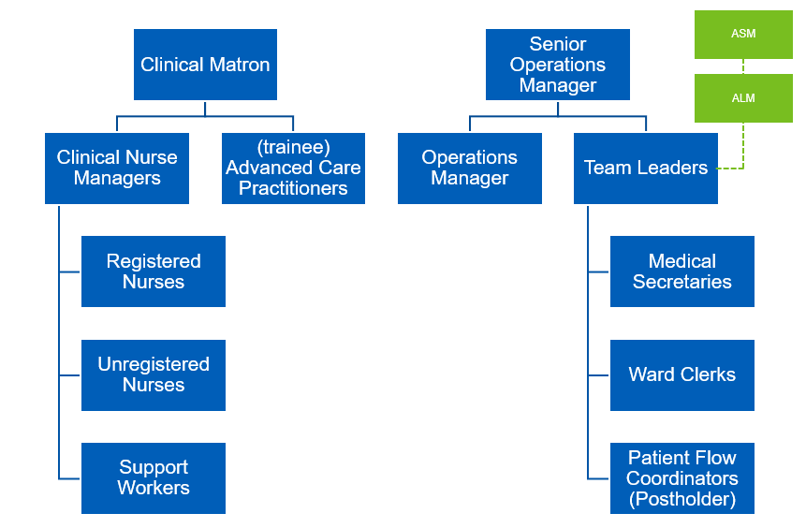

KEY RESULT AREAS/PRINCIPAL DUTIES AND RESPONSIBILITIES
- Maintaining the flow on the unit to enable to NIC to assist with clinical issues.
- Gaining and recording data to assist the NIC for bed meeting.
- Maintaining clear and precise communications across all staff on the unit along with all senior staff, clinical matron, CNM, Site management team, senior operations manager/operations manager.
- Follow up outstanding pre-booked appointments, x-rays, MRIs etc. to ensure they are still happening.
- Assist with ensure patients are being allocated to suitable bed spaces.
COMMUNICATION/RELATIONSHIP SKILLS
- Liaise closely with clinical staff, especially the Lead Consultant, NIC and Manager of the Day alerting them to any capacity issues and any referred patients from ED who are nearing the 4 hours wait target.
- Liaise with ED and other wards to ensure that communication is timely and accurate.
- Build solid foundations with care setting, to ensure a smooth liaising regarding patients.
- Act as a link from the senior staffing team to the RN/HCA/support workers.
- Assisting with ensuring patients/ families have clear discharge plan understanding.
ANALYTICAL/JUDGEMENTAL SKILLS
- Liaise closely with clinical staff, especially the Lead Consultant, NIC and Manager of the Day alerting them to any capacity issues and any referred patients from ED who are nearing the 4 hours wait target.
- Liaise with ED and other wards to ensure that communication is timely and accurate.
- Build solid foundations with care setting, to ensure a smooth liaising regarding patients.
- Act as a link from the senior staffing team to the RN/HCA/support workers.
- Assisting with ensuring patients/ families have clear discharge plan understanding.
PLANNING/ORGANISATIONAL SKILLS
- Organise, plan and actively chase any intervention the patient may need to ensure they flow into and through the department with minimum delay. This may involve dealing with multiple queries at any one time. Examples include:
  - Providing advance notification to staff in the MTU of bed availability within AMU and ensuring patients are moved from MTU in a timely manner to allow for patient arrivals from GP, ED and SWASFT.
  - Plans to admits patients from SDEC to the unit.
  - Updating and prioritising the support workers’ jobs through EPIC, as appropriate.
  - Working with the Support Workers to prioritise patient moves (e.g. to radiology or wards) to maximise flow in the unit.
  - Booking transport – this may be via relatives or via patient transport (according to Trust protocols) – for patients being discharged.
  - Chasing X-rays, blood results, echocardiograms or requesting specialty input.
- Inform nurses when beds become available on wards.
- Work with the NIC to deliver the plan of patient moves that will match the demand e.g. for side rooms, high care beds, short stay beds etc.
- Maintain high standards of communication across the unit to ensure the flow is maintained.
PHYSICAL SKILLS
- During periods of high demand the post holder may be required to transfer patients to other wards.
PATIENT/CLIENT CARE
- To be based in a front line clinical area, therefore exposed to patients who may present in a confused, aggressive, distressed or seriously ill state.
- To deal with bereaved, difficult or distressed relatives and visitors with sensitivity and tact.
POLICY/SERVICE DEVELOPMENT
- To contribute to service improvement by identifying areas for improvement.
- Participate in tests of change and gather data to assess benefits of any changes.
- Keep up to date with all required learning and new learning that may be necessary to carry out this role.
- Uphold the trust values in all areas of work.
FINANCIAL/PHYSICAL RESOURCES
- Notify the Admin Team Leader when departmental stocks are running low, as appropriate.
HUMAN RESOURCES
- Assist with on the job training of new staff when appropriate on the role of a PFC.
INFORMATION RESOURCES
- Monitor information from EPIC to gain an overview of the state of the department and expected patients.
RESEARCH AND DEVELOPMENT
- Staff are encouraged to undertake surveys and audits as necessary in relation to the role/department.
FREEDOM TO ACT
- Demonstrate initiative in delivering any plans agreed with NIC.
- Ensure any issues that will prevent the smooth flow of patients are escalated to the NIC.
OTHER RESPONSIBILITIES
- To undertake any other duties appropriate to the grade as may be required to support patient flow.
- To take part in regular performance appraisal.
- To undertake any training required in order to maintain competency including mandatory training, e.g. Manual Handling.
- To contribute to and work within a safe working environment.
- The post holder is expected to comply with Trust Infection Control Policies and conduct him/herself at all times in such a manner as to minimise the risk of healthcare associated infection.
- As an employee of the Trust, it is a contractual duty that you abide by any relevant code of professional conduct and/or practice applicable to you. A breach of this requirement may result in action being taken against you (in accordance with the Trust’s disciplinary policy) up to and including dismissal.

This post has been identified as involving access to vulnerable adults and/or children and in line with Trust policy successful applicants will be required to undertake a Disclosure & Barring Service Disclosure Check.
THE TRUST- VISION AND VALUES
Our vision is to provide safe, high quality seamless services delivered with courtesy and respect. To achieve our vision we expect all our staff to uphold our Trust values. Our Trust values are:

- Honesty, Openness & Integrity
- Fairness,
- Inclusion & Collaboration
- Respect & Dignity

We recruit competent staff that we support in maintaining and extending their skills in accordance with the needs of the people we serve. We will pay staff fairly and recognise the whole staff’s commitment to meeting the needs of our patients.

We are committed to equal opportunity for all and encourage flexible working arrangements including job sharing.

We are committed to recruiting and supporting a diverse workforce and welcome applications from all sections of the community, regardless of age, disability, gender, race, religion, sexual orientation, maternity/pregnancy, marriage/civil partnership or transgender status. We expect all staff to behave in a way which recognises and respects this diversity, in line with the appropriate standards.
GENERAL
This is a description of the job as it is now. We periodically examine employees' job descriptions and update them to ensure that they reflect the job as it is then being performed, or to incorporate any changes being proposed. This procedure is conducted by the Manager in consultation with the jobholder. You will, therefore, be expected to participate fully in such discussions. We aim to reach agreement on reasonable changes, but if agreement is not possible, we reserve the right to insist on changes to your job description after consultation with you.

The RD&E is a totally smoke-free Trust. Smoking is not permitted anywhere on Trust property, including all buildings, grounds and car parks. For help to quit call: 01392 207462.
POST | Patient Flow Co-ordinator
BAND | 3

Requirements | Essential | Desirable
QUALIFICATION/ SPECIAL TRAINING  NVQ III in Customer Care or equivalent relevant experience  GCSE A-C or equivalent in Maths and English  Key board skills  Medical terminology | E  E  E | D
KNOWLEDGE/SKILLS  Basic computer skills  Excellent telephone manner  Ability to problem solve  Extracting information/listening skills  Motivation/negotiation skills  Good decision-making skills  Knowledge of patient flow  Knowledge of Trust procedures including admissions | E  E  E  E  E  E  E | D
EXPERIENCE  Previous proven admin/clerical/reception  Dealing with the general public  Working in a busy, acute environment  Previous NHS experience  Experience of dealing with difficult/distressed people and situations | E  E  E  E  E
PERSONAL ATTRIBUTES  Excellent communication skills  Excellent organisational skills  Ability to work in a multidisciplinary team  Able to use own initiative and work with minimal supervision  Ability to remain calm and work under pressure  Ability to prioritise and multi-task  Flexible to meet needs of service  Confidence in dealing with a variety of people both professionals and others  Approachable  Willingness to learn new skills  Smart appearance  Highest integrity  Professional approach  Caring disposition | E  E  E  E  E  E  E  E  E  E  E  E  E  E
OTHER REQUIRMENTS  To work additional hours to provide cover for annual leave or sickness  Bank holiday working | E  E
P
E
R
S
O
N

S
P
E
C
I
F
I
C
A
T
I
O
N

FREQUENCY

(Rare/ Occasional/ Moderate/ Frequent)
WORKING CONDITIONS/HAZARDS |  | R | O | M | F
Hazards/ Risks requiring Immunisation Screening
Laboratory specimens | Y/N | Y
Contact with patients | Y/N
Exposure Prone Procedures | Y/N
Blood/body fluids | Y/N | Y
Laboratory specimens | Y/N | Y
Hazard/Risks requiring Respiratory Health Surveillance
Solvents (e.g. toluene, xylene, white spirit, acetone, formaldehyde and ethyl acetate) | N
Respiratory sensitisers (e.g isocyanates) | N
Chlorine based cleaning solutions  (e.g. Chlorclean, Actichlor, Tristel) | Y
Animals | N
Cytotoxic drugs | /N
Risks requiring Other Health Surveillance
Radiation (>6mSv) | N
Laser (Class 3R, 3B, 4) | N
Dusty environment (>4mg/m3) | N
Noise (over 80dBA) | N
Hand held vibration tools (=>2.5 m/s2) | N
Other General Hazards/ Risks
VDU use ( > 1 hour daily) | Y |  |  |  | Y
Heavy manual handling (>10kg) | Y |  | Y
Driving | N
Food handling | N
Night working | N
Electrical work | N
Physical Effort | Y |  |  |  | Y
Mental Effort | Y |  |  |  | Y
Emotional Effort | Y |  |  | Y
Working in isolation | N
Challenging behaviour | Y |  |  |  | Y

